FRACTAL ANALYSIS OF PRESSURE CHANGES
DURING GAS BUBBLE EMISSION

Romuald Mosdorf * and Janusz T. Cieslinski **

* Institute of Informatics, Bialystok Technical University
Wiejska 45 A, 15 351 Bialystok, Poland
** Chair of Heat Technology, Technical University of Gdansk
Narutowicza 11/12, 80952 Gdansk, Poland

BACKGROUND

A variety of systems for effecting gas-liquid contacting have been studied. The injection devices used vary from simple orifices, nozzles, capillaries, holes (sonic holes) and slots to multiple orifice plates or even porous (sintered) disks. The complexity of the process is enormous. There are numerous system and physical parameters including physical properties of the two phases, gas flow rate, pressure above nozzle or orifice plate, height of the liquid, gravity conditions which exert varying levels of influence on the formation of bubbles. Hence, most of the efforts have been devoted to the formation of bubbles from single nozzles or orifice plates.
Generally, investigation of bubble motion and sizing in laboratory experiments has relied on high-speed photography^{1,5}. Frequency data were taken by a stroboscope method^{6,7} or application of photodiodes⁸. Mori et al.⁹ have developed a new method to measure the rise velocity and the shape of a bubble with an electrical triple probe. Manasseh^{2,10} has applied an acoustic technique coupled with high-resolution photographs for bubble sizing. More recently novel video techniques have been applied, e.g. Bergez¹¹ has obtained simultaneous recordings of bubble emission and wall temperature measured with thermochromic liquid crystal by use of high-speed colour video camera together with xenon flash, Tassin and Nikitopoulos¹² and Dias et al.³ have developed the video-imaging method applied for a measurement of constant bubbling frequency based on stroboscopic video technique. In recent years several laser techniques have been developed for simultaneous measurements of bubble velocity and size. Among the latter are holography¹³ and the phase-Doppler method¹⁴.
In the present study, an acoustic technique for measurement of pressure changes during bubble emission has been developed. Air bubbles were generated on artificial sites formed by glass nozzles. Fractal analysis has been applied in order to analyse the measured data.

EXPERIMENTAL APPARATUS AND PROCEDURE

The air bubbles were emitted from glass nozzles submerged in distilled water at a depth of 25 cm in a cylindrical tank of 30 cm in diameter and 37 cm height. The volume of the settling chamber was 0.03 m³. The settling chamber is fed by air coming from a gas buffer reservoir through a pressure regulator and a rotameter. The pipe from the rotameter to the settling chamber is a 2 mm inner diameter aluminium tube. The scheme of the experimental equipment is shown in Fig. 1.
Three glass nozzles were used, with internal diameters of 0.3 mm, 0.6 mm, and 0.9 mm. Two hydrophones were employed: B&K 8105 and headphone microphone N641. It was only about 10 mm away from the bubble neck-break point.

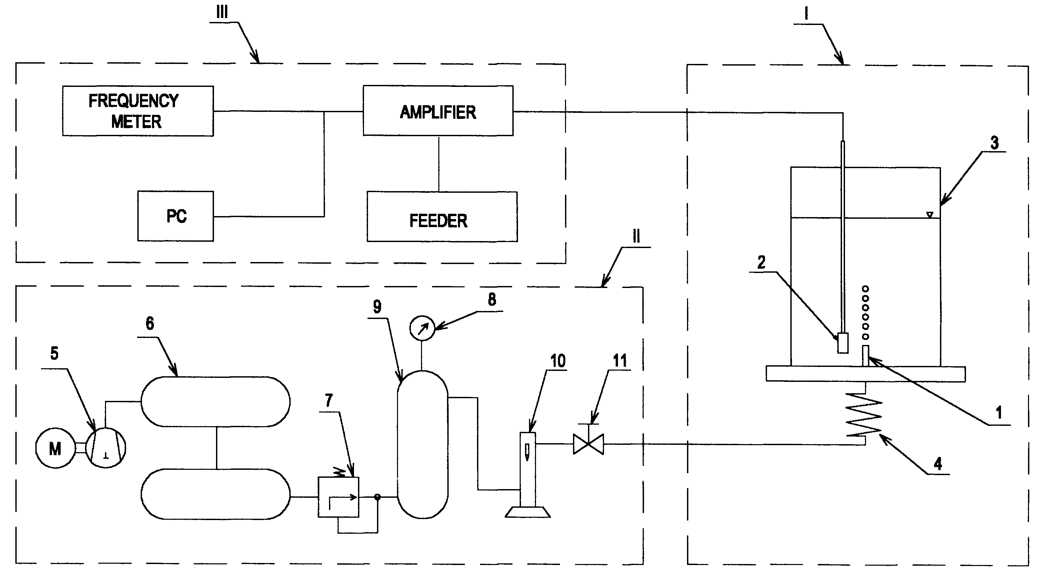

Figure 1. Experimental equipment for gas bubbling: I- injection system (1 – injection device, 2-hydrophone, 3-water tank, 4-capillary tube), II - air system (5-compressor, 6-air tank, 7-valve, 8-manometer, 9-settling chamber 10-rotameter, 11-valve), III - data acquisition system with audio
card

ANALYSIS OF EXPERIMENTAL DATA

Fast development of theoretical and experimental research on dynamic systems resulted in the formulation of numerous methods of classification and analysis of non-stationary processes⁴. One of the methods is the so called model of deterministic chaos based upon the analysis of solutions of differential equations describing the investigated phenomena. The method was developed thanks to the increase of computational capacity. The analysis of the experimental data with the application of deterministic chaos enables a more detailed analysis of physical processes in comparison with traditional statistical analysis.
The notion of deterministic chaos can be explained as irregular (that is chaotic) changes of quantities characterising a non-linear system for which the laws of dynamics univocally determine its evolution in time, provided its earlier history is known.
The chaotic dynamic system has the following properties⁴:
- trajectory of the chaotic system in the phase space does not form any single geometric object such as circle or torus, but resembles the structure of fractal,
- chaotic dynamic system is sensitive to the changes of initial conditions.
Takens⁴, proved that after the disappearance of transient effects the attractor can be reconstructed by means of measurement of the single component of a vector describing the dynamic system. The application of Taken’s theorem in connection with possibilities of modern measuring and computing techniques enables the analysis of chaotic processes on the basis of experimental data. The analysis of the measuring signal allows determining of several characteristics of the dynamic system including correlation dimension, Kolmogorov entropy and Lyapunov exponents.
The analysis of the experimental data is initiated by determination of time-delay. For that purpose the autocorrelation function is calculated. The quantity of time-delay τ is determined from the condition⁴: C(τ)≈0.5*C(0). The alternative method of time-delay τ calculation consists in determining of Hurst exponent. The image of the attractor in n-dimensional space depends upon time-delay τ. When the time-delay is too small the attractor gets flattened which makes further analysis of its structure impossible.
The trajectories of the chaotic system in the phase space do not form any single geometrical object such as circle or torus, but form objects called the strange attractors of the structure resembling the one of a fractal. One of the essential characteristics of fractals is their dimension. For experimental data the correlation dimension D₂ is calculated.
For the stochastic data the correlation dimension increases with the increase of the embedding dimension. If the examined data are deterministic chaos character, then the value of D₂ approaches constant. This value determines the correlation dimension of the attractor investigated in M dimensional space. The calculation of the correlation dimension is done for the embedding dimension M>2D+1, where D is the correlation dimension of the attractor considered⁴.
Samples of voltage signal generated by microphone were recorded at the frequency of 8 kHz. In Fig. 2 the typical changes of measurement signal generated by single departing bubble are presented. The application of such indicators as autocorrelation function, Hurst exponent, the largest Lyapunov exponent and correlation dimension measurement signal are discussed in this paper.

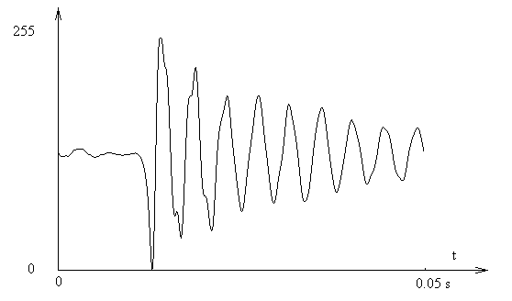

Figure 2. Typical changes of measurement signal generated by single departing bubble (pressure changes in small time scale)

In Fig. 3 the typical changes of measured signal and 3D return map have been presented.

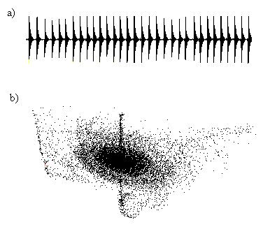

Figure 3; a) Typical changes of measurement signal generated by many departing bubbles;
b) three dimensional return map of measurement signal generated by many departing bubble

In Fig. 4 the results of calculation of correlation dimension have been presented. In the graph of correlation integral two areas can be distinguished. In Fig. 4 the changes of correlation dimension in these two areas are shown. In both areas the analysed attractor has fractal properties. For the first area the attractor has the correlation dimension close to D=1, while for the second area, the fractal dimension amounts D=3.6. The result obtained for the second area may be interpreted as characterising long-term oscillations of pressure (shown in Fig. 3a) and the result obtained for the first area as characterising the process of pressure oscillations shown in Fig. 2.

CONCLUSION

For all investigated values of air pressure, the occurrence of deterministic chaos was noted. By means of fractal analysis two processes responsible for formation of water-air patterns were identified. The analysis enables to suppose that the above processes occur in different time scales and are characterised by different fractal dimension. The correlation dimension of the process taking place in smaller time scale changes between 0.5 and 1.5, but the correlation dimension of the process taking place in bigger time scale is close to number 3.6.

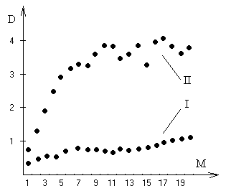

Figure 4. Correlation dimension for process of long-term pressure oscillations characteristic
for bubble departure (II) and for process of pressure oscillations in small time scale (I)

REFERENCES

- Kumada T., Sakashita H. and Yamagishi H., Pool boiling heat transfer-I. Measurements and semi-empirical relations of detachment frequencies of coalesced bubbles, Int. J. Heat Mass Transfer, Vol. 38, pp. 969-977, 1995.
- Manasseh R., Acoustic sizing of bubbles at moderate to high bubbling rates. Proceedings of Exp. Heat Transfer, Fluid Mech. and Thermodynamics, Brussel, pp. 943-947, 1997.
- Dias M.I., Breit R. and Riethmuller M.L., Non-intrusive measurement technique to analyze bubble formation. Proceedings of Experimental Heat Transfer, Fluid Mechanics and Thermodynamics, Brussel, pp. 949-956, 1997.
- Schuster H.G., Deterministic Chaos. An Introduction, (Polish version) PWN, Warszawa 1993.
- Ivey H.J., Relationships between bubble frequency, departure diameter and rise velocity in nucleate boiling, Int. J. Heat Mass Transfer, Vol. 10, pp. 1023-1040, 1967.
- Singh A., Mikic B.B. and Rohsenow W.M., Effect of superheat and cavity size on frequency of bubble departure in boiling, Trans. ASME. J. of Heat Transfer, Vol. 99, pp. 246-249, 1977.
- Srinivas N.S. and Kumar R., Prediction of bubble growth rates and departure volumes in nucleate boiling at isolated sites, Int. J. Heat Mass Transfer, Vol. 27, pp. 1403-1409, 1984.
- Kling G., Über die Dynamik der Blasenbildung beim Begasen von Flüssigkeiten unter Druck, Int. J. Heat Mass Transfer, Vol. 5, pp. 211-223, 1962.
- Mori Y., Hijikata K. and Kuriyama L., Experimental study of bubble motion in mercury with and without a magnetic field, Trans. ASME. J. of Heat Transfer, Vol. 99, pp. 404-410, 1977.
- Manasseh R., Yoshida S. and Rudman M., Bubble formation processes and bubble acoustic signals. Proceedings of ICMF’98, Lyon, 1.2-9, 1998.
- Bergez W., Nucleate boiling on a thin heating plate: heat transfer and bubbling activity of nucleation sites, Int. J. Heat Mass Transfer, Vol. 38, pp.1799-1811, 1995.
- Tassin A.L. and Nikitopoulos D.E., Non-intrusive measurements of bubble size and velocity, Experiments in Fluids, Vol. 19, pp. 121-132, 1995.
- Lauterborn W. and Hentschel W., Cavitation bubble dynamics studied by high-speed photography and holography, Ultrasonics, Vol. 23, pp. 260-268, 1985.
- Grehan G. et al., Measurement of bubbles by Phase Doppler technique and trajectory ambiguity. Proceedings 7th Int. Symp. Developments in Laser Techniques and Applications to Fluid Mechanics. Lisbon, pp. 290-302, 1994.

