SIMULATION OF TWO-PHASE MULTI-COMPONENT FILTRATION
IN LAYERED RESERVOIR

A.N. Chekalin, V.M. Konyukhov, A.V. Kosterin
Kazan State University, Kazan, Russia
ABSTRACT. The oil displacement in a layered reservoir with use of the thickening agents of various type is considered. Main attention is given to filtration of chemically reacting mixture, when the movable field of thickening agent (e.g., hydrogel) is being created in reservoir consisting from hydraulically interconnected layers. The mathematical simulation of such process in the vertical cross-section of reservoir is done on base of well-known model of two-phase five-component filtration within the large-scale approximation. The governing system includes hydrodynamic and physical-chemical groups of equations. To solve this system, the effective numerical methods and algorithms are developed. The presentation and analysis of some computational experiments are given and, in particular, shown that in comparison with polymer flooding the using of the movable hydrogel field leads to much higher efficiency of the reservoir development.

1. MATHEMATICAL THEORY

Oil field development under standard water-flooding of the layered inhomogeneous reservoirs is characterized by the low oil recovery factor, as their layers are being non-uniformly exploited. To improve this technology, the highly-viscous agents are used to increase a superseding ability of water, that leads to enlarging of flooding zone in reservoir. They can be classified under two types, in the first of which a thickening agent, formative the viscous field, enters reservoir by way of ready mixture, and in the second one such field is being created during filtration process. The filtration theory of ready mixtures does not require description of their formation process. In this case, typical for polymer flooding, to determine the composition it is enough to give the thickening agent concentration in water (see, e.g. [Volkov et al., 1997]). In the second type of action on reservoir the filtration and the mixture formation occur simultaneously and these processes are interconnected among themselves. Mathematical model of such phenomena should include two blocks of equations - hydrodynamic and physicochemical one. Equations of two-phase filtration within large-scale approximation can be written by usual way:

$\frac{∂ \text{mS}}{∂ t}+\text{div}v_{w}=0$, $\frac{∂ m\left(1−S\right)}{∂ t}+\text{div}v_{o}=0$, (1)
$v_{w}=−kk_{w}^{}\left(S\right)/μ_{w}\left(C\right)⋅∇p$, $v_{o}=−kk_{o}^{}\left(S\right)/μ_{o}\left(C\right)⋅∇p$

Here $S$ - the water saturation, $p$ - pressure, $m$- porosity, $k$ - absolute permeability, $k_{w}^{}$, $v_{w}$ and $k_{o}^{}$, $v_{o}$ - relative phase permeability and velocity of water and oil respectively. The system (1) is supplemented by the mass transfer equations of mixture components:

$\frac{∂ \text{mS}\left(C_{1}+a_{1}\right)}{∂ t}+\text{div}\left(C_{1}v_{w}\right)=−M_{1}ν_{1}ω$, $\frac{∂ \text{mS}\left(C_{2}+a_{2}\right)}{∂ t}+\text{div}\left(C_{2}v_{w}\right)=−M_{2}ν_{2}ω$,
$\frac{∂ \text{mS}\left(C+a\right)}{∂ t}+\text{div}\left({Cv}_{w}\right)=−\text{Mν}ω$, $ω=k_{+}{\left[C_{1}\right]}^{ ν_{1}}{\left[C_{2}\right]}^{ ν_{2}}−k_{−}{\left[C\right]}^{ ν}$ (2)
Simulating the mass transfer with taking into account physicochemical processes in the equations (2) we suppose, firstly, that the mixture consists of two components $R_{1}$ and $R_{2}$ with the mass concentrations $C_{1}$ and $C_{2}$, and that the reaction $ν_{1}R_{1}+ν_{2}R_{2}=νR$ between them determines the concentration $C$ of the thickening agent $R$. Secondly, the composition of mixture (water phase) influences two-phase filtration only by viscosity dependence of water phase on the thickening agent concentration: $μ_{w}=μ_{w}(C)$. In relation (2) magnitude $ω$ is difference between numbers of acts of reaction in its forward and inverse direction per time unit, $M_{i}$, $M$ - molecular masses, $[C]=\text{ C/M }$- number of moles of component per volume unit of fluid, $a_{i}$, $a$ - masses of components at fixed (sorbed) condition, bound with movable concentrations by sorption isotherms $a_{i}=a_{i}(C_{i})$, $a=a(C)$, $i=1,2$. The term «sorption» includes such phenomena as physical and chemical adsorption of admixture at surface of the porous medium skeleton, dissolution of admixture in a material of skeleton grains, and also the mechanical retention of admixture in narrowing of porous channels. Note, that in the present work we consider situation when the hydrogel is being generated from two components which are sequentially injecting into reservoir. The sorption of the first component is going more intensively and, therefore, its motion is slower, so the second component overtakes the first one on its back front and the chemical reaction between them take place here.

In method of local chemical equilibrium, the numbers of acts of reaction in forward and inverse direction are equal, therefore, if $ω=0$ then $k_{+}{\left[C_{1}\right]}^{ ν_{1}}{\left[C_{2}\right]}^{ ν_{2}}=k_{−}{\left[C\right]}^{ ν}$ or $C_{1}^{ν_{1}}C_{2}^{ν_{2}}/C^{ν}=K(T)$, where K - constant of chemical reaction. It is necessary to pay attention to fact that the occurrence of last relation leads at $ω=0$ in equations (2) to over-determination of model: one "superfluous" equation is being added. The conflict resolution consists in following. Let $τ$ is stabilization time of chemical equilibrium. The residence time of components within physical elementary volume of spatial scale $l$ is $\bar{τ}=\text{ml}/v_{w}$. If $τ\text{<< \{}\bar{τ}$ then in comparison with the hydrodynamic change of concentrations the chemical equilibrium is being stabilized practically instantaneously. It means, that the number of acts of reaction during time $\bar{τ}$ is very great and the magnitude $ω$ represents an indeterminate difference of large numbers. According to standard method, in such case the magnitude $ω$ may be considered as unknown. Then "paradox" of over-determination disappears. Physically, the combination of all equations (2) implies, that the mixture composition is very close to equilibrium, the reaction rate in both directions is very great, the difference between numbers of reaction acts in both directions is unknown and equal to $ω$.

Of special interest is situation that the controllable hydrogel field influences on the filtration process in layered inhomogeneous reservoir consisting from layers with different physical properties, when the mass exchange flows between layers takes place. The field experience has shown that creation of the unmovable hydrogel fields in such reservoirs is low-efficient usually as the fluid easily flows round of high-viscous barriers and already at small distance from them unmovable fields do not influence on redistribution of flows between layers. Obviously, that in layered inhomogeneous reservoirs it is expedient to create the movable thickening fields. In further we shall consider a plane-parallel filtration in vertical cross section of such reservoir. The injecting well and producing well (galleries) uncover the reservoir from its bottom to roof on left and right boundary accordingly. On the injection well the pressure is given, on the producing well - either pressure or flow rate. On boundaries between layers the absolute permeability has discontinuity of the first kind and the usual conjugation conditions are fulfilled here. The bottom and roof of reservoir are impenetrable. To solve equations (1,2), we used the finite-difference methods. We'd like to note only some ideas of developed approaches. The grid was built by such manner that its step along X- horizontal axes is constant, and in Z - vertical direction the grid is non-uniform. Grid step is determined for each layer. To improve an approximation of streams, the grid was moved at a half step as in X-direction, so also along Z-axes (in each layer). System (1,2) was approximated by the completely conservative finite-difference scheme. New iterative method of solving an obtained system of discrete equations was developed. This method has a high rate of convergence (3-5 iterations) at each discrete instant. Its rate does not depend as on total number of mesh points, so on the system coefficients whose values may have distinction on several orders.

2. PRESENTATION OF COMPUTATIONAL EXPERIMENTS
Let’s consider a concrete example of oil displacement with use movable hydrogel field in reservoir consisting from five layers of same thickness (2 m). The absolute permeability of layers are 0.1, 1.6, 0.4, 1.2, 0.2 mcm², $μ_{o}/μ_{w}^{o}=10$, where $μ_{w}^{o}$ - viscosity of water phase at $C=0$. The first component is being injected from the start of reservoir exploitation, and the second one - almost at once upon the creation the first gelling component field. The volumes of injected components are 0.15 and 0.2 shares of the reservoir pore volume accordingly. On injection well (gallery) its flow rate is given. The calculation was done till the flooding factor of producing well $Θ$ equal to 96%. Some results of computational experiments are presented in Table 1 and in Figures 1,2. Variants 1, 2 and 3 correspond to the standard water flooding, hydrogel and polymer flooding.
Table 1
 |  | $$\tilde{η}$$ |  |  | $$Q$$ |  |  | $$η$$
Variant $⇒$ |  | 1 | 2 | 3 | 1 | 2 | 3 |  | 1 | 2 | 3
L | 1 | 4.9 | 7.3 | 12.8 | 0.041 | 0.035 | 0.036 |  | 26.2 | 47.4 | 39.4
a | 2 | 47.5 | 44.6 | 43.9 | 0.962 | 0.329 | 0.499 |  | 60.4 | 65.8 | 64.5
y | 3 | 30.6 | 32.6 | 34.8 | 0.135 | 0.091 | 0.112 |  | 50.8 | 66.2 | 59.3
e | 4 | 36.4 | 34.5 | 43.1 | 0.654 | 0.258 | 0.331 |  | 59.1 | 66.3 | 62.8
r | 5 | 9.4 | 9.8 | 17.3 | 0.078 | 0.069 | 0.067 |  | 43.7 | 53.3 | 49.1
Reservoir |  | 25.7 | 25.7 | 30.4 | 1.870 | 0.782 | 1.045 |  | 48.1 | 59.8 | 55.0

As can be seen in Table 1, the creation of gelling fields has not changed the characteristics of the water-free period exploitation in comparison with the standard water flooding, though some distinction between the saturation distributions already takes place in reservoir. Because of this the increasing of the oil recovery factor $\tilde{η}$ in the less-permeable layers and its decreasing in high-permeable ones occurs. At same time the polymer flooding has raised the oil recovery factor $\tilde{η}$ of reservoir. Such "retardation" of the hydrogel influence on the oil recovery factor is stipulated by time lag of its creation. To the end of water-free period the hydrogel is generated only in neighborhood of injecting well and the saturation redistribution because of the mass transfer flows between layers does not lead to essential effect on the flow rate of producing well. However, on the forward front of the hydrogel field is being already formed a highly saturated petroleum zone («the oil bank»).

Creation of hydrogel field (in high-permeable second and fourth layers and in the middle layer) has such effect that the filtered fluid aspires to flow round this barrier through less-permeable first and fifth layers, i.e. the fluid penetrates in these layers at back front of the field, and at forward front it issues out from them. As result, the first component of mixture is pushed aside to boundaries between these and high-permeable layers, and it, in turn, has an effect on size of barrier in this reservoir area.
Owing to such filtration process, the hydrogel field is pushed aside also to the above mentioned boundaries and "adheres" to them (see Fig.2). Its stayed thin part in the second, third and fourth layers keeps on increasing the oil displacement from less permeable layers. If the volume of components, injected into reservoir, is poor, then the rupture of barrier in this place and, hereupon, an intensive expansion (up to a some limit size) of the «corridor», formed in highly permeable layers, will occur. At the same time the flooding rate is being considerably decreased in the less permeable layers.
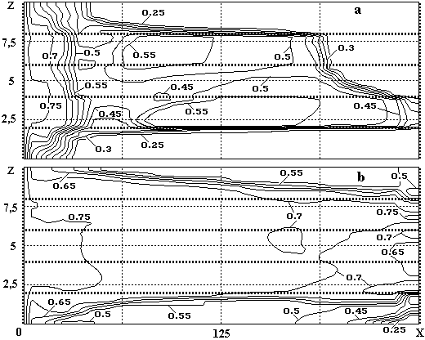
Figure 1. Distributions of the water saturation in reservoir:
(а) at breakthrough point of water in producing well,
(b) - at end point of the reservoir exploitation

The presence of the hydrogel field in reservoir leads to considerable intensification of the mass transfer flows between layers and their intensity is much more than under standard or polymer flooding in spite of the fact that to the end of exploitation, when used the movable barrier, the fluid volume Q, produced from reservoir, is 2.4 and 1.3 times less than same parameter of the above regimes (see Table 1). These flows considerably increase the uniformity of the layers development and, as result, at the end of exploitation the layered structure of reservoir is not visible practically in the isosates map (see Fig.1). Such uniformity of the saturation distribution under polymer flooding is not possible usually [Volkov et al., 1997].

As we noted earlier, the oil bank is being generated at forward front of movable barrier. When this bank reaches the producing well, the falloff of its flooding and the further stabilization of the flooding factor takes place at enough low level. In this case the rate of the oil recovery factor is increasing. Hereafter, when the hydrogel field is approached to this well (gallery), the flooding factor of the production well is fast growing up to some limiting value. Such process leads (over against the standard water flooding) to comparatively short-time operation of this well at condition of high value of the flooding factor and, hence, cuts the output of associated water. Simultaneously, the time of reservoir exploitation greatly decreases (see Table 1). One can see also from this table that injection of gelling agents and creation of the hydrogel field enhances the oil recovery factor $η$ of reservoir (of 11.7% in presented example) and every its layers at the completion instant of the reservoir exploitation. It is interesting, that the oil output is most increased (of 21.2%) in the first less-permeable layer (for comparison in the second high-permeable layer the augmentation of $η$ has compounded 5.2%). Moreover, it turned out even that the oil recovery factor $η_{3}$ of the third layer is some more than value $η_{2}$ of the second one, although its permeability is four times less (in case of the standard water flooding and polymer flooding $η_{3}$ is less of 9.6% and 5.2% then $η_{2}$ accordingly).

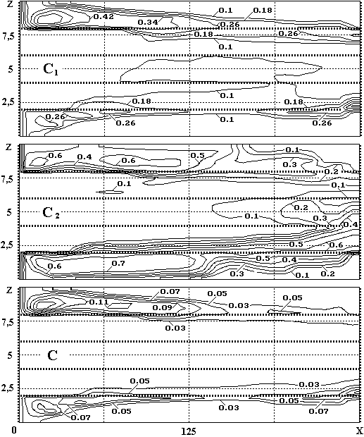
Figure 2. Concentration distributions $C_{1}$, $C_{2}$and $C$ of gelling agents
and hydrogel in reservoir at the end point of its exploitation

- Conclusions

Some main results of our investigations can be formulated as follows. The oil displacement in the layered reservoir under the hydrogel flooding can greatly differs from the filtration processes at the standard water flooding and polymer flooding. There is a possibility to achieve considerable uniformity of development of layers with different permeability and to improve the basic exploitation parameters of reservoir by means of the controllable movable hydrogel field.

REFERENCES

- Yu.A. Volkov, V.M. Konyukhov, A.N. Chekalin, Investigation of the Process of Water-Oil Displacement in Laminated Reservoirs Taped by Horizontal Wells, Proceeding of ICHMT Symposium, Antalya, November 3-7, 1997, pp. 435 - 447.

