INVESTIGATION OF A FLUIDIZED BED
IN INCLINED PIPES

Bachtiyar Yakubov¹, Josef Tanny¹, David M. Maron¹ and Neima Brauner²

¹Holon Academic Institute of Technology, P.O.B. 305, Holon, 58102, Israel
²Faculty of Engineering, Tel Aviv University, Ramat Aviv, Tel Aviv 69978, Israel

ABSTRACT

This paper presents an experimental investigation of the effect of various particle properties on the fluidization and hydro-transport processes of solid particles in upward inclined pipes. The experiments were carried out in a glass pipe, 2.54 cm in diameter and 2.3 m long, using different types of particles. The results show that the particle diameter, density and the initial height of particles in the pipe have a considerable effect on the critical flow rate of particle escape from the fluidized bed.

INTRODUCTION

Many important processes occur under conditions of fluidization in inclined ducts. Such processes are: refining from the sulfur and hydro-cracking of oil fractions, the modern hydrogenization of coal for production of fuel oil, refining of sewage, processes in oil-extracting, washing the grains in a sand cork formed during oil production processes¹ and cooling systems of nuclear power plants.

In a previous paper² we focused on the effect of the inclination angle on the structure and dynamics of the fluidized bed and on the critical flow rate of particle escape from the bed. It was shown that the inclination of the pipe has a considerable effect on the fluidized bed structure and that the escape flow rate attains a maximum at inclination of about 45°. In this paper we present the results of further experiments that were focused on the effect of various particle parameters on the escape flow rate. In particular we study the effects of particle size, particle density and the initial height of particles in the bed (concentration) on the escape flow rate.

EXPERIMENTAL SETUP AND PROCEDURES

The experimental apparatus is shown in Fig. 1. In the following, the numbers in parentheses indicate the item number in Fig. 1. The experiments were carried out in a glass pipe (1), 2.54 cm in diameter and 2.3 m long. The transparent glass pipe allowed the visualization and recording of the flow and transport processes during the experiment. The pipe could be positioned at inclination angles in the whole range from horizontal to vertical, α = 0° - 90°. Thus vertical, horizontal and inclined fluidized beds could be studied. The pipe was equipped with inner circular nets, embedded at its top and bottom, to prevent the escape of particles from the pipe. A scale (2) was attached along the pipe to facilitate the measurements of the instantaneous fluidized bed position and height. The accuracy of this measurement was estimated as ± 0.0025 m. A water tank (6) and a pump (5) were used to circulate the fluid through the pipe.

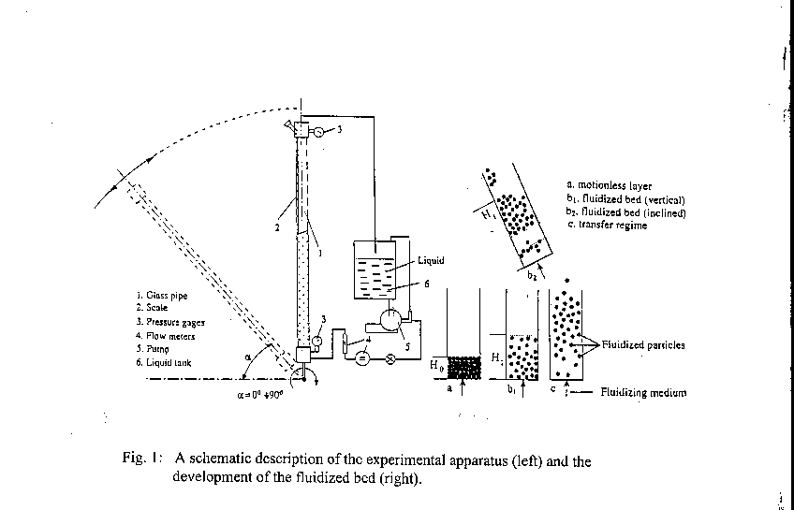
meter was a commercial cumulative meter (METERS) with an error of ±0.001 l/min. The particle flow patterns were imaged by a CCD camera, the output of which was displayed on a monitor and also recorded by a time-lapse VCR for later reviewing. In all the experiments reported in this study, the working fluid was water.

Two sets of experiments were carried out. In the first, the effect of the initial height of particles in the bed on the escape flow rate was studied. To start an experiment, a certain amount of particles were introduced into the pipe, the latter being positioned at a certain inclination. The experiments were carried out with 13 different amounts of particles in the pipe, corresponding to H₀, the initial height of the particles measured from the pipe bottom. The value of H₀ was varied from almost zero (few particles in the pipe) up to 0.6 m. These experiments were conducted with particles of density 1.25 g/cm³ and diameter of 3.2 mm.

In the second set, the effects of the particle diameter and density on the escape flow rate were investigated at a constant initial height H₀ = 35 cm. Particles of the same density (1.25 g/cm³) and three different diameters, 1.5, 2.5 and 3.2 mm, were used. The effect of the density was investigated by using two types of particles of nearly the same diameter, 1.2-1.4 mm and 1.5 mm, and densities of 2.65 and 1.25 g/cm³ respectively.

Each experiment was begun at a low flow rate of the fluidizing liquid. This flow rate was then increased gradually in order to follow the evolution of the fluidized bed as a
function of the water flow rate. The experiment was terminated at a critical flow rate
where the onset of particles escape from the fluidized bed was observed, i.e., a hydro-transportation process started.

RESULTS

The effects of particle diameter and density are presented in Figures 2 and 3. Fig. 2 presents the critical flow rate for the onset of particle escape from the bed as a function of the inclination angle, for three types of particles with the same density but different diameters. First it is observed that for all diameters, the critical flow rate reaches a maximum value at inclination of about 45°, as was observed in². For lower and higher inclinations, the critical flow rate is reduced. The figure shows that the critical flow rate generally increases with the particle diameter. For the diameters 1.5 and 2.5 mm the results are nearly the same but for the particles of 3.2 mm diameter, the critical flow rate is higher. This effect is most pronounced for inclination angles between 30° to 80°. For inclinations below 30° and above 80° (almost vertical pipe), the effect of the diameter on the escape flow rate is small.

Fig. 3 presents the escape flow rate as a function of the inclination angle, for particles of almost the same diameter but substantially different densities. Again we observe that the maximum flow rate is at an inclination angle of about 45°. The results show that the critical flow rate increases significantly with the density for all inclination angles. For the heavier particles, however, the critical flow rate decreases as the inclination is reduced from 45° to 20°, but for inclinations smaller than 20° the critical flow rate is increased. This is because at these small inclinations (nearly horizontal pipe) the flow cannot transport the heavy particles that rest on the lower side of the pipe. Thus a larger flow rate is required to transfer these particles away from the bed.

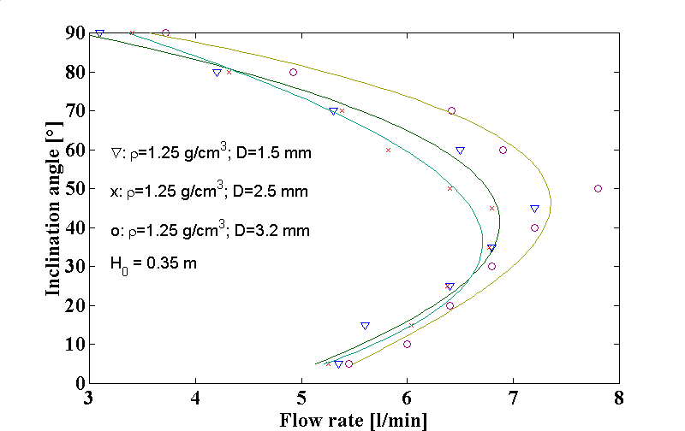

Fig. 2: The effect of particle diameter on the critical flow rate for the onset of particle
escape from the fluidized bed.

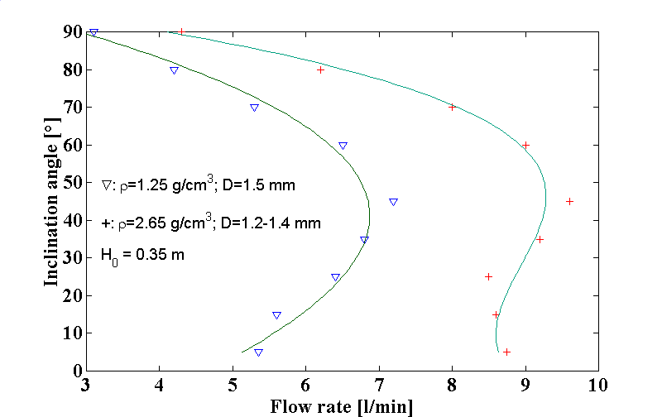

Fig. 3: The effect of particle density on the critical flow rate for the onset of particle
escape from the fluidized bed.

Fig. 4 shows the effect of the initial height of particles in the pipe, H₀, on the escape flow rate, at three different inclination angles, 10°, 45° and 90° (vertical pipe). We first observe that for all inclinations, the initial particles height has a considerable effect on the escape flow rate. For inclined pipes (10°and 45°) the escape flow rate initially increases with the particles height, up to H₀ = 0.025 m, at which value the escape flow rate reaches a maximum value. For higher values of H₀ > 0.025m, the escape flow rate generally decreases with H₀. The same result was obtained for inclinations of 30° and 65°, not shown in Fig. 4. In the case of a vertical pipe (90°) the behavior is different and the escape flow rate generally decreases with H₀, for the whole range of 0 < H₀ ≤ 0.6 m. Another interesting observation in Fig. 4 is that for H₀ larger than approximately 0.4 m, the effect of H₀ on the escape flow rate is smaller as compared to its effect at lower values of H₀.

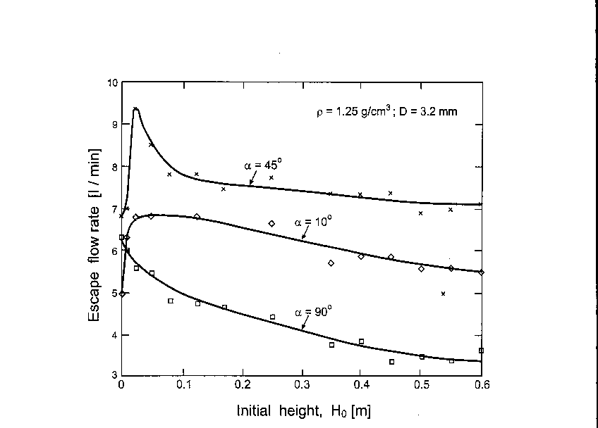
Fig. 4: The effect of the initial height of the particles in the pipe (concentration) on
the critical flow rate for the onset of particle escape from the fluidized bed.

CONCLUSIONS

From the experiments reported above the following conclusions can be drawn:
- The escape flow rate increases with the particle diameter.
- The escape flow rate increases with the particle density.
- The escape flow rate generally decreases with the initial height of particles in the pipe, H₀. For very small initial heights and inclined pipes, the escape flow rate increases with H₀.
- For all particle diameters, densities and initial heights, the escape flow rate has a maximum value at pipe inclination of 45°.

REFERENCES

1. B. Yakubov, Effective Technological Processes in Oil-Gas Extraction - Mechanics
of Fluidized Bed, Baku, Azernshr, p. 160, 1990.
- B. Yakubov, J. Tanny, D. Moalem Maron and N. Brauner, Experimental Study on
the Characteristics of a Fluidized Bed in Inclined Pipes, Two-Phase Flow
Modelling and Experimentation 1999, Edizioni ETS, Pisa, Italy, 1999, pp.
1825-1832.

