FUEL DISINTEGRATION IN GAS ATOMIZERS

M.P. Levitsky*, Y.M. Shtemler*, Y. Berkovich**
*Institute for Industrial Mathematics,
4/24 Yehuda Hanachtom Str., Beer-Sheva 84249, Israel
**Israel Electric Corporation, POB 10, Haifa 31000, Israel

INTRODUCTION
Fuel atomization has numerous technical applications in boiler burners for power plants, for combustion chambers of engines, etc¹. In spite of a wide choice of available atomizer designs, the pressure-swirl atomizers (Fig. 1a) are mainly employed for fuel disintegration in power-plant practice. In the present work gas atomizers (Fig. 1b) are experimentally investigated using air for water-jet disintegration. The liquid jet enters a convergent-divergent gas nozzle through a central tube with an exit within the diffuser. Supersonic velocities of the gas and low velocities of the liquid provide for a high velocity difference in the diffuser necessary for the liquid jet to be atomized into small droplets. The results are compared with those for pressure-swirl atomizers and with theoretical prediction.


Fig. 1a. Scheme of the pressure-swirl atomizer.
Fig. 1b. Scheme of the gas atomizer with a central body.

A tangential inlet to the pressure-swirl atomizer, α spray angle, arrows indicate flow direction.
A is gas flow in the gas atomizer, B is the liquid flow, C central body, α spray angle, T is the throat of the nozzle, arrows indicate flow direction.

Main Drawbacks of Pressure-Swirl Atomizers: 1. Relatively coarse droplets after atomization (~125μm) leading to the low quality of fuel combustion. 2. Non-homogeneous droplet-size distribution. 3. High pressure heads (~4÷7 MPa), and as corollaries: erosion in the atomizer ducts; high-hardness steels for duct manufacture; short service life and high cost; 4. Spray angle is less than 70º-90º; 5. Deterioration of spray quality with decrease in the fuel flow rate under its control.

In some applications, as boiler burners, the air is supplied into the combustion chamber at near-atmospheric pressure and has to be additionally compressed for fuel atomization. To reduce the expenses only a part of the entire air is compressed in such devices, while the ratio of the liquid/gas mass flow is held of the order of unit or larger. To provide the value of the spray angle necessary for effective fuel burning in boiler burners a central body is introduced behind the exit from the liquid delivery tube (Fig. 1b). The efficiency of this (first) type of gas atomizers is experimentally compared with that for the traditionally employed pressure-swirl atomizers. In other applications, as combustion chambers of engines, the air is supplied at sufficiently high pressure and can be fully employed for fuel atomization. In this case relatively small ratios of liquid/gas mass flow rate ${{\overset{˙}{m}}_{l}}/{{\overset{˙}{m}}_{g}}\text{\sim }$0.1÷0.3 are usually employed in gas atomizers of the second type without a central body (Fig. 2). In the current work experimental data for second-type atomizers are compared with results of prior theoretical modeling for estimation of the atomizer’s geometry and operating conditions necessary for producing a finely dispersed gas-liquid mixture. The theoretical modeling used for comparison^{2,3} has been based on the following consideration. Disintegration of the liquid jet occurs in two stages: primary and secondary atomization^{5,6}. At the first stage, the jet is atomized into coarse droplets or ligaments almost immediately at the outlet from the liquid delivery tube. Possible mechanisms of the corresponding liquid-jet instability have been considered by^{6,7} and references therein. At the second stage, interaction between the gas stream and coarse liquid fragments causes their breakup into fine droplets and mixing with the surrounding gas. Since the details of primary and secondary atomization are not yet fully understood^{5,6,} the flow scheme has been simplified (Fig. 2). Just behind the outlet from the delivery tube, the liquid jet is assumed to be disintegrated due to its instability, mixing with a gas annulus and forming a coarsely dispersed mixture, and the primary atomization zone is described as a ‘primary atomization interface’. The formed mixture has been described by the phase insulation model⁸ with the same velocities and temperatures of the droplets as the jet at the exit from the liquid delivery tube. Secondary atomization occurs in a zone that has been described as a steady-state shock wave in the two-phase stream (referred to as ‘atomization shock’) in the sense of satisfying the integral conservation laws. The resulting mixture is supposed to be modeled in homogeneous-equilibrium limit with equal subsonic velocities and the same temperatures of the components⁸. Note that such a limit accurately represents a real mixture consisting of sufficiently small droplets (see review⁹) as it is often desirable in applications. The relations between the system parameters on both sides of the atomization shock, derived in a quasi-one-dimensional approximation, are independent of the final diameter of droplets. Effects of surface tension, liquid viscosity, flow losses and phase transitions have been ignored. The liquid has been assumed to be incompressible, and pressures in the phases are equal. The problem has been reduced to a modified problem of gas-dynamics requiring neither a detailed description of the liquid jet breakup nor the use of empirical correlations for dynamic and thermodynamic interactions of droplets and gas. In Fig. 4 parametrical regions of the atomizer’s geometry and operating conditions are shown (bounded by two upper and lower branches) necessary for producing the finest possible mixture at several dimensionless liquid mass flow rates _{l}=0, 0.1, 0.2, 0.25. The final diameter of droplets cannot be determined within such modeling, since it depends on relative velocity, surface tension, etc. Thus, only an indirect comparison is possible of the results in Fig. 6 with experimentally measured droplet diameters that are presented in the next section.

Fig. 2. Scheme of the gas atomizer without central body.
In Fig. 2 the following notation are used: A is gas flow in the nozzle, B is the liquid flow in the delivery tube, C coarsely dispersed mixture in phase-insulated limit, D finely dispersed mixture in homogeneous-equilibrium limit, P primary atomization interface, S secondary atomization interface (atomization shock), T throat of the nozzle, arrows indicate flow direction.

EXPERIMENTAL STAND AND TESTING RESULTS
A drop-size measurement system based on a laser device located behind the atomizer is shown in Fig. 3.

Fig. 3. Scheme of the drop-size measurement system.
1 atomizer, 2 water delivery tube, 3 air delivery tube,4,5 pressure gauges,
6 flow rate meter, 7 computer,8 drop-size gauge with moving probe 9, 10 spray jet.
The drop-size distribution histograms and dependences of the normalized number of droplet N on droplet size d and the Sauter mean diameter measured in microns are obtained. All measurements were carried out at the same distance behind atomizers at different radial coordinates beginning from the periphery of the spray jet in equal steps with four stations across the spray jet. The final results have been averaged across the spray jet. Experiments as well as numerical simulations have been carried out at normal stagnation temperatures of the air and water.

Efficiency Comparison of Gas and Pressure-Swirl Atomizers.
In Fig. 4 and 5 experimental results are compared which have been obtained for the pressure-swirl atomizer (Fig. 1a) and for the gas atomizer of the first type with a central body (Fig. 1b). Comparison of the results for pressure-swirl atomizer with those for gas atomizer shows that the gas atomizer allows a decrease in mean drop size from 125 μm (=1200kg/h, Δp_{l}=6.18 MPa, α=70º) up to 61 μm (=1100kg/h, Δp_{g}=0.61 MPa, α=70º, _{l} ≈0.5, ≈ 0.14, ≈ 3.5). It is shown also that droplet distribution is significantly more homogeneous in the case of the gas atomizer. As was mentioned above, deterioration of spray quality takes place for conventional pressure-swirl atomizers with decrease in the fuel flow rate under its control. Spray quality variation is obtained with decrease in the liquid flow rate for the gas atomizer of the first type. It is noted that the spray quality rises in the case of the gas atomizer.

Fig. 4. Drop-size histogram Fig. 5. Drop-size histogram
for pressure-swirl atomizer (=125μm). for gas atomizer (=61μm).
=1200kg/h, Δp_{l}=6.18 MPa, α=70º. =1100kg/h, Δp_{g}=0.61 MPa,
α=70º, _{l} ≈0.5, ≈ 0.14, ≈ 3.5.

Comparison of Experimental Data with Theoretical Prediction
Experimental results (experimental points marked by X with the Sauter mean diameter in microns written to the right from X) for second-type gas atomizers (without a central body) are compared with the results of numerical simulations in Fig. 6 (adopted from ^{2,3}).
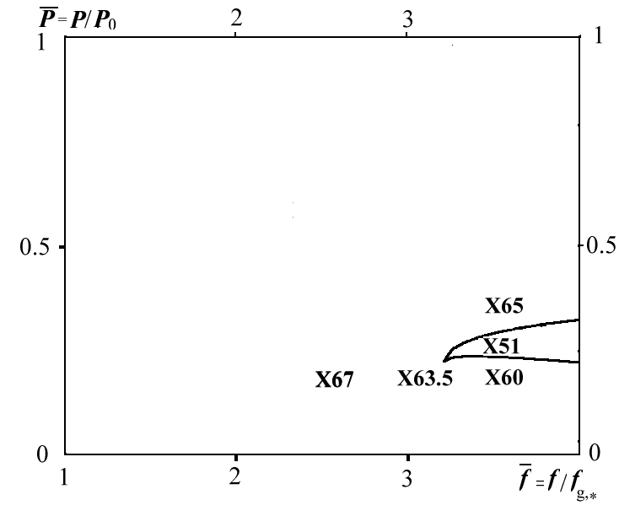
Fig. 6. Comparison of experimental data with theoretical prediction at _{l} =0.25.
Dimensionless pressure vs cross-section area of the nozzle for the air-water system.

CONCLUSIONS
On the basis of the present tests we may characterize the gas atomizers of the first type in comparison with pressure-swirl atomizers: (i) finer droplets after atomization (~50-70 μm); (ii) lower pressure heads through both fuel and air lines (~0.3÷0.5MPa); (iii) more homogeneous droplet-size distribution,; (iv) any desirable spray angle (from 60º up to 150º) can be provided by introducing of central body into the divergent part of the nozzle; (v) non-deterioration of spray quality with a decrease in the fuel flow rate under flow rate control.

Comparison of experimental data for gas atomizers of the second type with results of numerical simulation (Fig. 6) demonstrates the applicability of the prior theoretical model for rough estimation of the atomizer’s geometry and operating conditions necessary for producing the finest possible mixture.

REFERENCES
1. A.H. Lefebvre, Atomization and Sprays, Hemisphere, New York, 1989.
2. Shtemler Y., Levitsky M.P.,. Shreiber I.R., Levitsky S.P., On liquid jet disintegration in gas nozzles, 2d International Symposium on Two-phase flow modelling and experimentation, Pisa, 1999.
3. Shtemler Y., M.P. Levitsky, I.R. Shreiber, S.P. Levitsky and Y. Berkovich , Two-stage atomization model for liquid jet disintegration in gas atomizers, Journal of Applied Mechanics and Engineering, v.5, N 4, 2000.
4. Y.I. Naida, Deformation and disintegration of liquid particles by a gas stream, Sov. Powder Metal. Ceram., vol. 3, pp.187-190, 1971.
5. A. Unal, Effect of processing variables on particle size in gas atomization of rapidly solidified aluminum powder, Material Science and Techn., vol. 3, pp. 1029-1039, 1987.
6. X. Li, Mechanism of atomization of a liquid jet, Atomization and sprays, vol. 5., pp. 89-105, 1995.
7. S. S. Sadhal, P. S. Ayaswamy, J. N. Chang, Transport Phenomena with Drops and Bubbles, chap. 7, Springer, New York, 1996.
8. .B. Wallis, One-Dimensional Two-phase Flow, chap.8, McGraw-Hill, New York, 1969.
9. G.M. Faeth, Evaporation and combustion of sprays, Prog. Energy Comb. Sci., vol. 9, pp. 1-76, 1987.

