NUMERICAL SIMULATION OF FOREST FIRE

C. Paz *, F. Fuentes* and S. García*

*Mechanical Engineering Department
University of Vigo. Lagoas-Marcosende, nº9 36200 Vigo. Pontevedra. Spain.

In this paper, a numerical model developed for modelling forest fires is presented. Governing equations of an incompressible fluid flow (mass, momentum and energy) have been formulated with a turbulent modified k-ε model to simulate an atmospheric surface layer and with a one-step chemical fire propagation model. The lower part of the domain is occupied by a drag layer to represent a forest.

INTRODUCTION

The problem of describing the physical process of the propagation of forest fire is very complex and not totally understood. Forest fires involve a wide range of unknown variables: fuel moisture content, type of fuel and its thermal properties, wind flow over complex terrain, atmospheric stability, etc. Of the various factors which affect the fire spread, the most important is the local wind speed and this is the most difficult to forecast. The other factors can be estimated or at least their values vary over a limited range depending on the season of the year, or the localization of the place and the local geography.
Several authors have proposed models to predict the fire front movement. Rothermel´s fire spread model (1972) is the basis for most computer-based fire management applications in the United States, with significant use in other countries. Rothermel´s model¹ was developed from a strong theoretical base provided by Frasden (1971), who applied the conservation of energy principle to a unit volume of fuel ahead of an advancing fire in a homogeneous fuel bed. Final form was given by Rothermel, with adjustments by Albini² (1976). Fire spreads more rapidly in the direction of the wind and the direction of upslope, so a ellipse is often used to quantify the shape of a point source fire. This is the idea of models based in Huygens principle (Anderson (1982) y Catchpole (1985) and De Mestre ³(1989) y Richards (1988)); any point of the fire front is propagating as a ellipse and front fire in a new time is the envolvent of this ellipses
The object of this paper is to resolve an unsteady fluid flow with a non-staggered finite volume technique to provide a local wind field with a chemical fire propagation model, based upon the principle of conservation of energy, to predict the behaviour of a fire front. Numerical model is presented below.

PHYSICAL MODEL

Combustion process start with a preignition phase. This phase includes a endothermic reactions by which the temperature of fuel is raised to the point where the water evaporates and volatiles are realesed. Heated vegetation fuels produce combustible gases as product of pyrolisis and by volatilization of waxes, oils and other compounds. Then, the solid fuel and its rate of volatilization is our interest in this phase. We describe this behaviour by a Arrenius type equation.
When ignition temperature is realeased, an exothermic reaction occurs. Fuel and oxidizer are initially separated and combustion occurs in the zone where the gases mix. Now, our interes is the gas phase and its behaviour is described by momentum, energy and turbulence quantities equations.

Governing equations

Mass conservation:
$\frac{∂u_{i}}{∂x_{i}}=0$ (1)
Momentum:
$\frac{∂u_{i}}{∂t}+u_{j}\frac{∂u_{i}}{∂x_{j}}=−\frac{1}{ρ}\frac{∂P}{∂x_{i}}+\frac{∂}{∂x_{j}}\left(ν_{\text{ef}}\frac{∂u_{i}}{∂x_{j}}\right)+{βg}_{i}{Tδ}_{i2}+F_{i}$ (2)
Enthalpy:
$\frac{∂h}{∂t}+u_{j}\frac{∂h}{∂x_{j}}=\frac{∂}{∂x_{j}}\left(\frac{ν_{\text{ef}}}{σ_{h}}\frac{∂h}{∂x_{j}}\right)+Q$ (3)
Kinetic energy of turbulence:
$\frac{∂k}{∂t}+u_{j}\frac{∂k}{∂x_{j}}=\frac{∂}{∂x_{j}}\left(\frac{ν_{\text{ef}}}{σ_{k}}\frac{∂k}{∂x_{j}}\right)+G+G_{B}−ε−G_{D}$ (4)
Rate of dissipation of turbulent energy:
$\frac{∂ε}{∂t}+u_{j}\frac{∂ε}{∂x_{j}}=\frac{∂}{∂x_{j}}\left(\frac{ν_{\text{ef}}}{σ_{ε}}\frac{∂ε}{∂x_{j}}\right)+\frac{ε}{k}\left(C_{1ε}G+C_{3ε}G_{B}+C_{4ε}G_{D}−C_{2ε}ε\right)$ (5)
where:
$G=ν_{T}\left(\frac{∂u_{i}}{∂x_{j}}+\frac{∂u_{j}}{∂x_{i}}\right)\frac{∂u_{i}}{∂x_{j}}$ (6)
$G_{B}=βg\frac{ν_{T}}{σ_{T}}\frac{∂T}{∂x_{j}}$ (7)
$G_{D}=\frac{1}{2}C_{D}a\left|\vec{v}\right|v^{2}$ (8)
$ν_{\text{ef}}=ν_{T}+ν$ (9)
$ν_{T}=C_{μ}\frac{k^{2}}{ε}$ (10)
and C_{1ε}=1.44, C_{2ε}=1.92, C_{μ}=0.09, σ_{k}=0.7, σ_{h}=σ_{t}=0.7
where u _{i} is the velocity in the xi direction, P is the pressure, ρ is air density, β is the volumetric expansion coefficient of the air, g is the gravitational acceleration, T is temperature, ν is kinematic viscosity and ν_{T} is kinematic eddy viscosity.
F_{i} is the drag force in the x_{i} direction due to the forest and is equal to the product of plant area density a, a drag coefficient C_{D} and the square of the local velocity. The force opposes the local wind vector. A term due to the drag caused by the vegetation has been included in the k-ε model to represent the removal of turbulent kinetic energy by the action of the drag. The empirical coefficient C_{4ε} was optimised by Svensson and Haggkvist ⁴ .
On the other hand, buoyancy forces disturb the simple picture of isotropic turbulence assumed by the k-ε model: a production term G_{B} to describe the exchange of turbulent kinetic energy with potential energy is included in the k-equation and its effect on the dissipation equation is taken into account too. The inclusion of the C_{ε3}R_{f} was proposed by Rodi⁵ , where R_{f} is the Richardson number of the flux and C_{ε3} takes the value unity in horizontal layers and zero in vertical shear layers. We assume C_{ε3}=0 (see Boss et al⁶ ).
In order to define the value of the heat source Q of the enthalpy equation, we consider the follow one-step reaction:
$\text{Fuel}→\text{products}+\text{heat}$ (11)
Then, if the initial concentration of fuel is C₀, the values of the concentration for each time step are given, using Arrenius law, by:
$\frac{\text{dC}}{\text{dt}}=−s(T){\text{Ae}}^{−\frac{E_{A}}{\text{RT}}}C=−s(T)λC$ (12)
and the heat source Q:
$Q=s(T){\text{HAe}}^{−\frac{E_{A}}{\text{RT}}}C$ (14)
where H is the reaction mass enthalpy, and s(T) is given, follows⁷, by:
$s(T)=\left\{\begin{matrix}1 & \text{if} T>T_{\text{vol}} \\ 0 & \text{in} \text{other} \text{case}\end{matrix}\right.$ (15)
to take into account solid fuel begins to disappear from T_{vol} , then, heat source in enthalpy equation must be appear from that temperature.

MATHEMATICAL MODEL

The transport equations have been integrated over each control volume centred on each scalar node P in the computational domain. Each flux is assumed to be constant across the face of each cell. A fully implicit scheme of second order accuracy in time is blended with the first order implicit Euler scheme to help to prevent oscillations.
In order to know the values of the variables at the cell faces for the treatment of the convection term, we have to interpolate. A first order upwind with a deffered correction with a central scheme has been used. Pressure-velocity coupling is obtained using the SIMPLE algorithm. modified follows Peric⁸. Diffusion terms are discretized using central differencing.

Boundary conditions and other computacional aspects:

The computational domain extends horizontally and vertically over a finite domain of size 500m in each direction. The forest occupies the terrain between 70-420m from the inlet and was specified as a uniform leaf area density. The mean flow is aligned with the x-direction and it was prescribed as a power law 1/7. The inlet turbulent kinetic energy and the dissipation rate were specified as:
$k(z)=\frac{1\text{.}5(\text{ytop}−y)}{\text{ytop}}$ (25)
$ε(y)=\frac{0\text{.}\text{41}{\left(k(y)\right)}^{15}}{y}$ (26)
The upper boundary is treated as a frictionless, rigid lid with zero mass, momentum, heat and turbulent kinetic energy flux. At the lower boundary, a well-known ‘law of the wall’ was applied.We take a initial temperature distribution as following:
$$T(\vec{x},0)=\left\{\begin{matrix}T_{1} & \text{if}\left|\vec{x}−{\vec{x}}_{o}\right| & R_{1} \\ T_{2} & \text{if}\left|\vec{x}−{\vec{x}}_{o}\right| & R_{2} \\ T_{2}+(T_{1}−T_{2})e^{\frac{{}^{R_{1^{2}}−{\left|\vec{x}−{\vec{x}}_{o}\right|}^{2}}}{{}^{{R_{2^{2}}−\left|\vec{x}−{\vec{x}}_{o}\right|}^{2}}}} & \text{if}\text{other} & \end{matrix}\right.$$
with a constant initial fuel distribution.

RESULTS

A grid comprising 69x 39 control volumes was used. Forest occupies the first fifteen volumes of the grid. Figure 1 shows the temporal evolution of temperature profiles for a wind average velocity of 2 m/s (figure 1.a)and for 5 m/s(figure 1.b).Future works will include a energy equation for the solid phase (to have into account radiative and conductive heat transport through the fuel and water vaporization , pyrolysis and combustion ) and the equations for the chemical species (fuel, oxidizer and products).

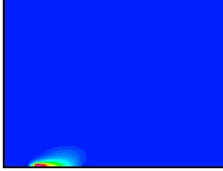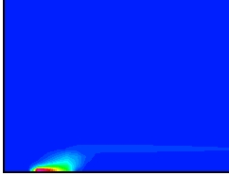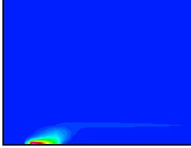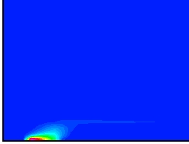
Figure 1 a

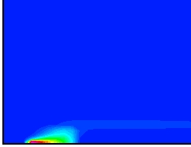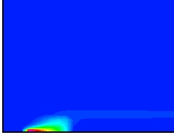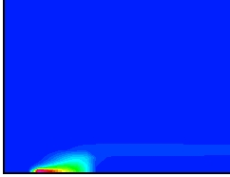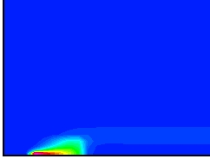
Figure 1b

ACKNOWLEDGEMENTS

Financial support for this work is due to Xunta de Galicia (Spain) under project: XUGA32106B98.

REFERENCES

- Rothermel, R.C. , Anderson, Fire spread caracteristics determined in laboratory, Forest Service USDA Res. Pap. INT-69 ,1969.

- Albini, F, A model for fire spread in wildland fuels by radiation, Combust. Sci. Technol. 42, 1985.

- Catchpole, T., de Mestre, N., Physical models for a spreading line fire, Aust. For. 49 (2), 102-111, 1986.

- Svenson, V., Haggkvist, K., A two-equation turbulence model for canopy flows, J. of Wind Engineering and Ind. Aerod. , 35, 201-211, 1990.

5. Rodi, W., Turbulence models and their aplication in hidraulics-a state of the art review', SFB Report 80/T/125, University of Karlsruhe ,1978.

6. Boss, W.G., van Der Elsen, T., Hoogendorn, C., Numerical study of stratification of a smoke layer in a corridor, Comb. Sci. Technol, 46, 333, 1986.

- Asensio, I. ,Simulación numérica de procesos de combustión en medios naturales, Tesis doctoral, Universidad de Salamanca, 1998.

8. Ferziger, J., Peric, M., Computational Methods for Fluid Dynamic, Springer-Verlag,1999.

