APPLICATIONS OF MAGNETIC FLUIDS IN HEAT TRANSFER

Vasile Pode, Romulus Minea
“Politehnica” University Timişoara, Faculty of Industrial Chemistry
and Environmental Engineering, Victoriei Sq. 2, 1900 Timişoara, România.

INTRODUCTION

Magnetic fluids may be defined as colloidal dispersions in a supporting liquid. The chemical characteristics of the magnetic fluids are imparted by the type of the liquid dispersion medium (water, diesters, petroleum, mineral oils, fluorocarbons, silicone oils), while the magnetic characteristics depend on the concentration of the magnetic particles.
The remarkable properties of the magnetic fluids (long-term stability at the working temperatures, high magnetic saturation and initial magnetic susceptibility, low viscosity and vapor pressure, absence of a significant aggregation in the presence of a uniform magnetic field, stability in gravitation fields, and fair thermal conductivity) result in multiple applications :
• intensification of the heat transfer ;
• heat carriers ;
• sealing (tightening) technique ;
• magnetofluide separation processes ;
• measuring devices, transducers, sensors, etc.
The research concerning light absorption by magnetic fluids based on petroleum showed that in the range 500-600 nm occurs an enhancement of the spectral absorption coefficient, which makes it possible the utilization of magnetic fluids as absorbent media for solar energy^{1,2}.
In this paper are presented the results of the research concerning the utilization of magnetic fluids as heat carriers in the capture of solar energy.

EXPERIMENTAL

The magnetic fluid used in the experimental research was obtained by the chemical precipitation method³⁻⁴ and exhibited the following characteristics : density, ρ = 1007 kg/m³, concentration 0.23 g Fe₃O₄/cm³, saturation magnetization M_{s} = 200 Gs.
In order to achieve the photothermal conversion of the solar energy has been built and experimented a solar collector without concentration of the solar rays, in plane arrangement, in the following variants :
- with a single transparent surface (Figure 1) ;
- with two transparent surfaces (Figure 2) ;
- with internal coil (Figure 3).

Figure 1. Solar collector with a single Figure 2. Solar collector with two transparent surfaces.
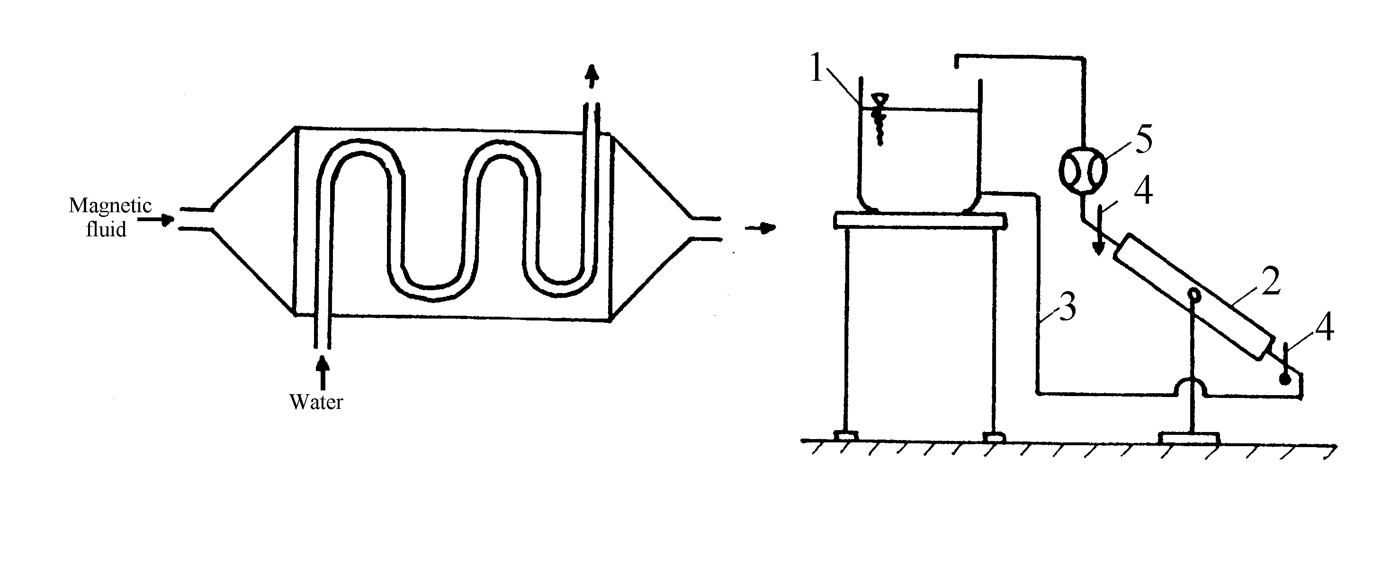
Magnetic
fluid
Water

Figure 3. Solar collector with internal coil.

The solar collectors may be operated under steady state (motionless magnetic fluid inside) or non-stationary (dynamic) regime (when the magnetic fluid is circulated through the collector at a certain output).
The research concerning the performances of the magnetic fluids in solar energy capture have been carried out in the (experimental) installation presented in Figure 4.

Figure 4. Installation for the determination of performances of magnetic fluids as heat carriers for
solar energy capture : 1 - magnetic fluid tank (reservoir) ; 2 - solar collector ;
3 - connection pipes ; 4 - thermometers ; 5 - flowmeter.

The experimental parameters had in view were the inlet and outlet temperatures of the magnetic liquid and its output.

RESULTS AND DISCUSSION

1. Solar collector with a single transparent surface, in steady state

The variation of the inlet (t_{i}) and outlet (t_{f}) temperatures of the magnetic fluid as a function of time is presented in Figure 5.
One notes that after reaching a certain temperature (about 60°C) the losses of heat to the external medium become as important that an equilibrium is established between the heat received and the heat ceded and the temperature of the magnetic fluid remains practically constant. The solar collector with a single transparent surface has the disadvantage to be in direct contact with the atmosphere air currents, which results in high losses of heat in the environment.

2. Solar collector with two transparent surfaces, in steady state.

In Figure 6 is presented the variation of the magnetic fluid inlet and outlet temperatures as a function of time.
The more pronounced increase of the magnetic fluid temperature (up to 100°C) may be explained by the fact that the air between the two transparent surfaces acts as an insulating layer, thus preventing the losses of heat to the external medium.

Figure 5. Inlet and outlet temperatures of the Figure 6. Inlet and outlet temperatures of the
magnetic fluid versus time. (for the magnetic fluid versus time. (for the
solar collector with a single trans- solar collector with two transparent
parent surface, in steady state) surfaces in steady state)

3. Solar collector with two transparent surfaces, in dynamic regime

In order to achieve significant determinations under dynamic regime it was necessary to firstly keep the magnetic fluid motionless until an optimum temperature (about 80°C) was reached. After that, the magnetic fluid has been circulated at different outputs.
The data presented in Figure 7 and Figure 8 show a stabilization of the outlet temperature at high values (95-100°C) for low outputs and at lower values for higher outputs.

Figure 7. Inlet and outlet temperatures of the magnetic fluid versus time. (for the solar collector with
two transparent surfaces in dynamic regime) : a - 1.5 l/h output ; b - 2.4 l/h output.

Figure 8. Inlet and outlet temperatures of the magnetic fluid versus time. (for the solar collector with
two transparent surfaces in dynamic regime) for an output of 8.7 l/h.

The correlation between the thermal flux obtained and the output of the magnetic fluid allows for choosing the working conditions such as to obtain the desired temperature and amount of heat (Figure 9).

Figure 9. Thermal flux versus output of magnetic fluid.

This implies the calculation of the useful heat absorbed at different outputs according to the relation:
Q = V⋅ρ_{l}⋅c_{i}⋅Δt (1)
where : V - the output of the magnetic fluid, m³/s ;
ρ_{l} - the density of the magnetic fluid, kg/m³ ;
c_{i} - the specific heat of the magnetic fluid ;
Δt - the difference between the outlet and inlet temperatures of the magnetic fluid.

Dividing the value of the useful heat absorbed by the surface of the solar collector gives the values of the thermal flux presented in Table 1.

Table 1. Values of the thermal flux for various outputs of magnetic fluids.

No. | Output, l/h | Thermal flux, W/m²
1 | 1.5 | 240
2 | 2.4 | 400
3 | 8.7 | 700

CONCLUSIONS

The magnetic fluids can be used as absorbent media for the solar energy. They have been tested with a solar collector without concentration of the solar rays, in plane arrangement and the following versions : with a single transparent surface and with two transparent surfaces (in steady and dynamic regime).
The experiments carried out under dynamic regime with a solar collector with two transparent surfaces allowed for the correlation of the output of the magnetic fluid with the thermal flow obtained. This in turn allows to choose the working conditions such as to obtain the necessary temperature and amount of heat.

REFERENCES

- Luminosu, I., Minea, R. and Pode, V., Etude experimentale sur l’absorbtion spectrale de la lumiere dans les fluides magnetiques, Chem.Bull.Univ.POLITEHNICA Timişoara, Vol. 32, pp. 77 – 81, 1987.
- Avram, M., Pop M. and Lucaci, A., Fizica moleculei, Lit. Univ. Timişoara, Timişoara, Romania, 1979.
- Gropşian, Z., Minea, R. and Pode, V., Unpublished data, 1988.
- Pode, V., Agenţi purtători de căldură, Eurobit Publ. Co.,Timişoara, 1999.

