PRESSURE DROP AND HOLD-UP IN LIQUID-LIQUID FLOWS

J. Lovick, R. Bristow, P. Angeli

Department of Chemical Engineering, University College London, Torrington Place,
London WC1E 7JE, ENGLAND.

INTRODUCTION

Two-phase liquid pipeline flows occur in many areas of the process industry and in the petrochemical industry, where the oil-water flows are common in production wells or in subsea pipelines. In contrast to gas-liquid flows, however, the literature in liquid-liquid flows is rather limited. Moreover, results from gas-liquid systems cannot be readily used in liquid-liquid ones due to a number of differences between them; for example liquid-liquid systems have large range of viscosity ratios and a more complex interfacial chemistry compared to gas-liquid systems¹.

During the simultaneous flow of oil and water a number of flow patterns can appear which range from fully separated to fully dispersed ones ²⁻⁵. Stratified flow in particular has received more attention, since the low flow velocities and well defined interface favour both experimental and theoretical investigations ⁶⁻⁷. For fully dispersed systems information is available mainly from work in stirred vessels ⁸. This can offer insight on the tendency of each phase to be dispersed, but due to the different system configurations, results from stirred tanks on energy requirements and drop size distribution cannot be directly applied to pipeline flows.

The available information is even more limited for the intermediate flow patterns between the stratified and the fully dispersed ones. The work presented in this paper is aimed at the investigation of the flow behaviour, and particularly pressure drop, phase distribution and hold-up of liquid-liquid flows with an emphasis on medium and high flow velocities.

EXPERIMENTAL SYSTEM

The experimental work was performed in the liquid-liquid flow facility shown in Fig. 1. This consists of the following sections:
- Storage section: Two storage tanks are used, one for each test fluid.
- Pumping section: Two centrifugal pumps are used which pump the fluids via a flow control valve and a recycle valve so that the flowrate entering the test section can be controlled. Two variable area flow meters provide accurate measurement of the flowrates.
- Test section: It consists of two eight meter sections of 38mm ID stainless steel pipe connected by a U-turn. Each section is made up of 2m and 1m pipes that are connected together by tri-clamp fittings which give a smooth crevice free joint. On each section there is a 1m transparent acrylic pipe through which the flow can be observed. At each end of the transparent sections there are quick closing valves which can trap the flowing mixture in the sections and allow hold-up measurements to be made. Pressure transducer ports are placed on four 2m pipes which can be moved around as desired to allow pressure measurements at any location along the pipe.
- Separator section: This contains the separator vessel (approximately 800 litres) which houses a ‘KnitMesh Coalescer’ designed to increase the rate of separation of the two fluids.

Flow pattern boundaries were investigated through visual observation. At high flow velocities where visual observation is insufficient to give a clear identification of the flow patterns, complimentary methods are required. In this work, a conductivity probe was used to monitor the variations of phase continuity in a pipe cross-section, which can be related to the existing flow pattern. The probe was also used to find the interface height in the stratified flow experiments.

Oil and water were used as test fluids, and the properties of the oil are shown in Table 1 below:

Table 1. Oil Properties
Product Name | EXXSOL D140
Density | 828 kgm⁻³
Viscosity | 6.0cP @ 25°C
Surface tension | 27.6mN/m @ 25°C
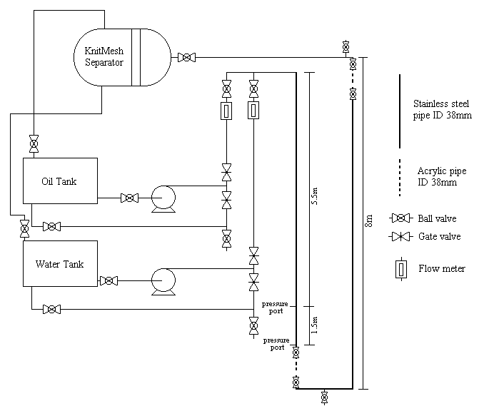Oil-water interfacial tension | 44.69mN/m @ 25°C

Fig. 1. Liquid-liquid flow facility

RESULTS

Stratified Flow
Input oil fraction
Fig. 2. Velocity ratio against mixture velocity for constant input oil volume fractions

Stratified flow experiments were carried out at two constant input oil volume fractions, 76.9% and 61.5%, with mixture velocities varying from 0.04 m/s to 0.35 m/s. At these conditions the flow of both liquids was laminar. Pressure drop was measured at 5.5 m from the inlet over a length of 1.5 m (Fig. 1). It was found that pressure drop increases as the mixture velocity increases, and also that an increase in the oil volume fraction results in higher pressure drop for the same mixture velocity. Using the conductivity probe the interface position was also measured in the centre and at the wall of the pipe, at the end of the first half of the test section. From these measurements the in-situ hold-ups and the velocity ratios, S, were calculated. The velocity ratio is defined as the ratio of the in-situ average oil to water velocity and can be found from the input oil/water volume ratio to the in-situ one.
Two-fluid model ⁹  Pipe wall | + 0.057m/s | o 0.072m/s
◊ 0.086m/s | x 0.101m/s | ⬧ 0.116m/s

Fig. 3. Interface position for 61.5% input oil volume fraction at different mixture velocities
(lower half cross section of pipe)

The data on velocity ratio seem to depend mainly on the mixture velocity (Fig. 2). It was found that at mixture velocities greater than 0.075m/s, S is less than 1, while at lower mixture velocities, S is greater than 1. It is expected to have S less than 1 for the 76.9% input fraction (high mixture velocities) as more oil is present in the pipe and in contact with the pipe wall. It will therefore tend to move slower than the water. However for 61.5% input oil fraction, although more oil is in the pipe at the inlet, as the mixture velocity decreases, S increases and finally becomes greater than 1 which means that oil is travelling faster than the water. In Fig. 3 the interface position for 61.5% input oil volume fraction at different mixture velocities can be seen. This data shows that as the mixture velocity decreases the interface height increases, resulting in the velocity ratio variations shown in Fig. 2. The results will also be compared with Computational Fluid Dynamics simulations.

Dispersed Flow

Experiments have also been carried out at mixture velocities 2m/s, 2.5m/s, 3m/s and 3.5m/s, where the flow pattern is mixed, for input oil volume fractions ranging from 0% to 100%. All the experiments started with single phase oil. Pressure drop measurements were taken in the same position as in stratified flow. The results can be seen in Fig. 4. Pressure drop follows similar trend for all mixture velocities with an initial gradual decrease in value as the oil fraction increases up to 60%, apart from the case of the highest mixture velocity. With a further increase in oil fraction there is a brief increase in pressure drop before it reaches a minimum at about 72% to 80% oil. The pressure drop then increases as the oil fraction decreases further. The fluctuations in pressure drop between 64% to 84% oil are associated with the flow pattern. Phase continuity was recorded using the conductivity probe at the same location where pressure drop was measured and the range of oil volume fractions where both phases are continuous is shown with dotted lines in Fig. 4. The flow pattern is dispersed with water or oil as the continuous phase, for oil fractions respectively below or above those indicated by dotted lines. The pressure drop fluctuations coincide with the oil fraction range where both phases are continuous.
Mix. vel.
Fig. 4. Pressure drop against input oil volume fraction for different mixture velocities

Hold-up was also measured at the same range of conditions as pressure drop, at the end of the first half of the test section (Fig. 1). Using the quick closing valves, the mixture was trapped in the transparent section and after the two phases had settled, the interface height was recorded. The results, presented as velocity ratio, S, against input oil fraction, are shown in Fig. 5 for the lowest (2m/s) and highest (3.5m/s) mixture velocities used. There is a slight dependence of the velocity ratio on mixture velocity, with S being closer to 1 at high mixture velocities. However, S seems to depend mainly on the input oil volume fraction. The velocity ratio is larger than 1 for input oil fractions above about 30%, which means that the water tends to be held back. Although this is to be expected for the water continuous cases, it is possible that in the oil continuous cases (high oil volume fraction) a film of water may form at the bottom of the pipe which results in lower in-situ water velocities. This film was observed visually at the low flow rates but its presence will have to be verified. More difficult to explain is the values of S less than 1 for oil fractions below 30%, where water is the continuous phase. This implies that the dispersed oil phase is moving slower than the continuous phase. In order to explain this behaviour the distribution of the two phases in a pipe cross section and its effect on hold-up will have to be investigated.
Mix. vel.

Fig. 5. Velocity ratios against input oil fraction for different mixture velocities

References
1. Valle, A., Multiphase Pipeline Flows in Hydrocarbon Recovery, Multiphase Science and Technology, Vol. 10, pp. 1-139, 1998.
2. Angeli, P. and Hewitt, G.F., Flow Structure in Horizontal Oil-Water Flow, International Journal of Multiphase Flow, Vol. 25, No. 7, pp. 1117-1140, 2000.
3. Arirachakaran, S., Oglesby, K., Malinowsky, M., Shoham, O. and Brill, J., An Analysis of Oil/water Flow Phenomenon in Horizontal Pipes, SPE Proc. Prod Operational Symp. SPE 18836, pp. 155-167, 1989.
4. Charles, M.E., Govier, G.W. and Hodgson, G.W., The Horizontal Pipeline Flow of Equal Density Oil-Water Mixtures, Canadian Journal of Chemical Engineering, Vol. 39, pp. 27-36, 1961.
5. Trallero, J.L., Oil-Water Flow Patterns in Horizontal Pipes, PhD Thesis, University of Tulsa, 1995.
6. Brauner, N., Maron, D. and Rovinsky, J., A Two Fluid Model for Stratified Flows with Curved Interfaces, International Journal of Multiphase Flow, Vol. 24, pp. 975-1004, 1998.
7. Kurban, A.P.A., Stratified Liquid-Liquid Flow, PhD Thesis, Imperial College London, 1997.
8. Davies, G.A., in Science and Practice of Liquid-Liquid Extraction, Clarendon Press, Oxford, pp. 245-342, 1997.
9. Taitel, Y. and Dukler, A.E., A Model For Predicting Flow Regime Transitions in Horizontal and Near Horizontal Gas-Liquid Flow, AIChE Journal, Vol. 22, pp. 47-55, 1976.

