PREDICTION OF INTERACTIONS BETWEEN BURNERS IN MULTI-BURNER SYSTEMS

S Kucukgokoglan, A Aroussi, S.J Pickering

School of Mechanical, Materials, Manufacturing Engineering and Management
University of Nottingham, Nottingham, NG7 2RD, UK

Keywords: CFD, Turbulent Modelling, Swirling Flow, Burner, Furnace, Flow Pattern

Abstract
Numerical predictions, made using Computational Fluid Dynamics (CFD), are presented describing the behaviour of the performance of three different turbulence models for turbulent isothermal swirling flows, from multiple burners enclosed in furnace type geometry. The numerical models being used are: standard k-ε, RNG k-ε, and realisable k-ε. The realisable k-ε, model is a new model to be used in this type of application that needs to be compared with well-established models. The grid for the enclosed furnace-type geometry of the rig was created using the GAMBIT V.1.0.4 package, and the predictions from the CFD models have been obtained using the commercial CFD code FLUENT version 5.1
Predictions of four burners on a three-dimensional axisymmetric mesh show the near burner region is accurately predicted by increasing the mesh density. In full furnace simulations a fine mesh has been used within the near burner region to eliminate mesh dependency. This is because flame ignition generally occurs within one and a half burner diameters downstream of the exit with this type of burner design, and in this region a substantial amount of the total nitrous oxides emissions (NOx) is produced.
The standard k-ε and RNG k-ε are well established models in predicting turbulent isothermal swirling flows, which have been compared successfully to experimental results. Comprehensive comparisons of the three models show that good agreement is achieved with a high mesh resolution. In general, the velocity profiles, contours and flow patterns of the realizable k-ε, model are in general good agreement with the standard k-ε, RNG k-ε, models, indicating that the general flow-field within the furnace has been predicted accurately.
1 INTRODUCTION
Over the past decade, research within the field of coal-fired boiler technology has been primarily dealt with the reduction of pollutant emissions, in particular NOx. Methods of reducing NOx within coal flames include air staging, where the burner inlet flows are separated into two or more co-axial annular jets, and reburn where fuel and then over-fire air are introduced separately location from the burner in the upper part of the boiler furnace [1].
Coal is carried by a primary air flow, injected close to the burner central axis, and swirl is introduced to the outer secondary and, sometimes, tertiary air flow streams. Swirl plays an important part in NOx reduction as it induces a phenomenon known as vortex breakdown, where a central re-circulation zone (CRZ) is produced [2]. The CRZ re-circulates and burns hot volatile gases released from the coal, in a low oxygen region, suppressing the formation of NOx.
Burner technology is relatively advanced, and designs are generally optimised in large combustion test rigs to reduce pollutant emissions. Nevertheless, It is often found that performance deteriorates when the burners are fitted on site in the multiple burner banks contained within large power station furnaces.
Experiments on full-scale furnaces present difficulties, not only because of their sheer size, but also because of the high temperatures within the flames. A lack of experimental data also adds uncertainty when building physical isothermal models representative of real furnaces.
Full-furnace simulations using Computational Fluid Dynamics (CFD) modelling is one possible solution to the problem, on the other hand, there are always uncertainties with these models due to turbulence model closure assumptions and numerical diffusion. The lack of experimental data also means that predictions cannot always be validated. Moreover, the simulation of a full-scale furnace using CFD is computationally uneconomical.
2 Numerical models
The main features of the turbulence are the random fluctuations of fluid velocity over space and time. These random fluctuations occur over very small distances (as small as 0.1mm in air) in space and time compared to the overall domain. In order for a turbulent flow to be modelled accurately the computational mesh spacing must be smaller than the smallest element of turbulent motion (eddy) but cover the entire control volume. The computations will have to be unsteady using a time-step smaller than that of the fastest eddy. This leads to an impossibly large number of grid nodes. The calculations required are beyond the capabilities of current computing technology.
As engineers are not usually interested in the fluctuating components of flow a statistical approach is taken. This is achieved by averaging over a time scale that is large compared with the turbulent motion. Those results in equations describe the flow in terms of the mean velocities and pressures. However, these equations contain unknowns representing the Reynolds stress and transport of mean momentum, thus, additional equations are needed to solve for all the parameters. This is described as "turbulence modelling". This solves the Navier-Stokes equations, the continuity equation and some additional differential equations. The number of these additional equations increases with the complexity of the model.
Basically, turbulent models incorporated with the governing equations are used to determine the Reynolds Stresses. In FLUENT, the turbulent model options are entered in the three numerical models; i.e. the standard k-ε, RNG k-e, and realisable k-ε models, used in this study.
The k-ε model focuses on the mechanisms that affect the turbulent kinetic energy. The standard k-ε model in FLUENT falls within this class of turbulence model and has become the workhorse of practical engineering flow calculations in the time since it was proposed by Jones and Launder [3] Robustness, economy, and reasonable accuracy for a wide range of turbulent flows explain its popularity in industrial flow and heat transfer simulations. It is a semi-empirical model, and the derivation of the model equations relies on phenomenological considerations and empiricism. As the strengths and weaknesses of the standard k-e model have become known, improvements have been made to the model to improve its performance. Two of these variants are available in FLUENT: the RNG k-ε model [4] and the realisable k-ε model [5].
In the Re-Normalisation Group (RNG) k-ε model, the theory is employed to set up the turbulence transport equations for the turbulent kinetic energy k and eddy dissipation rate [4]. The RNG k-ε model was derived using a rigorous statistical technique (called re-normalisation group theory). It is similar in form to the standard k-e model, but includes the effect of swirl on turbulence is included in the RNG mode enhancing accuracy for swirling flows.
The realisable k-ε model is a relatively recent development and differs from the standard k-ε model in two important ways: the realisable k-e model contains a new formulation for the turbulent viscosity, and a new transport equation for the dissipation rate has been derived from an exact equation for the transport of the mean-square vorticity fluctuation [6]. The realisable k-ε model satisfies certain mathematical constraints on the Reynolds stresses, consistent with the physics of turbulent flows. Neither the RNG k-ε, nor the standard k-ε model is realisable. An immediate benefit of the realisable k-ε model is that it predicts more accurately the spreading rate of both planar and round jets. It is likely to provide superior performance for flows involving rotation, separation and recirculation.
3 Computational Program
For this study, the Cartesian co-ordinate system is used to set up the geometry of the computational region the single burner model, and the Body-Fitted Co-ordinates to generate the grid, i.e. the matrix of the points of interest in the computational region. The geometries and grid (Figure 1) of all the computational regions considered in this study were set up with GAMBIT V.1.0.4.
The strategy of grid generation within the computational region and density of the grid play an important role in the prediction accuracy [7]. The grid was non-uniform, with high density in zones of great interest and low density in zones of less interest, so that minimal computational effort was required whilst gaining sufficient accuracy.
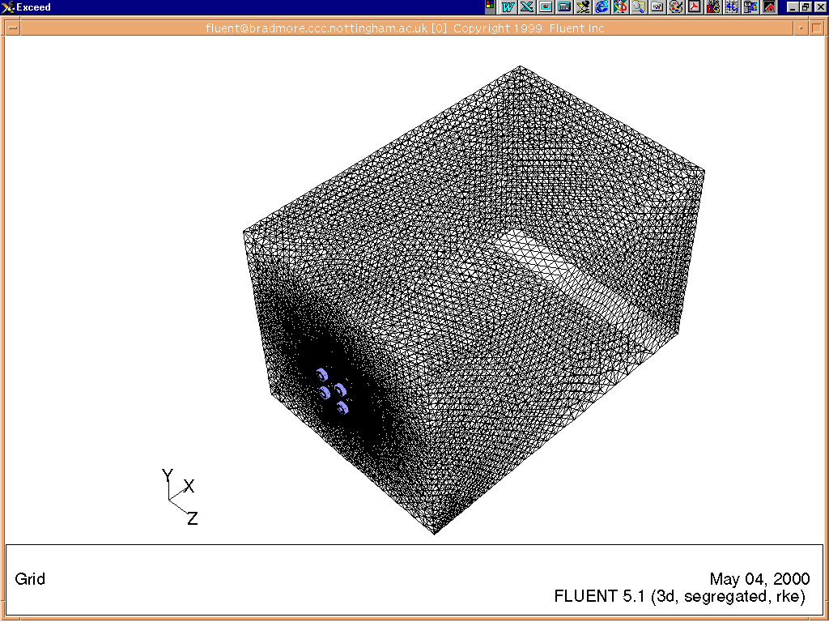
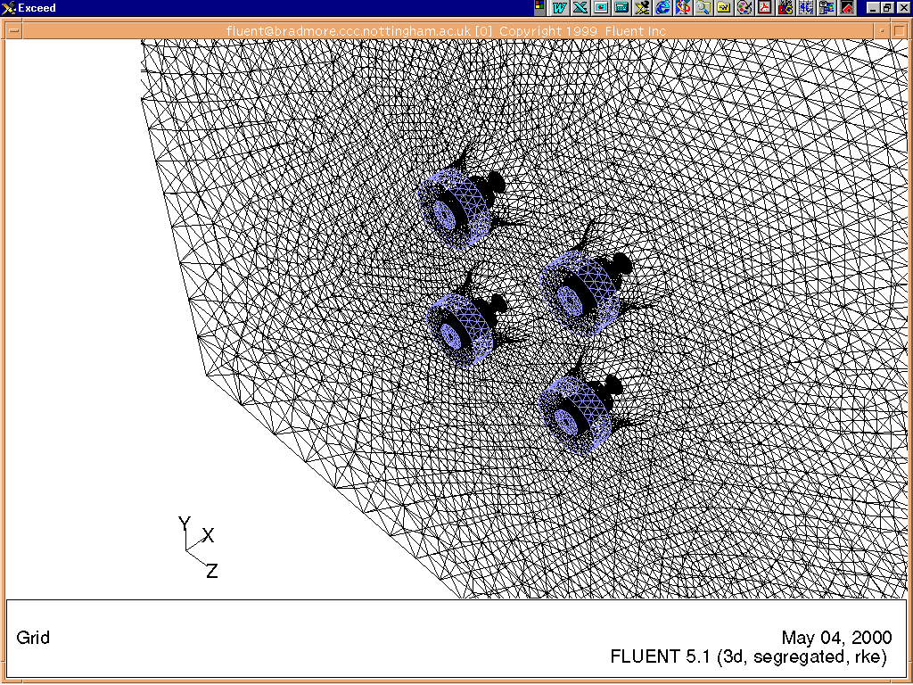
Figure 1 Grid for four burner enclosed in furnace

In order to obtain a grid-independent solution, the grid should be refined until the solution no longer varies with additional grid refinement. In this study, the general cell size of the grids for the computational regions is about 5cm x 5cm.
The predictions from the CFD models have been obtained using the commercial CFD code FLUENT version 5.1. The symmetrical boundary condition is specified on the symmetrical planes. At the inlet of the computational region, the boundary condition is based on the experimental set-up. Theoretically, zero gradient condition can be given at the outlet boundary. These boundary conditions can be expressed as follows: Inlet, outlet and wall boundary conditions. Some assumptions about boundary conditions that were not directly measured had to be made. These were:
- Velocity components and turbulence quantities at the primary and secondary inlets were constant, which is ‘flat-profiled’.
- Turbulence intensity at the burner inlet was 5-10%.
- The angle of the flow at the secondary inlet was equal to the vane angle, that is, 40º
4 Results and Conclusion
The results obtained from the 3D CFD models are presented as velocity magnitudes, and velocity magnitude histogram. A sample result at 13mm from the burner exit is shown in Figure 2. A close comparison of the three models shows that good agreement is achieved with a high mesh resolution.
In addition, Velocity magnitude histograms have been used for a global 3D-velocity comparison of the three numerical models. The histograms (figure 3) indicate a very good agreement between the methods in general. However, the velocity magnitude histogram from the RNG k-ε model shows slight differences at the lowest velocity range between 0.2 to 0.52 m/s.
In general, the velocity magnitudes flow patterns (figure 2) and histograms of the realisable k-ε model are very similar to the standard k-ε model, and in a good agreement with RNG k-ε model, indicating that the general flow-field within the furnace has been predicted accurately. In the past, the standard k-ε model has, been criticised for its inability to predict swirling flow phenomena [8]. Therefore, It has been shown that the mixing of swirling burner flows issuing from typical isothermal scale models of burner geometries can be predicted well using the standard k-ε, Realisable k-ε and RNG k-ε turbulence model, together with a fine computational mesh.
References
[1] Wendt J. O. L., “Mechanisms Governing the Formation and Destruction of NOx.”, Combust. Sci. and Tech., Vol. 108, pp. 323-344, 1995.
[2] Lilley D. G., “Swirl Flows in Combustion: A Review”, AIAA Journal Vol. 15, NO. 8,1977
[3] Launder, B.N. and Spalding, D. B. Lectures in Mathematical Models of Turbulence. Academic Press, London, England, 1972
[4] Yakhot,A. and Orszag, S. Renormalisation Group Analysis of Turbulence: I.Basic Theory. Journal of Scientific Computing, 1(1):1-51, 1986
[5] Shih, T.-H., Liou,W.W., Shabbir,A., and Zhu,J. A new k-ε Eddy-Viscosity Model for High Reynolds Number Turbulent Flow-Model Development and Validation. Computers Fluids, 24(3):227-238, 1995
[6] Fluent 5 Users Guide, Vol.2. July 1998
[7] Lin, S.and Griffiths, A.J.; CFD simulation of cooling air flows within shrouded finned heater/cooler systems used on barrel extruders; Proceedings of the Joint ASME/JSME Fluid Engineering Annual Conference, Hilton Head Island, South Carolina, USA, August 13-18, 1995.
[8] Weber, Visser and Boysan, “Assessment of Turbulence Modelling for Engineering Prediction of Swirling Vortices in the Near Burner Zone”, Int. J. Heat and Fluid Flow, Vol. 22, No. 3. 1990

Figure 2 :Velocity Vectors Figure 3 :Velocity Magnitude of Histograms
Velocity Vectors Standard K-ε Model  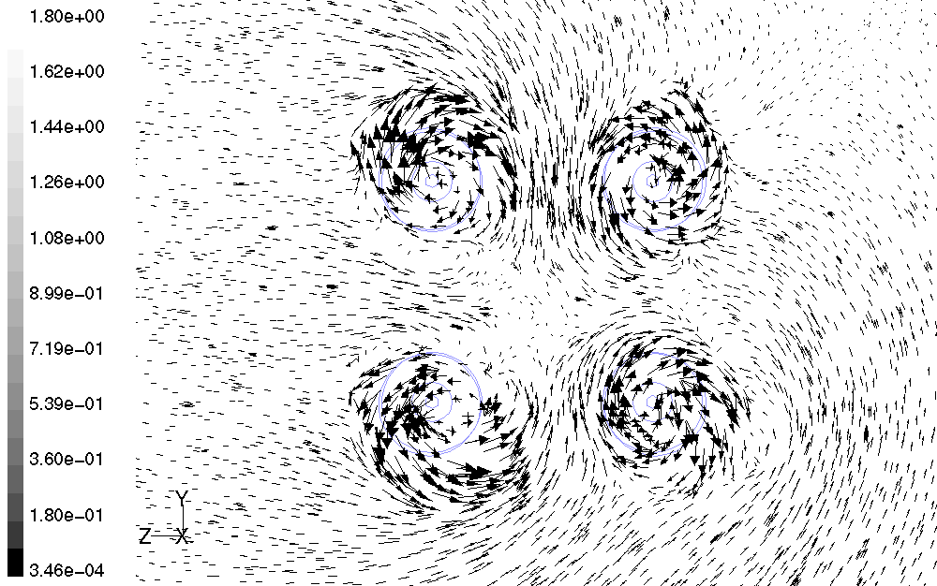 | Histogram of Velocity Magnitude Standard K-ε  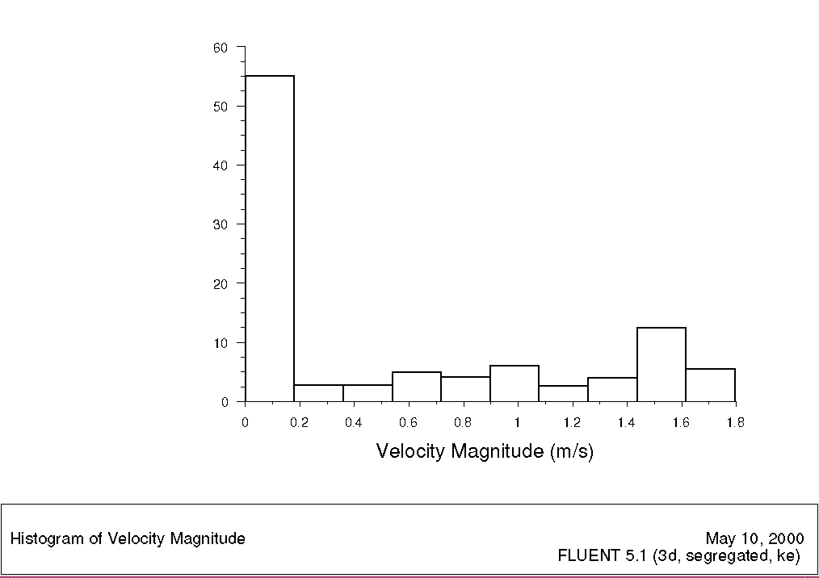
Velocity Vectors Realisable K-ε Model  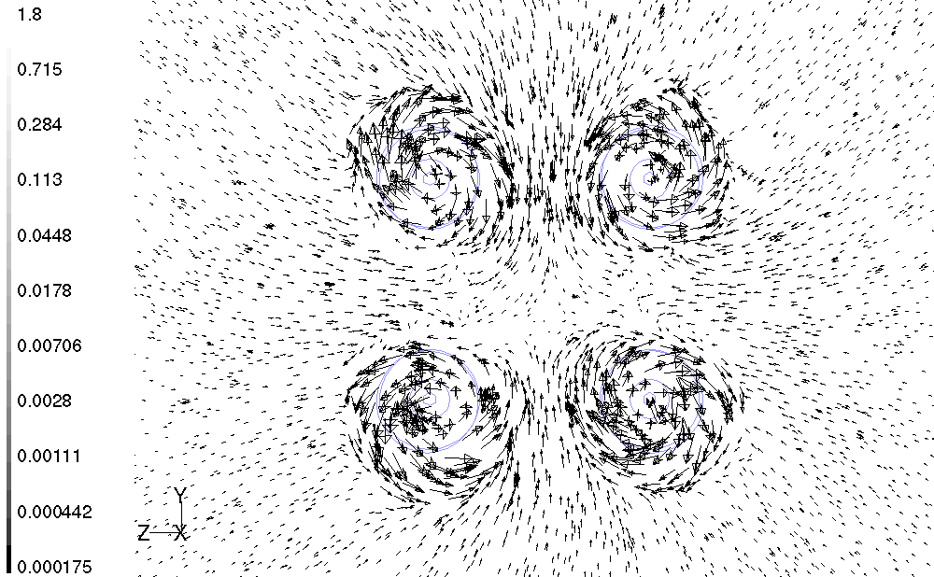 | Histogram of Velocity Magnitude Realisable K-ε  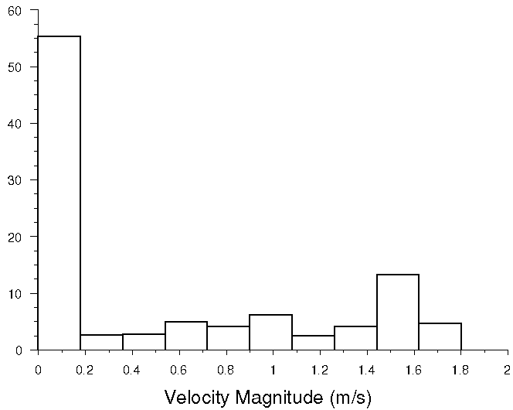
Velocity Vectors RNG K-ε Model  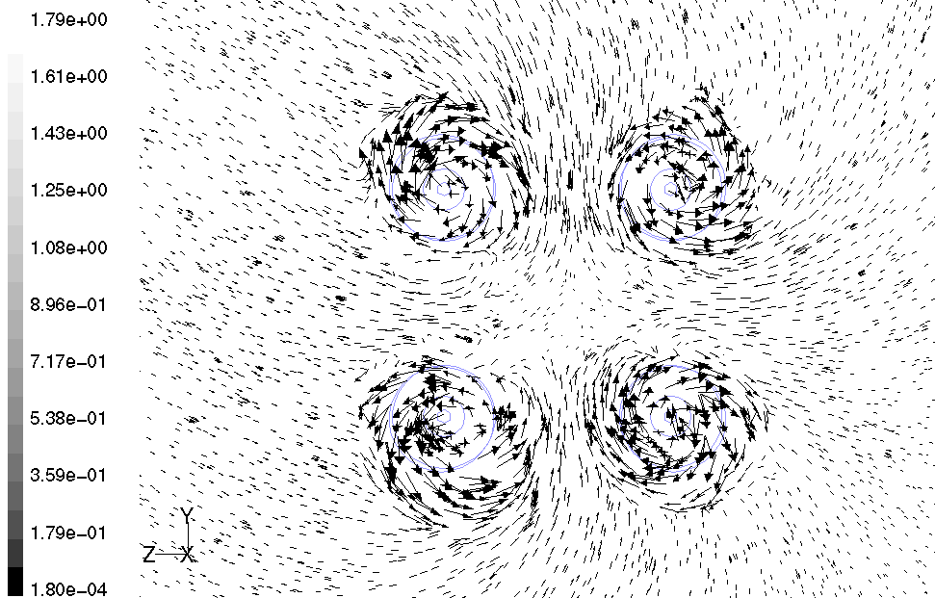 | Histogram of Velocity Magnitude RNG K-ε  