Spray Evolution of A Multijet TM Injection System for Diesel Applications

L. Allocca, F.E. Corcione, S. Alfuso, A. Montanaro

Istituto Motori – CNR
Viale G. Marconi, 8 – 80125 Napoli – Italy

ABSTRACT

The electronically controlled multiple injection strategies and the high injection pressure have modified the combustion mode in diesel engines to meet the new and more stringent emission regulations. The initial injections enable the reduction of noise and NO_{x} emissions while the late one acts on the unburned fuel and particulate emissions.
The criticism of the injection apparatus is in the punctual control both of the amount of injected fuel and the injection timing. Under limit conditions, the electro-hydraulic circuit and the mobile equipment inertia couldn’t allow the electro-injectors in following exactly the Electronic Control Unit (ECU) command.
The configuration of the injection system influences strongly the amount and the modalities of the discharged fuel. In fact, the dwell time between injections, in a fixed strategy, and the fuel delivered in any pulse are influenced by the high-pressure pipeline length and the injection pressure. At equivalent nozzle opening time, the injected total fuel and the quantity delivered in any pulse depend on the adopted strategy and the settlement of the electro-injector.
In this paper a punctual study of the factors, influencing the instantaneous and the total injected fuel, has been carried out. An electro-injector, from Multijet TM injection apparatus, has been fuelled with diesel-like fluid and controlled by a Programmable ECU (PECU). Different injection strategies have been implemented and instantaneous measurements of the injected quantity have been carried out by the AVL Injection Rate Gauge Meter. A six holes microsac nozzle Φ=0.145 mm has been used. The tests have been conducted for different injection pressures (60 to 160 MPa) and strategies and for different pipe lengths.
The sprays have been produced in single-shot mode in a pressure controlled optically accessible vessel and enlightened by synchronized flashes. The images have been acquired by an AVL 513D Engine Videoscope matched with the injection command at different instant from the Start Of Injection (SOI) and analyzed off-line by a dedicated image-processing software.
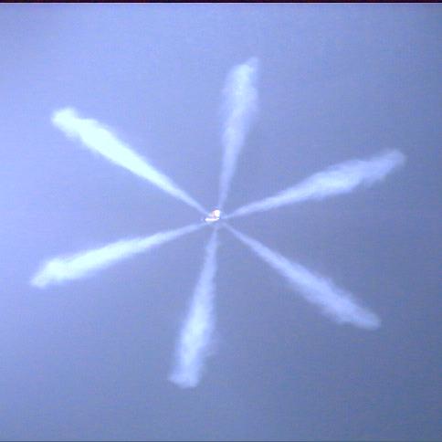
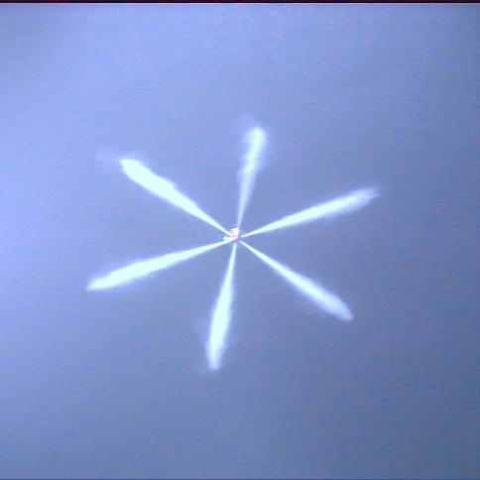
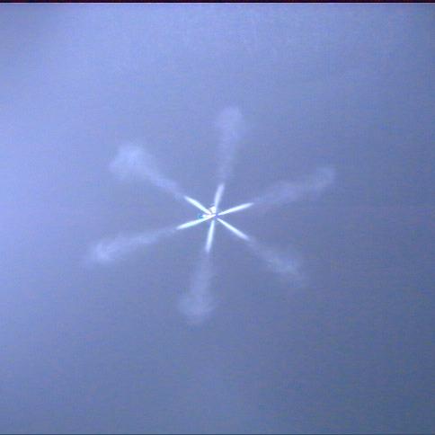
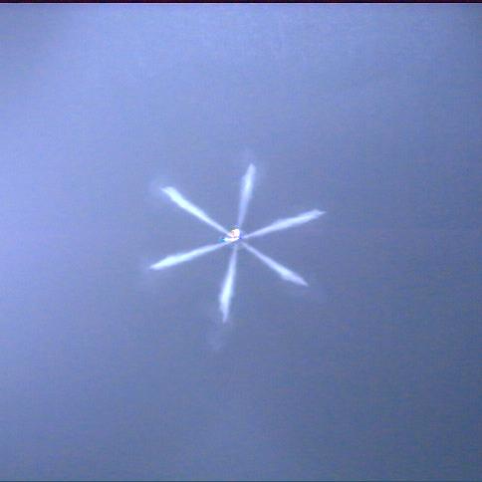
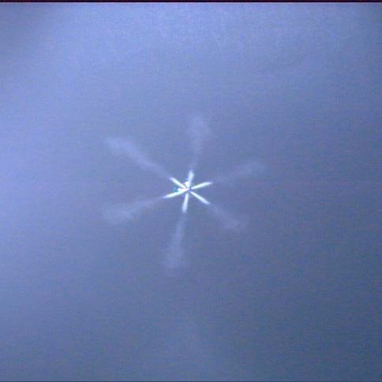
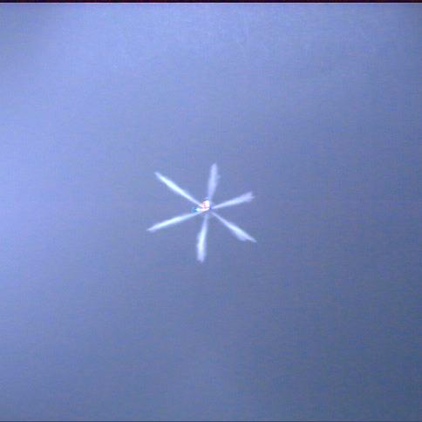
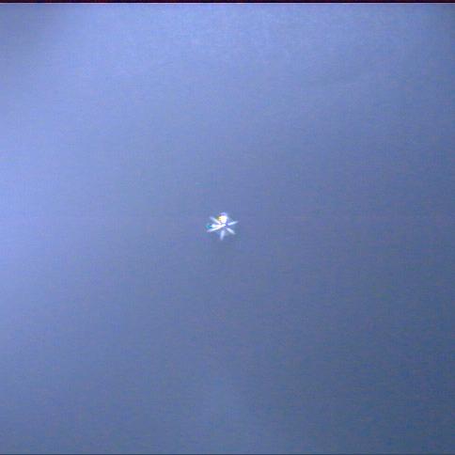
In figure 1 images of the fuel emerging from the nozzle (top) have been reported for a pilot+pre+main strategy (bottom) at atmospheric backpressure and 120 MPa injection pressure. The timing of the strategy is: pilot 270 μs, d_{w1} 1500 μs, pre 270 μs, d_{w2} 1500 μs, main 550 μs. The pictures, collected by a large scale objective, show the jets behaviour for the three single injections highlighting a rather uniform space penetration and cone-angle. The frames in the top part corresponds to the dots in the solenoid current (bottom). The total amount of fuel delivered per stroke in the strategy is 23.82 mg distributed in 1.90, 2.32 and 19.60 for pilot, pre and main, respectively. The vessel has been filled with SF₆ which high molecular weight enabled reaching the desired densities at lower pressure than the air or N₂. Measurements of spray characteristics have been carried out at gas density in the vessel ranging from 1.16 to 52.6 kg/m³.
Fig. 1 – A triple strategy injection (bottom) and (top) the images, related to the dots, of the evolving jets at 120 MPa injection pressure and atmospheric backpressure
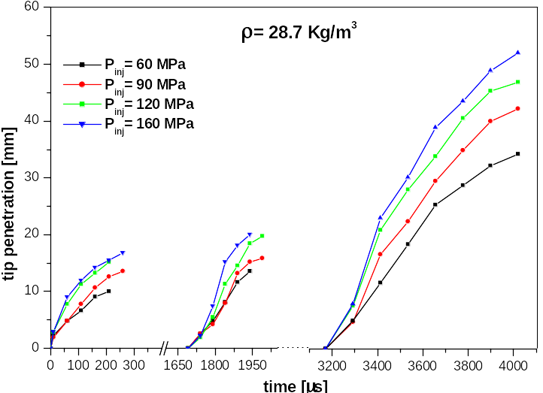
In figure 2 the tip penetrations of the three pulses in the tested strategy are reported for injection pressures ranging 60 to 160 MPa and gas density 28.7 kg/m³.
Fig. 2 – Tip penetrations of the jets in a triple strategy for injection pressures of 60, 90, 120 and 160 MPa and gas density in the vessel of 28.7 kg/m³
For all the three injections an increasing penetration versus injection pressure is find. Pilot and pre are less penetrating than main because of the shortest injection duration. Pilot is less penetrating than pre according to the effective shorter duration (230 μs against 275 μs) and consequently lowest amount of delivered fuel.
The response of the injection apparatus versus the timing variation in the strategy has been checked. d_{w1} has been varied to verify the minimum d_{well} time for obtaining the complete closure of the nozzle and an equal injected quantity in pilot and pre pulses. Finally, the behaviour of the system for high values d_{w1} and d_{w2} to consider negligible the influence on the mobile equipment has been considered. The results are reported in figure 3. The bottom part of the figure reports the solenoid current whereas in the top part the behaviour of the injector and the measured time have been reported with indicated the amount of injected fuel per pulse.
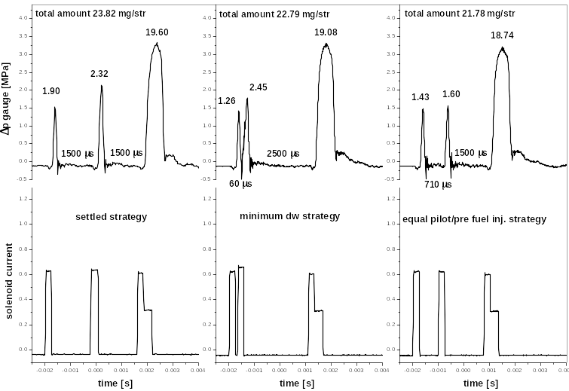
In the first column the settled strategy is shown. The pre injection delivers about 20% more fuel than pilot in spite of equal excitation time while, to obtain similar injected quantity in pilot and pre injections, a d_{well} time of 710 μs needs between the two pulses (third column).
Fig. 3 – Injector behaviour for different timing in a triple strategy at comparable total amount fuel
Finally, d_{w1} has been reduced to verify the minimum d_{well} time for reaching a complete closure of the nozzle between two commands. It has been 60 μs with quantities of 1.26 and 2.45 mg injected in pilot and pre, respectively. The duration of the main injection has been slightly adapted for obtaining comparable total amount of injected fuel.
The injection apparatus has been further investigated altering its electronic command parameters and the hardware. Measurements on single pulses and total amount of injected fuel have been carried out varying the rise time of the solenoid commands (37 to 330 μs), the total length of the high pressure pipelines (from 150 to 600 mm), the nozzle hole shapes (k factor) and modifications to the volume of the injector main body for the needle lift relief.

REFERENCES

- Henein N.A., Lai M.C., Singh I.P., Zhong L., Han J., Characteristics of a Common Rail Diesel Injection System under Pilot and Post Injection Modes. SAE Paper 2002-01-0218
- Corcione F.E., Vaglieco B.M., Corcione G.E., Vitale G., Carpentieri F., Multiple Injection Strategies for Low Emissions of a New Small Common Rail D.I. Diesel Engine. Engine Combustion Processes, March 18/19, 2003 – Munchen
- L. Allocca, S. Alfuso, F.E. Corcione, Assessment of Dynamic Performances of Diesel Solenoid Injectors for a Multiple Injection Common Rail System, SAE_NA 2003-01-21, ICE 2003 – Capri, Sept. 14-19, 2003
- Potz D., Christ W., Dittus B., Diesel Nozzle - the Determining Interface between Injection System and Combustion Chamber. THIESEL 2000, Valencia

