Experimental Analysis of a Liquid Atomization Process at Low Weber Number

Dr. Christophe Dumouchel
CNRS UMR 6614 – CORIA
Université et INSA de Rouen
76801 Saint Etienne du Rouvray – France
Christophe.Dumouchel@coria.fr
00 33 2 32 95 36 23

Liquid sprays produced by the ejection of liquid into a gaseous environment at rest are constituted of drops with different sizes. In all applications, the spray drop size distribution is a major parameter that needs to be controlled. However, predictions of drop size distribution in any situations are not possible so far and depend largely on empirical knowledge. The main reason for this is that very little is known about the way ligaments and drops are torn off from a perturbed liquid flow due to a deficit of experimental investigations on this topic.
Most experimental approaches provide correlations between some working conditions (injection pressure, nozzle dimensions) and macroscopic characteristic features of the issuing flow (angle, break-up length) or characteristics of the spray (mean diameter, dispersion parameter) but the behavior of the liquid flow and the break-up mechanism are very seldom studied despite their importance in the process.
Except in specific situations, liquid atomization is a process of liquid-gas interface area production. As soon as the liquid issues from the nozzle, it is perturbed by instabilities whose growth induces an increase of the liquid-gas interface. This phenomenon continues until liquid break-up occurs, stopping the liquid-gas interface increase. The drop size distribution of the resulting spray depends on the amount and on the shape of liquid-gas interface at the instant of break-up: the more interface is produced, the smaller the diameter of the drops. The liquid gas interface and its relationship with the spray drop size distribution appear to be important points to be addressed.
For non-air assisted atomization processes, which are those considered here, the initial energy given to the liquid via the injection pressure ΔP_{i} is divided in three parts. The main part is transmitted to the fluid as flowing kinetic energy. The second part is dissipated in frictions. The third part includes energies conveyed by the liquid flow other than the flowing kinetic energy (non-axial liquid flow, turbulence or cavitation…). The part dissipated in frictions is definitively lost, but the energy contained in the third part is potentially available for atomization. The contribution of the flowing kinetic energy to the atomization process is a function of the Weber number (based on the gas density) of the issuing liquid flow. A low Weber number (< 10) indicates that the interaction between the liquid and the gas is weak and does not help atomization.
Thus, the behavior of non-air assisted low Weber liquid flow is mainly dependent on the flow characteristics at the nozzle exit other than the flowing kinetic energy. The study of any atomization process involving such liquid flow must start with a detailed description of the flow inside the nozzle.
The present lecture reports the experimental analysis of a liquid atomization process at low Weber number and with no air assistance. The major objective of this work is to characterize the liquid gas interface during atomization and to study correlations with internal liquid flow characteristics and drop size distribution.
Series of low injection pressure cavity nozzles showing different geometrical dimensions (Fig.1) are experimentally studied. A single liquid is used (CSL2) and the injection pressure is kept low (from 2 to 5 bar). As the discharge orifice diameter (hole in disk 3) is small (180 µm) the Weber number of the issuing liquid flow is always small enough to neglect the possible influence of the aerodynamic forces on the atomization process. According to the studies on cavity nozzles found in the literature the spray characteristics mainly depend on the liquid turbulence that develops in the nozzle thanks to drastic deflected paths imposed to the liquid.
Fig. 1: Geometry of the cavity nozzle
The present experimental study investigates first the internal liquid flow thanks to the use of the code Fluent focusing on the characteristics of the flow at the nozzle exit section. The behavior of the liquid flow is studied by analyzing flow images with high spatial and temporal resolution (Fig. 2). This analysis concentrates on the measure of the spatial variation of the local interface length that characterizes the amount of the liquid gas interface, and on the measure of the local fractal dimension of this interface to characterize its shape. Finally, the spray drop size distributions are measured with a Malvern Spraytec.
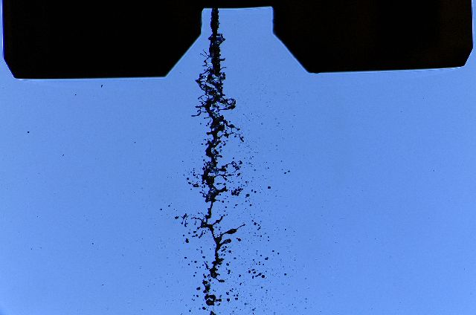
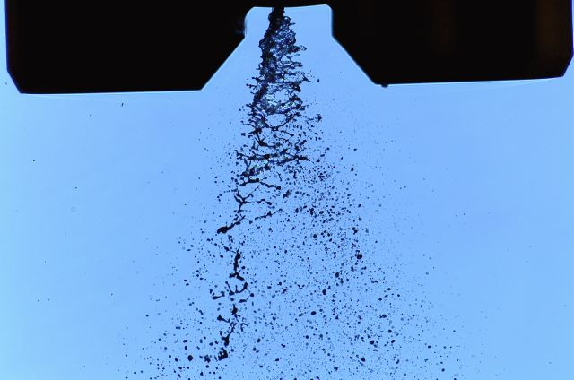
It is found that internal deflections imposed to the liquid induce the production of turbulence as well as a double-swirl structure of the flow at the nozzle exit section. This non-axial flow component is of paramount importance (Fig. 2). Indeed the surface energy per unit volume of the resulting spray (σ/D₃₂) is found linearly dependent on the sum of the turbulent kinetic energy (ρ_{L}T_{ke}) and the non-axial kinetic energy at the nozzle exit (E_{k}):
Fig. 2: Example of issuing liquid flows showing the influence of the eccentricity (same turbulent kinetic energy, higher non-axial kinetic energy on the right image)

$$\frac{σ}{D_{\text{32}}}=0\text{.}\text{013}\left(E_{k}+ρ_{L}T_{\text{ke}}\right)+\text{61}$$

This result shows that the atomization process is not controlled by the liquid turbulence only but depends on he non-axial liquid flow also. Thus, the sum E_{k} + ρ_{L}T_{ke} represents the energy available for the atomization process.
As far as the liquid flow behavior is concerned, it is found that the local interface length and the local fractal dimension are well representative of the atomization process. An example of their spatial evolution is shown in Fig. 3. As soon as the liquid leaves the nozzle, the local interface length L increases, reaches a maximum (L_{max}) and decreases to zero. The increase of L is due to the presence of growing perturbations on the liquid gas interface. The position at which L = L_{max} correspond to the position at which the break-up starts and the position corresponding to L = 0 indicates where the atomization process is completed. It is found that L_{max}, which obviously is a characteristic of the liquid flow break-up, is related to the energy available for atomization (E_{k} + ρ_{L}T_{ke}) regardless of injection pressure and nozzle geometry, and correlates well with the spray surface energy per unit volume (σ/D₃₂).
The local interface fractal dimension reported a spatial evolution similar to the one observed for the local interface length (Fig. 3). It is interesting to note that the beginning of the atomization process is also characterized by a maximum value of the fractal dimension (δ_{max}) and that this fractal dimension is correlated to the issuing flow characteristics as follow:

Fig. 3: Example of spatial evolution of local length and fractal dimension of the liquid gas interface during the atomization process

Fig. 4: Correlation between the interface fractal dimension at the instant of break-up and the constraint diameter of the MEF application.

$$δ_{\text{max}}=1\text{.}{\text{0810}}^{−5}\left(0\text{.}\text{14}E_{k}+ρ_{L}T_{\text{ke}}\right)+1\text{.}\text{07}$$

This result shows that the fractal nature of the interface is mainly due to the presence of liquid turbulence but the liquid gas interface tortuosity is also a function of the non-axial kinetic energy.
Being in a situation where the liquid break-up is likely controlled by surface tension forces (low Weber number), the time at which break-up starts must equate a capillary characteristic time. This assumption led to the definition of a capillary length scale a_{m} characteristic of the break-up:

$$a_{m}∝{\left(\frac{h_{m}^{2}σ}{ρV_{q}^{2}}\right)}^{1/3}∝{\left(\frac{σ}{C_{D^{2}}}\frac{h_{m}^{2}}{{ΔP}_{i}}\right)}^{1/3}$$

a_{m} was found to correlate very well with the interface length L_{max} regardless the nozzle geometry and the injection pressure. However, the drop size distribution dispersion is not related to the spatial variation of this length during the atomization process.
Finally, the surface-based drop size distributions were analyzed by the following mathematical function obtained from the application of the Maximum Entropy Formalism (MEF):
$$f_{s}(D)=q\frac{{\left(\frac{3}{q}\right)}^{3/q}}{Γ\left(\frac{3}{q}\right)}\frac{D^{2}}{D_{q+2,2}^{3}}\text{exp}\left[−\left(\frac{3}{q}\right){\left(\frac{D}{D_{q+2,2}}\right)}^{q}\right]$$
Besides a rather good representation of the experimental size distribution by this function, it was found that the constraint D_{q+2,2} correlate very well with the fractal dimension at the instant of break-up (Fig. 4). This result shows the physical relevance of the MEF approach. It also shows that the spray drop size distribution is depending on two major characteristics of the liquid gas interface, i.e., the amount of interface and its shape. The amount of interface is related to the distribution size parameter whereas the shape of the interface is related to the dispersion parameter of the spray drop size distribution.

