Experimental and Numerical Investigation of Turbulent Spray Flows

H.-W. Ge*, M. Vogelgesang*, E. Gutheil*
I. Düwel†, H. Kronemayer†, C. Schulz‡

*Interdisziplinäres Zentrum für Wissenschaftliches Rechnen,
Universität Heidelberg, Im Neuenheimer Feld 368, 69120 Heidelberg, Germany

†Physikalisch-Chemisches Institut, Universität Heidelberg
Im Neuenheimer Feld 253, 69120 Heidelberg, Germany

‡Institut für Verbrennung und Gasdynamik, Universität Duisburg-Essen

Lotharstrasse 1, 47057 Duisburg, Germany

ABSTRACT

INTRODUCTION
Turbulent spray flows are frequently encountered in industrial processes such as internal combustion engines, gas-turbine combustors, liquid-fuelled furnaces and aircraft propulsion. Therefore it is important to enable detailed simulations of spray combustion processes in order to optimize efficiency and emissions of practical combustion systems. Droplet size and velocity distributions were measured in an ethanol-fuelled model spray burner for a non-reactive case as well as for the reacting spray by different methods. The measurements are compared to simulation results of droplet evaporation in turbulent spray flows.

EXPERIMENTAL SETUP
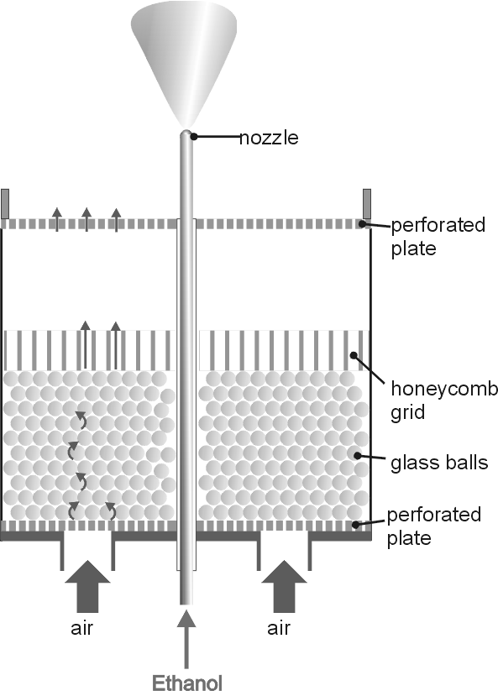
Spray experiments were performed in a spray burner that was developed in cooperation with the University of California at Berkeley¹. It consists of a central fuel nozzle (Delavan 67700-5), a perforated brass plate that provides a homogeneous air-coflow on top of the central burner bowl (Figure 1). The geometric Reynolds number Re = 19,565 of the non-reactive flow was calculated from particle imaging velocimetry (PIV) of the mean droplet velocities².
Droplet size distributions and droplet velocity distributions were measured for the non-reacting spray without co-flow close to the nozzle exit where the differences between reacting and non-reacting are expected to be small. Droplet sizes and velocities were measured by Phase Doppler Anemometry (PDA) (cf.³). The PDA gives reliable results for sizes of spherical droplets in thin sprays only. Additionally, average droplet size distributions have been obtained from drop-size imaging measurements⁴. Imaging of gas phase temperature in the spray flame is in progress based on multi-line laser-induced fluorescence measurements with seeded NO⁵. The results will be presented in a forthcoming publication.

Figure 1 Schematic set-up of the spray burner

EXPERIMENTS
Ethanol is heated to 45°C before injection into quiescent air at room temperature. Two cases with different injection pressures p = 1.4 bar and 2.0 bar are investigated. The radius and axial and radial velocity of the droplets are measured at three different axial positions x downstream of the nozzle exit: x = 2, 5 and 7.5 mm. In case of p = 2.0 bar spray breakup occurs closer to the nozzle. Thus, the overall number of non-spherical droplets is smaller and the PDA data is more reliable. Therefore, this case is used for the comparison of experiment and simulation.

SIMULATION
The conservation equations of the gas flow including an extended k-ε turbulence model⁶ to account for interaction of the gas with the droplets are employed. The poly-disperse spray is represented by a finite number of point-volume droplet parcels. Each measurement is taken as a droplet parcel. The trajectories of droplets are calculated by a Lagrangian stochastic parcel method⁶. The model includes the infinite-conductivity model for droplet heating and droplet vaporization in a convective gas flow⁷ as well as the equation for droplet motion. Currently, droplet interaction, breakup, and coalescence are neglected.
The governing gas-phase equations are used for a steady two-dimensional axi-symmetrical jet where the low Mach number approximation is used as well as the boundary layer approximation. The gas phase model includes the flamelet model for turbulent spray diffusion flames where laminar spray flamelets⁸ are considered. Flamelet libraries are available for the fuels methanol and ethanol in air as well as for the hydrogen/oxygen system. Here, an ethanol spray in air is considered. Methanol spray flow modeling is presented in⁹ and¹⁰.
The numerical solver is a hybrid solver that includes a finite volume method based on the SIMPLE algorithm. The spray source terms of the gas-phase equations, resulting for the interaction with the liquid, require a modification of the solver to account for these additional terms.

RESULTS and DISCUSSION
The simulations shown here have been performed for a non-reactive ethanol/air spray. Figure 2 shows comparisons of experimental and numerical results of ensemble-averaged droplet velocity, Sauter mean radius as well as droplet size at two different axial positions x. An additional experiment at x = 2 mm provides initial conditions for the computations.
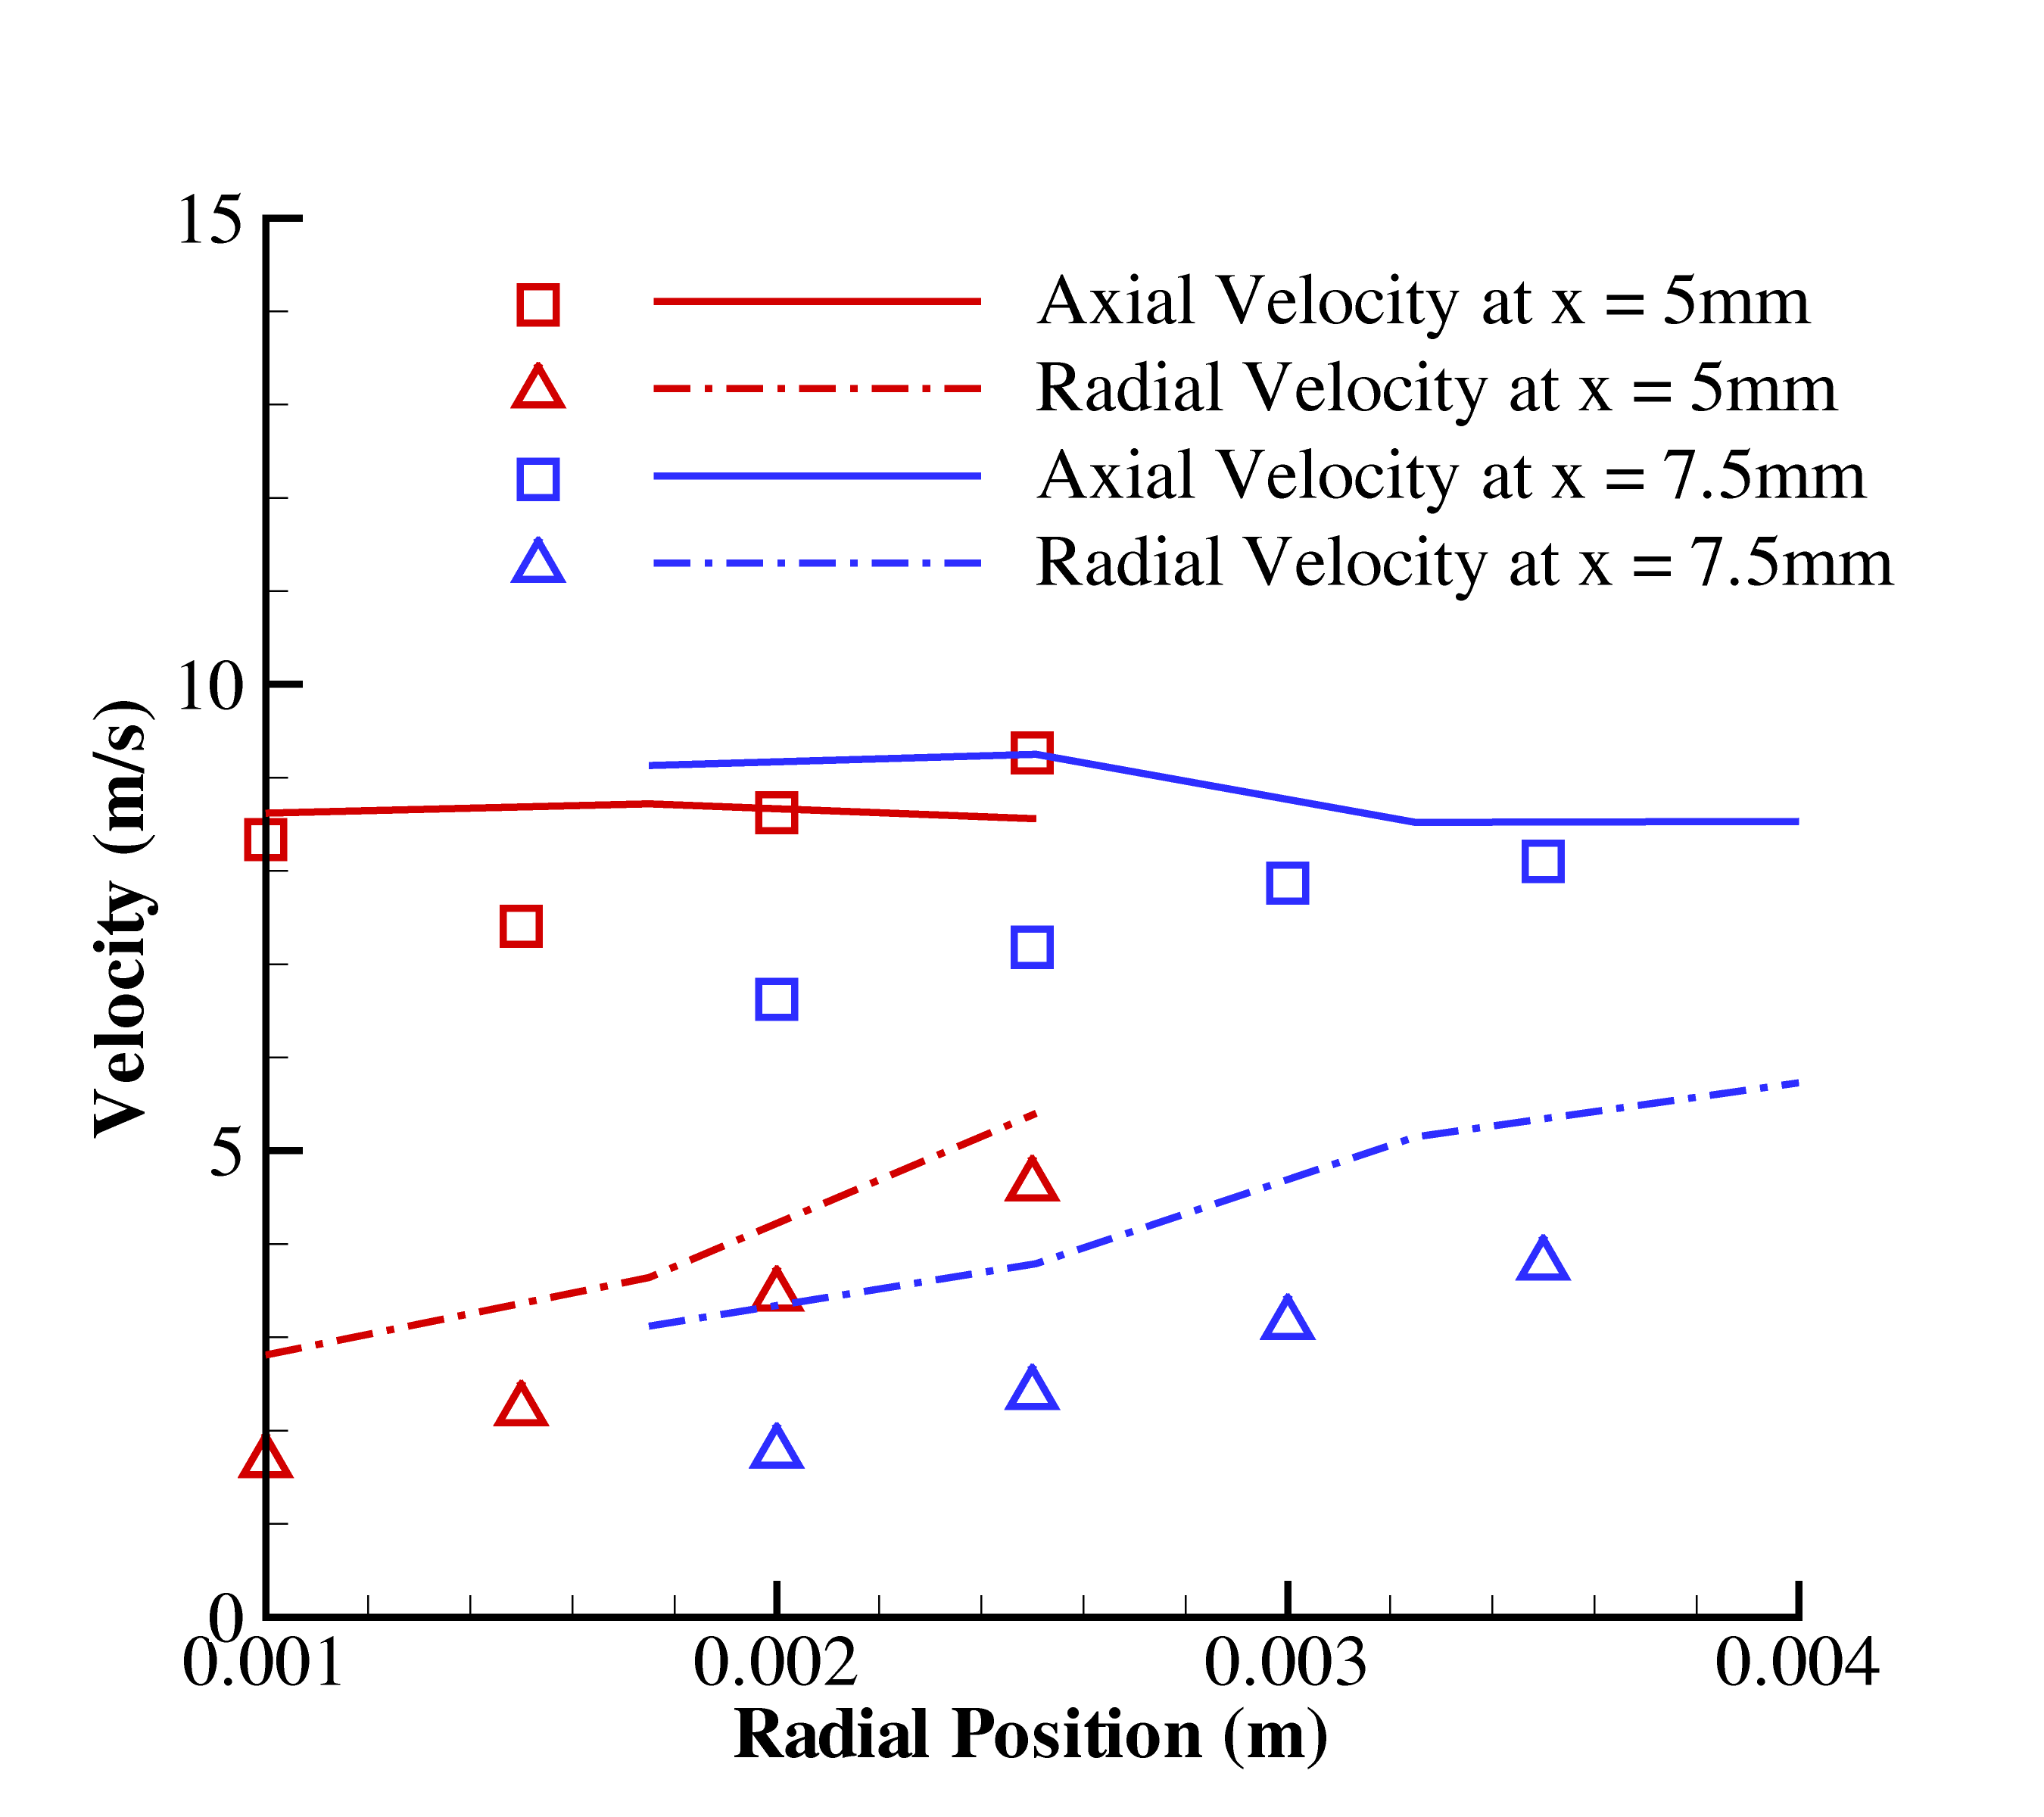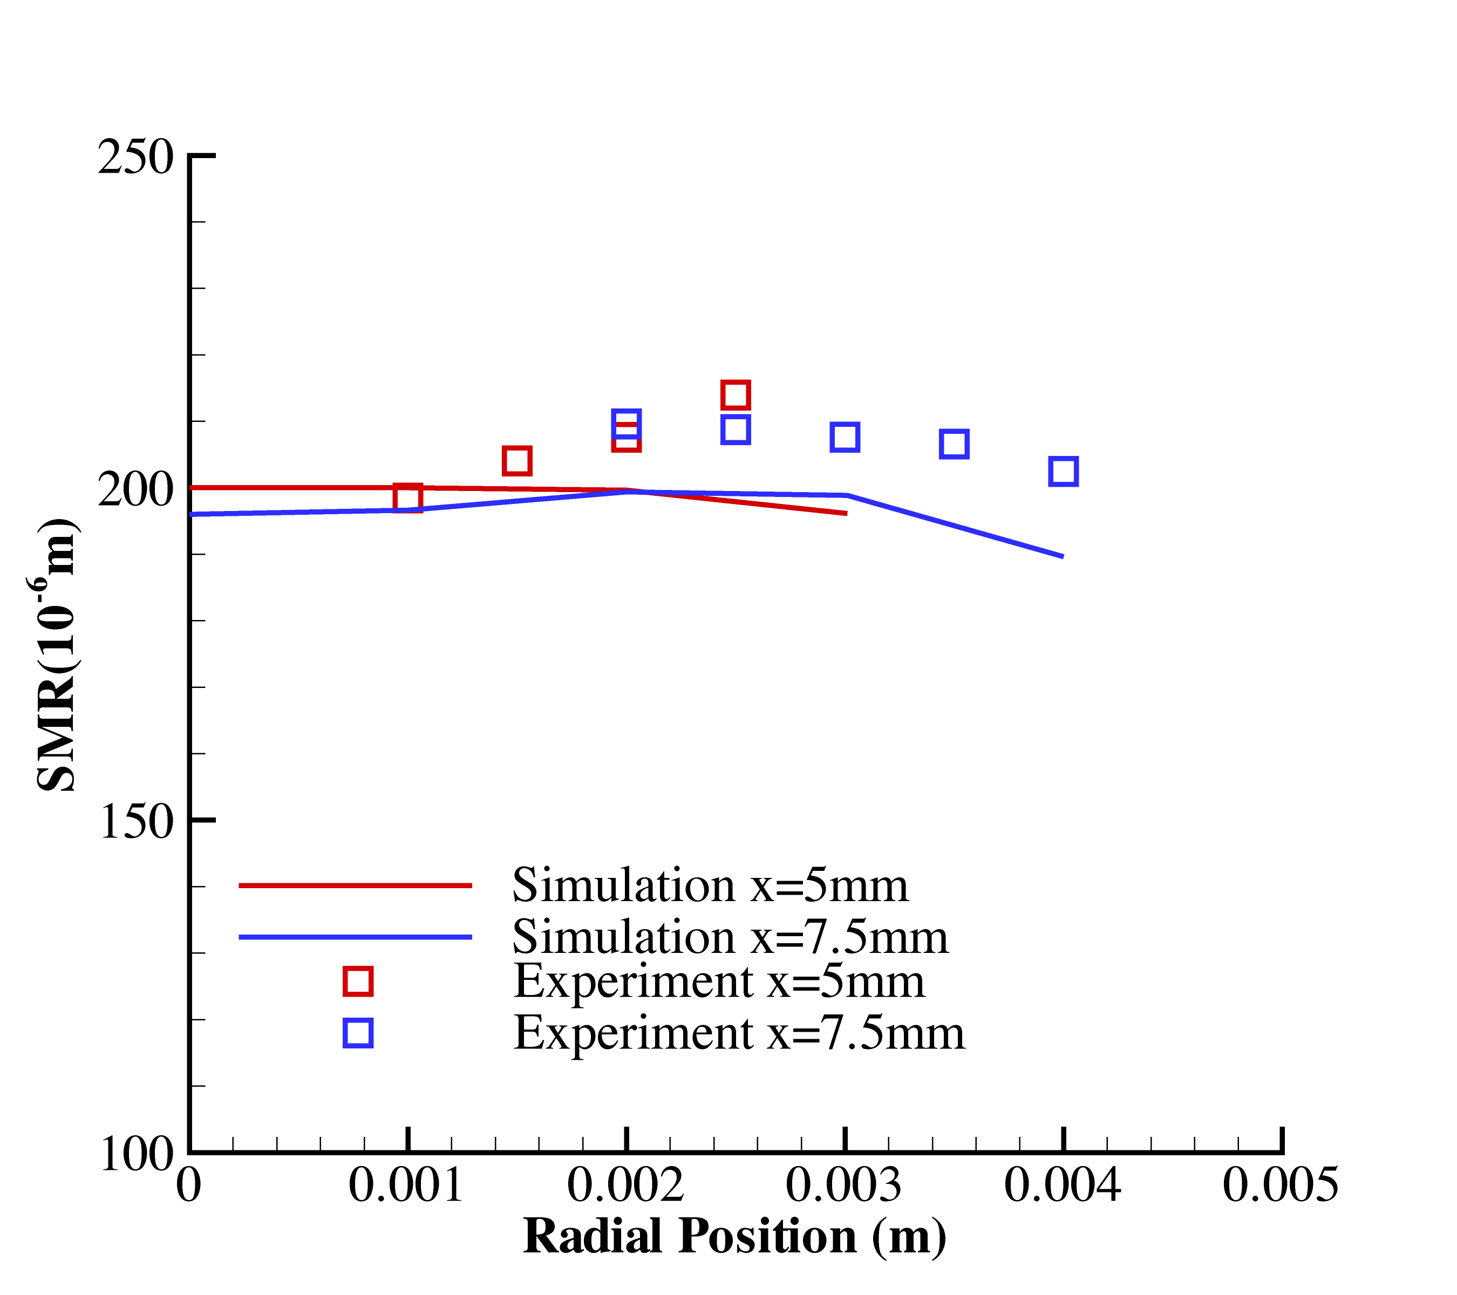
Figure 3: Radial profiles of Sauter mean radius of droplets at section x = 5 mm and 7.5 mm. Symbols: experiment, lines: simulation
Figure 2: Radial profiles of ensemble-averaged droplet velocities at x = 5 mm and 7.5 mm. Symbols: experiment, lines: simulation.

The lines in Figs. 2 and 3 show simulated and the symbols measured values. Considering the fact that the initial gas velocity distribution was not measured, the agreement is good. The simulated values of the droplet velocities are systematically higher than the measured values by up to 30%. This causes a higher droplet evaporation rate leading to up to 10% smaller droplet radii compared to the experimental values. The discrepancies between experiment and simulation in the droplet velocities can be attributed to the unknown initial gas flow velocities, the coarse initial droplet size in the experiment and to experimental uncertainties.
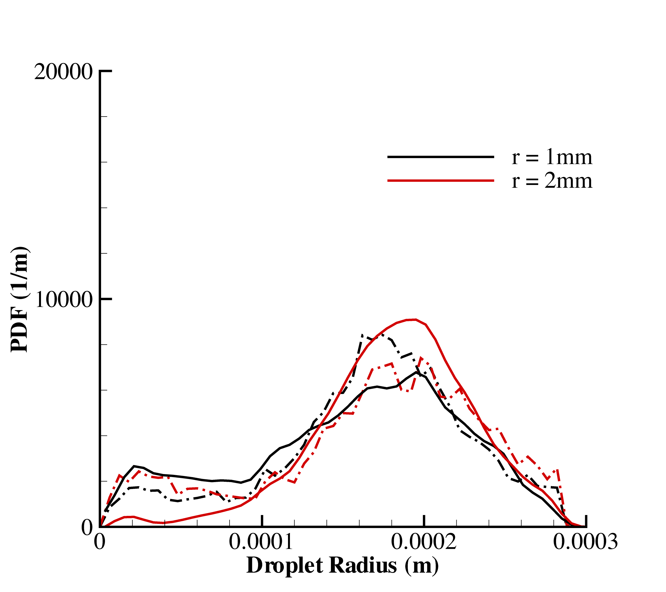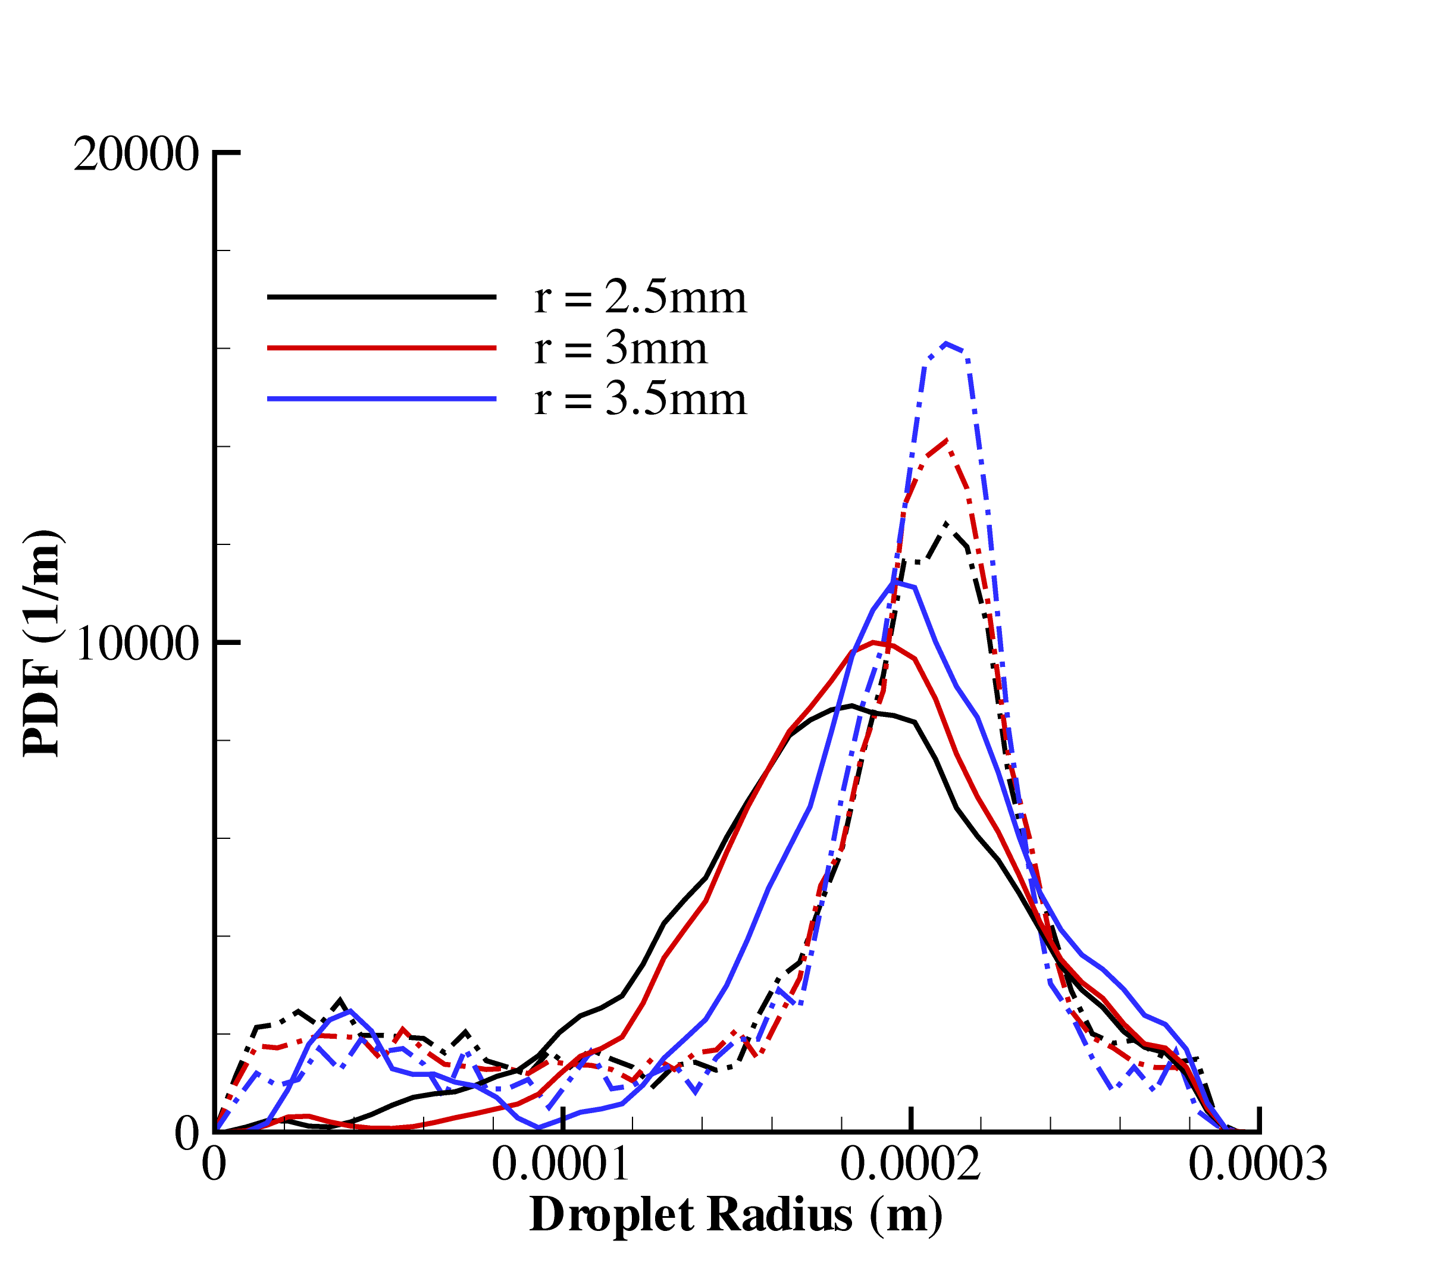
Figure 4: Droplet size distribution at various radial positions, r, for two different distances from the nozzle x = 5 mm (left) and x = 7.5 mm (right). Solid lines: simulation, dashed lines experiment.

Figure 4 shows the comparison of droplet size distribution from numerical simulation and experiment. The size of the droplet radii ranges from 0 to 300 µm. In the present computation, the whole range is split into 50 equal-sized intervals. The number fraction of each interval is calculated and then the PDFs of droplet radii are evaluated. The numerical results are in good agreement with experimental data and show the shift of the peak value as vaporization proceeds.

CONCLUSION
This work shows that turbulent spray flows can be well described by means of numerical simulations. Detailed models are suitable to predict the evolution of both droplet size and velocity distributions in the non-reactive ethanol spray if initial conditions after the spray breakup are known from measurements. The probability density functions for droplet size distribution are in good agreement with experiment.

REFERENCES

- R. Cabra, Y. Hamano, J.Y. Chen, F. Acosta, D. Holve and R.W. Dibble, Spring Meeting of the Western States Section of the Combustion Institute, Golden, CO, March 14, 2000.
- T. Kunzelmann, PhD Diss. , Universität Heidelberg, Heidelberg, 2002
- W.D. Bachalo, Part. Part. Syst. Charact., Vol.11, 1994.
- I. Düwel, T. Kunzelmann, J. Schorr, C. Schulz and J. Wolfrum, ICLASS, paper 9-3, Sorrento, 2003.
- W.G. Bessler and C. Schulz, Appl. Phys. B, Vol.78, pp.519-533, 2004.
- C. Hollman and E. Gutheil, Combust. Sci. Tech., Vol.135, pp.175 – 192, 1998.
- Abramzon, B. and Sirignano, W. A., Int. J. Heat Mass Transfer, vol.9, pp.1605-1618, 1989.
- E. Gutheil, Prog. Comp. Fluid Dynamics, in press, 2004.
- H.W. Ge and E. Gutheil, Proc. ILASS Europe Conf., pp.136-141, Nottingham, UK, September 2004.
- H.W. Ge and E. Gutheil, Atomiz. Sprays, accepted, 2005.

