CFD Simulation of Medicinal Spray Deposition in an Anatomically Realistic 17-Generation Human Bronchial Tree Model

T. Gemci*, V. Ponyavin, and Y. Chen
Nevada Center for Advanced Computational Methods
University of Nevada Las Vegas, Las Vegas, NV 89154-4027
*Email: tgemci@nscee.edu

Extended Abstract

This CFD study reports the medicinal spray deposition in the lung airways in an anatomically realistic 17-generation lung bronchial tree model. An understanding of the anatomy and morphometry of the airways and the lungs forms the first step in an examination of pulmonary aerosol deposition. Studies of the airways are becoming increasingly more detailed supporting efforts to provide more efficient delivery of inhaled medications and to understand the effects of inhaled pollutants. Particle diffusion within the human airways plays a critical role in aerosol therapy and inhalation toxicology. Particle deposition patterns in the carinal region area are highly affected by impinging gas flow fields. This has important implications for risk assessment programs and aerosol therapy protocols.
The uptake of particulate matter by inhalation leads to complex transport processes influenced by unsteady convection through a non-dichotomously branching network of conducting tubes. The properties of the particulate matter; their diameter and density distributions and its affinity to adhere to the mucous linings of those conduits play a crucial role in the subsequent uptake by, and deposition pattern within, the pulmonary tract. While the respiratory tract may be the target organ of concern with regard to many pollutants, for others it is merely one route of entry into the body. Furthermore, pulmonary flow features are closely related to the anatomical details of the branching network of some 23 generations of pulmonary airway conduits.
A widely-used model for CFD simulations and predictions of gas transport, particle deposition and dosimetry is that a regular, dichotomic branching pattern (Synder et al. (1981), Zhao and Lieber (1994), Calay et al. (2002), Lee and Lee (2002), Liu et al. (2003), Kleinstreuer and Zhang (2003), Nowak et al. (2003), Shi et al. (2004), Zhang and Kleinstreuer (2004)), a representation that has its origin in the so-called trumpet model (Weibel, 1963). Weibel’s study was used to develop the widely used symmetric model. Our up-to-date literature search showed that all previous CFD simulations of the structures in the human bronchial trees have been limited to the study of simple bifurcations with up to the 9-Generations.
The paper represents a 3-D CFD study of an anatomically realistic 17-generation lung bronchial tree model based on the high-resolution computer tomography (HRCT) data by Schmidt et al. (2004). Physical morphometry is essential for adequately simulating fluid and particle dynamics in human lung airways with available large number of generations. In recent years there are couple researches focusing on the generation of lung airways models by mathematical algorithm development and also by new experimental imaging techniques (Tawhai et al. (2000), Spencer et al. (2001), Tgavalekos et al. (2003), Sera et al. (2003), and Schmidt et al. (2004)). Up-to-date the best anatomically explicit human lung model with 17-generations was developed by Schmidt et al. (2004). Fig. 1 shows their bronchial tree models which were derived from High-Resolution Computer Tomography (HRCT) imaging of an in vitro preparation. Their model data were provided from a human lung of an adult male, free of pathological alterations. Fig. 1a shows the 3D surface representation of the segmented volume of the bronchial tree and the cartilage rings can be observed in the main upper generations. The tube model reconstructed from an abstracted topological graph adapt in Fig. 1b contains 1453 bronchi up to the 17th generation.

  - (b)
Figure 1. 3D visualization of bronchial tree models from Schmidt et al., 2004. (a) Surface representation of segmented volume data; (b) Visualization of a tube model reconstructed from an abstracted topological graph data.

This numerical study will represent the first published CFD particle deposition study of geometry with 1453 bronchi (17-generations) of the human lung airways. The entire human lung has 23-generations of pulmonary airway conduits. Fig 2 shows a selected airflow field results in the 17-generation lung bronchial tree model.

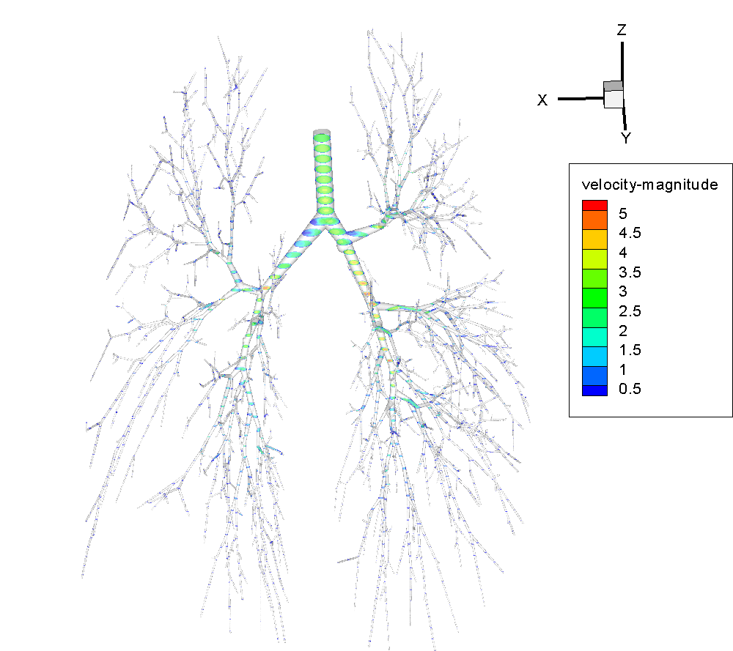

Fig. 2. Airflow velocity-magnitudes at selected cross-sectional areas in the 17-generation human lung bronchial tree model. The inlet velocity corresponds to a steady-state adult inhalation flow rate of 28.3 L/min.

Snyder, B., Dantzker, D.R., and Jaeger, M.J. Flow Partitioning In Symmetric Cascades of Branches. Journal of Applied Physiology, 51(3): 598-506, 1981.
Zhao, Y. and Lieber, B.B. Steady Inspiratory Flow In a Model Symmetric Bifurcation. ASME Journal of Biomechanical Engineering, 116: 488-496, 1994.
Calay, R.K., Kurujareon, J., and Holdø, A.E. Numerical Simulation of respiratory Flow Patterns Within Human Lung. Respiratory Physiology & Neurobiology, 130: 201-221, 2002.
Lee, D.Y. and Lee, J.W. Dispersion of Aerosol Bolus During One Respiration Cycle in a Model of Lung Airways. Journal of Aerosol Science, 33: 1219-1234, 2002.
Liu, Y., So, R.M.C., and Zhang, C.H. Modeling the Bifurcating Flow In an Asymmetric Human Lung Airway. Journal of Biomechanics, 36: 951-959, 2003.
Kleinstreuer, C. and Zhang, Z. Targeted Drug Aerosol Deposition Analysis For a Four-Generation Lung Airway Model With Hemispherical Tumors. ASME Journal of Biomechanical Engineering, 125: 197-206, 2003.
Zhang, Z and Kleinstreuer, C. Airflow Structures and Nano-particle Deposition In a Human Upper Airway Model. Journal of Computational Physics, 198: 178-210, 2004.
Weibel, E.R. Morphometry of the Human Lung. Berlin, Springer Verlag, 1963.

