THERMAL EXPLOSION IN A COMBUSTIBLE GAS CONTAINING FUEL DROPLETS.

I. Goldfarb*, V. Gol’dshtein*, D. Katz*
* Department of Mathematics, Ben Gurion University of the Negev, POB 653,
Beer Sheva, Israel

The study of droplet ignition is a long-standing subject of interest because of the many applications to furnaces, spark ignition engines and gas turbines. The consideration of the ignition of a spray as an explosion problem, while the droplets are simply regarded as a source of the endothermicity is the innovation of this work.
Since long time delays before the self-ignition event seem to be typical of any two-phase system the purpose of this work is to investigate this type of the dynamics. We focus on classification of the possible thermal behavior of the system and single out ignition delays as important characteristics of the model. The work uses the zero-order approximation of the geometrical asymptotic method of integral manifolds to give analytical expressions for the ignition delay criteria as functions of the system parameters.
The main physical processes incorporated in the model are evaporation, thermal radiation and highly exothermic oxidation reaction. To clarify the competition between these processes we restrict our analysis to a spatially homogeneous and adiabatic approach. The pressure changes in the reaction volume and their influence on the combustion process are neglected, and the combustible gas component is assumed deficient reactant during the process. These two assumptions allow us to ignore the changes of the gas mixture density. In addition, we assume that the thermal conductivity of the liquid phase is much higher than that of the gas one. This leads to the heat transfer coefficient dependence, at the interphase boundary, only on the thermal properties of the gas. The droplets size distribution is thought monodispersive. The chemical reaction is modeled as a first-order highly exothermic reaction.
The governing equations are presented as following three ODEs:
$ρ_{g}c_{\text{pg}}α_{g}\frac{{\text{dT}}_{g}}{\text{dt}}={\text{ηρ}}_{g}α_{g}Q_{g}A\text{exp}\left(−\frac{E}{{\text{RT}}_{g}}\right)−4{πR}_{d}^{2}n_{d}\left(h_{c}\left(T_{g}−T_{s}\right)+k_{1}σ\left(T_{g}^{4}−T_{s}^{4}\right)\right)$ (1)
$\frac{{\text{dR}}_{d}}{\text{dt}}=−\frac{1}{{Lρ}_{L}}\left(h_{c}\left(T_{g}−T_{s}\right)+k_{1}σ\left(T_{g}^{4}−T_{s}^{4}\right)\right)$ (2)
$α_{g}\frac{dη}{\text{dt}}=−α_{g}ηA\text{exp}\left(−\frac{E}{{\text{RT}}_{g}}\right)+4{πR}_{d}^{2}n_{d}\frac{1}{{Lρ}_{g}}\left(h_{c}\left(T_{g}−T_{s}\right)+k_{1}σ\left(T_{g}^{4}−T_{s}^{4}\right)\right)$ (3)
$k_{1}=R_{d}^{b}⋅{\text{10}}^{3}\left(a_{1}−a_{2}⋅\frac{T_{g}}{\text{1000}}\right), a_{1}=0\text{.}1, a_{2}=−0\text{.}\text{05}, b=0\text{.}5$, (4)
where T is temperature (K), E is activation energy, Q_{f} is combustion energy (J kg⁻¹), R is the universal gas constant, C is the specific heat capacity, A is a constant pre-exponential rate factor, $ρ$ is density (kg m⁻³), $α$ is the non-dimensional volumetric phase content,
$c_{\text{fs}} \left(c_{f}\right)$ is the concentration near (far from) droplets (kmol m⁻³), $η=c_{f}/c_{\text{fs}0}$ is the non-dimensional mole fraction of the combustible gas, $R_{d}$ is droplet radius (m), L is evaporation liquid energy (J/kg), n is number of the droplets per unit volume (m⁻³), h (h_{m}) is the heat (mass) transfer coefficient, W_{f} is molecular weight (kg kmol⁻¹). The system (1)-(3)is subject to the following initial conditions:
$T_{s}|_{t=0}=T_{s0}$, $T_{g}|_{t=0}=T_{g0}$, $η|_{t=0}=c_{f0}/c_{\text{fs}0}$, $R_{d}|_{t=0}=R_{d0}$.
To obtain a closing relation for the system (1)-(3) we assume that the quasi-stationary approximation for the heat transfer coefficient describes the dynamics of the evaporating liquid with sufficient accuracy. It means that the droplet boundary is assumed to be at the saturation conditions and its temperature $T_{s}$ determines the partial pressure $P_{\text{fs}}$of the fuel vapor near droplets. This, in turn, determines the concentration $c_{\text{fs}}$of the fuel vapor near droplets.
Another additional equation comes from the Clausius-Clapeyron law:
$c_{\text{fs}}=\frac{P_{s0}\text{exp}\left(−\frac{{\text{LW}}_{f}}{R}\left(\frac{1}{T_{s}}−\frac{1}{T_{s0}}\right)\right)}{{\text{RT}}_{s}}$ (5)
The original set of governing equations (1)-(3) represents a multi-scale system (due to the presence of the processes that have essentially different characteristic times) and can be reduced to a conventional singularly perturbed system of ODEs. This allows us to apply the powerful technique of the geometrical version of the integral (invariant) method (MIM) for its analysis. MIM allows us to decompose the phase space analysis of an arbitrary multi-scale system into separate studies of its fast and slow subsystems ([1],,)
The analysis of the system trajectory in the phase space along with the MIM approach yields the trajectory that consists of two parts. The first part is characterized by the fast motion from the initial point toward the attractive branch of the slow curve. While the fast motion takes place, the slow variable conserves its initial value. During the second part, the fast motion occurs along the slow curve up to the turning point. The slow variable (based on the system momentum) conserves its value. The latter is determined at the matching point.
The delay time is defined as the time-period during which the trajectory moves along the slow curve until the fast thermal explosion occurs, i.e. the time-period between the trajectory intersection point with the slow curve and the appropriate turning point.
In the case where the gas temperature is the fast variable the following expression of the delay time is obtained:
$τ_{\text{delay}}=−\int_{1}^{r_{tΩ}}{\frac{3r^{2}\text{dr}}{ε_{2}\left(η_{0}+\frac{δ−1}{ε_{2}}\left(1−r^{3}\right)\right)\text{exp}\left(θ_{g}\left(θ_{s},r\right)\right)}}$ (6)
where $θ_{g}$, $θ_{s}$, $r$, $η$ are the dimensionless variables introduced according to [4].
In the case of the fast droplet radius the appropriate expression looks as follows:
$τ_{\text{delay}}=−\int_{1}^{0}{\frac{d\left(r^{3}\right)}{ε_{2}σ^{−1}\left[\text{exp}\left(\left(\frac{T_{g0}b}{T_{d0}}\right)θ_{s0}+\left(\frac{T_{g0}}{T_{d0}}−1\right)\frac{{\text{LW}}_{f}}{T_{g0}R}\right)−\frac{T_{g0}}{T_{d0}}η\left(r\right)\right]\left(εr+ε_{1}ε_{3}r^{2+b}\right)}}$ (7)

CONCLUSIONS

1. The assumption that the droplets are semi-transparent leads to the increase of the delay time in the case of the fast gas temperature, and to its decrease in the case of the fast droplet radius.
2. The analysis of the model allows us to conclude that in the parametric regions, where the gas temperature is fast, the delay time increases with the increase of the droplets number, and decreases with the increase of the droplet radius.
3. The similar study is performed in the practically important parametric regions, where the droplet radius is fast and gas temperature changes slowly. Here, the delay time decreases with the increase of the droplets number, and increases with the increasing droplet radius.
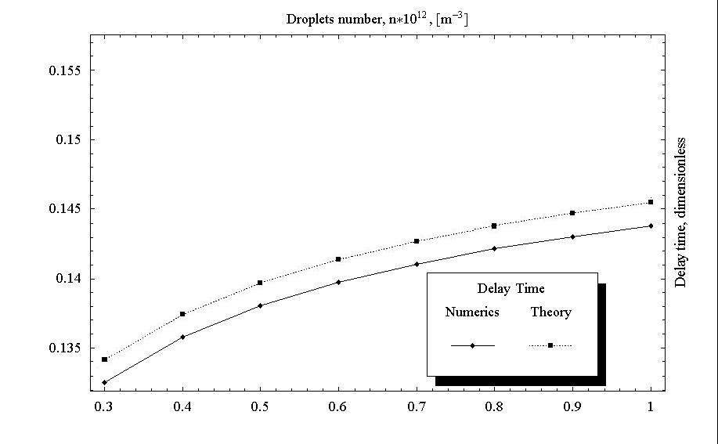
Figure 1. Fast gas temperature case. Numerics vs theory.
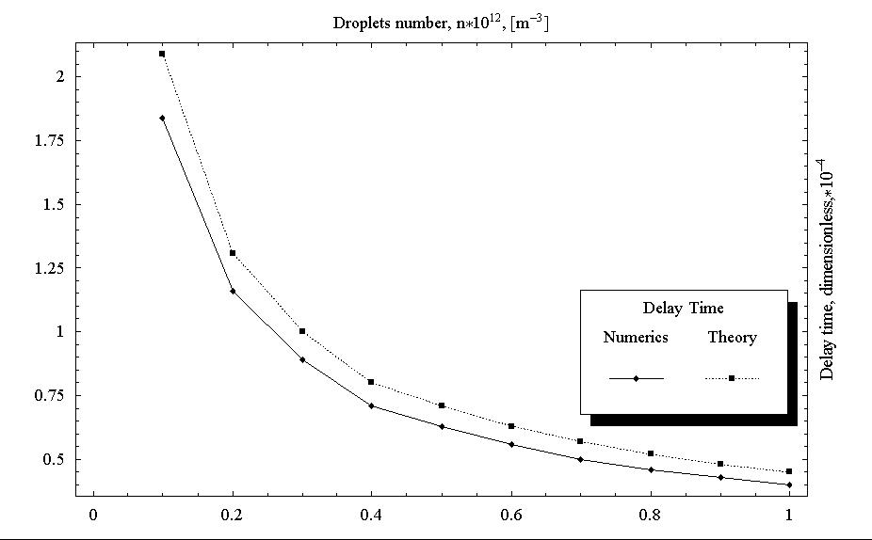
Figure 2. Fast droplet temperature case. Numerics vs theory.

REFERENCES

[1] Babushok V I and Gol’dshtein V M 1988 Structure of the thermal explosion limit Combust.Flame 72 211-6.
[2] Gol’dshtein V M and Sobolev V A 1992 Singularity Theory and Some Problems of Functional Analysis (AMS Translations, series 2, vol. 153)(Providence , RI:American Mathematical Society) pp 73-92.
[3] Dombrovsky L A, Sazhin S S, Sazhina E M, Feng G, Heikal M R, Bardsley M E A, Mikhalovsky S V 2001 Heating and evaporation of semi-transparent diesel fuel droplets in the presence of thermal radiation Fuel 80 1535-1544.
[4] Semenov N N Zur Theorie des Verbrennungsprozesses. Z. Phys. Chem (vol. 48, 571-581)

