TURBULENCE EFFECTS ON THE INTERFACE EVOLUTION FOR HIGH VELOCITY LIQUID JETS

Ali Jafari and Nasser Ashgriz
Department of Mechanical and industrial Engineering,
University of Toronto, Toronto, Ontario, Canada, M5S 3G8
ashgriz@mie.utoronto.ca

INTRODUCTION

Many flows in nature and industries involve turbulent free surfaces or material interfaces between two fluids. In these types of flows, the shape of the interface as a sharp discontinuity and the flow turbulence characteristics play an important role in the dynamics of the problem. The accurate prediction of the position, curvature and topology of the interface, as well as detailed modeling of turbulent flow is essential in simulating the problem.

METHODOLOGY

In this paper, the Volume of Fluid (VOF) interface tracking method is combined with Large Eddy Simulation (LES) formalism to investigate the dynamics of turbulent interfaces in detail. This approach is necessary especially in case of atomizing liquid jet flows where the mechanism of breakup near nozzle region remains unclear although many theories have been proposed, including aerodynamic shear stresses acting through stripping and Kelvin-Helmholtz instabilities, inner liquid turbulence, velocity profile relaxation causing bursting effect in case of large velocity differentials, bulk liquid oscillation resulting in toroidal surface perturbations, and cavitation-induced disturbances which may act in several ways. In practice, it is experimentally very difficult to separate and investigate these different effects. This computational method, however, is believed to have the potential to overcome these difficulties.

The main issues concerning combined LES-VOF methodology is to develop and implement accurate and stable numerical techniques. The numerical technique for interface tracking should be able to maintain the interface sharpness on non-uniform grid while producing stable and bounded solutions [1]. This is achieved using High-Resolution (HR) schemes. LES demands a non-diffusive scheme, but in general two-phase calculations are unstable requiring some kind of artificial solution bounding at phase interfaces. Since the high-order (HO) schemes generate over/under shoots and oscillatory behavior in the presence of steep gradients (such as negative or larger than one values for volume or mass fraction), their use is not appropriate in multifluid and multiphase systems. High-resolution (HR) schemes are designed so as not to generate unphysical over/under shoots. HR schemes are derived by enforcing a boundedness criterion, such as the Convection Boundedness Criterion (CBC), on a base HO scheme [2]. This transforms the linear but unbounded HO scheme into a bounded but non-linear HR one. A one-equation subgrid scale (SGS) model is used for LES calculations [3]. Also, for the temporal discretization, backward differencing scheme which is second order implicit is used. The equations are solved using second-order spatial and temporal discretization schemes preserving the proper limits on physically-bounded variables. The solution procedure employs the implicit PISO algorithm, in conjunction with conjugate gradient methods.

RESULTS

A preliminary result of VOF-LES is presented here. We present the results of a two-dimensional (axisymmetric) simulation of high-speed diesel jet in compressed air. We focus on the region just downstream of a 200 micron in diameter nozzle from which issues a turbulent liquid flow at a mean velocity of 250 m/s with high frequency sinusoidal inlet velocity perturbations to mimic the actual turbulent pipe flow characteristics. The extent of the solution domain is 3mm*1.6mm which is 15D*8D. The inlet is located at the lower left part of the domain while the wall boundary conditions are used for upper left part to resemble the real situation. The lower boundary is axis of symmetry and for the other boundaries we use free (or atmosphere) boundaries. Two grid resolutions are used. The first (coarse) grid is 75*100 and the second (fine) grid is 150*200. We have refined the grid near the nozzle tip to capture the important scales in that region.

We see the evolution and atomization of the liquid jet in Figs. (1) and (2) (for coarse and fine grids respectively) where the volume fractions are shown at different times. The red regions represent pure liquid, the dark blue represents pure gas and the other colors the transitional region. It can be seen that surface instabilities are created close to the nozzle exit. These waves grow through aerodynamic shear to form ligaments and then either break off to form droplets and/or roll up and continue to grow. This is in accordance with accepted theory on triggered Kelvin-Helmholtz instabilities and somehow agrees qualitatively with available experimental observations for this class of sprays. Comparing Figs. (1) and (2) to see the differences between the two grid resolutions, it can be seen that at later stages the differences are clear where we see breakup of spray where the liquid body discontinues in the fine grid, unlike in coarse grid.
In conclusion, this preliminary simulation is promising in the hope that LES-VOF simulations would shed more light into the mechanism of atomization and to examine the interplay between different parameters.

REFERENCES

¹ Wang, J.P., Borthwick, A.G.L., and Eatock Taylor, R., Finite-volume-type VOF method on dynamically adaptive quadtree grids, Int. J. Num. Meth. Fluids, Vol. 45, pp. 458-508, 2004.
² Leonard, B.P., The ULTIMATE conservative difference scheme applied to unsteady one-dimensional advection, Comput. Methods Appl. Mech. Engrg., Vol. 88, pp. 17-74, 1991.
³ Piomelli, U., Large-eddy simulation: achievements and challenges, Vol. 35 (4), pp. 335-362, 1999.
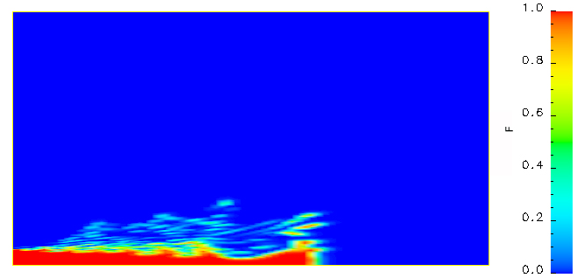 | 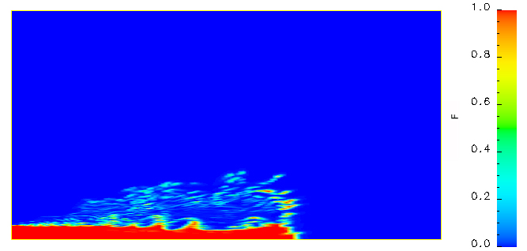
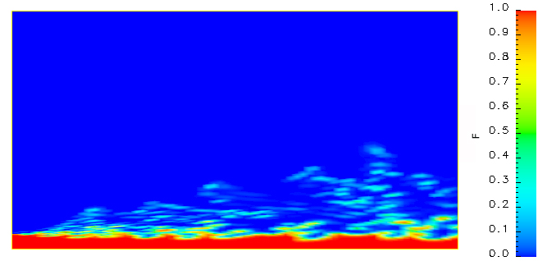 | 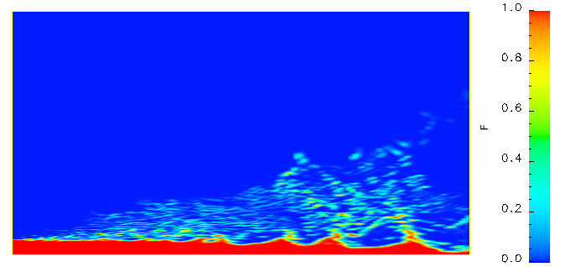
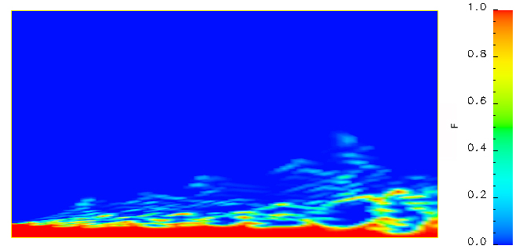 | 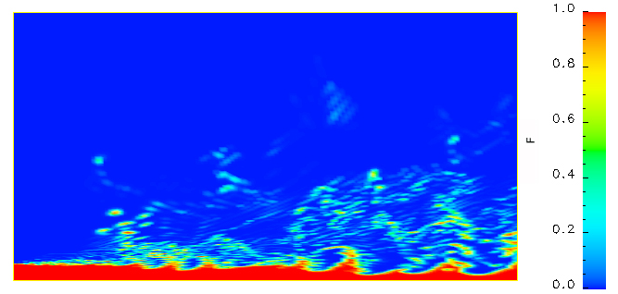
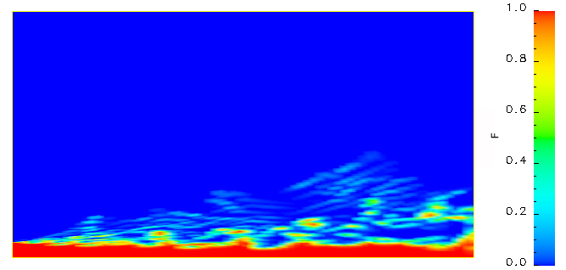 | 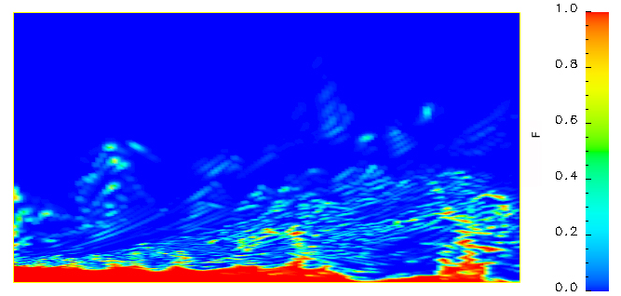
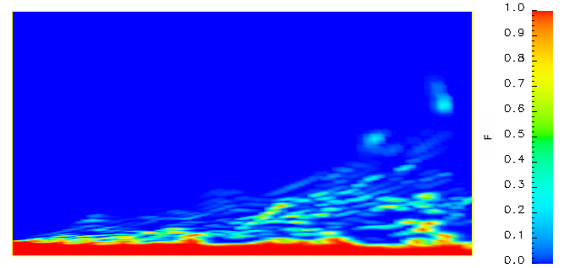 | 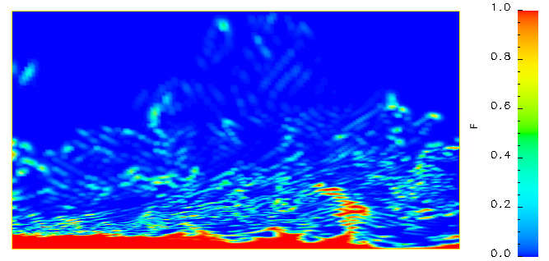
Fig. (1): Evolution of spray for the coarse grid (contours of volume fraction) at times t=4.9, 10.9, 20, 30.9, and 62.2 microseconds. | Fig. (2): Evolution of spray for the fine grid (contours of volume fraction) at times t=5, 10.3, 20.1, 30, and 61.5 microseconds.

