UNSTEADINESS IN EFFERVESCENT SPRAYS – A COMPARISON OF two MEASUREMENT METHODS AND the INFLUENCE OF OPERATION CONDITIONS

Jan Jedelsky, Miroslav Jicha
Faculty of Mechanical Engineering
Brno University of Technology, Technicka 2, 61669 Brno, Czech Republic

INTRODUCTION

The effervescent atomizer was introduced by Prof. Lefebvre¹ several years ago. The technology seems promising, although several operation-related issues are known; in particular spray unsteadiness observed under certain operating conditions. Its negative effects are apparent mainly in combustion applications. Spray unsteadiness in regimes with a high gas-to-liquid ratio by mass (GLR) arises due to interaction between a liquid film and high-velocity gas passing down along the central axis of the atomizer mixing chamber². Unsteadiness appears also in slug flow³ or in transition between bubbly and annular flow⁴, connected with big changes of the void fraction in the two-phase mixture and the existence of liquid bridges between the gas bubbles flowing through the exit orifice.

Up to now, several methods have been developed to quantify spray unsteadiness. Edvard & Marx’s method⁵ uses a comparison of the measured interparticle arrival time distribution with a theoretical distribution function modelled as an inhomogeneous Poisson process. This method was employed by Luong & Sojka⁴ and Fritsching & Heinlein⁶. An alternative method is based on measurement of two-phase flow pressure fluctuations in the vicinity of the exit orifice³. A simplified relation between pressure fluctuations and liquid flow rate fluctuations at the exit orifice is used. The pressure oscillations based measurement method was also used by Osakabe & Horiki⁷ and other researchers studying the quality of the gas-liquid mixture. A planar droplet sizing technique, based on combined measurement of Laser Induced Fluorescence intensity and scattered light intensity of spray droplets was used by Domann & Hardalupas⁸ to quantify the spray unsteadiness. The mean and rms of liquid volume, surface and Sauter Mean diameter (SMD) were used to evaluate the unsteadiness.

In this paper, we applied the Edvard & Marx’s method⁵ and the method based on pressure fluctuation measurements³ to a simple effervescent atomizer. Light heating oil was atomized, using air as the atomizing medium. Measurements were taken over a wide range of liquid flow rates and air gauge pressures. A set of results obtained for both of the methods is used for comparison as well as for evaluation of operation conditions upon spray unsteadiness.

Atomizer description

A simplified transparent Plexiglas version of an industrial effervescent atomizer as described in Jedelsky & Jicha³ was used for experiments. The liquid enters by a central orifice on top, while the air enters by side orifices and is injected into the liquid, from each side, through a set of 15 holes with 1 mm in diameter. The internal diameter of the aerator is 8 mm and the length of the mixing tube, downstream of the last row of air holes, is 80 mm. The two fluids form a two-phase mixture, flow downstream and exit the atomizer through an orifice to the ambient atmosphere. The exit orifice has a diameter of 2.5 mm and a length of 0.7 mm. The atomizer was studied in a vertical position of the main axis. Air and oil temperature, gauge pressure and flow rates were measured. The experiment and test bench description can be found in Jedelsky & Jicha³.

Spray unsteadiness measurement

Spray unsteadiness was evaluated by the method developed by Edvard & Marx⁵. Dantec 1D Phase/Doppler Particle Analyser was used to measure spray properties. More than 30,000 samples were taken in each run. Measurement was carried out at the atomizer axis, 50 mm downstream of the exit orifice. Constant binning of interparticle time histogram was made. Interparticle histograms were calculated and represented starting at some minimum interparticle arrival time to avoid bias effects⁶. A Chi-square analysis was performed to compare the experimental interparticle time distribution with the theoretical one. The χ² value was used to represent the spray unsteadiness. As shown in Fig.1, shorter interparticle time gaps occur more frequently then the theoretical model based on inhomogeneous Poisson process predicts. Our results are in accordance with those acquired previously^{4,6}, although our atomizer generally shows a higher level of unsteadiness than atomizers described in previous works.
Fig.1: Comparison of experimentally acquired and theoretical interparticle time distribution. Air Gauge Pressure 0.1MPa, Oil Flow Rate 16ml/s.

Two-phase flow unsteadiness measurement

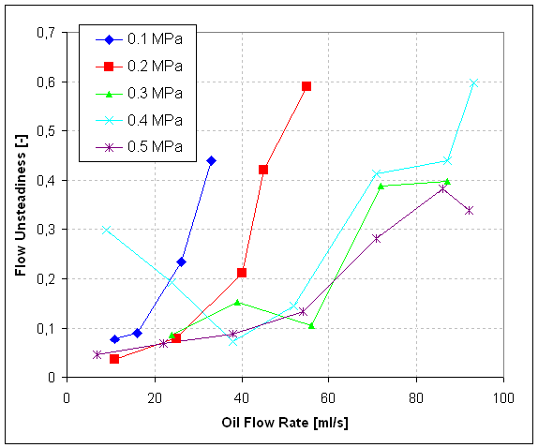
The two-phase flow unsteadiness evaluation method described in Jedelsky & Jicha³ was applied. The two-phase mixture pressure changes were measured by a small quartz pressure sensor Kistler 601A placed in the mixing channel at a position 10 mm upstream of the exit orifice. A simplified relation between pressure fluctuations and liquid flux changes at the exit orifice was derived, assuming that pressure fluctuations inside the mixing chamber are small with respect to the average pressure. The processes were considered isothermal with constant input fluid flow rates. The relation shows that the liquid flow rate fluctuation is proportional to the time derivative of the pressure fluctuation. Then, for the flow unsteadiness at the exit orifice defined as a ratio of rms of the liquid flow rate $M_{l_{\text{rms}}}^{'}$ and the mean liquid flow rate ${\overline{M}}_{l}$ is:
Fig.2: Flow unsteadiness for different values of the Air Gauge Pressure and Oil Flow Rate.
Fig.2: Flow unsteadiness for different values of the Air Gauge Pressure and Oil Flow Rate.
$U=\frac{M_{l_{\text{rms}}}^{'}}{{\overline{M}}_{l}}=k⋅{\left[\frac{dp^{'}}{\text{dt}}\right]}_{\text{rms}}$ (1)
The parametrer k depends on the mixing chamber volume, fluid physical properties and the operation conditions. Note that also the experimentally derived equation $U≃{\left(p_{\text{rms}}^{'}/\bar{p}\right)}^{1/2}$ yields good results. Here $p_{\text{rms}}^{'}$ is the pressure fluctuation rms value and $\bar{p}$is the mean gauge pressure inside the mixing chamber. The results for the air gauge pressure range 0.1-0.5 MPa are shown in Fig.2. It is apparent that the unsteadiness depends on the operation conditions and also on the two-phase flow pattern inside the mixing chamber.
A comparison of the spray and the two-phase flow unsteadiness

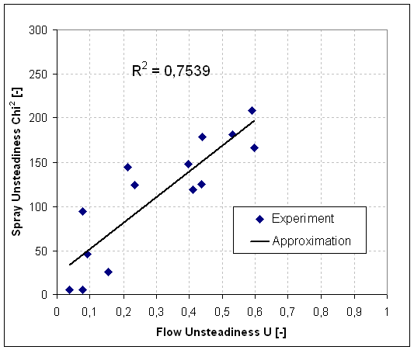
The results provided by the two methods are compared in Fig.3. There is a good but not a perfect agreement between spray unsteadiness evaluated after Edvard & Marx⁵ and the two-phase flow unsteadiness evaluated after Jedelsky & Jicha³. The differences in results could be explained by noting that the pressure fluctuations represent an overall unsteadiness, while the unsteadiness calculated from the interparticle arrival time is valid only for a specific location in the spray. It is known that unsteadiness varies also with radial and axial position in the spray^{4,6}.
Fig.3: Correlation between the spray and two-phase flow unsteadiness.

Conclusions

A comparison of spray unsteadiness results based on pressure fluctuation measurements and results based on interparticle time gap statistical evaluations was made. There is a good correlation between the two methods. An advantage of the method based on pressure fluctuation measurements is that it allows for an overall evaluation of unsteadiness, while the method based on interparticle arrival time provides information on unsteadiness at a point in the spray, so that spatial changes of the spray unsteadiness can be studied. Measurements made for a wide range of liquid flow rates and air gauge pressures show a significant influence of the atomizer operation conditions on the spray unsteadiness.

REFERENCES

- Lefebvre, A.H., Atomization and Sprays, chap. 4, Tailor & Francis, Bristol, 1989.
- Chin, J. S. and Lefebvre, A. H., A Design Procedure for Effervescent Atomizers, Journal of Engineering for Gas Turbines and Power, Vol. 117, pp. 266-271, 1995.
- Jedelsky, J. and Jicha, M., Characteristics of a Two-phase Flow Inside the Mixing Chamber of an Effervescent Atomizer, Proceedings of 3rd International Symposium on Two-Phase Flow Modelling and Experimentation, Pisa Italy, 2004.
- Luong, J. T. K. and Sojka, P. E., Unsteadiness In Effervescent Sprays, Atomization and Sprays, Vol. 9, No. 1, pp. 87-109, 1999.
- Edwards, C. F. and Marx, K. D., Multi-Point Statistical Structure of the Ideal Spray, Part II: Evaluating Steadiness Using the Interparticle Time Distribution, Atomization and Sprays, Vol. 5, pp. 475-506, 1995.
- Fritsching, U. and Heinlein, J., Analysis of Single Point Particle Time Series for Detection of Droplet Clustering in Sprays, Proceedings of 3rd International Symposium on Two-Phase Flow Modelling and Experimentation, Pisa Italy, 2004.
- Osakabe, M. and Horiki, S., Estimation of two-phase flow quality with pressure difference oscillation, Proceedings of 3rd International Symposium on Two-Phase Flow Modelling and Experimentation, Pisa Italy, 2004.
- Domann, R. and Hardalupas, Y., Planar Droplet Sizing for Quantification of Spray Unsteadiness, Proceedings of 18th International Conference on Liquid Atomization and Spray Systems - ILASS-Europe 2002, Zaragoza Spain, 9-11 September 2002.

