ATOMIZED SPRAYS FOR ADJUSTMENT OF LOCAL HEAT TRANSFER IN METAL QUENCHING

Jacek Król, Eckehard Specht*
Institute of Fluid Dynamics and Thermodynamics,
Otto-von-Guericke-University, Universitätsplatz 2, 39106 Magdeburg, Germany

ABSTRACT

For the hardening of metallic solids, these are heated up and then quenched. For an intensive cooling the metallic workpieces are quenched with liquids. Thereby the Leidenfrost phenomenon occurs. A vapour film forms on the hot surface. This film collapses after the surface temperature falls below the Leidenfrost temperature. If the surface is re-wetted with the liquid, the heat transfer in this region of nucleate boiling is a few orders of magnitude higher than in the region of film boiling. The heat transfer for this mechanism of cooling has already been researched in great detail. For water spray quenching the studies of Incropera¹, Reiners^{2, 4}, Specht/Jeschar³ should be mentioned. All coolants have the same disadvantage, the non-uniform break-down of the vapour film. The vapour film breaks down much faster at edges, corners and roughness peaks. This breake-down cannot be influenced technically in quenching processes. The different course of re-wetting over the workpiece surface leads to different quenching speeds of the component parts. As a consequence, non-uniform hardness distribution, warping and distortion occur. A new quenching method was investigated with Atomized Spray Quenching. In this method water is atomized to a fine spray using compressed air and sprayed onto the hot metallic surface as sketched in figure 1. Only single droplets touch the surface, became deformed and transfer heat. Afterwards they rebound and taken away by the superposed air flow. The water film cannot form. The undefined break-down of the vapour film at edges, corners and roughness peaks is avoided in this process. Nevertheless, water can be used as a coolant.
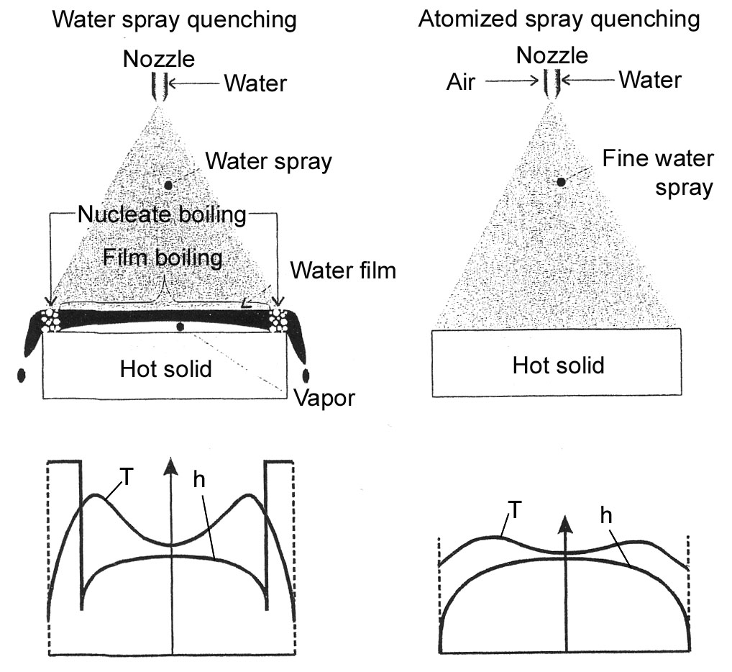
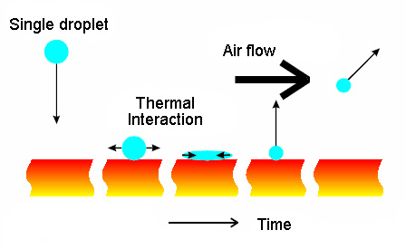
Figure 1. Principle of atomized spray cooling.

Figure 2. Water and atomized spray quenching in comparison.

Figure 2 schematically illustrates the quenching of a hot slab from a temperature higher than Leidenfrost temperature. In water spray quenching a vapour layer forms. The heat is mainly transferred by conduction through the vapour. At the edges, the vapour layer collapses immediately. Thus nucleate boiling occurs at these locations and the heat transfer coefficient h strongly increases. As a result the temperature strongly decreases. With atomized spray quenching, the profile of the heat transfer coefficient and thus the temperature profile is more even.

Experimental set-up

The measurement set-up sketched in figure 3 was used to investigate atomized spray quenching. The main component of the measurement set-up is a thin, electrically heated metal sheet. This metal sheet is cooled from one side by the water spray. The time dependent run of the local surface temperature is registered on the opposite side by an infrared camera. To correlate the heat transfer with the water spray characteristics, the distribution of the drop velocity and the drop diameter of the spray were measured with a combination of 2D-Phase-Doppler-Anemometer and patternator. Internal mixing air blast atomizers were used for the water spray generation. The maximum of the velocity and mean volumetric diameter d₃₀ measured within the investigations are about v=30 m/s and d₃₀=20 μm, respectively in the centre of the spray. The right hand side of Fig. 3 depicts a metal sheet that is shaped like an edge. It was used to investigate the influence of the surface geometry on the Leidenfrost temperature.

a)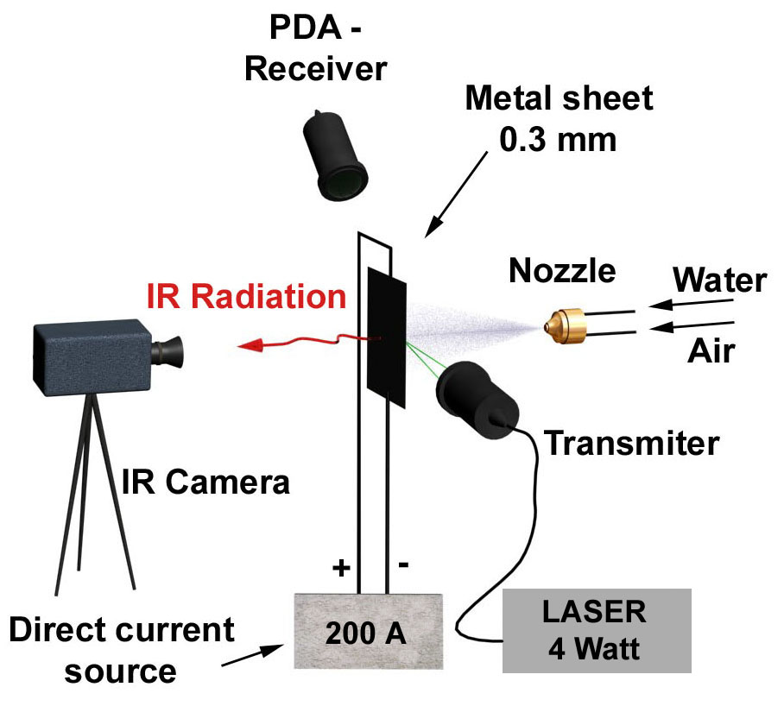 b)
X
Z
Metal
Sheet
Infrared
Camera
Nozzle

Figure 3. Experimental set-up: a) quenching of a flat metal sheet, b) quenching of an edge.

Research

The aim of the measurements of the atomized spray quenching was to find out the influence of the main parameters on heat transfer such as:
- diameter of the droplets,
- velocity of the droplets,
- impingement density,
- quality of water,
- roughness of surface.
The heat transfer coefficient depending on the impingement density is presented in figure 4 for water spray quenching and for atomized spray quenching. The impingement density exerts the highest influence on the heat transfer coefficient. For atomized spray quenching the heat transfer coefficients also increase with the air pressure. This occurs because of the changing droplet characteristics, mainly the change in the velocity and diameter. Atomized Spray Cooling leads to much higher heat transfer coefficients than water spray cooling. The advantage of this method is demonstrated in figure 5 for the quenching of an edge. The spray centre is directed to locations at different distances ranging from x = 0 mm to 25 mm from the spray centre.

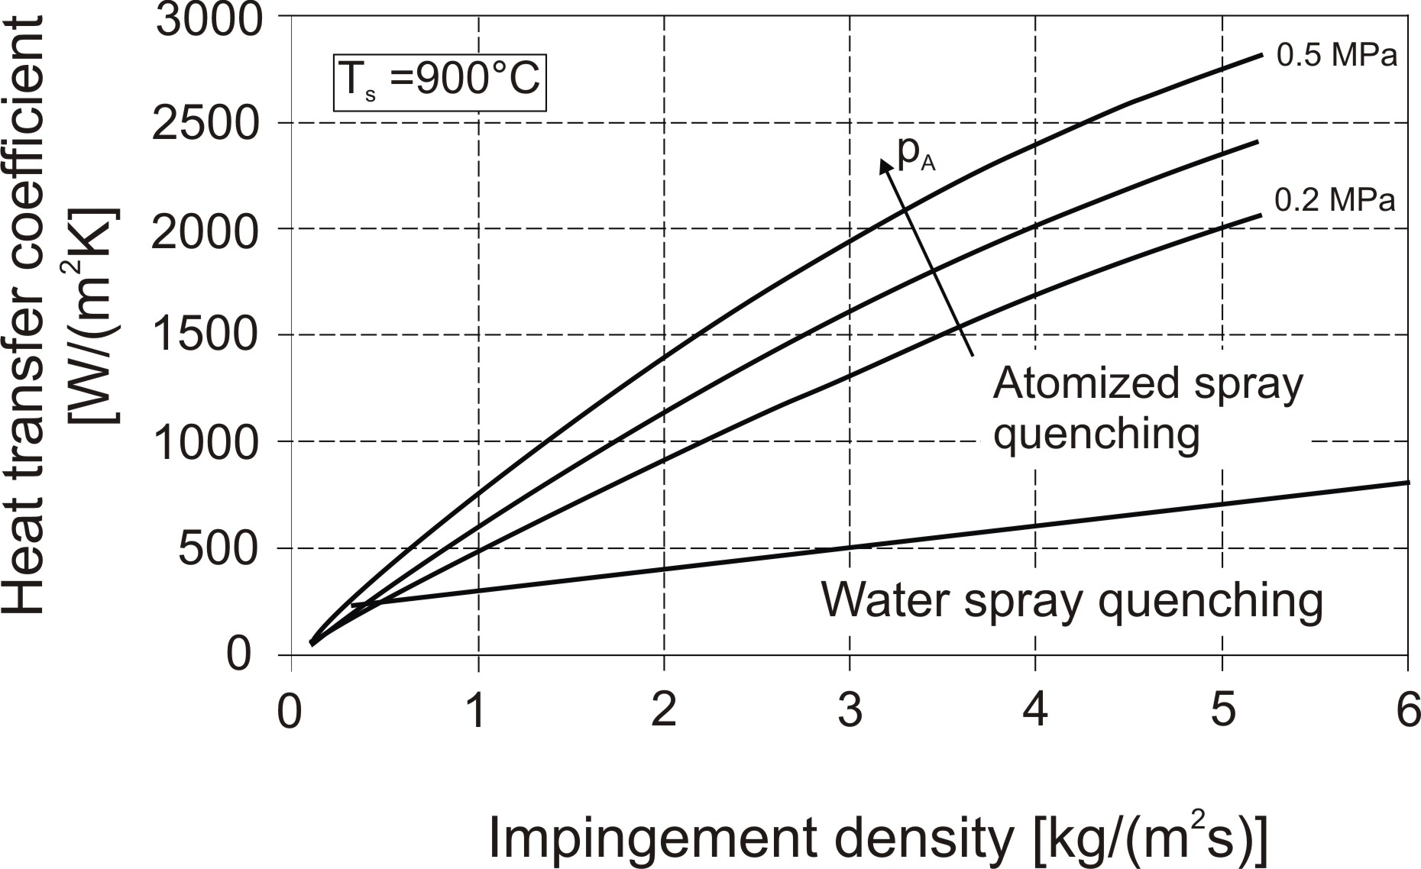

Figure 4. Heat transfer coefficient versus impingement density.

Figure 5 depicts the sequences of the temperature on the top surface in the spray centre and on the bottom surface directly below the edge. The sequences of the temperature for the spray centre remains almost the same and the temperatures on the bottom surface directly below the edge are nearly independent from the cooling of top surface. No collapse of the film and no nucleate boiling occur at the edge.
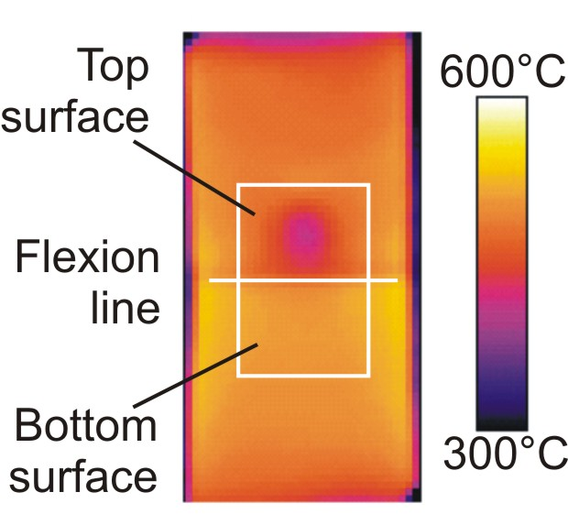
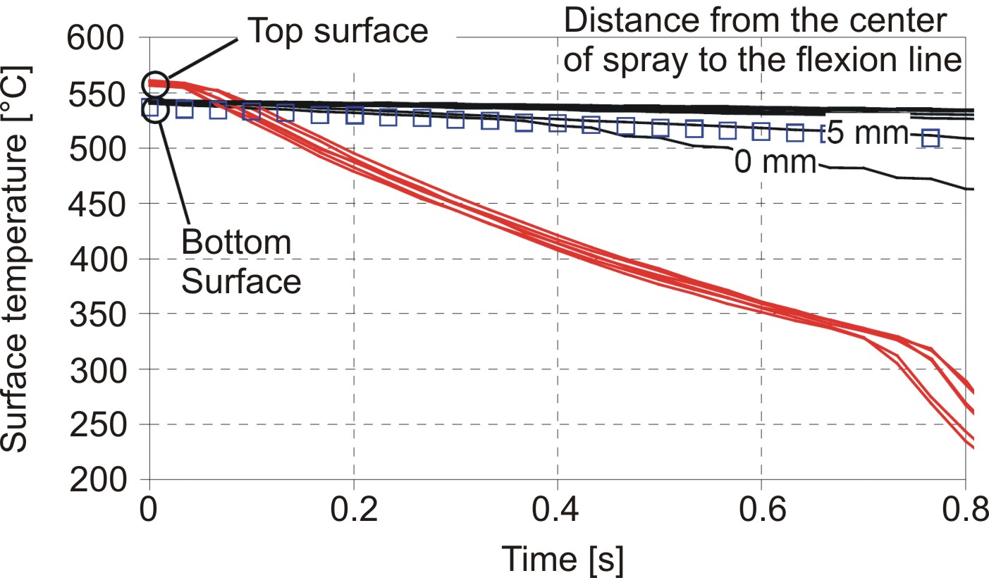

X = 0 mm
5 mm
10 mm
25 mm

- b)

Figure 5. Quenching of an edge: a) run of temperature, b) picture from infrared camera.

REFERENCES

1. Filipovic, J., Incropera, F. P., Viskanta, R., Quenching Phenomena Associated With a Water Jet: II. Comparison of Experimental an Theoretical Results for The Film Boiling Region, Experimental Heat Transfer, Vol. 8, pp 119-130, 1995.
2. Reiners, U., Warmeubertragung durch Spritzwasserkuhlung heißer Oberflächen im Bereich der stabilen Filmverdampfung, PhD. Thesis, TU Clausthal, 1987.
3. Specht, E., Jeschar, R., Heat Transfer in Continuous Casting During Spray Water Cooling, Proceedings of Oji International Seminar, Tomakomai, October 28-31, 1990, pp 535-547.
4. Jeschar, R., Reiners, U., Scholz, R., Heat Transfer During Water and Water – Air Spray Cooling in the Secondary Cooling Zone of Continuous Casting Plants, Proceedings of the 69th Steelmaking Conference, Washington D. C., April 6-9, 1986, Vol. 69, Book 1, pp 511-521.

