MODELLING AND EXPERIMENTAL INVESTIGATION OF THE HYDRAULIC JUMP IN LIQUID FILM FORMED BY IMPINGING JET

Jarosław Mikielewicz* and Stanisław Gumkowski**
*Institute of Fluid-Flow Machinery Polish Academy of Sciences, Gdańsk, Poland
**Gdansk University of Technology, Gdańsk, Poland

ABSTRACT
Theoretical analysis of the phenomenon of impingement of a circular liquid jet on a plate has been carried out. In the considered case spreading of the liquid on a plate is caused by the inertia and gravity forces. For supercritical film flow in some conditions a hydraulic jump is formed. The circular-symmetrical hydraulic jump exhibits behaviour quite different then that commonly observed, caused by the planar jet. A new theoretical model of the phenomena of hydraulic jump has been formulated. Theoretical results have been compared with own and other available experimental data.

KEY WORDS: Liquid jet, spreading of the liquid, hydraulic jump

1. INTRODUCTION
Liquid flow down the surface of the wall occurs in spray cooled heat exchangers or condensers as well as in a variety of chemical engineering installations. The process of liquid flow in spray cooled heat exchangers is different from that in condensers. Both processes have been investigated theoretically and experimentally. The flow of gravity driven liquid films formed due to vapour condensation was investigated in [1]. In the case of gravity driven flow, the trajectory of the liquid film is determined by the gradient of wall steepness. The inertia forces are neglected there. However, in the case of impingement of a liquid jet on the surface, the inertia forces must be taken into account as they have a great effect on the flow of a forming liquid film. The process of flow of a liquid film on a horizontal surface after the impingement was investigated theoretically and experimentally in [2,3]. In some conditions a hydraulic jump is formed in the flowing liquid film. The phenomenon of hydraulic jump is very important for the process of heat transfer in the spreading film. After the jump in sub-critical region the slow moving liquid exhibits degraded heat transfer characteristics. Prediction and control of the jump location is important in thermal design. This paper presents a new simple model of hydraulic jump allowing us to predict the film thickness before and after the jump as well as its radial location.

- ANALYSIS
Let us consider a liquid jet impinging on a horizontal plate shown in Fig.1. On the plate, the liquid is spreading due to inertia and gravity forces.
d
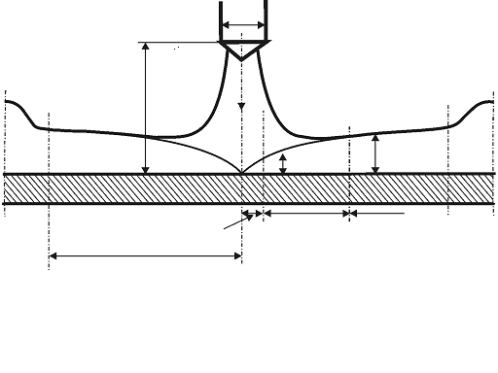

H
u_{d}
Stagnation region
r_{h}
Developing region
Fully developed region
δ(r)
h(r)
Fig. 1. Impingement of a liquid jet on a flat surface.
A hydraulic jump occurs when the flow suddenly changes from supercritical (Fr>1) to subcritical (Fr<1), which is accompanied by a sudden increase in liquid film thickness. Critical conditions of the flow correspond to Fr=1, when the liquid mass velocity and the velocity of disturbance propagation over the shallow water surface are equal. The hydraulic jump is analogous to shock wave in gas flow when the flow changes from supersonic (Ma>1) to subsonic (Ma<1) flow. We will consider a case when the inlet Froud number is higher than unity. Then it is possible that a circular hydraulic jump occurs at some distance r_{h} from the centre of impingement. Direct adaptation of the momentum balance theory to impinging jet jumps was first proposed by Watson [4]. The subsequent investigators modified his theory [4]. However some investigators reported weak agreement of their experimental data with the standard model of hydraulic jump. Previous studies have generally concluded the failure of the standard jump momentum balance. The purpose of the present paper is to improve the standard model by including energy losses due to sudden expansion of the flow after the jump. The standard approach to the solution of the described problem is to consider a momentum balance for inviscid flow. We use the Bernoulli equation for average streamline instead of the momentum equation. (Fig.2)
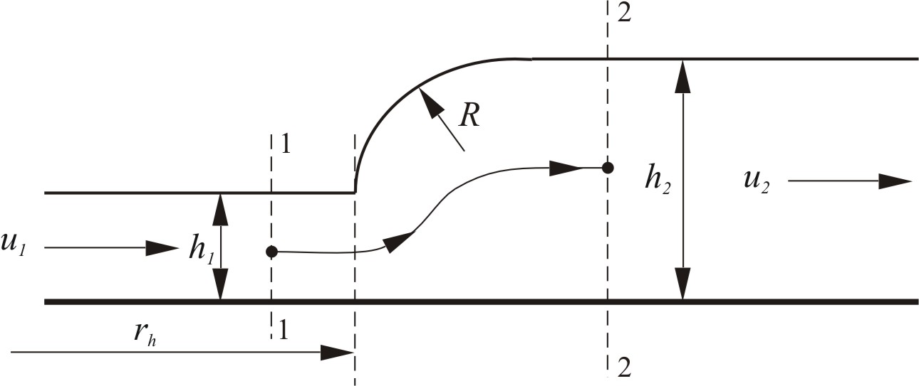
Fig. 2. Sketch of the hydraulic jump

In order to extend the standard approach, let us include in the extended Bernoulli equation for viscid flow the losses of energy caused by sudden expansion:
$\frac{p_{1}}{ρg}+H_{1}+\frac{u_{1}^{2}}{2g}=\frac{p_{2}}{ρg}+H_{2}+\frac{u_{2}^{2}}{2g}+h_{\text{loss}}$ (1)
The symbols are shown in Fig. 1.
For the discussed case $p_{1}$= p₂ and H₁=h₁/2 , H₂=h₂/2
This yields from (1):
$\frac{h_{1}}{2}+\frac{u_{1}^{2}}{2g}=\frac{h_{2}}{2}+\frac{u_{2}^{2}}{2g}+h_{\text{loss}}$ (2)
The mass balance equation for the film is:
$Q=\frac{{πd}^{2}}{4}u_{d}=2{πr}_{1}u_{1}h_{1}=2{πr}_{2}h_{2}$ (3)
These two equations (2) and (3) describe the phenomenon of hydraulic jump
The evaluation of mechanical energy losses during hydraulic jump can be found in any text book, dealing with local losses in a duct [5], as:
$h_{\text{loss}}=\frac{(u_{1}−u_{2})^{2}}{2g}k$ (4)
Introducing (4) and (3) into (2) after some algebraic transformation we obtain
: $\frac{h_{2}}{h_{1}}=\frac{1}{2}\frac{u_{1}^{2}}{{\text{gh}}_{1}}[1−k+\sqrt{(1−k)^{2}+4\frac{(1+k){\text{gh}}_{1}}{u_{1}^{2}}}=\frac{1}{2}{\text{Fr}}_{1}^{2}[1−k+\sqrt{(1−k)^{2}+4\frac{(1+k)}{{\text{Fr}}_{1}^{2}}}$ (5)
For k=1
$\frac{h_{2}}{h_{1}}=\sqrt{2}\frac{u_{1}}{\sqrt{{\text{gh}}_{1}}}=\sqrt{2}{\text{Fr}}_{1}$ (6)
instead of the standard formula which neglects energy losses [4,5]:
$\frac{h_{2}}{h_{1}}=\frac{1}{2}(−1+\sqrt{1+8{\text{Fr}}_{1}^{2}})$ (7)
The obtained relationships (5),(6) and relation (7) represent the dependence between the ratio of the thickness before and after the hydraulic jump as a function of Froud number.
Balancing the hydrostatic pressure force behind the jump and the surface tension force along the surface of the jumps we obtain:
$(h_{2}−h_{1})ρg=\frac{σ}{R}$ (8)
where R is the radius of curvature of the surface roller. This radius of curvature at the jump is about one half of the jump height, hence,
$(h_{2}−h_{1})=\sqrt{\frac{2σ}{ρg}}$ (9)
For laminar flow, the upstream film thickness which depends on the radius co-ordinate r, can be calculated as in the earlier paper of the author [6]. Assuming $u_{d}=u_{1}$we have good approximation for the film thickness in the developed supercritical region as [6]:
$h_{1}=\frac{d}{4}=\text{const}$ (10)
Relations (8), (9) and (10) allow us to determine the hydraulic jump location.
Taking into account eq. (10), one can obtain, after several fundamental transformations, the following relationship:
$\frac{r_{h}}{d}=\sqrt{2}\frac{{\text{Fr}}_{d}}{\frac{4\sqrt{2}}{\text{We}}+1}\sqrt{(1+4\frac{\sqrt{2}}{\text{We}})(1−k)+1+k}$ (11)
For k=1gives:
$\frac{r_{h}}{d}=\sqrt{2}\frac{{\text{Fr}}_{d}}{\frac{4\sqrt{2}}{\text{We}}+1}$ (12)
where:
${\text{Fr}}_{d}=\frac{u_{d}}{\sqrt{\text{gd}}}, \text{We}=d\sqrt{\frac{ρg}{σ}}$
The analysis shows that the radius of the hydraulic jump depends on the following dimensionalless numbers:
$\frac{r_{h}}{d}=\frac{r_{h}}{d}({\text{Fr}}_{d},\text{We})$

3. EXPERIMENTAL APPARATUS
Experimental apparatus, shown schematically in Fig.3, consists of a closed water loop created by: water tank, water pump, water flow-meter, gauze filter, control valve, nozzle and flexible pipes. The plates, on which the jet impinges, were made of brass, of aluminium, of glass and organic glass and were exchangeable. During experiments the impinging jet has been directed to the centre of the plate, but the assembly was equipped with a special device, which enabled impingement of the jet at an arbitrary point of the plate, at an arbitrary angle and optional nozzle-to-plate distance. The diameter of the hydraulic jump has been measured by means of a projected shadow of a measuring net on the plate, where the hydraulic jump was formed. The method enables a non-invasive measurement of the parameter of the hydraulic jump. The border between the area of a very thin film before and a much thicker film after the hydraulic jump, was very sharp and oscillating. The oscillations of the border were equal to about one millimetre whereas the corresponding oscillation of the diameter of the hydraulic jump could be estimated at the level of about 2-3mm. Oscillations of the border between thin and thick liquid layers were caused by intensive wave motion of surfaces of the thin as well as thick water layer.
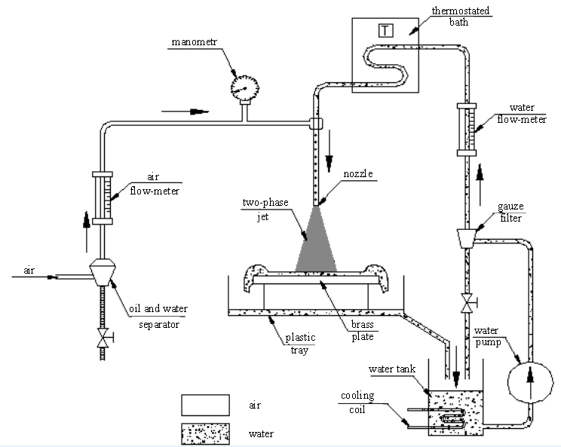
Fig.3. Schematic diagram of experimental apparatus

The measuring apparatus ensured the stability of mass flow rates as well as its precise regulation. The investigations were carried out in the following range of parameters:- mass flow rate of water impinging jet, =2÷7[kg/h], nozzle-to-plate distance, H=0,1 and 0,06[m], Results of experimental investigations have been shown graphically in Fig.4 and Fig.5

4. COMPARISON OF THEORETICAL AND EXPERIMENTAL RESULTS
The supercritical flow of spreading liquid film was analysed. Such a film can reach jump conditions. Sample calculations were carried out for the ratio of h₂/h₁ according to formulas (5) and (6). The results of the calculations with experimental data are presented in Fig. 4 and Fig.5.
The comparison of the simple model with experimental data [7,8] is presented in Fig.4
Comparison of the simple theory with experimental data shows a fairly good agreement (Fig.4). The hydraulic jump can occur in response to a variety of disturbances before the flow reaches the critical conditions. Then the flow turns into a sub-critical one.

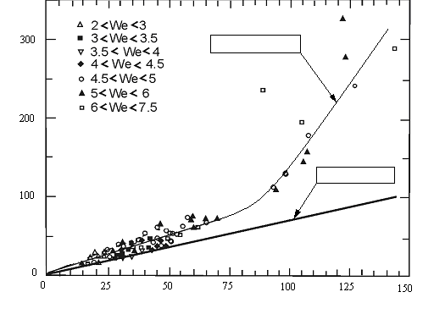
$$\frac{h_{2}}{h_{1}}$$
eq. (6) and (7)
${\text{Fr}}_{d}$
eq. (5) for k=1,01
Fig. 4. Plot of data $\frac{h_{2}}{h_{1}}$as a function of Froud number Fr_{d} [7]

$${\text{Fr}}_{d}$$
$$\text{eq}\text{.}(\text{11})\text{ for k=1,01}$$
Fig.5 Plot of ratio $\frac{r_{h}}{d}$as a function of Froud number ${\text{Fr}}_{d}$

5. FINAL CONCLUSIONS
A simple model of hydraulic jump taking into account losses of mechanical energy has been put forward in the paper. The model lends itself, after certain modifications, to investigations of heat transfer at liquid jet impingement on flat, circular surfaces. As mentioned in the Introduction the model can be useful in calculations of performance of spray cooled heat exchangers and other installations.
It has been shown that the simple model is capable of describing the phenomenon of hydraulic jump. The thickness of the film before and after jump is local and depends on the Froud number only. The obtained coincidence of the model and with experimental data is fairly good.
The presented results should be treated as preliminary. Further investigations, specially concerning the stability of a liquid layer and heat transfer between the liquid layer and the plate are being conducted.

NOMENCLATURE
d-nozzle diameter r-cylindrical coordinate,
g-acceleration of gravity, p-pressure
h-film thickness, ρ-liquid density,
Q-volumetric flow rate, σ-surface tension
ν-kinematics viscosity, u-nozzle velocity,
Fr =$\frac{u_{d}}{\sqrt{\text{gd}}}$- Froud number, $\text{We}=d\sqrt{\frac{\text{ρg}}{σ}}$-Weber number.
Re = $\frac{u_{d}d}{ν}$-Reynolds number,
Subscripts
1-inlet, 2-outlet, r-radial.

REFERENCES
[1] Karimi A. H.: Laminar condensation on helical reflux condensers and related configurations, Lexington, Kentucky, 1976.
[2] Thomas S., Hankey W., Faghri A.: One-dimensional analysis of the hydrodynamic and thermal characteristics of thin film flows including the hydraulic jump and rotation , Transaction of the ASME, Vol. 112, August 1990.
[3] Rahman M . M . , Hankey W. I,. , Faghri A . : Analysis of the fluid flow and heat transfer in a thin liquid film in the presence and absence of gravity, Int. J. Heat Mass 'Transfer, Vol. 34, 199l.
[4] Watson E. J. The radial spread of liquid over a horizontal plane. J. Fluid Mech. (1964), 20. 481-499
[5] Douglas J.F., Gasiorek J. M.,Swaffield J. A., Fluid Mechanics, Longman, (1998)
[6] Mikielewicz J and Mikielewicz D. Wymiana ciepła w rozwiniętym filmie laminarnym powstałym z uderzenia strugi o powierzchnię. XII Sympozjum Wymiany Ciepła i Masy, AGH-Kraków 2004.(in polish)
[7] Liu X., Lienhard V J. H. The hydraulic jump in circular jet impingement and in other thin liquid films. Experiments in Fluids 15, 108-116 (1993)
[8] Craik D. D. And others. The circular hydraulic jump. J. Fluid Mech. (1981) vol. 12 pp. 347-362 .
[9] Ishigai S. And others. Heat transfer of the Impinging Round Water Jet in the Interference Zone of Film Flow along the Wall. Bulletin of the JSME, vol. 20 No 139, (1977)

The paper has been funded by the State Committee for Scientific Research,
Grant No. PB 10B 06624

