MODELLING AND EXPERIMENTAL INVESTIGATION OF THE HYDRAULIC JUMP IN LIQUID FILM FORMED BY IMPINGING JET

Jarosław Mikielewicz* and Stanisław Gumkowski**
*Institute of Fluid-Flow Machinery Polish Academy of Sciences, Gdańsk, Poland
**Gdansk University of Technology, Faculty of Mechanical Engineering, Gdańsk, Poland

ABSTRACT

Theoretical analysis of the phenomenon of impingement of a circular liquid jet on a plate has been carried out. In the considered case, spreading of the liquid on a plate is caused by the inertia and gravity forces. For supercritical film flow in some conditions a hydraulic jump is formed. The circular hydraulic jump exhibits behaviour quite different from that commonly observed in planar jets. A new theoretical model of the phenomena of hydraulic jump has been formulated. Theoretical results have been compared with own and other available experimental data.
The occurrence of the phenomenon of hydraulic jump is very important for the process of heat transfer due to the spreading film. After the jump, in the subcritical region, of the liquid flow the rate of heat transfer tends to decrease. Prediction and control of jump location is important in thermal design.
A hydraulic jump occurs when the flow suddenly changes from supercritical (Fr>1) to subcritical (Fr<1) flow, which is accompanied by a sudden increase in liquid height. Critical conditions of the flow correspond to Fr=1, when the liquid velocity and the velocity of disturbance propagation over the shallow water surface are equal. The hydraulic jump is analogous to a shock wave in gas flow when the flow changes from supersonic (Ma>1) to subsonic (Ma<1) flow. We will the consider case when the inlet Froud number is greater than unity, then it is possible that a circular hydraulic jump is occurs at some distance from the centre of impingement. Direct adaptation of the momentum balance theory to impinging jets was first put forward by Watson [4]. The subsequent investigators modified his theory. However, some investigators have reported rough agreement of their experimental data with the standard model of hydraulic jump. Previous studies have generally concluded the failure of the standard jump momentum balance. The purpose of the present paper is to improve the standard model by considering energy losses due to sudden expansion of flow after the jump. The standard approach to solution of the described problem is to consider a momentum balance for inviscid flow. We use the Bernoulli equation for the average streamline instead of the momentum equation.
The losses of mechanical energy occurring during hydraulic jump can be taken from any text book dealing with local losses in a duct, as:
$h_{\text{loss}}=\frac{(u_{1}−u_{2})^{2}}{2g}k$ (1)

After some algebraic transformations, from the Bernoulli equation and mass balance equation one obtains equation:
$\frac{h_{2}}{h_{1}}=\frac{1}{2}\frac{u_{1}^{2}}{{\text{gh}}_{1}}[1−k+\sqrt{(1−k)^{2}+4\frac{(1+k){\text{gh}}_{1}}{u_{1}^{2}}}=\frac{1}{2}{\text{Fr}}_{1}^{2}[1−k+\sqrt{(1−k)^{2}+4\frac{(1+k)}{{\text{Fr}}_{1}^{2}}}$ (2)

For k=1
$\frac{h_{2}}{h_{1}}=\sqrt{2}\frac{u_{1}}{\sqrt{{\text{gh}}_{1}}}=\sqrt{2}{\text{Fr}}_{1}$ (3)
instead of a standard formula which neglects energy losses [3],[4]:
$\frac{h_{2}}{h_{1}}=\frac{1}{2}(−1+\sqrt{1+8{\text{Fr}}_{1}^{2}})$ (4)
The obtained equations (2),(3) together with Eq. (4) represent a relationship between the depths of the liquid layers downstream h₂ and upstream h₁ of the jump.
After some fundamental transformations, the following relationship between the ratio r_{h}/d and Froud and Mach number was found:
$\frac{r_{h}}{d}=\frac{{\text{Fr}}_{d}}{\frac{4\sqrt{2}}{\text{We}}+1}\begin{aligned}\sqrt{2+4\frac{\sqrt{2}}{\text{We}}(1−k)}\end{aligned}$ (5)
For k=1, it gives: $\frac{r_{h}}{d}=\sqrt{2}\frac{{\text{Fr}}_{d}}{\frac{4\sqrt{2}}{\text{We}}+1}$ (6)
where:${\text{Fr}}_{d}=\frac{u_{d}}{\sqrt{\text{gd}}}, \text{We}=d\sqrt{\frac{ρg}{σ}}$
The diameter of the hydraulic jump was measured experimentally by means of a projected shadow of a measuring net on the plate, where hydraulic jump was formed. The method enables a non-invasive measurement of the diameter of the hydraulic jump.
The supercritical flow of the spreading liquid film was analysed. Such a film can reach jump conditions. Simple calculations were carried out for the ratios of h₂/h₁ and r_{h}/d based on the formulas (2) and (5).In the calculations k was taken as k=1. The results of the calculations and experimental data [5],[6] are presented in Fig.1 and Fig.2.
Comparison of the theory with experimental data shows fairly good agreement. The hydraulic jump can occur in response to a variety of disturbances before the flow reaches the critical conditions. Then the flow turns into a sub critical one.
The presented model lends itself, after certain modifications, can be applied for application to the case of jet impingement on cylindrical surfaces. As mentioned in the foreword, the model can be useful in calculations of performance of spray cooled heat exchangers and other installations.
As it is shown above the simple model is capable of describing the phenomena of hydraulic jump with satisfactory accuracy for practical applications. The thickness of the film before and after jump and its location depend on the Froud number only. The obtained coincidence of the model and experimental values is fairly good. The presented results should be treated as preliminary. Further investigations especially concerning the stability of a liquid layer and heat transfer between the liquid layer and the plate, are in progress.

NOMENCLATURE
d-nozzle diameter g-acceleration of gravity,
h_{loss}-energy losses p-pressure
h-film thickness, r_{h}-radius of the hydraulic jump,
u-film velocity, u_{d}-liquid velocity in the nozzle
ν-kinematics viscosity, ρ-liquid density,
σ-surface tension
Ma-Mach number ${\text{Fr}}_{h}=\frac{u_{d}d^{2}}{8r_{h}\sqrt{{\text{gh}}_{1}^{3}}}$-Froud number,
Fr_{d} =$\frac{u_{d}}{\sqrt{\text{gd}}}$-Froud number, $\text{We}=d\sqrt{\frac{ρ g}{σ}}$-Weber number
Subscripts
1-before the hydraulic jump, 2-behind the hydraulic jump.

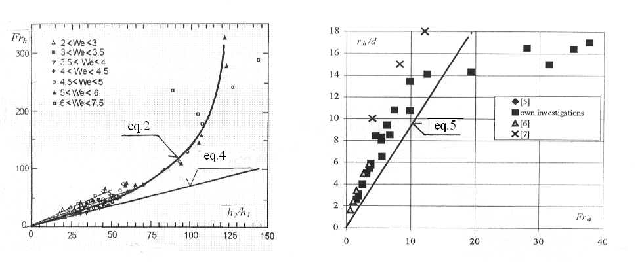
Fig.1.Plot of data as Froude number versus ratio  of downstream to upstream depth h₂/h₁ | Fig.2. Plot of data as Froude number Fr_{d} versus ratio r_{h}/d.

REFERENCES

[1]Thomas S., Hankey W., Faghri A.: One-dimensional analysis of the hydrodynamic and thermal characteristics of thin film flows including the hydraulic jump and rotation , Transaction of the ASME, Vol. 112, August 1990.
[2] Rahman M . M ., Hankey W. I,., Faghri A.: Analysis of the fluid flow and heat transfer in a thin liquid film in the presence and absence of gravity, Int. J. Heat Mass 'Transfer, Vol. 34, 199l.
[3] Watson E. J. The radial spread of liquid over a horizontal plane. J. Fluid Mech. (1964), 20. 481-499
[4] Mikielewicz J and Mikielewicz D.: Wymiana ciepła w rozwiniętym filmie laminarnym powstałym z uderzenia strugi o powierzchnię. XII Sympozjum Wymiany Ciepła i Masy, AGH-Kraków 2004.
[5] Liu X., Lienhard V J. H.: The hydraulic jump in circular jet impingement and in other thin liquid films. Experiments in Fluids 15, 108-116 (1993)
[6] Craik D. D. and others.: The circular hydraulic jump. J. Fluid Mech. (1981) vol. 12 pp. 347-362 .
[7] Ishigai S. and others.: Heat transfer of the Impinging Round Water Jet in the Interference Zone of Film Flow along the Wall. Bulletin of the JSME, vol. 20 No 139, (1977)

