Experimental and theoretical investigation of spray cooling heat transfer on macro and micro level

Mariya Nacheva*, Teodor Todorov, Dimitar Dontchev, Juergen Schmidt
Institute of Fluid Dynamics and Thermodynamics
Otto-von-Guericke-University, 39106 Magdeburg, Germany
*DFG-Graduiertenkolleg “Micro-Macro Interactions in Structured Media and Particle Systems”

Many technical processes in the metallurgy, process engineering and minimum cooling technology demand a rapid cooling of hot surfaces. Such a cooling can be obtained by different liquids and techniques. The spray cooling is often preferred because of the good adaptability to different cooling requirements.

The realization of defined cooling conditions requires the knowledge of the heat transfer coefficient (HTC) on macro level. The cooling fluid, its mass flux and the spray characteristics (velocity and size of the droplets) influence the HTC in the spray cooling. In most research works, the HTC is correlated as a function of the mass flux. However, other studies consider as well its dependence on the droplet size, droplet velocity, material properties and the temperature of the wall. Significant discrepancies can be observed while comparing results obtained by different authors. These differences can be explained by the employment of different test conditions and different nozzles. In the majority of the scientific works, the parameters that influence the HTC were not varied independently from one other. In the present work, the influence of the spray characteristics on the HTC is investigated for stable film boiling above the Leidenfrost point. In this regard, each parameter (mass flux, droplet velocity and droplet size) is varied while keeping the others constant. Previous results were already presented⁵.

Two experimental methods (quasi-stationary and transient) are used for the estimation of the HTC. The quasi-stationary method can be applied only when the fluid impingement density is uniform. If this condition is not fulfilled the vapor film collapses rapidly. The employed experimental set-up is sketched in Fig. 1. A Phase-Doppler-Anemometer (PDA) was used to determine the spray characteristics-the volume mean diameter and the mean velocity of the droplets. Distilled water was used as the cooling liquid. The mass flux was measured by patternator. An electrically heated metal sheet (60 x 43 x 0.3 mm) was used for the heat transfer experiments. The constant electrical current supply (up to 400 A) provides a nearly constant heat flux. The HTC was calculated from the temperature field of the “dry” side of the surface when the calibration of the heat losses on the same side is taken into account. The temperature field of the metal plate was determined by means of the IR-Thermography. The test section was coated, Fig. 2, using a high temperature resistant laquer, whose emissivity was determined as a function of the temperature.

An inverse heat conduction algorithm based on the Beck’s function specification procedure¹ was used to analyze the experimental data. The HTC can be calculated at the „spray” side since the boundary conditions at all other sides are known and the temperature history at the “coated” side, Fig. 2, can be obtained by means of the IR-Thermography. The computation of the 2D-temperature field, where the surface coating is taken into account, is based on the Finite–Difference–Method (FDM). The inverse method is applicable to both steady and unsteady measurements. The calculations in the case of a nearly uniform impingement density can be simplified.

Full cone (Bete CW 25, Lechler 460.406) and flat spray (Lechler 432.404, Lechler 432.366) water nozzles were used. Large variations in the impingement density, droplet diameter and mean droplet

Figure 1 Experimental set-up | Figure 2 Scheme of the test section and conditions for the mathematical model

velocity are necessary for a systematical studies. Each spray parameter has to be varied nearly independently while keeping the other two approximately fixed. Pressure (0.1-0.9 MPa), water flow rate (28-105 l/h), nozzle distance (0.04-0.5 m) and temperature of the test section (200-600 °C) were the varied experimental parameters.
Figure 3 Local distribution of HTC over the surface

Typical results are presented in Fig.3 for the nozzle Bete CW 25, which produces nearly uniform water distribution. At the rims of the area the vapor film begins to collapse. For the data reduction a small area (25 x 15 mm) of the centre of the plate was selected. The HTC was calculated for each point of the chosen area.

Figure 4 Influence of the droplet size | Figure 5 HTC vs. impingement density

The behavior of the HTC with the wall temperature, Fig. 4, shows that the influence of the droplet diameter is negligible. Two sets of data illustrating the effects of the droplet velocity, Fig. 5, were obtained by using both experimental methods. The full points in Fig. 5 correspond to the unsteady state method. The droplet velocity is varied from 3.5 to 8 m/s. It can be seen that the impingement density has the strongest effect on the HTC in comparison to other parameters. The HTC increases also clearly with increase in the droplet velocity. Similar results for dependence of the HTC on the velocity ware presented for unstable film boiling by Chen³.

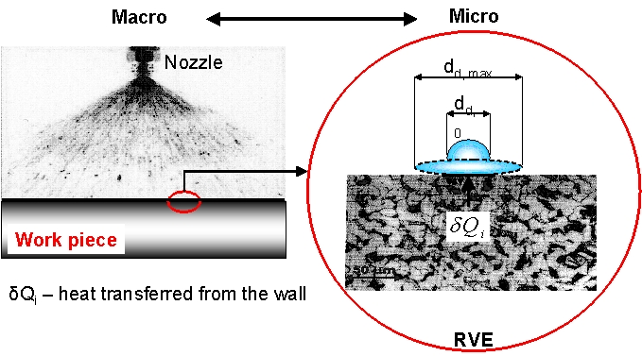
Figure 6 Micro-Macro-Interaction by spray cooling | Figure 7 Model comparison for the evaporation efficiency of a single droplet

For a better theoretical explanation of the influence of the droplet size and velocity observed our aim is to model the spray cooling on micro level. The direct interaction of single droplets with the wall is considered firstly for dilute sprays. One single drop and a characteristic part of the surface, which dependences on the spray parameters, constitute a representative volume element (RVE), Fig. 6. As the droplet reaches the surface, most of the heat is transferred in the first stage, when the liquid is in direct contact with the material and before a vapor film is formed. After the impact, the drop spreads out to its maximum diameter. Time-dependent droplet propagation is considered and a first approach is presented. From this function and the numerical solution of the transient 2D-heat conduction problem using the enthalpy method and FDM, the heat delivered by the wall can be calculated. This heat is characteristic for a certain drop type and permits the calculation of the HTC by considering of the droplet flux. Results are compared with those of Bolle/Moureau², Puschmann⁴, and Wruck⁶, Fig. 7, based on the evaporation efficiency $ε_{v}=\frac{Q_{\text{drop}}}{M_{\text{drop}}⋅{Δh}_{v}}$ of a single droplet.

Acknowledgment
The financial support of the German Research Foundation (DFG-Graduate College 828 “MicroMacro Interactions in Structured Media and Particle Systems”) is gratefully acknowledged.

References

1. | Beck, J., Blackwell B., Inverse heat conduction, Wiley-Interscience Publ., 1985.
2. | Bolle, L. and Moureau, J. C., Spray cooling of surfaces, in: Multiphase science and technology, Vol. 1, pp 1-97, McCraw-Hill, New York, 1982.
3. | Chen, R.H., Chow, L.C., Navedo, J.E., Effects on Critical Heat Flux in subcooled Water Spray Cooling, Int. J. Heat Mass Transfer, 45 (2002), 4033- 4043.
4. | Puschmann, F., Experimentelle Untersuchung der Sprühkühlung zur Qualitätsverbesserung durch definierte Einstellung des Wärmeübergangs. PhD Thesis, Otto-von-Guericke-Universität, Magdeburg, 2003.
5. | Schmidt J. and Boye H., Influence of Velocity and Size of Droplets on the Heat Transfer in Spray Cooling, Chem. Eng. Technol., Vol. 24, pp 255- 260, 2001.
6. | Wruck, N., Transientes Sieden von Tropfen beim Wandaufprall, PhD Thesis, Shaker Verlag, Aachen, 1999.

