Atomization and Combustion in LOX/H₂- and LOX/CH₄-spray flames

M. Oschwald, F. Cuoco, B. Yang, M. De Rosa
Institute of Space Propulsion, DLR Lampoldshausen, German Aerospace Center
74239 Hardthausen, Germany

Introduction
In liquid rocket propulsion H₂/O₂-combustion delivers the highest specific impulse, i.e. momentum per mass of propellant. Hydrogen and oxygen are therefore the propellants of choice in terms of thrust performance. Especially for high power booster engines however other performance characteristics have to be considered as well, as for example mass of tank structures for cryogenic propellants and evaporation losses of liquid hydrogen in the run-tanks. Furthermore the toxic potential of storable propellants like the hypergolic MMH/NTO or solid propellants is motivation to look for non-toxic propellant substitutes. For this reason in the last few years hydrocarbons have been taken into focus in Europe as fuels for rocket propulsion. Among these, CH₄ and Kerosene are particularly of interest. The main expected advantages using hydrocarbons are the high propellant density, reduced handling effort, and reduced safety precautions.
The technology of propellant injection is central for optimal rocket combustor performance due to its effect on liquid fuel atomization, mixing, combustion, and thermal and chemical load on combustor walls. Propellant injectors are key components controlling by a major part efficiency and stability of combustion. In main combustion chambers oxygen is injected in its liquid state, whereas the fuel - used for regeneratively cooling the combustor walls - is injected in the gaseous state. The standard injection element is the shear co-axial injector with the liquid injected through the central tube and the gaseous fuel through the annular slit.
For cold flow coaxial injection there are numerous experimental and theoretical investigations ([1]-[5]). Not very much data with systematic parameter variation for reactive sprays are available. Therefore there is need for proven injector design rules to minimize costs for expensive manufacturing and qualification tests during a development program. Unfortunately the predictivity of models for liquid fuel atomization, droplet evaporation, mixing and turbulent combustion are far from reliable outside the range of injection and combustion chamber conditions where these models have been adjusted and qualified. Thus despite the prominent role of the injection process, the complexity of atomization and spray combustion does not allow to predict injector performance from basic principles, injector design is based on empirical correlations.
At DLR Lampoldshausen work has been initiated to improve the knowledge and understanding of propellant injection and spray combustion for LOX/hydrocarbon fuels. The focus today is on methane. Although the trade off between methane and kerosene in respect to the overall system performance is not straight forward, methane is chosen for the basic investigations due to its relatively simple kinetics and well defined composition as compared to kerosene.
There is a huge data base on LOX/H₂-combustion in Europe. It is worthwhile then to compare LOX/CH₄ to LOX/H₂. One objective of the investigations is to prove whether concepts from LOX/H₂-injector design can be transferred to LOX/HC injection. That there may be limitations can be supposed when comparing the thermo-physical properties. Assuming a chamber pressure of 6MPa and H₂-injection temperatures of 120K and 280 K for hydrogen and methane respectively some properties are listed in Table 1. It can be seen, that at typical injection conditions H₂ is far in the supercritical region and shows in a good approximation ideal gas behaviour. Methane however is near critical and some properties will show significant deviations from ideal gas behaviour. The density of methane is about 4 times above, the thermal conductivity about 0.3 times that of H₂ at typical injection conditions. The laminar flame speed for CH₄/O₂ is about a factor of 2.5 below the value for H₂/O₂, which may be of importance for flame propagation and stabilization during the ignition transient and flame anchoring phenomenology at stationary conditions. Furthermore the remarkable difference in ignitability in the fuel rich limit has to be pointed out in this context. Especially the difference in these properties characterizing the combustion behaviour motivates to assume differences in the ignition characteristics of methane and H₂.

 | O₂ | CH₄ | H₂
critical temperature | 154.6 | 190.5 | 32.9 | [K]
critical pressure | 5.04 | 4.60 | 12.8 | [MPa]
density @ injector exit conditions |  | 47.3 | 11.7 | [kg/m³]
viscosity @ injector exit conditions |  | 12.0 | 4.94 | [µPa∙s]
specific heat @ injector exit conditions |  | 43,89 | 32.3 | [J/mol⋅K]
thermal conductivity @ injector exit conditions |  | 0.038 | 0.113 | [W/m⋅K]
laminar flame velocity @ ambient |  | 3.93 | 10.7 | [m/s]
ignitability limits |  | 5.1-61 | 4-94 | [Vol %]

Table 1: Thermo-physical properties of propellants (injector exit conditions: P=6MPa, T=120K for H₂, T=280K for CH₄)

Experimental Approach
LOX-spray combustion is investigated at DLR Lampoldshausen using several model combustors, which can be operated at pressures from ambient up to 10 MPa.
Validation of model predictions require quantitative experimental data obtained at well known boundary conditions. Quantitative measurements at representative combustion chamber conditions are challenging, modelling of the full complexity of rocket combustor phenomena is ambitious. Thus experiments of reduced complexity are performed to obtain data that can be used to validate models and simulation codes. For this reason the main results concerning LOX/CH₄-combustion have been obtained at the micro-combustor up to now (see Figure 1). The combustor is equipped with a single shear-coaxial injector and has full optical access for diagnostic purposes. The pressure is limited to 1.5 MPa. A blown down vacuum system can be connected to the test facility to allow ignition tests under high-altitude conditions.
A variety of injection conditions can be adjusted by varying the injector dimensions and the combustion chamber pressure. Results of LOX/H₂- and LOX/CH₄-sprays are compared based on similar non-dimensional numbers characterizing the injector exit conditions, e.g. Weber-number We, momentum flux ratio J, and velocity ratio R_{V}.
$\text{We}=\frac{ρ_{\text{fuel}}(v_{\text{fuel}}−v_{\text{ox}})^{2}d_{\text{ox}}}{σ}$ $J=\frac{{\left({ρv}^{2}\right)}_{\text{fuel}}}{{\left({ρv}^{2}\right)}_{\text{ox}}}$ $R_{V}=\frac{v_{\text{fuel}}}{v_{\text{ox}}}$
The spray is visualized with Schlieren photography, the flame by imaging the radiation of the OH-radical. Both visualization methods can be applied at frame rates up to several 10KHz to resolve transient phenomena.
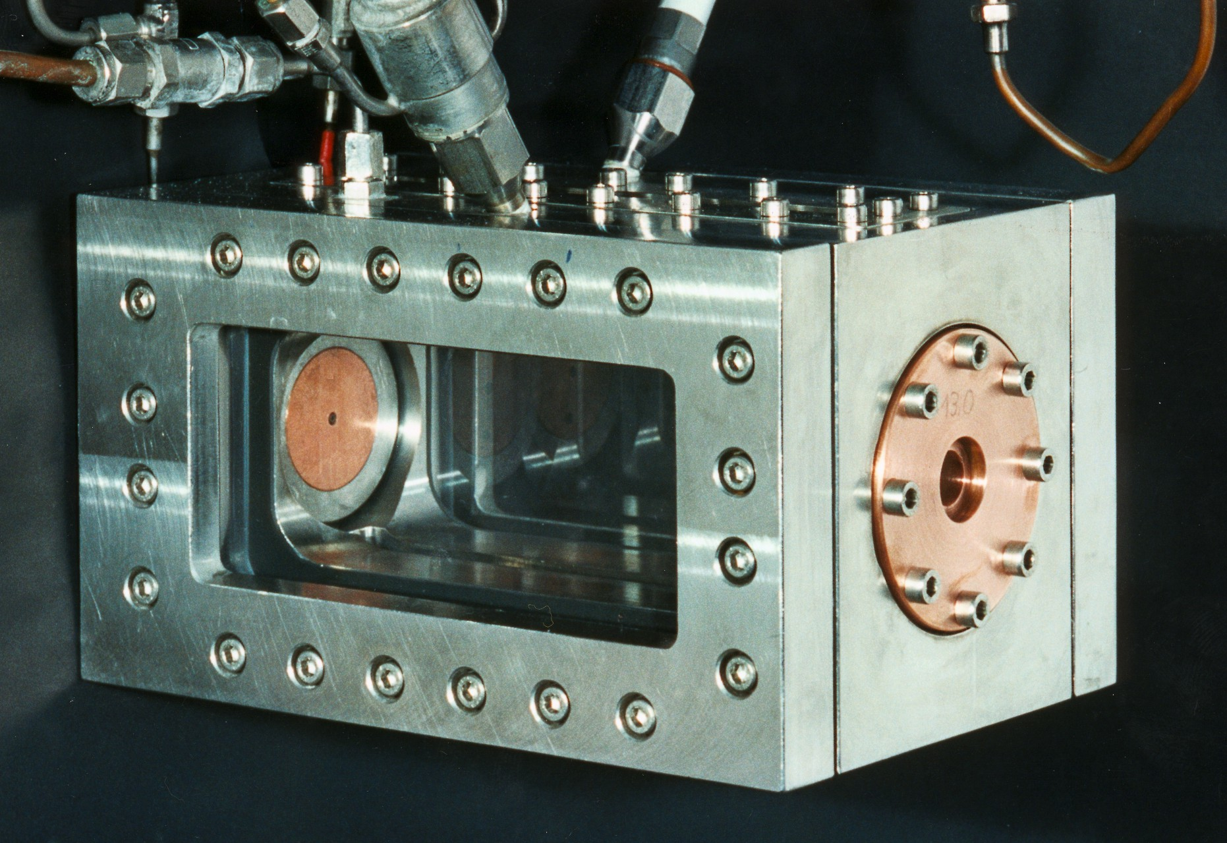
Figure 1: Micro-combustor

Results
Figure 2 show visualizations of the flame and of the LOX-spray for CH₄/O₂- and H₂/O₂-flames obtained at ambient combustion chamber pressure. The momentum flux ratio and Weber-number have been kept constant at values near J=0.6 and We=7500. The results clearly show that although injection conditions were similar for methane and H₂ the spray patterns as well as the flames show significant differences. Atomization of the LOX-jet is clearly more efficient in the case of methane as compared to H₂. The flame angle for methane is larger than for H₂. Scaling of the injector dimensions from hydrogen to methane by using We-number or momentum flux ratio is therefore not guaranteeing similar performance.
For LOX/H₂-combustion the flame was always anchored at the injector, whereas for CH₄/LOX in most cases lifted flames have been observed as can be seen in Figure 2b. The corresponding Schlieren image shows that the spray pattern is clearly changing downstream the position where the flame anchors. This demonstrates the influence of the combustion process on atomization. The spray formation is not only controlled by flow properties at the injector exit, i.e. cold flow properties. Other properties controlling e.g. flame stabilization like kinetics, heat transfer etc. have to be considered.

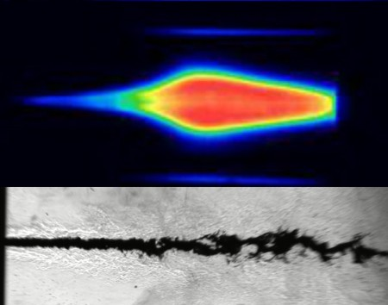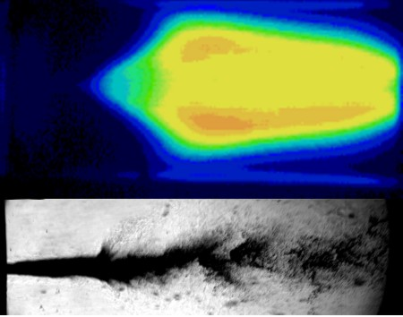
(a) We=7007, J=0.65 (b) We=7936, J=0.56

Figure 2: (a) LOX/H₂-spray flame, (b) LOX/CH₄-spray flame at similar Weber-number We and momentum flux ratios J
The visual break-up length of the LOX-spray has been determined from the Schlieren images. Note that the visible break-up length may overestimate the intact core length, which may be hidden by the dense spray. There are theoretical arguments that predict for coaxial cold-flow injection an intact core length of $L/{D_{l}}≈6/\sqrt{J}$, that is a decrease of L with J. There is no quantitative agreement for the visible break-up length with this prediction found in these hot fire tests and the investigated range of J-values. However for CH₄ as well as for H₂ the visible break-up length is decreasing with increasing J. It has to be noted, that the rate of decrease with J is different for both fuels, thus it is not only the J-value, that controls the visible break-up length. This correlation however is much weaker for H₂ than for CH₄.
(a) (b)
Figure 3: Break-up length

Ignition characteristics has been investigated by igniting the LOX/fuel-spray by laser-induced gas-break down. The evolution of the flame kernel in the early time after ignition is detected with a high-speed intensified CCD-camera. From these images the velocity with which the flame front moves through the combustor volume has been extracted. The flame front velocity show a week a correlation with the We-number for both propellant systems (see Figure 4), and no correlation with J. At similar We-number the flame front velocity of the H2/O2-system is about 3 times that of the CH4/O2-system, the ratio is very near to that of the laminar burning velocities.
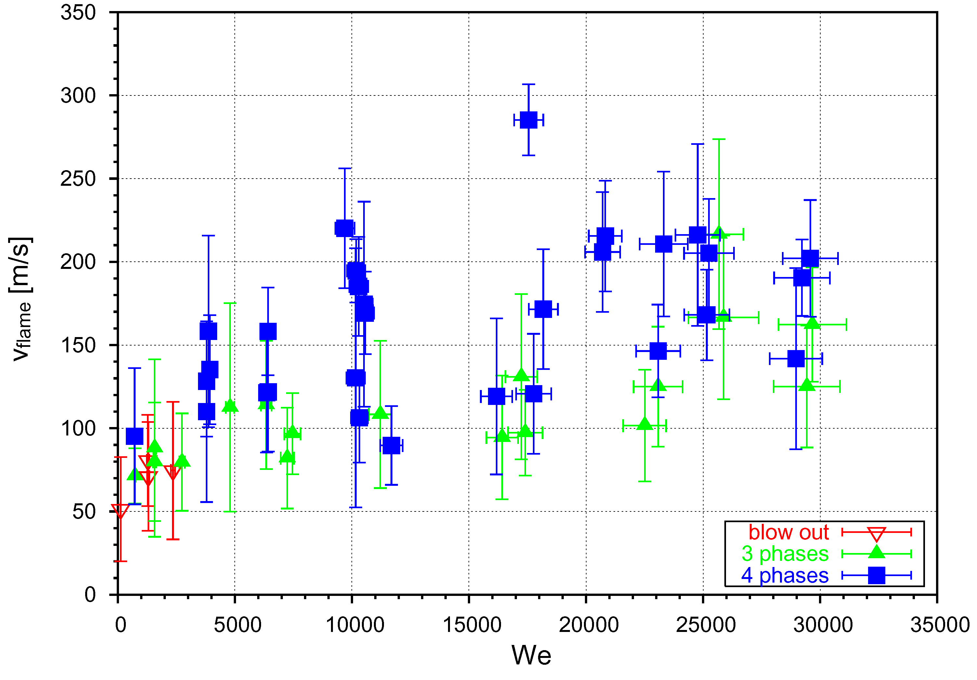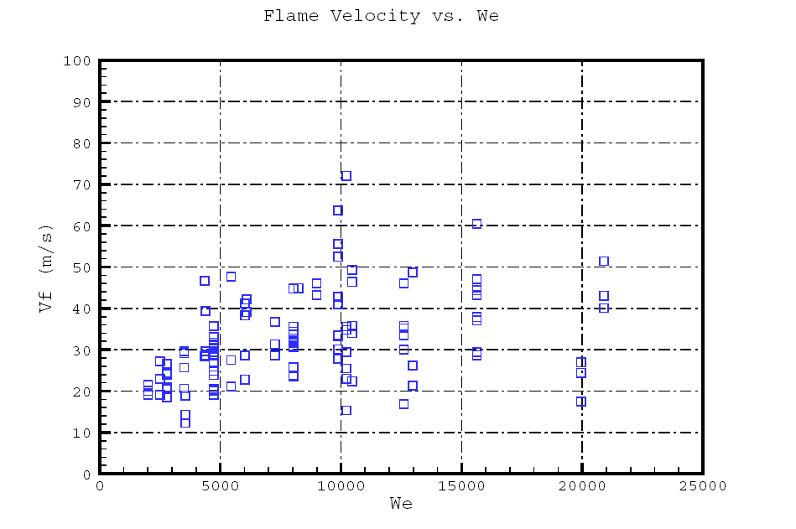
(a) (b)
Figure 4: flame velocity as function of We-number for (a) LOX/H₂- and (b) LOX/CH₄-ingition

Conclusion and Outlook
The results obtained up to now showed, that the general dependence of the spray and flame characteristics is similar for both O₂/H₂ and O₂/CH₄. However it obvious that non-dimensional numbers characterising the fluid-dynamical interaction of the two fluids at the injector exit are not sufficient to scale injector performance from one fuel to the other. Especially the interaction of combustion with atomization has to be taken into account as well.
Co-axial injection of LOX/H₂ at representative pressure conditions have been analyzed by various diagnostic tools at the P8 test facility during the last years. Tests are currently in preparation using LOX/CH₄ as propellants. At representative pressures O₂ as well CH₄ are in the trans- and supercritical thermodynamic state. Real gas behaviour has to be taken into account and the specific characteristics of transport phenomena at these thermodynamic conditions have to be considered. As an example the specific heat of methane and the thermal diffusivity of oxygen is shown in Figure 5. In the near critical region the specific heat exhibits a pronounced maximum, another fingerprint of the near critical property is the minimum in the thermal diffusivity κ=λ/(ρ c_{P}). For LOX/H₂ the change of the atomization mechanism at pressures above the critical pressure of oxygen has been investigated at the P8-facility. The experiments will show how the trans-critical behaviour of methane will influence the atomization, mixing and flame stabilization process.
(a) (b)
Figure 5: (a) specific heat of CH₄ and (b) thermal diffusivity of O₂ at 6 MPa
References
- Villermaux E., “Mixing and Spray Formation in Coaxial Jets”, Journal of Propulsion and Power, Vol. 14, No. 5, 1998.
- Juniper M., Candel S., “Edge Diffusion Flame Stabilization Behind a Step over a Liquid Reactant”, Journal of Propulsion and Power, Vol. 19, No. 3, 2003.
- Hardalupas Y., Whitelaw J.H., “Characteristics of Sprays Produced by Coaxial Airblast Atomizers”, Journal of Propulsion and Power, Vol. 10, No. 4, 1994.
- Porcheron E., Carreau J.L., Prevost L., Le Visage D., Roger F., “ Effect of Injection Gas Density on Coaxial Liquid Jet Atomization”, Atomization and Sprays, vol. 12, 2002.
- Lasheras J.C., Villermaux E., Hopfinger E.J., "Break-up and atomization of a round water jet by a high-speed annular air jet", Journal of Fluid Mechanics, Vol. 357, pp. 351-379, 1998

