EXPERIMENTAL INVESTIGATION OF SPRAY WALL INTERACTION IN FUEL DIRECT INJECTION

Grzegorz Popiolek, Hartwig Boye, Jürgen Schmidt
Institute of Fluid dynamics and Thermodynamics
Otto von Guericke University; 39106 Magdeburg, Germany

The potential benefits associated with gasoline direct injection engines in both fuel economy and transient fuel management have been already highlighted in several recent publications^{1,2}.
Different injection techniques were developed. Among them, the spray guided injection technique is regarded to be a method which possesses high potential, but still could not be brought to the series production. The actual direct injection systems like for example the FSI from VW Company use the wall and air guided process. Disadvantages of this technique are relative high carbon mono-oxide and hydrocarbon emissions³ particularly in stratified load mode caused among other things by wetting of the piston surface.
In order to improve wall guided process as well as the development of a spray guided one, detailed investigations of the spray – wall interaction phenomena are required. For this reason, three measuring techniques: PDA, High Speed Video and IR-thermography, which combined together should complement one each another. While in previous publications, PDA measurement results^{4,5} were already described, this paper concentrates on two remaining measuring methods.
One of the experimental aims was to investigate the occurrence of the Leidenfrost temperature that influences the heat transfer process. Furthermore the determination of this temperature is of great meaning for modeling of the spray wall interaction and for development of modern materials for piston surface coating, in order to improve the preparation of fuel-air mixture in wall guided process. In many publications, correlations to estimate this temperature T_{Leid}=f(T_{C}, T_{Fl}, $\sqrt{λ⋅ρ⋅c}$) are given⁶. However regarding to the mentioned correlations further important parameters were not included, like the impingement density and the surface roughness, and their influence must be determined in experimental way. Visualizations of the wetting process of piston surface using high speed cinematography were applied in this study, which allowed us to make conclusions about duration and physical characteristic of the spray – wall interaction. On the other hand, the employed infrared thermography allowed us to investigate the occurrence of the Leidenfrost phenomena on the basis of the sheet metal transient temperature changes resulting from the spray impingement. This study includes systematical experimental investigations performed for different liquids, sample temperatures and injection pressures under atmospheric conditions.
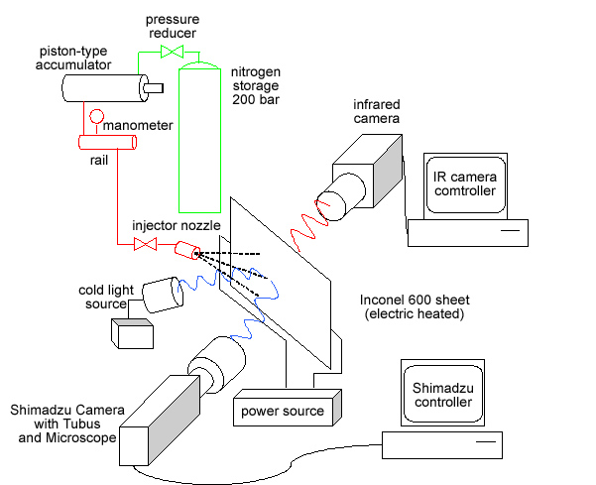
The schematic diagram of the experimental setup is presented in figure 1.
To provide the hollow cone profiled nozzle with respective injection pressure, there was a 200 bar nitrogen bottle used, which coupled with a piston type fuel accumulator to carry the pressure forward to the injector. The experimental pressure can be adjusted in between 5 and 130 bars by the pressure reducer. A special rail system was constructed, which allowed us to adjust the angle between the nozzle axis and the sheet metal in a range from 0° to 90°, and to vary the distance between the nozzle and the sample from 10 mm to 100 mm.
Experiments with 100µm thick Inconel sheet metal, which heated directly in order to obtain required surface temperature, were carried out with gasoline and with different fluids like n-Octane, n-Hexane and 1,2,4-Trimethylbenze and their mixtures. The nozzle / sheet metal distance amounted about 35 mm.
Figure 1.The experimental setup.

For spray - wall interaction measurements and boiling regime investigations on the sheet metal surface, a high speed recording camera ISIS V2 from Shimadzu Company was used. This prototype is marked by a maximum screen change frequency of 1 MHz with a high light sensitivity. Visualization experiments were carried out in both macroscopic and microscopic way. The macroscopic visualization shows its advantages in visualization of the whole spray development process (figure 2). Figure 2a shows the spray during the impingement process, while in fig. 2b the gasoline wetted region can be clearly recognized. Furthermore in fig. 2b, the measuring impingement areas (MP 1,2,3,4) are marked where the investigation of the droplets interactions and heat transfer mechanisms on the microscopic way took place.

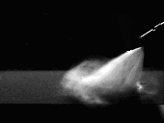
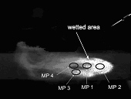

a) b)
Figure 2.Macroscopic visualisation: spray development process (a), wetted region and measuring areas for microscopic investigations (b).

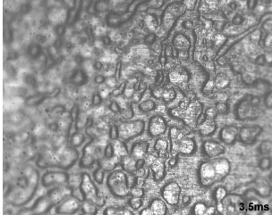
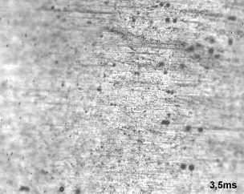

a) b)

Figure 3.Microscopic spray - wall visualizations 3.5 ms after the nozzle triggering for n-octane, measuring position MP 2 (nozzle close position), for sample temperatures 170 °C (a) and 230°C (b).

Figure 3a illustrates the partial gasoline wetting at the sample temperature of 170 °C. The boiling process is predominated by the convective boiling mechanism. Only few upcoming boiling bubbles can be recognized. For the sample temperature 230°C (fig. 3b), there was no surface wetting and only a few sliding droplets on the investigated surface were noticed.
The thermographic experimental program consisted of measurements of transient sample temperatures resulting from spray impingement on the hot wall. With the thermographic system AGEMA THV 900 in in-line scanning mode, a recording frequency of 2550 Hz was reached.
Figure 4a presents the sheet metal transient temperature and its derivatives with time for n-octane, for two chosen sample temperatures at MP 2, while the chart in Figure 4b compares the characteristic of the dimensionless temperature $Θ=\frac{T_{0}−T_{t}}{T_{0}−T_{L}}$ for gasoline and n-octane at all investigated temperature regions. In the Θ definition means: T₀-steady sheet metal temperature before injection, T_{t}- sheet metal temperature at the time of t=5 ms after first droplet contact with the hot wall and T_{L}- liquid temperature before injection at ambient conditions.

a) b)
Figure 4.Sample temporal temperature gradients for n-octane (a), and Θ characteristics for n-octane and gasoline at investigated temperature regions (b).

High sample temperature gradient at 170°C exists between 1 and 1.5 ms and a significant temperature decrease (fig 4a) lead to the conclusion that at this point an almost complete wetting of the sample surface with n-octane occurs. This can be also confirmed by the high speed visualisation at the same sheet metal temperature (fig. 3a). The Leidenfrost phenomenon seems not to occur at this temperature level, although the wall overheating of 45⁰C exists.
For the sample temperature of 230°C, temperature derivatives with time decrease significantly in comparison to the lower temperature sample, and at this point no wetting of the surface was noticed (fig. 3b). The Leidenfrost temperature for n-octane has occurred around 200°C as shown in the Θ - plot with different sample temperatures (fig. 4b). The Θ - values are approximately constant in the range from 150°C to 190°C and decrease suddenly between 190°C and 200°C.
Experimental results give us partial images of the complex spray - wall interaction process, which takes place during the droplet contact with hot solid surfaces. The obtained temperature profiles with consideration of the Leidenfrost phenomena give a complete picture of droplet - wall interactions and boiling regimes on the metal sheet surface. The comparison of these regimes for different atomized fluids with the surface temperature variation, were supported by the high speed visualization and the IR - thermographic methods. The results obtained can be useful for the validation of numerical models, where the information about temperature and heat flux density distributions is needed.
Further projects should focus on the dynamics of the fuel-wall interaction in the pressure chamber under temperature and pressure conditions similar to those prevalent in spark ignition engines with direct fuel injection.

REFERENCES

1. Spicher, U., Direkteinspritzung im Ottomotor, expert verlag , Renningen, 2001.
2. Tschöke, H., Diesel- und Benzindirekteinspritzung, Tagung. Diesel- und Benzindirekt-einspritzung, Essen, 2000.
3. Boye, H., Schmidt, J., Suck, G.,Thermographic investigation of the fuel-surface interaction under atmospheric conditions, Heat Transfer 2002, Proceedings of the Twelfth International Heat Transfer Conference,2002.
4. Popiolek, G., Boye, H., Könnig, M., Diaz, M.C., Schmidt, J., PDA – Analysis of fuel spray wall interactions under atmospheric conditions, Conference Modelling Fluid Flow,Budapest, 2003.
5. Popiolek, G., Boye, H., Könnig, M., Schmidt, J., PDA – Measurements of spray characteristics in the fuel direct injection, 4th European Thermal Sciences Conference, Birminghamt, 2004..
6. Chandra, S.,Droplet evaporation and combustion near a surface, Phd Thesis., Cornell University, 1990.

