A COMPARATIVE RANS/LES STUDY OF TRANSIENT GAS JETS AND SPRAYS UNDER DIESEL CONDITIONS

Mariafrancesca Valentino, Xi Jiang, and Hua Zhao
Mechanical Engineering, School of Engineering and Design
Brunel University, Uxbridge UB8 3PH, UK

Transient gas jets and liquid sprays are encountered in a broad range of practical applications. In a combustion engine, spray significantly affects the fuel consumption and exhaust emissions of the engine, where the phenomena are very complex. Two of the reasons leading to the complexity are that sprays in internal combustion engines are highly transient in nature and that the interactions between the two phases are quite complex and not completely understood and difficult to investigate experimentally.
Numerical simulation represents a useful tool to obtain spray characteristics that can be effectively utilized to interpret available experimental data, to execute pre-calculations for altered operating conditions, and to guide experimental work. The existing CFD studies of sprays have been done primarily within the Reynolds-averaged Navier-Stokes (RANS) modelling framework, where ensemble-averaged equations for fluid mechanics were solved. Due to the intrinsic ensemble-averaging, RANS approach does not provide exact information on unsteady features of the process. The recent developments in direct and large eddy simulation (LES), however, offer an opportunity to fully investigate transient processes by providing temporally and spatially resolved solutions. Particularly, LES provides a promising technique to simulate unsteady turbulent flows under conditions comparable to laboratory experiments or engineering applications at affordable computational costs. For applications in combustion engines, extensive CFD studies based on RANS approach have been performed for gas jets and sprays under diesel condition. However, there is still a lack of knowledge on the transient nature of the processes.
This study aimed at a better understanding of the transient nature of axial–symmetric gas jets and sprays under diesel conditions, with particular attention spent to investigate the entrainment characteristic of sprays and gas jets (the entrainment rate of hot air into sprays is, as matter of fact, an important phenomenon, which controls evaporation rates, mixing rates and liquid penetration length). To achieve this, LES has been employed where large-scale structures are directly resolved while the small scales are modelled using the sub-grid scale modelling. Due to the absence of time-averaging, LES allows access to unsteady features of the process, which can provide valuable insight into transient gas jets and sprays under diesel conditions. The LES performed in this study utilizes the $k−$equation model by Menon et al ¹, which was used to investigate the in-cylinder unsteady mixing process in a direct injection engine ².
To evaluate the performances of RANS modelling approach and LES, a comparative study has been performed for the same cases of gas jets and sprays, all selected from the experimental work by Andriani et al ³. The limits of LES method for the axial-symmetric problems and of coupling of LES method with actually more popular spray models are also discussed.

REFERENCES
- Menon, S., Yeung, P. K. and Kim, W. W., Effect of Subgrid Models on the Computed Interscale Energy Transfer in Isotropic Turbulence, Computers & Fluids, Vol. 25, No. 2, pp 165-180, 1996.
- Sone, K. and Menon, S., Effect of Subgrid Modeling on the In-Cylinder Unsteady Mixing Process in a Direct Injection Engine, ASME Journal of Engineering for Gas Turbines and Power, Vol. 125, No. 2, pp 435-443, 2003.
- Andriani, R., Coghe, A. and Cossali, G., Near-Field Entrainment in Unsteady Gas Jets and Diesel Sprays: A Comparative Study, Proceedings of the Combustion Institute, Vol. 26, pp 2549-2556, 1996.

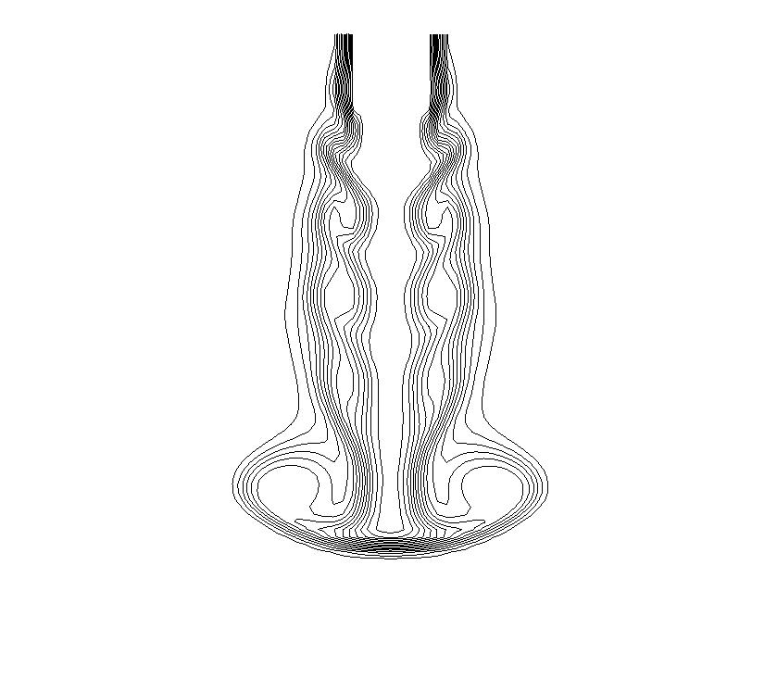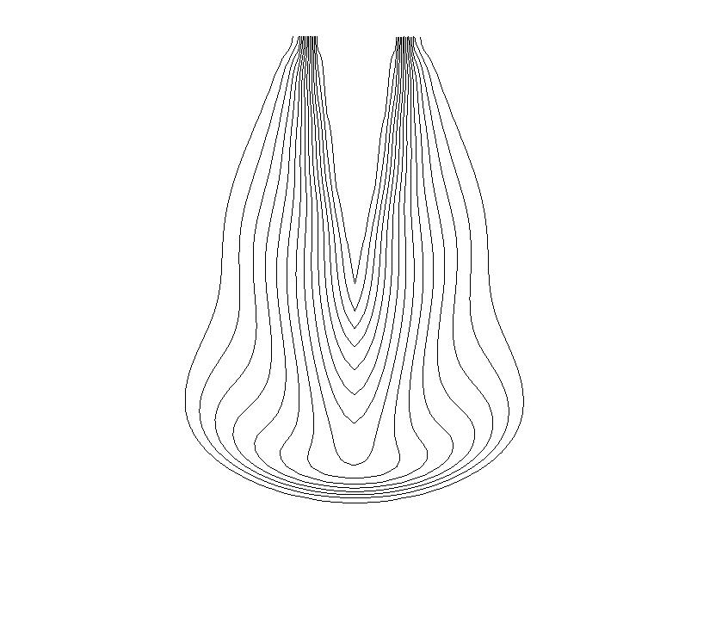
Figure 1. Mass fraction contours (at 0.2ms) of a gas jet with $κ=1\text{.}\text{48}×{\text{10}}^{4}{{\text{cm}}^{2}}/{s^{2}}$ for the LES simulation (on the left) and with with $κ=1\text{.}\text{48}×{\text{10}}^{4}{{\text{cm}}^{2}}/{s^{2}}$ and $ℓ=1\text{.}5×{\text{10}}^{−2}\text{cm}$ for the RANS one (on the right)

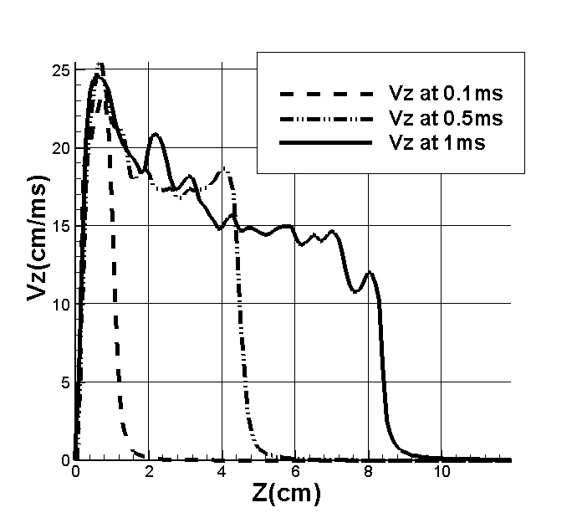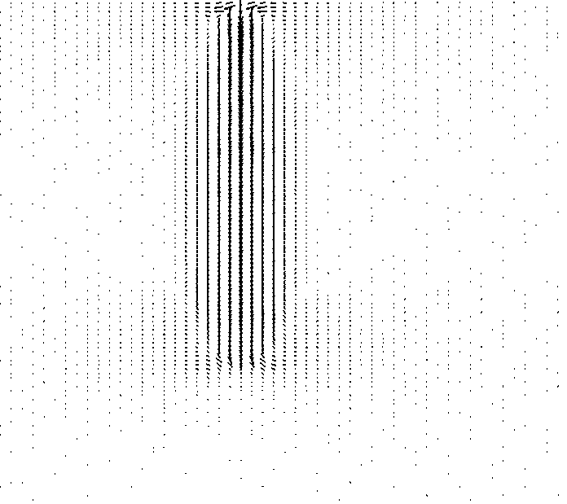

Figure 2. Time evolutions of the centreline velocity (at 0.1ms, 0.5ms and 1ms) and velocity vector plots (at 1ms) of a liquid spray with $κ=1\text{.}\text{48}×{\text{10}}^{2}{{\text{cm}}^{2}}/{s^{2}}$ and $ℓ=1\text{.}5×{\text{10}}^{−1}\text{cm}$.

