EFFICIENCY RAISE OF RANQUE-HILSCH VORTEX TUBES

Vasilyev V.I.*, Zarenkov A.A.**
*Institute of Experimental Meteorology Scientific Production Association "Typhoon",
Obninsk, Russia. Email: vasilev@typhoon.obninsk.org
**SP "Cooling products", Obninsk, Russia. Email: zarenkov@mail.ru

The vortex effect of Ranque-Hilsch is used in technique for a long time. Vortex effect term is " self-arbitrary " temperature separation of airflow in to cold and hot ones. The history of this effect begins in 1931, when the French engineer Ranque has received the patent for his device under a title "a vortex tube". According to the data of his experiences the entering flow of compressed gas was divided in the vortex tube in to two flows with different temperatures. On the one end of vortex tube the hot air appears on the other the end the cold air goes out. Air (gas) enters a vortex tube through tangential input, which is located closer to the cold end of a tube. The difference in temperatures between the hottest and coldest layers in a vortex tube can be more 100'С.

The vortex tube is structurally extremely primitive, but the aerothermodynamic processes happening in it, remain unclear till now. In a turbulent flow a powerful current of heat from the centre to a rim (outlying) self-arbitrarily arises: in the centre the flow is always colder than in a rim. And these layers in a centrifugal force field exist several millimeters apart from each other. Shortcoming of vortex tubes is that they have low efficiency. One of the methods of efficiency raise of a vortex tubes is the introduction of a compounding device on that end where a hot flow exits¹⁻⁴. The scheme of installation for investigation of tubes Runque-Hilsch is presented in Fig. 1.
measure
P_{in}, V_{in}, T_{in}

compressed air supply
VORTEX TUBE
compressor
measure
V_{c}, T_{c}
stopcock
(valve)
cold end
hot end
cold
flow
hot
flow

Fig. 1. Installation for investigation of vortex tubes Runque-Hilsch.

Pressure P_{in} (atm) and rate of the air, included in a tube, V_{in} (l/min) set by the compressor. The air from the compressor after measuring P_{in}, V_{in}, temperature (T_{in}) moves in the vortex tube. The investigations were carried out using three values of pressure 2, 3 and 4 atm. Temperature T_{c}, rate of the air V_{c} (l/min), going out through the cold end of a vortex tube, were measured. On an exit of hot air from a vortex tube the cock was installed which allowed to regulate the exit of hot air (together with cold air) from a maximum level up to zero. The different compounding devices (insertion) were interposed into the hot end of a vortex tube through an orifice in the cock. The investigation of influence of different insertions on an exit of cold air from a vortex tube Ranque- Hilsch was carried out. There were determined (1) associations of temperature of cold air T_{c} with the rate of the air going out from the cold end V_{c}, (2) association of cold air temperature T_{c} with the rate ration of going out cold air to entering air V_{c}/V_{in}, (3) effectiveness of cooling (q). In all cases the measuring were carried out using three values of pressure P_{in}, thus the parameters of an insertion were varied: length L, exterior diameter D, weight M. The insertions had an interior orifice d or hadn’t it, they were flexible and rigid.
T_{c} = f(V_{c}, P_{in}, L, D, d, M), (1)
T_{c} = f(V_{c}/V_{in}, P_{in}, L, D, d, M), (2)
q = α·ΔT = (V_{c}/V_{in})·(T_{in} – T_{c}) = f(V_{c}/V_{in}, P_{in}, L, D, d, M), (3)
where L is length of an insertion (mm), D is exterior diameter of an insertion (mm), d is diameter interior orifice of an insertion (mm), M is weight of an insertion, α = V_{c}/V_{in} is relative exit of the cold air, ration of an exit cold air to an entering one, q is effectiveness of cooling.

In a Fig. 2 the results of investigation of a round insertion from plastic are shown. The diameter is 5 mm, the length is 80, 90 and 100 mm, the diameter interior orifice is 3 mm; P1=2, P2=3, P3=4 atm. 80с and 90с is the interior orifice of an insertion is closed, where 80 and 90 is length of insertion. 80(P1) etc., where 80 is the length of an insertion, and P1 is the pressure on an input of a vortex tube. P1, P2, P3 in the figure means that the investigation was carried out without an insertion, that is the testing a vortex tube Ranque-Hilsch was carried out.
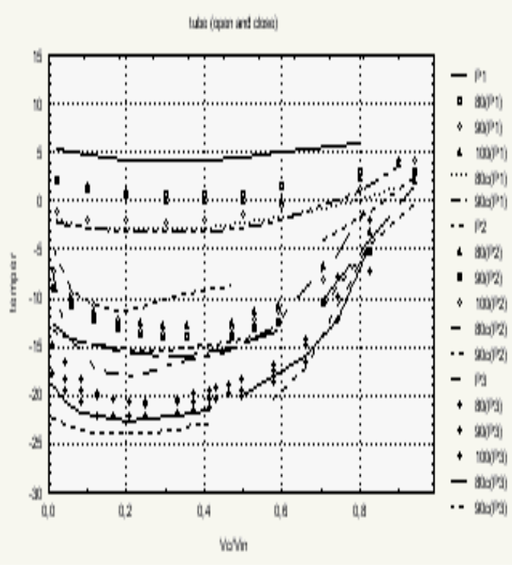
a) b) c)
Fig. 2. Investigation results of the vortex tube without an insertion (P1, P2, P3), with a round insertion from plastic, with an interior orifice and without an orifice.

The measuring began at the open cock and further at its gradual concealment and till complete overlapping of hot air. The results have shown: 1) the insertion considerably raises the effectiveness of cooling, 2) the interior orifice worsens the effectiveness of cooling, 2) the best length for the given insertion is 90 mm.

In a Fig. 3 the effectiveness of cooling for two insertions is shown. The first insertion: the exterior diameter is 3 mm, the interior orifice is not presented, material is the polyethylene, the length is 80, 90, 100 mm, entering pressure P_{in} = P1, P2, P3; P1=2, P2=3, P3=4 atm. The results of investigations show, (Fig. 3 а): 1) the insertion improves effectiveness of cooling, 2) the best length of an insertion is 100 mm, 3) effectiveness of cooling of the given insertion is worse than previous (Fig. 2). Second insertion: the exterior diameter is 8 mm, the interior orifice is not presented, material is the plastic, the length is 80, 90, 100 mm, entering pressure P_{in} = P1, P2, P3; P1=2, P2=3, P3=4 atm. The results of investigations show (Fig. 3 b): 1) the insertion improves effectiveness of cooling, 2) the best length of an insertion is 80 mm, for P1 is 90 mm, 3) effectiveness of cooling of the given insertion is better than the second (Fig 3 a).
a) b)

Fig. 3. Effectiveness of cooling for two different insertions.

The investigation of three insertions shows: 1) the insertions improves effectiveness of cooling, 2) the effectiveness of cooling depends on a type of an insertion: on its weight, length, thickness, presence of an interior orifice, entering pressure, 3) the best effectiveness of cooling is given by the third insertion (Fig. 3 b), as q = α·ΔT reaches 24 degrees with 80 % an exit of cold air, α = 0.8. The observed data up to α = 0.8 represent practically straight line. The effectiveness of cooling of other insertions is worse. Thus, the introduction in the hot end of a tube Ranque-Hilsch of a compounding device (insertion), that is making an additional perturbation to a flow of air (gas), gives the possibility to increase the effectiveness of cooling, that is to reduce temperature of cold air and to increase volume of an exit of cold air.
.
REFERENCES

1. Kolomiets S. M., Vasiljev V.I., Visheratin K.N., Zarenkov A.A. Ranque Vortex Tube - Some Ways to Raised Efficiency. International conference "Fluxes and Structures in Fluids", 12-th Session. Sanct Petersburg, June 23-26, Abstracts. p.92-93, 2003.
2. Vasiljev V.N., Visheratin K.N., Zarenkov A.A., Kolomiets C.M. Vortex tube RF patent. No 2205335 from 08.11.2001.
3. Vasiljev V.N., Visheratin K.N., Zarenkov A.A., Kolomiets C.M. Vortex tube RF patent. No 2211414 from 25.01.2002.
4. Visheratin K. N., Vasiljev V.I., Kolomiets S. M., Zarenkov A. A.. Increasing Ranque vortex tube cold production efficiency by twisted air flow disturbance. Third International Conference on Heat Powered Cycles (HPC 2004 Conference), 11-13 October, Larnica, Cyprus. ISBN01874418353. Thermal Systems. 1203. P. 1-8.

