Analyze and design of an new reactor functioning with controlled pulverization vacuum

M. DELGADO-ROSAS, V. SOBOLIK, K. ALLAF, A. BELGHIT*

Laboratoire de Maîtrise des Technologies Agro-industrielles (LMTAI)
Université de La Rochelle – Av. Michel Crepeau
17000 La Rochelle – France
*E-mail : abelghit@univ-lr.fr

Traditional drying by pulverization is amply used for a long time in food industry. The purpose of these last years of new methods of pulverization were born and are especially to improve quality of the product at a relatively low cost, for biological products of pieces but these techniques offer difficulties with to liquid products.

It is for that one sought in this paper, to present an analysis of a new reactor which we developed which makes it possible to remove the maximum of quantity of possible water, while profiting from the phenomenon of self-vaporization induced by the fact of the pulverization of a solution overheated in an enclosure of very reduced pressure. Several complex solutions were used, we present here the experiments undertaken on tomato juice.

The results obtained could prove the feasibility of this process, which makes it possible to remove the maximum of water by controlling the exit and inlet temperatures by the phenomenon of self-vaporization due to the variation of pressures to which the product is subjected. In this process, drying is fast and the temperature remains very low, which allows a good conservation of the quality of the products.

We present here the diagram of the experimental installation, the engine used and an example of result obtained.

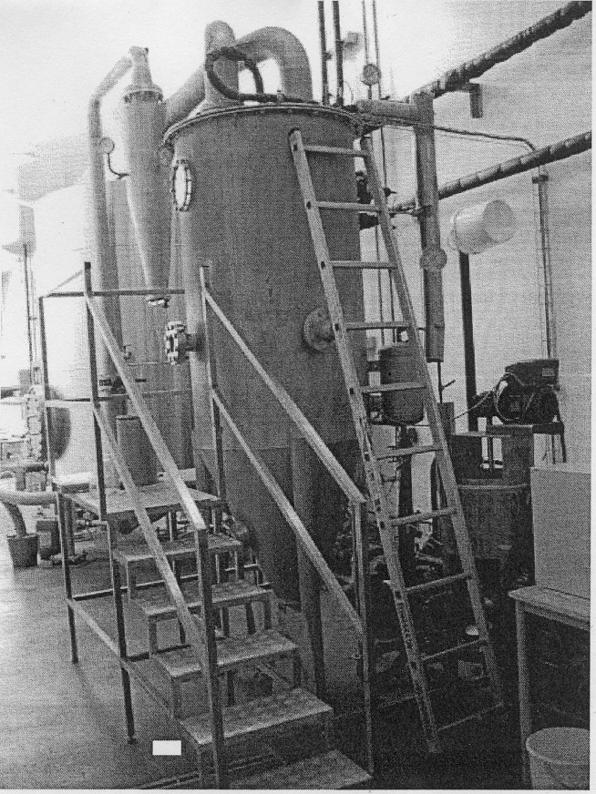

Figure 1: Photograph of experimental equipment

Figure 2: Water percentage removed compared to the product
(Tomato juice pulverization (7%, m.s.) and tomato puree (27%, m.s.)
at temperature (60-75°C) and one initial pressure in the room of 6 mbar).
(m.s. : matter dries)

