Heating Surface Temperature Fluctuation Characteristics
near a Flow Obstruction Simulating a Spacer of A BWR
in A Transient Boiling Flow within a Vertical Annular Channel

Tohru Fukano*, Shoji Mori*
* Department of Mechanical Engineering Science,
Faculty of Engineering, Kyushu University
6-10-1,Hakozaki, Higashi-ku, Fukuoka, 812-8581, JAPAN

When a flow obstruction such as a spacer is set in a boiling two-phase flow within an annular channel, the inner tube of which is used as a heater, the temperature on the surface of a heater tube is severely affected by the existence of the spacer. In some cases the spacer has a cooling effect, and in other cases it causes the dryout of the cooling water film on the heating surface resulting in the burnout of the tube. In the present paper we will discuss the influences of a spacer in a transient boiling flow in the case of the stepwise change of experimental parameters, such as the heat flux and the mass flow rate.

Introduction
It is desired to operate nuclear power stations safely as well as to design high efficient ones. According to an experimental result obtained by a large-scale apparatus, the thermal design of a BWR is restricted by heat removal from nuclear rods in close vicinity of cylindrical spacers which support nuclear rods in a BWR (Arai et al.¹). It is necessary to make clear the burnout mechanism near the cylindrical spacers in a BWR, since its mechanism is not fully understood yet.
Experimental apparatus
The test section, which consisted of concentric double tubes as shown in Fig.1, was vertically set in a closed forced convection loop. The inner tube, with 16.0mm in O.D., of the test section was used as a heater. The outer tube, with 30.0mm in O.D. and 26.0mm in I.D., was made of Pyrex glass so as to observe the flow configuration within an annular channel. A working fluid, distilled water, was supplied into the test section through a pre-heater. The geometry of a spacer which was made of quartz glass and locations of thermocouples were shown in Fig.2 and Fig.3, respectively. It must be noted that the system pressure was about atmospheric pressure which is largely different between our experimental and a BWR operating conditions.

Experimental results and discussion
The heat flux was changed stepwise while keeping inlet water velocity U_{in} =0.1m/s constant.

Case of the stepwise increase of the heat flux
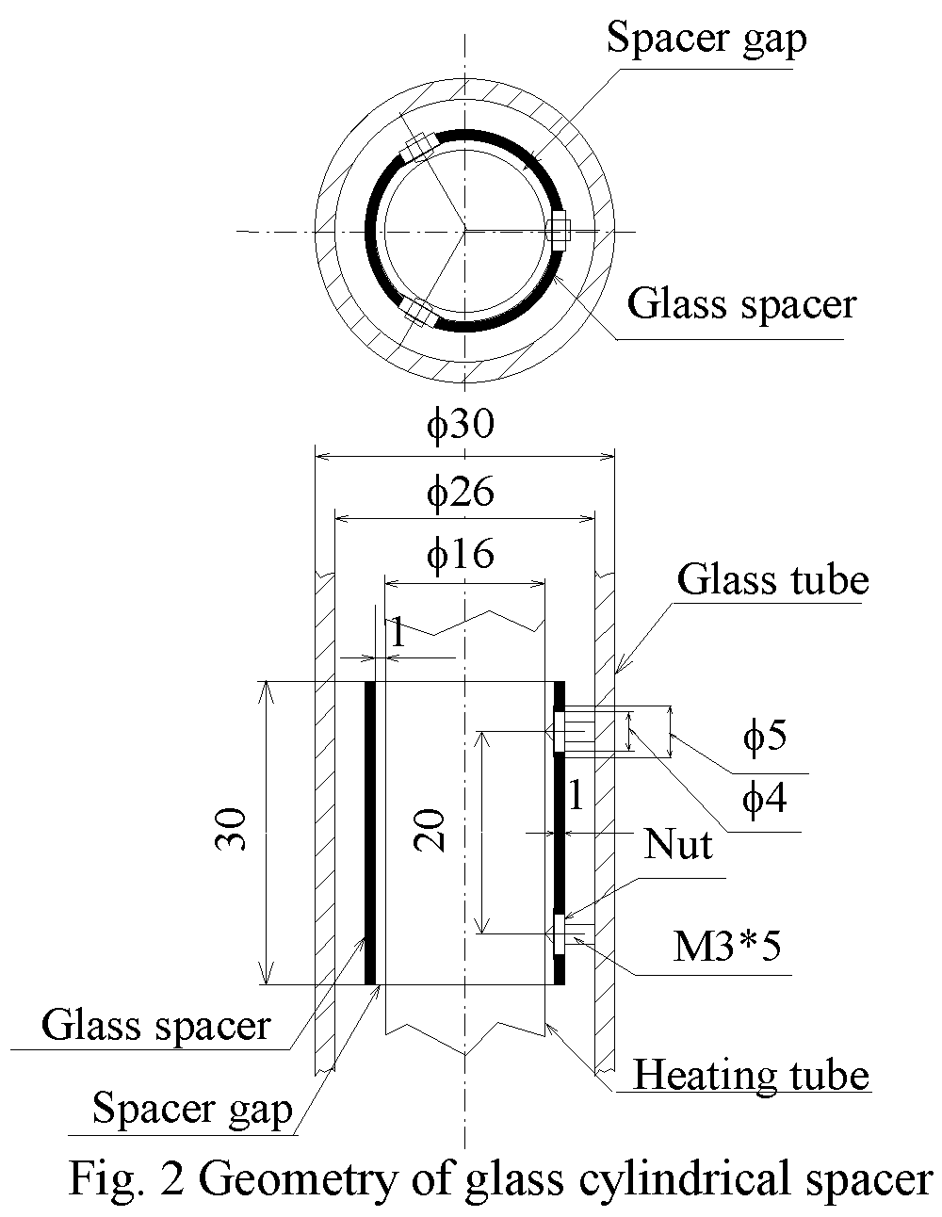
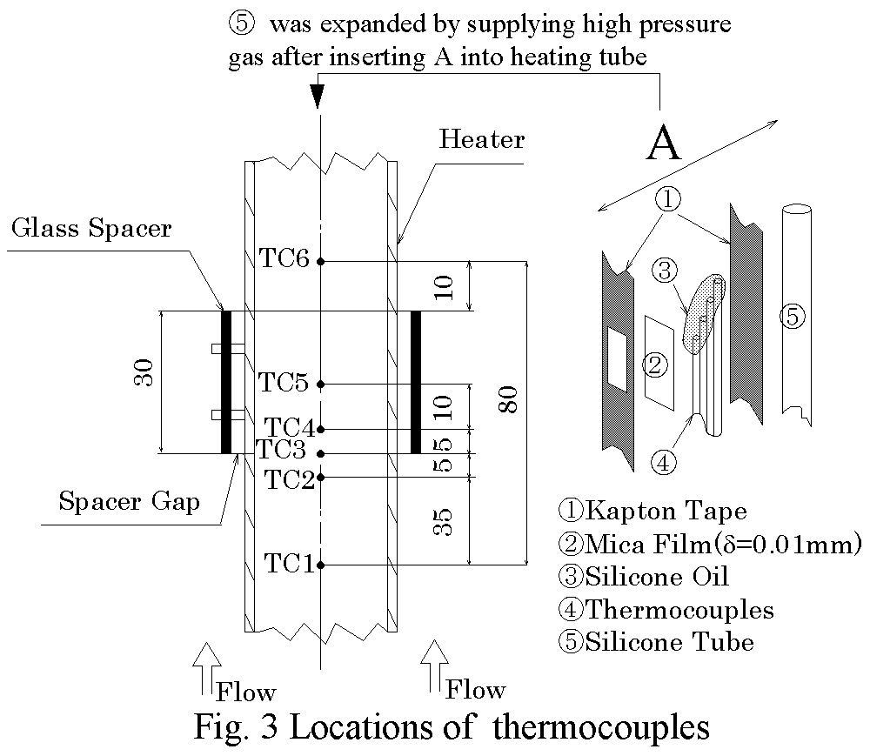
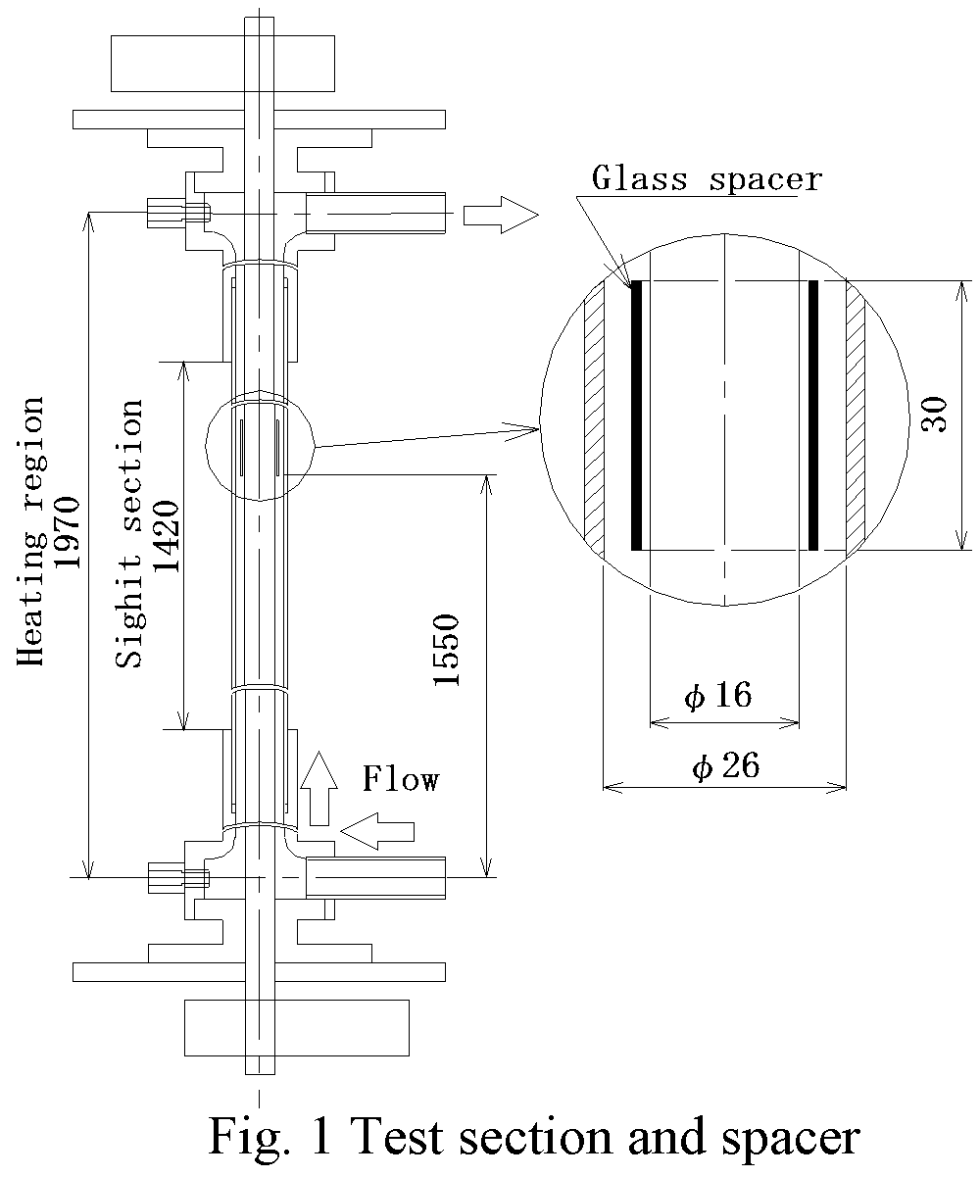

Irrespective of the magnitude of the change, the burnout or the large temperature rise never occurred if the heat flux after the change q_{aft} was smaller than the steady burnout heat flux. And the burnout occurred without exception provided q_{aft} is almost equal to or larger than the steady burnout heat flux. That is, the transient behavior caused by the stepwise increase of the heat flux does not play an important role in the burnout heat flux.

Case of the stepwise decrease of the heat flux
The experimental condition at the spacer before the change was constant (q≅220 kW/m², j_{G}≅35 m/s, j_{L}≅0.08m/s, x≅0.22) in all the experiments described in this section. Figures 4(a) and (b) show the time traces of T_{wout} in the case of the stepwise decrease of the heat flux. Vertical lines at the bottom of Fig.4 express the time at which disturbance waves were observed at the spacer by a high-speed video recorder.
Figure 4(a): Flow patterns after the change were disturbance wave flow as before the change. In this experimental condition the temperature fluctuation was not intense because disturbance waves passed continuously by the spacer in both cases after and before the change.
Figure 4(b): If the decrement of the heat flux, -Δq, was further increased than in Fig. 4 (a), the maximum increment of the wall temperature rise ΔT_{max} became large at the locations inside the spacer and reached about 20K at 2.6 seconds after the change. This drastic increase of T_{wout} was caused by the dryout of the thin water film which was caused as a result of the large-scale drainage in the region around the leading edge of the spacer. Here the term “drainage” is used in this paper to express the phenomena, a rapid decrease of film thickness at the region inside and upstream of the spacer on account of the spacer interrupting the reverse flow due to gravity from the downstream side to the upstream side of the spacer. As shown in Fig.4 (b), disturbance waves did not pass by the spacer for about 2.4 seconds after the change. The base film became thin by the combined effects of the drainage and the evaporation, and after all dried out at the leading edge of the spacer.
A series of pictures shown in Fig. 5 was simultaneously recorded with the temperature fluctuations T_{wout} shown in Fig. 4 (b).The drypatches are shown by hatched parts in Fig. 5.The drypatch occurred at first at the leading edge of the spacer as well as at the screw to fix the spacer, and then spread rapidly to both regions inside and upstream of the spacer. Close inspection of the correspondence between Fig. 4 (b) and Fig. 5 reveals that T_{wout} of TC2 to TC5 begins the quick increase nearly at the same instant as the edge of the drypatch reaches each thermocouple, and to decrease nearly at the same instant the disturbance wave reaches there. It is noticed that T_{wout} always decreases just before the quick increase of T_{wout}. This fact shows that quite thin water film which is formed just before its dryout has high heat transfer coefficient. The reason why the drypatches spread rapidly to inside the spacer at first rather than upstream is considered as follows. The water film thickness inside the spacer is thinner than upstream (Fukano et al.²). In addition, the thinner the
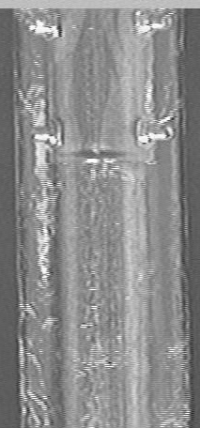
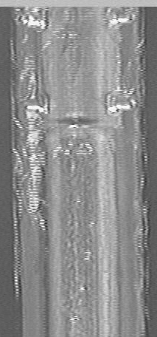
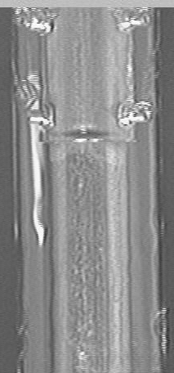
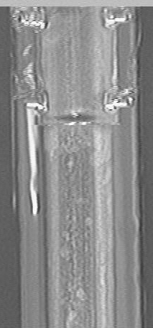
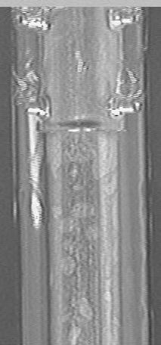
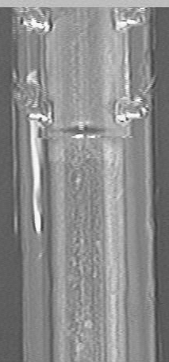
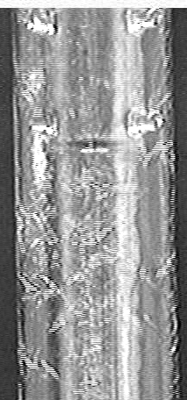
Spacer
Drypatch
(1) 19.8s
(2) 20.0s
(7) 21.0s
(4) 20.4s
(3) 20.2s
(6) 20.8s
(5) 20.6s
Spacer

Fig.5 Change of flow configuration near the spacer in Fig.4 (b) (U_{in} =0.1m/s , ΔT_{sub} =10 K)

Fig.4 Temperature fluctuation in the case of the stepwise decrease of the heat flux (U_{in} =0.1m/s , ΔT_{sub} =10 K)

water film, the higher the heat transfer coefficient, and resulting in the incipient of the drypatch inside the spacer. In this case the burnout, however, did not occurr even when ΔT_{max} reached about 20 K, because the heat flux after the change was low and T_{wout} did not exceed the leidenfrost temperature. It is noticed from the discussion above that the increment of T_{wout} caused by the stepwise decrease of the heat flux depends strongly on both the duration of the existing the drypatch and the magnitude of the heat flux, which may determine about the occurrence of the burnout of the heating surface. However, T_{wout} (TC6) downstream of the spacer hardly increased due to the existence of water accumulated there because of the wake of both the spacer and the spacer gap.
As shown in Fig.4 (b), the passing frequency of disturbance waves remarkably decreased in short time after the change. This is because it takes time for the flow pattern to adjust to new experimental condition after the change, since the shear force of vapor flow acting on the water film suddenly became smaller with the decrease of the heat flux. And accordingly the water lump can not be transferred as disturbance waves until it becomes large enough for a new and low vapor velocity. It is noted that ΔT_{max} near the spacer becomes smaller gradually in case that ⎢-Δq ⎢ becomes larger than the case in Fig.4 (b), because the heat flux after the change was smaller with larger ⎢-Δq ⎢.

Case of the stepwise decrease of the mass flow rate
The stepwise decrease of the mass flow rate was established by suddenly opening a bypass-line valve while keeping the inlet subcooling of test section (ΔT_{sub} =10K) and the heat flux (q≅225 kW/m²) constant. Regardless of the magnitude of decrement of the mass flow rate, the burnout occurred provided that the mass flow rate after the stepwise decrease was smaller than that of the steady burnout, i.e., U_{in}=0.1 m/s in case of q≅225 kW/m². Thus, it is concluded that the transient behavior caused by the stepwise decrease of the mass flow rate does not have a strong effects on the burnout heat flux.

CONCLUSION

In the present experimental research we investigated in detail the influences of a spacer on T_{wout} near the spacer in case of the stepwise change of experimental parameters, such as the heat flux and the mass flow rate.
The results are summarized as follows:
  - The transient behavior of a boiling two-phase flow caused by the stepwise increase of the heat flux or the decrease of the mass flow rate does not play an important role in the occurrence of the burnout.
  - The drypatches occur and spread rapidly to both regions inside and upstream of the spacer, depending on the magnitude of the stepwise change, even when the heat flux decreases. The magnitude of the temperature rise reaches temporally about 20K at the maximum in the present experiment. However, T_{wout} in the region downstream of the spacer did not increase due to accumulation of the water in the dead water region just downstream of the spacer.
  - Even if the flow pattern changes by the stepwise change of the operation parameter, the flow stably proceeds to a new state provided that the change of the operation parameter causes the increase of vapor velocity, i.e., the increase of the shear force acting on water film flows. On the other hand, if the change causes the decrease of the vapor velocity, it must be noticed that the burnout is possible to occur even when the operating condition after the change is such that the burnout should not occur.
  - The occurrence of the burnout in the present experimental condition is strongly dependent on the interval of disturbance waves.
REFERENCES
- Arai,K., Tsunoyama,S., Yokobori,S., and Yoshimura.K., Critical power characteristics in a rod bundle with narrow gap. Dynamics of Two-Phase Flow, CRC Press, 739-752, 1992
- Fukano,T., Kawakami,Y., Shimizu,H., and Sekoguchi,K., Film thickness in gas-liquid two-phase flow (4th report, film thinning mechanism during the drainage). Bulletin of the JASME, vol. 23, No.178, 553-560, 1980.

