NATURAL CONVECTION OF AIR IN A SQUARE CAVITY

D.Akrour*, R.Bennacer** and D.Kalahe*.

*Laboratoire de Mécanique des Fluides, Faculté de Physique

BP 32 El-Alia, Bab-Ezzouar16111, Alger, Algeria
Fax:0021321247344 e-mail: dalila_akrour@yahoo.com
**Université de Cergy Pontoise, France

In the present numerical study, three-dimensional steady flow analyses has been made on natural convection in a differentially heated cubical enclosure.
The detailed structures of the three-dimensional fields were scrutinised by using high resolution computational results over the range of Rayleigh numbers studied 10³ ≤ Ra ≤ 10⁶.
In this work 42*42*42 mesh frame is used in the x, y and z directions for 10³ ≤ Ra ≤ 5.10⁴ and 52*52*52 for Ra ≥ 10⁵ ( figure –1-)

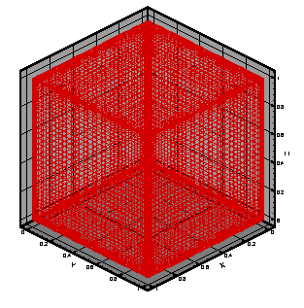

Fig.1. Grid distribution of computational domain

Examination of the perspective three dimensional fields revealed that the variations in the z-direction were evident particularly near the end wall. As the Rayleigh number increases, the convective activities intensify and significant z-variation tend to be confined into narrower areas close to the end walls, this is a result of boundary layer development .

The analysis is conducted by observing variation of the velocity vectors, pathlines and isotherms for different Rayleigh numbers. The details of the three dimensional flow and isotherms are described in order to investigate the effects of three dimensionalities on the fluid flow and thermal characteristics in enclosure.

The variation of Nusselt numbers on the hot and cold walls are also presented to show the overall heat transfer characteristics inside the enclosure. The three-dimensional data demonstrate reasonable agreement with the experimental measurement.
Utilizing the above numerical results, heat transfer correlation over 10³ ≤ Ra ≤ 10⁶ for the three dimensional enclosure are proposed as : Nu=0.1291.Ra^{0.304} ( figure-2-)

Fig-2-: The overall Nusselt number at the colder wall

The predicted overall Nusselt number shows considerable discrepancies from the corresponding two dimensional solutions.

Keywords : Numerical simulation, 3-D natural convection , multigrid method.

REFERENCES

1. I.Sezai, A.A.Mohamad, Natural convection from a discrete heat source on the bottom of horizontal enclosure, I.J.H.M.T, 43, p.2257-2266 (2000).

2. J.Pallares, F.X.Grau, Franese Giralt, Flow transitions in laminar Rayleigh-Benard convection in a cubical cavity at moderate Rayleigh numbers, I.J.H.M.T,4 2 ,p.753-769 (1999).

