MIXED CONVECTIVE MODES DURING SOLIDIFICATION
OF BINARY ALLOYS

Haik Jamgotchian, Henri Nguyen Thi, Nathalie Bergeon, Bernard Billia
Laboratoire L2MP, UMR 6137, Faculté des Sciences et Techniques de St Jérôme, Case 151
F-13397 Marseille 20, France

Materials properties strongly depend on non-homogeneity left in the solid during processing. Important points to clarify in solidification process are role of convection on macrosegregation and on microstructure selection. In this work we analyze coupling of convection and solid-liquid interface morphology during upward Bridgman solidification of metallic and transparent alloys in a cylinder. Two driving forces of convection are examined: radial thermal gradient and solute axial gradient. The formation and dynamics of thermosolutal convective patterns coupled with convective pattern given by thermal radial gradient is studied for different experimental conditions.

EXPERIMENTS

In directional solidification, growth characteristics depend on three control parameters: alloy solute concentration, pulling rate V and thermal gradient G. On one hand the shape of interface is characterized post mortem by quenching and by metallographic techniques on lead–30 wt% thallium alloys¹. Successive polishing-chemical etching process in interfacial region of the transverse section gives microstructure pattern and level curves of macroscopic shape of interface. Growth velocity varies from 0.55 to 6.11 μm/s. Two crucible diameters are used in order to control thermal radial gradient and confinement: φ=4 mm and φ=9.5 mm, with imposed thermal axial gradient respectively 55°C/cm and 40°C/cm.

On other hand, the dynamics of solid-liquid interface is studied on succinonitrile-acetone alloys, equivalent to metallic alloys in a cylindrical crucible, φ=10 mm diameter². Thermal gradient is kept constant (30°C/cm), and velocity varies from 0.5 to 2 μm/s. The solid-liquid interface is characterized by three complementary optical techniques. Two direct observation modes of the light providing bright field images of the interface, one transmitted through the whole length of the crucible and another one through radial direction. A Mach-Zehnder interferometer set-up on the longitudinal direction gives the shape and the position of the interface. In situ and real-time images are recorded on videotape.

RESULTS

Radial thermal gradient depends choice of alloys (metallic or transparent), initial conditions and also external parameters as crucible diameter, thermal conductibility of crucible and thermal profile of furnace³. However the axial solute gradient is intrinsic to the alloy solidification process. Lead-thallium and succinonitrile-acetone alloys exhibit similar thermosolutal instability, i.e. the axial solute gradient plays destabilizing effect. Front depression, solute accumulation and convection are actually coupled. For example the solute (solvent) accumulation occurs in depression of the interface and straight below ascending flow in the case of succinonitrile-acetone (lead–thallium) alloy. Consequently, morphological instability first initiates in interface areas of high solute concentration and propagates in the direction opposite to the horizontal solute gradient. Morphological instability does not occur homogeneously but according to the acetone macrosegregation induced by fluid flow over the phase boundary, i.e. morphological instability is shaped by convective pattern that gives rise to localized microstructures predicted by Chen and Davis⁴. Consequently, precise information on the convective modes is extracted from spatio-temporal evolution of macroscopic shape of solidification front and from dynamics of front of propagation of morphological instability, corresponding to the plan-cellular local transition. Nevertheless, for lead-30% thallium alloys we did not observe localized microstructure, due to the alloy phase diagram.

Thermosolutal convective pattern

The macroscopic shape of interface presents narrow depression canals corresponding to the thermosolutal convection (Fig.1). Lateral confinement θ (crucible diameter over wavelength at the threshold of thermosolutal instability) being very small for φ = 4 mm, we do not observe thermosolutal complete cell. For experiment 9.5 mm diameter (θ≈1) we usually observe only one (or two) thermosolutal cell almost centered in the crucible. A qualitative analysis is established by analogy with Bénard-Marangoni convective patterns⁵.

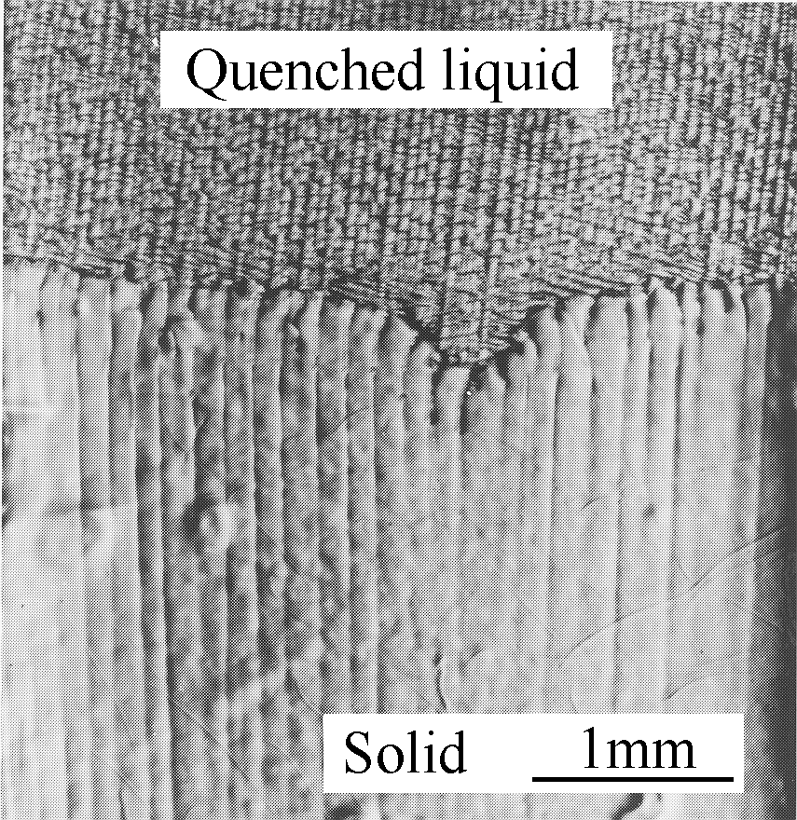  (a)  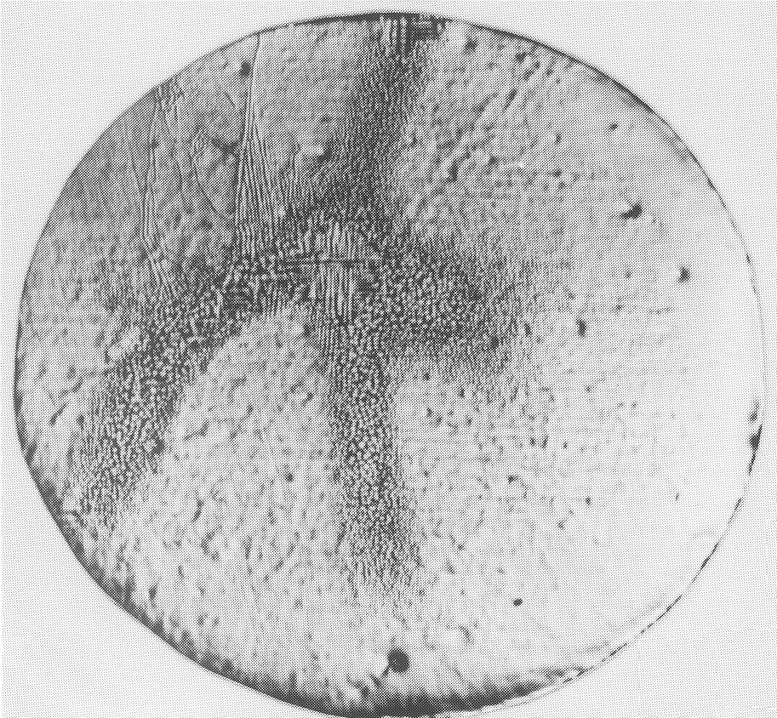  (b) | 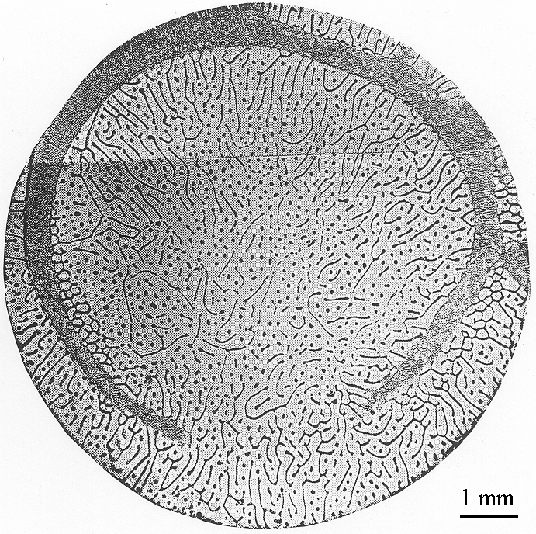  (c)

Figure 1 Effect of thermosolutal convection on macroscopic shape of the interface. a) Longitudinal section and b) transverse section, φ = 4 mm. c) Transverse section, φ = 9.5 mm

On succinonitrile-acetone alloys we frequently observe thermosolutal cellular pattern in the solidification initial transient. Periodicity of the structure is compared to the theoretical estimations of thermosolutal convection⁶⁻⁷. There is a good agreement between experiment and theoretical estimations.

Radial thermal gradient effect

By changing the crucible diameter we control the convection due to the thermal radial gradient. For φ=4mm, we observe weakly concave interface (Fig. 1a) and node formation by crossing of depression canals (Fig. 1b), which is not almost centered in crucible. However, for big diameter the macroscopic shape of the interface changes, becomes convex and thermosolutal cell is almost centered in the crucible. This effect is related to the thermal radial gradient, which becomes dominant for big diameter and coupled with thermosolutal cellular pattern.

For transparent alloys the growth velocity contribute to the level of thermal radial gradient. During initial transient of solidification, thermal radial and axial solute profiles progressively build up. The choice of convective modes in growth transient is strongly related to the dominant driving force during the formation of two profiles. However, for the same growth conditions, (succinonitrile- 0.2 wt% acetone alloy for velocities 1.4-1.8 μm/s), two major cases are observed function of initial crucible position: localized microstructure shaped by thermosolutal convective pattern (Fig. 2a) for thin solid seed case (0.5 mm) or focuslike local microstructure around the center of crucible (Fig. 2b) for thick solid seed case. In fact, initial crucible position changes only the value of initial thermal radial gradient due to the thermal exchanges between furnace and sample. Frequently, the effect of the radial temperature gradient becomes dominant in transient state, thus unstable area evolves into a disk-like local structure independently of initial conditions (Fig. 2c). For low concentration thermosolutal pattern is conserved in steady state.

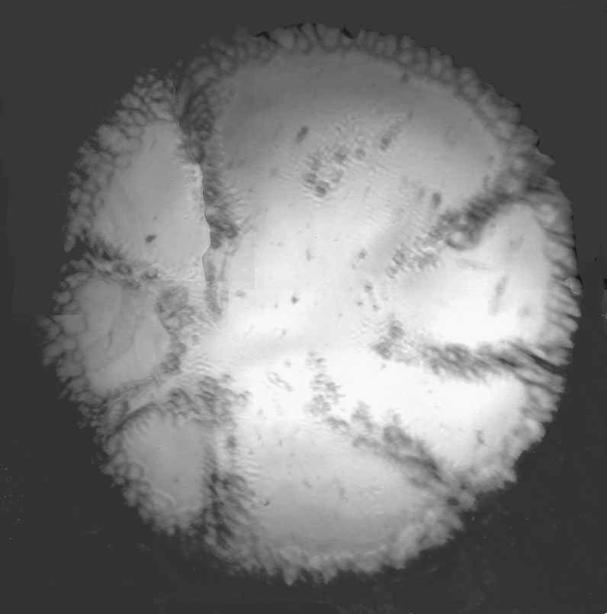  (a) | 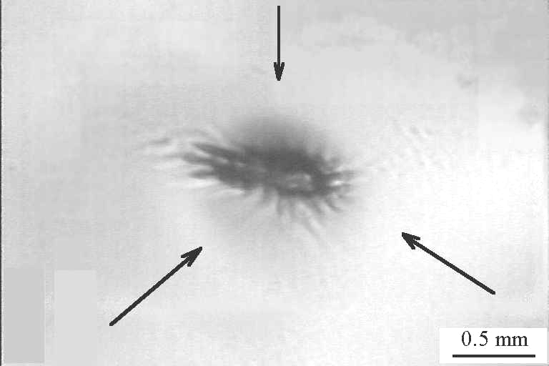  (b) | 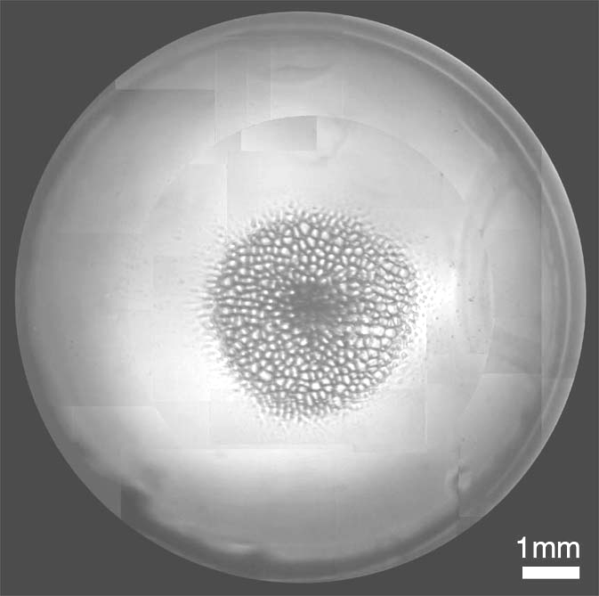  (c)

Figure 2: Localized microstructure corresponding to different convective patterns:
thermosolutal cellular pattern. Thermal radial gradient convective patterns:
b) focus-like localized microstructure and c) disk-like localized microstructure

REFERENCES

1. H. Jamgotchian, B. Billia and L. Capella, J. Cryst. Growth, Vol. 62, p. 539, 1983
2. N. Noël, F. Zamkotsian, H. Jamgotchian and B. Billia, Meas. Sci. Technol., Vol.11, p. 66, 2000
3. P. Haldenwang and R. Guerin, J. Cryst. Growth, Vol. 244, p. 108, 2002
4. Y.J. Chen and S.H. Davis, J. Fluid Mech., Vol. 421, p. 339, 2000
5. O.V. Vashkevich, A.V. Gaponov-Grekhov, A.B. Ezerskii and M.I. Rabinovich, Dokl. Akad. Nauk. SSSR Vol. 294, p. 563, 1987
6. S.R. Coriell, M.R. Cordes, W.J. Bottinger and R.F. Sekerka, J. Cryst. Growth, Vol. 49, p. 13, 1980
7. R.Z. Guerin, B. Billia and P. Haldenwang, Phys. Fluids A, Vol. 3, p. 1873, 1991

