TR 21 FC

KNOCK DETECTION IN GAS ENGINES BY ANALYSIS OF TRANSIENT HEAT TRANSFER

Jérôme Bellettre, Mohand Tazerout, E. Ollivier
Département Systèmes Energétiques et Environnement – Ecole des Mines de Nantes,
La Chantrerie, 4 rue A. Kastler, BP 20722, 44307 Nantes 3, France

Knock is due to an unexpected combustion in Spark Ignition (SI) engines. It is a result of spontaneous ignition of a portion of end gas in the engine chamber, ahead of the propagating flame. The very rapid heat release implied by this abnormal combustion generates shock waves that can lead to the decrease in output, the increase in some pollutants and the destruction of the engine. Although knock has been more or less overcome in gasoline engines by controlling the fuel quality, gas engines are not safe from knock. Natural gas contains different gases (CH₄, C₂H₆, etc.) with variable knock-resistance. Its composition varies widely with time and place. Consequently, an engine can start to knock if the gas reaches too low anti-knocking properties. A reliable method for the detection of knock in gas SI engine is then of high interest.

BACKGROUND

The knock detection is currently based on data generated by accelerometers or cylinder pressure sensors¹⁻². Due to its simplicity, accelerometry (vibration measurement) is largely employed in industry. Nevertheless, parasitic noises relative to engine operation often affect the quality of knock detection in this method. On the other hand, cylinder pressure data provide a direct and reliable way to analyze knock. The major disadvantage is that a suitable probe has to be provided inside the engine cylinder that may reduce the engine life time³.

Knock occurrence is accompanied by an important increase (up to 4 times higher) of the wall heat transfer inside the combustion chamber⁴⁻⁵. Thus, an alternative to the current methods could be the detection by analysis of the thermal signal measured near the outer side of the cylinder. However, the damping effect of the cylinder wall makes difficult such a detection.

METHOD AND MODELS

The present paper studies the possibility to develop this method. In order to achieve this goal, numerical simulations of the unsteady heat transfer across the cylinder wall and inside the coolant flow are performed. Unsteady heat transfer from the hot gas to the wall chamber is simulated by a self-developed program. This program allows fixing instantaneous local heat flux values deduced from the literature⁴ in case of both normal and knocking combustion. Heat transfer across the cylinder wall and governing equations regarding the coolant flow (continuity, momentum and energy) are solved by the finite volume technique in a 2D axisymmetrical configuration. The coolant is water and the flow is turbulent. The turbulence is treated by a well established model for turbulent heat and mass transfer: the Reynolds Stress Model. A low Reynolds number model approach (described in details in Lopez-Matencio et al.⁶) is retained to accounts for the wall effects. It allows also simulating instabilities in turbulent flows⁷.

Grid has been validated by checking the independence of the results. Different meshes with wall units included in a 0.5 - 2 range were tested. Moreover, numerical heat transfer from the wall to the coolant is in good agreement with theoretical correlation in the steady state case. Independence of the numerical results in a large range of time steps has been checked too (from T / 800 to T / 16000, where T is the cycle time: 0.08 s in the present case). Finally, the grid is composed of 70000 finite volumes, the time step is fixed at 10⁻⁴ s (corresponding to 30 steps during one combustion period) and 4 iterations per time step is adopted because more iterations do not improve the convergence of the simulations.

Once a converged solution is obtained (all the normalized residues are then less than 10⁻⁶), the transitional component of the thermal signal is analyzed in the whole computational domain. This analysis leads to evaluate the ability of a detection of a change in the signal amplitude due to a knocking combustion.

EXAMPLES OF RESULTS

Effect of the physical properties (diffusivity, effusivity: $e=\sqrt{{ρλc}_{p}}$) of the wall material is first investigated. The results show that an 11 % increase in the diffusivity of the wall leads to a 4 % increase in the amplitude of thermal signal at a 2 mm deepness. As expected, the wall effusivity has an inverse effect: an 11 % increase in the effusivity leads to a 4 % decrease in the amplitude of temperature signal on the internal side of the cylinder. The use of aluminum is simulated in a very small part of wall (in order not to decrease the engine efficiency). On the external side of this part very important gaps are observed regarding the signal amplitude after knocking cycles (10 K against 2 K in the case of a normal combustion).

Aluminum may not be employed in all engines. Steel is more usually used. In such a case, effect of modifications in the wall geometry enhancing the amplitude signal is investigated. The case of a small slot (1 mm deep and 6 mm long) on the external side of the cylinder wall is then studied. This decreases locally the wall thermal resistance and generates recirculation inside the slot. The thermal signal obtained in the water flow in this slot reveals a 0.9 K amplitude after knock and a negligible effect of a normal combustion (Fig. 1). Thus, the differences observed regarding the signal in the slot seem to be large enough to detect a knocking cycle from a normal one.

Knocking
cycle
Normal
cycle
Fig. 1 Example of thermal signal obtained inside the slot
(in the case of one knocking cycle every two cycles)

The consequence of a small rib put on the external side of the wall is finally studied. The rib makes the flow of coolant more turbulent. This may lead to increase locally the heat transfer and then to favour the thermal detection. Flows obtained behind this rib present streamwises (Fig. 2) very similar to those of other published results⁸⁻⁹. The thermal signal computed in the recirculation zone is compared to the transient heat transfer simulated without any rib. Two results from the recirculation zone are given, as example, in Fig. 3. In this case, only oscillations du to knock can be observed. They are significant (0.6 K) and are twice higher compared to those obtained without any rib. This may be very interesting for the development of a new and non-intrusive technology of knock detection.

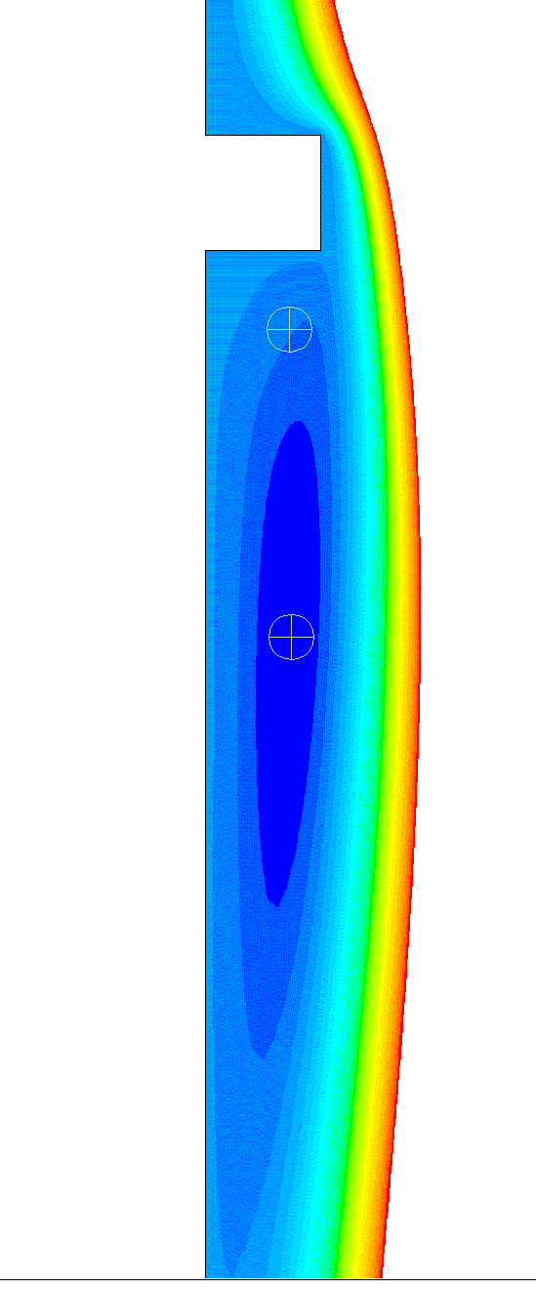
Cylinder wall
Rib
Coolant flow
Fig. 2 Streamwises observed behind the rib.

Fig. 3 Examples of temperature variation in the recirculation zone (in the case of one knocking cycle every two cycles)

REFERENCES

- Brecq, G., Tazerout, M. and Le Corre, O., A Comparison of Experimental Indices to Determine Knock Limit in CHP SI Engines, Proceedings of the 5th World Conference on Experimental Heat Transfer, Fluid Mechanics and Thermodynamics – ExHFT-5, Thessaloniki, September 24-28, 2001, Vol. 1, pp. 517-521.
- Brecq, G., Bellettre, J. and Tazerout, M., A new indicator for knock detection in gas SI engines, Int. J. Therm. Sci., Vol. 42, No. 5, 2003 (to appear).
- Brecq, G., Contribution à la Caractérisation Thermodynamique du Cliquetis dans les moteurs à Gaz : Application à de Nouvelle Méthode de Détection, PhD Thesis, University of Nantes, 2002.
- Syrimis, M., Characterization of knocking Combustion and Heat Transfert in a Spark-Ignition Engine, Ph.D. Thesis, University of Illinois, 1996.
- Syrimis, M. and Assanis, D.N., Piston Heat Transfer Measurements under Varying Knock Intensity in a Spark Ignition Engine, SAE Paper, No. 971667.
- Lopez-Matencio, J.L., Bellettre, J. and Lallemand, A., Numerical prediction of turbulent heat and mass transfer above a porous wall subjected to vaporisation cooling, I. J. Transport Phenomena (to appear)
- Mathelin, L., Bataille, F. and Lallemand, A., Blowing models for cooling surfaces, Int. J. Therm. Sci., 2001, Vol. 40, No. 11, pp. 969-980.
- Liou, T.M., Chen, S.H. and Shih, K.C., Numerical simulation of turbulent flow field and heat transfer in a two-dimensional channel with periodic slit ribs, Int. J. Heat Mass Transfer, Vol. 45, No. 22, pp. 4493-4505, 2002.
- Shafiqul Islam, M., Haga, K., Kaminaga, M., Hino, R. and Monde, M., Experimental analysis of flow structure in a fully developed rib-roughened rectangular channel with PIV, Experiment in Fluids, Vol. 33, pp. 296-306, 2002.

