A NUMERICAL STUDY ON THE SPRAY-TO-SPRAY IMPINGEMENT USING A HYBRID DROPLET COLLISION MODEL

Gwon Hyun Ko*, Seong Hyuk Lee**, Hong Sun Ryou***, Ki Bae Hong****

* PhD candidate, School of Mechanical Engineering, Chung-Ang University, Seoul, Korea
** Post-doctoral researcher, TPMR Center, Seoul National University, Seoul, Korea
*** Corresponding Author, Professor, School of Mechanical Engineering, Chung-Ang University 221, Heuksuk Dong, Dongjak Ku, Seoul, 156-756, Korea
**** Professor, Department of Thermal Engineering, Chungju University, Korea

INTRODUCTION

The spray-to-spray impingement is capable of enhancing liquid atomization. Its applications can be found in a variety of engineering fields such as the furnace combustion system, the agricultural industries, and the internal combustion engines. Although the O’Rourke model¹ for droplet-droplet collisions has been widely used for a long time in many commercial or in-house codes, there are some limitations. Inasmuch as the O’Rourke model assumes that a given parcel may collide with another parcel only if these two parcels lie in the same computational cell, it strongly depends on the adopted computational mesh, as pointed out by Gavaises². The second limitation is that the O’Rourke model cannot consider the preferred directional effects of droplets which move towards each other as indicated by Nordin³. It suggests that the original O’Rourke model may be inappropriate in describing the spray-to-spray impingement system where two impinging sprays do have the definite preferred directions of them. Also, the O’Rourke model does not take account of the variations of droplets sizes due to the droplet-droplet collisions, in spite of the fact that the collision-induced breakup process may be important near the spray-to-spray impingement region, as observed by Arai and Saito⁴. The main goal of the present study is thus to suggest a new hybrid droplet collision model in order to overcome such limitations as found in the O’Rourke model. Numerical simulations are performed for the impingement of two sprays, and the new hybrid model is compared with the O’Rourke model and the experimental data.

HYBRID DROPLET COLLISION MODEL

A way to determine the collision threshold conditions in the present hybrid model is somewhat different from that in the O’Rourke model. In the hybrid model, the droplet collision occurs when the following two criteria are met simultaneously. One is that the distance between two parcels, D₁₂, should be smaller than a critical radius, R_{crit}, and the other is that the relative displacement of two parcels, U₁₂Δt, for a finite duration time, Δt, must be larger than the distance between them. The mathematical expressions for these criteria are as follows:

$D_{\text{12}}≤R_{\text{crit}}=\frac{2(r_{1}N_{1}+r_{2}N_{2})}{N_{1}N_{2}}$,
$U_{\text{12}}Δt>\left|X_{2}−X_{1}\right|−(r_{1}+r_{2})$,

In addition to the collision threshold condition, the present model considers a collision-induced disintegration process resulting from the impingement of two droplets, unlike the O’Rourke model. The following relationship is simply made to control the variations of droplet size before and after impingement in the collision-induced disintegration regime as follows:
$D_{\text{new}}={βD}_{\text{old}}$,

where D_{new} and D_{old} represent the droplet diameters after and before the impingement. The reduction ratio, β , is adopted to consider the influence of the liquid film breakup.

RESULTS AND DISCUSSION

Numerical simulations are carried out for the spray-to-spray impingement system under the high and low gas phase pressures by using the new hybrid model and the O’Rourke model. As listed in Table 1, the experiment of Arai and Saito¹ is used for the cases of both L-1 and L-2 for the low gas phase pressure, whereas the experiment of Chiba et al.⁵ is adopted for the H-1 and H-2 cases for the high gas phase pressure. Figures 1 represents the spray patterns predicted by the present model and the O’Rourke model at t = 9 ms after injection starts for L-1 case. The hybrid model shows the enhanced atomization characteristics near the impingement region. As seen in Fig. 1(a), many

Table 1. Test cases for the numerical simulations
Case | L-1 | L-2 | H-1 | H-2
Fuel | Ethanol | Ethanol | Light oil | Light oil
Injection pressure [MPa] | 0.25 | 0.25 | 19.6 | 19.6
Gas phase pressure [Mpa] | 0.1 | 0.1 | 1.0 | 1.0
Impingement angle [°] | 90 | 45 | 90 | 60
Nozzle diameter [mm] | 0.81 | 0.81 | 0.25 | 0.25

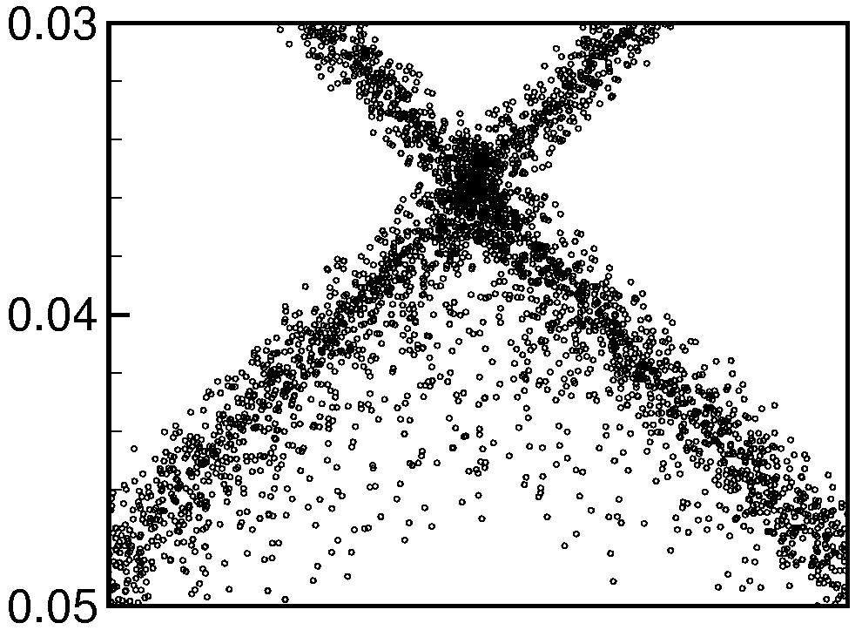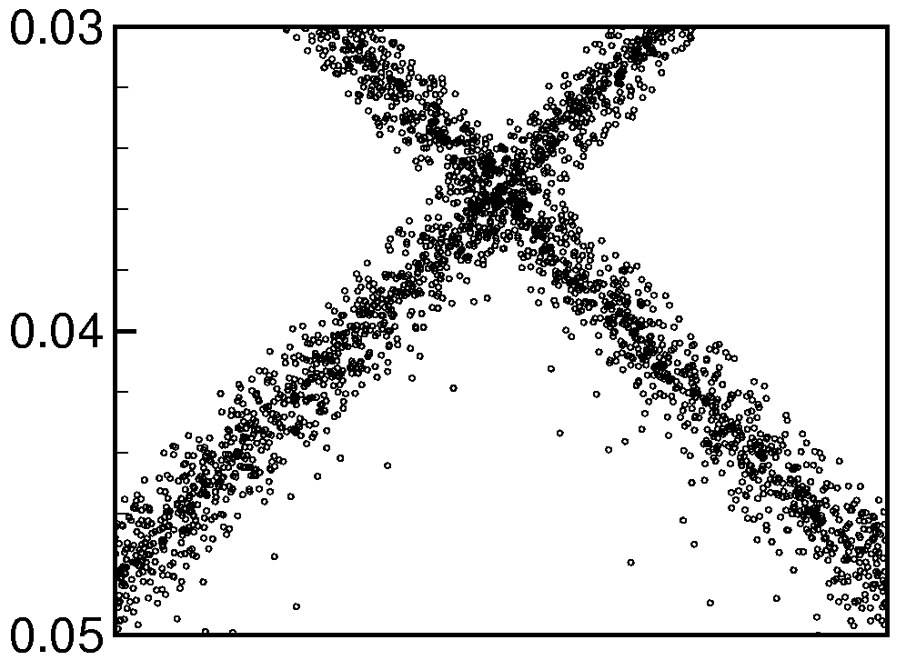
(a) New model (b) O’Rourke model
Figure 1. The predicted spray shapes around the impingement region for L-1 case at t=9 ms.

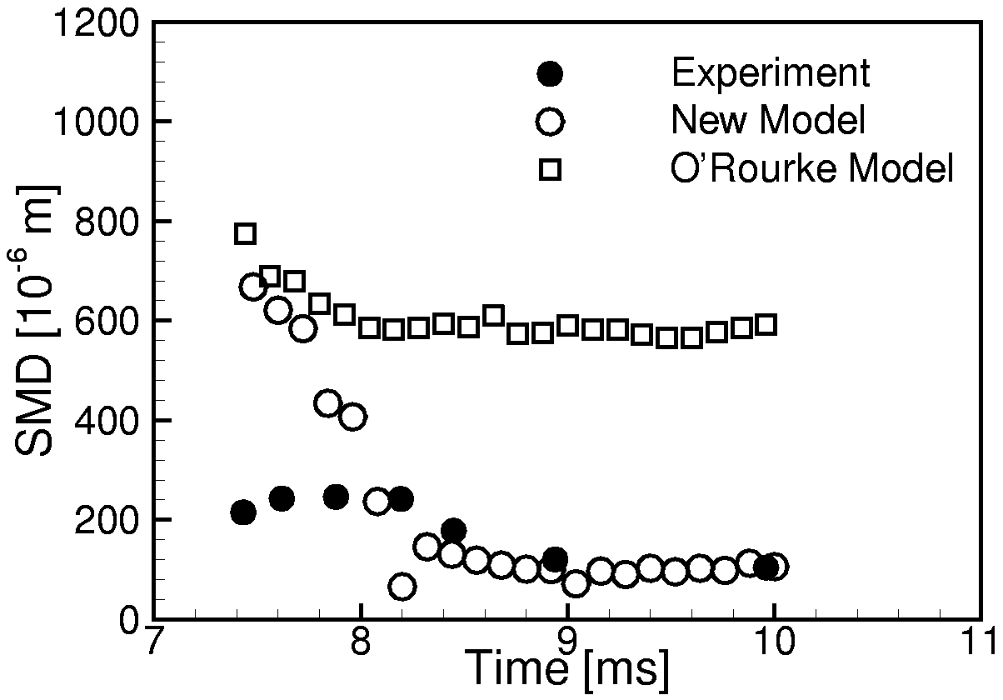
Figure 2. Comparisons of the SMD at 100 mm downstream from nozzle exit with experimental data⁴ for the L-1 case.
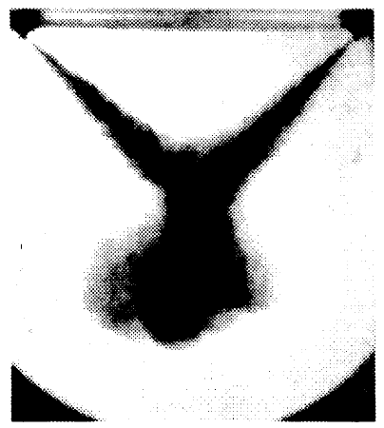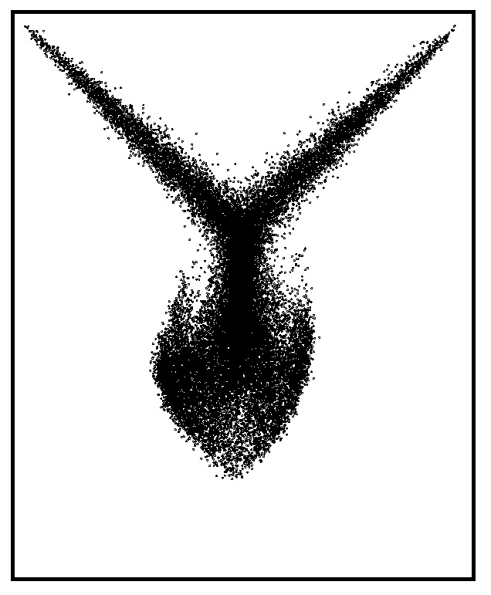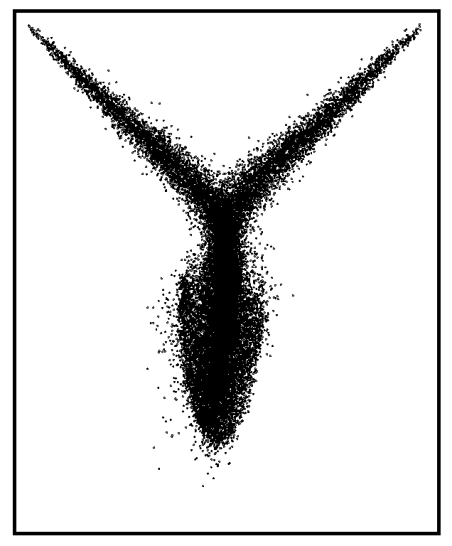
(a) Experiment (b) New model (c) O’Rourke model

Figure 3. Comparison of the predicted spray shape with the experiment⁵ for the H-1 case at t=2 ms.

droplets are newly formed due to collisions and interacted with main sprays as the spray develops downwards. However, the O’Rourke model fails to yield the small droplets due to collisions sufficiently. Figure 2 shows the SMD distributions for L-1 case at 100 mm downstream from nozzle exit. The hybrid model agrees well with experimental data after t = 0.8 ms, except at the early stage of injection start, whereas the O’Rourke model fails to predict the SMDs for a total duration time. Figure 3 compares the spray patterns for H-1 case at t = 2.0 ms after injection start. The present model yields better agreements with the experimental photographs than the O’Rourke model. It supports that the hybrid model is acceptable for predicting the spray-to-spray impingement system. However, the O’Rourke model significantly under-predicts the spray width. This discrepancy is because of differences between two models in predicting the collision frequencies.

CONCLUSION

In the cases of low gas pressure, the coarse distributions are present after impingement. It means that most of droplets pass through each other near the impingement region. The local SMDs predicted by the new hybrid model are in better agreements with experimental data than those by the O’Rourke model. For high gas pressure, the spray patterns changes into the swelled spray shape under the high pressure of gas phase. The hybrid model yields good agreements with the experimental photographs, whereas the O’Rourke model significantly under-predicts the spray width. Therefore, it can be concluded that the hybrid model is acceptable in predicting the collision and breakup processes in the spray-to-spray impingement system.

REFERENCES

- O’Rourke, P. J., Collective Drop Effects on Vaporizing Liquid Sprays, Ph.D. Thesis, Mechanical and Aerospace Engineering, Princeton University, USA, 1981.
- Gavaises, M., Modeling of Diesel Fuel Injection Processes, Ph.D. Thesis, Imperial College of Science and Technology and Medicine, Department of Mechanical Engineering, University of London, 1997.
- Nordin, N., Complex Chemistry Modeling of Diesel Spray Combustion, Ph.D. Thesis, Chalmers University of Technology, Sweden, 2000.
- Arai, M. and Saito, M., Atomization Characteristics of Jet-to-Jet and Spray-to-Spray Impingement Systems, Atomization and Sprays, Vol. 9, pp. 399 ~ 417, 1999.
- Chiba, T., Saito, M., Amagai, K. and Arai, M., Inter-Spray Impingement of Two Diesel Sprays, Proceedings of ICLASS2000, CA, USA, July 2000

