INFLUENCE OF DRAUGHTS ON THE BEHAVIOUR
OF A DYNAMIC air BARRIER Used IN AN OPEN PROTECTION DEVICE

Olivier Rouaud*, Michel Havet*, Camille Solliec**
*ENITIAA GEPEA - UMR CNRS 6144, rue de la Géraudière
BP 82225, 44322 Nantes 3, France
**Ecole des Mines de Nantes, GEPEA - UMR CNRS 6144, La Chantrerie
4 rue A. Kastler, BP 20722, 44307 Nantes 3, France
corresponding author : rouaud@enitiaa-nantes.fr

The influence of sudden external perturbations like draughts on an original safety device, made up of an unidirectional flow and a plane air jet, was assessed. Numerical simulations were carried out and compared with among others, laser tomography visualisations. Tracer gas experiments and numerical passive scalar evolution were also compared to quantify the protection efficiency of the system. In addition to the strong sensitivity of the system to the perturbations, our results show that a standard k-ε turbulence model is able to qualitatively describe the observed physical phenomena.

INTRODUCTION

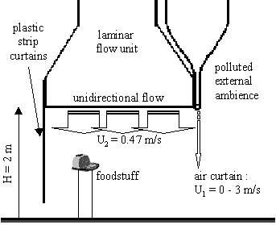
Air curtains made up of one or several plane air jets are now widely used as dynamic barriers to reduce the heat and mass transfers between two areas subjected to different environmental or climatic conditions. In food industries more particularly a plane air jet can be associated with a laminar flow unit to constitute an open protection device against potential airborne contamination. While the unidirectional flow blown from the laminar flow unit protects the food manufacturing, the air curtain allows the transit of people or materials (see Fig. 1). Although the efficiency of such devices was clearly demonstrated 1-4, there is a lack of studies which deal with the efficiency of these dynamic barriers subjected to external perturbations varying in time. To our knowledge, only Heitz 5 tackles these phenomena, in this case the influence of an arm introduction inside a mixing layer. Another perturbations such as draughts can occur in rooms and disrupt the development of the dynamic barriers. This research presents recent experimental and numerical results on the influence of draughts on the protection efficiency against particulate pollution of a plane air jet in isothermal conditions.
Fig. 1. Safety device against airborne contamination: original scale.

EXPERIMENTAL AND NUMERICAL METHODS

Draughts can be the consequence of door openings or outdoor wind effects. They are characterised by sharp changes of pressure, as shown in Fig. 2. Whether numerical or experimental studies, the aim was to obtain perturbations of the same order in the investigated geometry. Fig. 3 presents a sketch of the 2D geometry studied where the ¼ scale safety device is placed in an enclosure with controlled boundary conditions. A detailed description of the experimental set-up can be found in Rouaud 6. For the numerical simulations, the calculation field is discretised by about 10,000 cells and reproduces in details the geometry of the test bench. While the change of pressure is ensured by a simple manual door opening for the experiments, for the numerical study , particular pressure boundary conditions are applied on the left of the computational domain. As shown in Fig. 3, the time drops of the pressure obtained for both numerical and experimental studies are comparable.
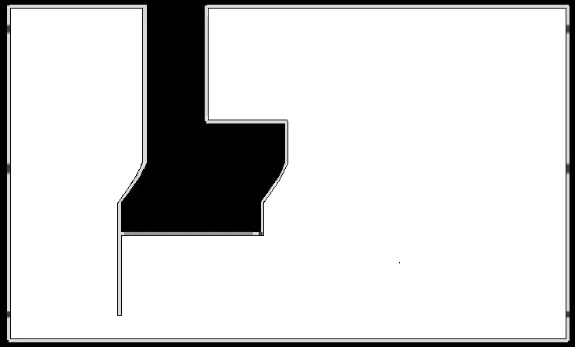
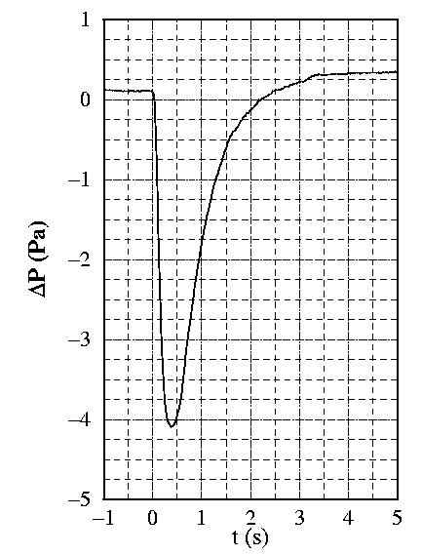
ΔP_{max}
external pressure conditions
air curtain
P₂
P₁
laminar flow unit
Fig. 2. Example of the pressure drop due to a door opening (measured in a 100 m³ room).
pollution
q₀C₀
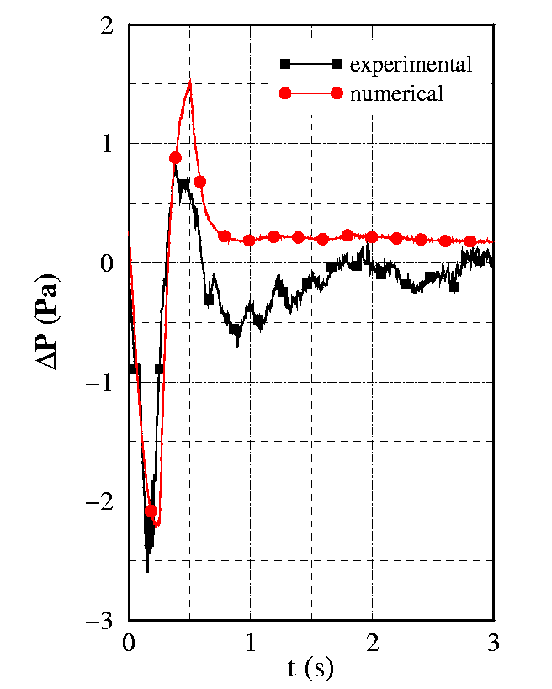
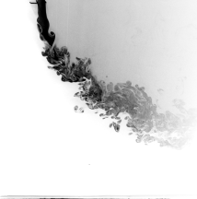
Fig. 3 Sketch of the domain investigated and evolution of the pressure with time ΔP = P₁-P₂.
sample points

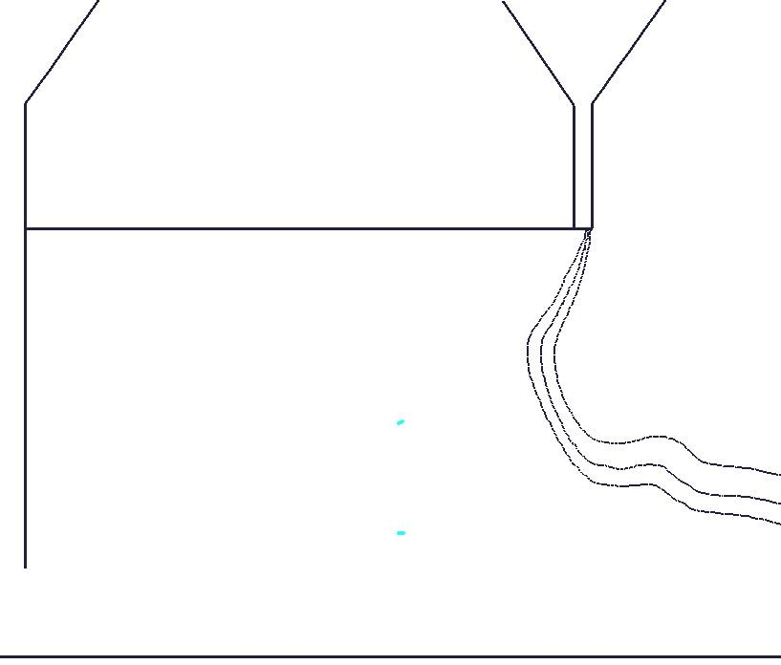
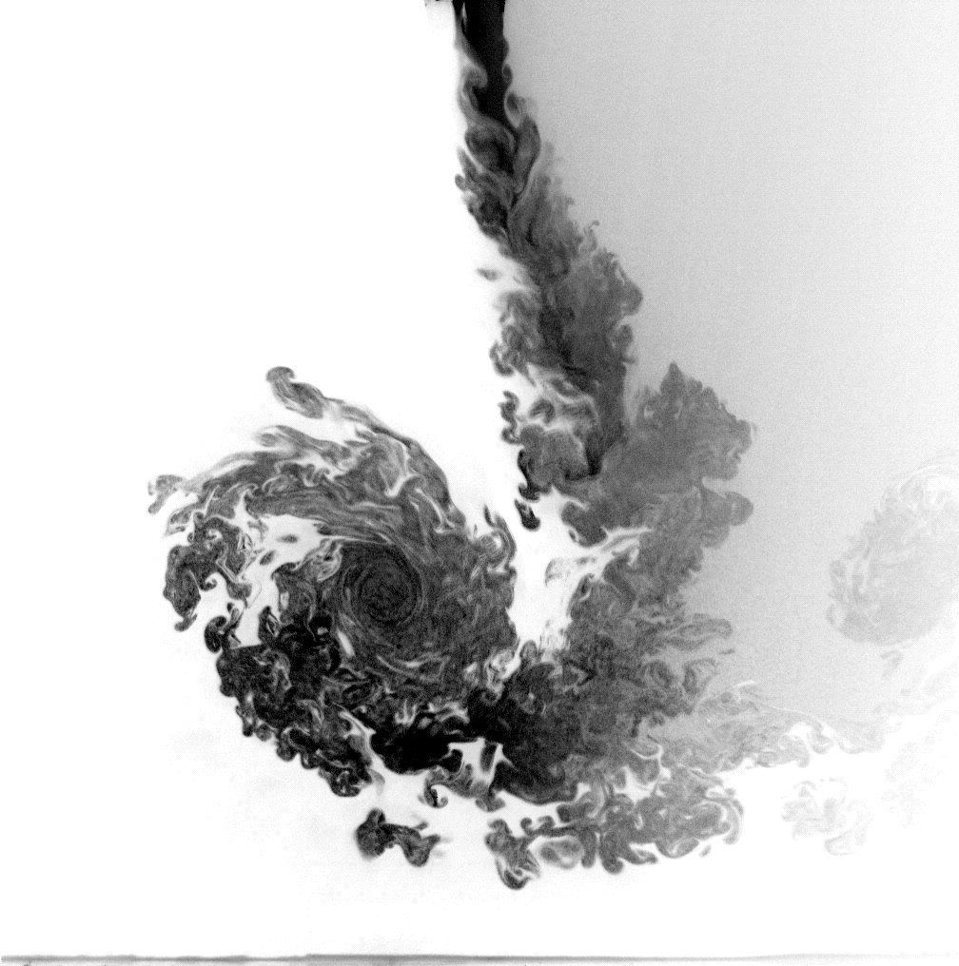
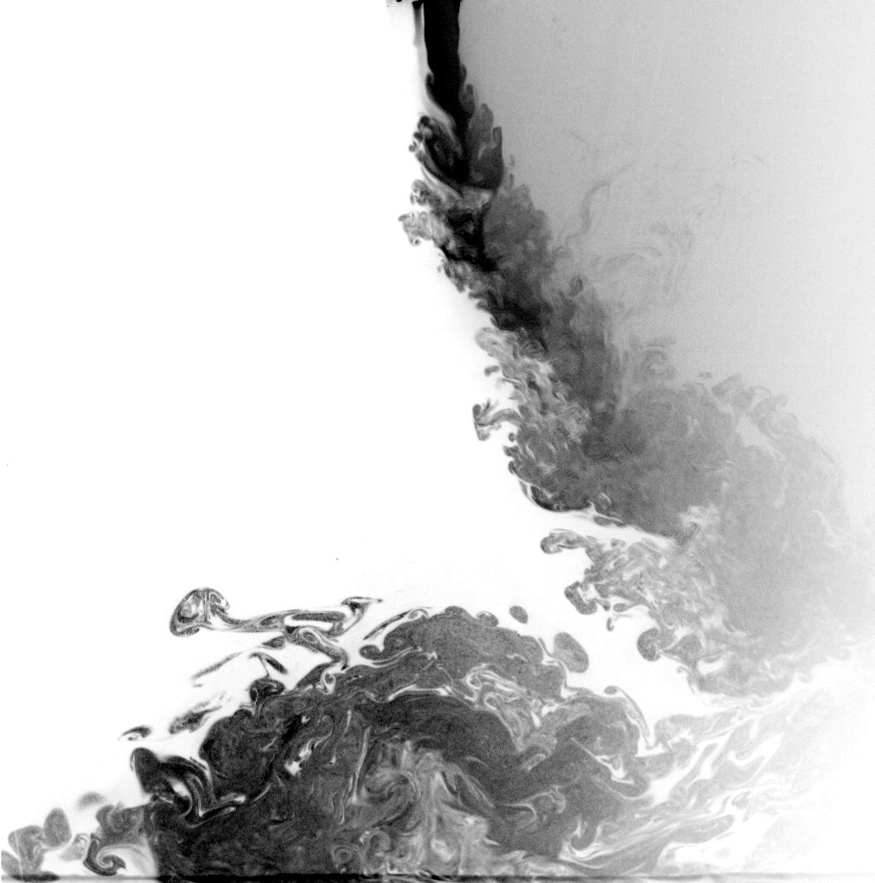
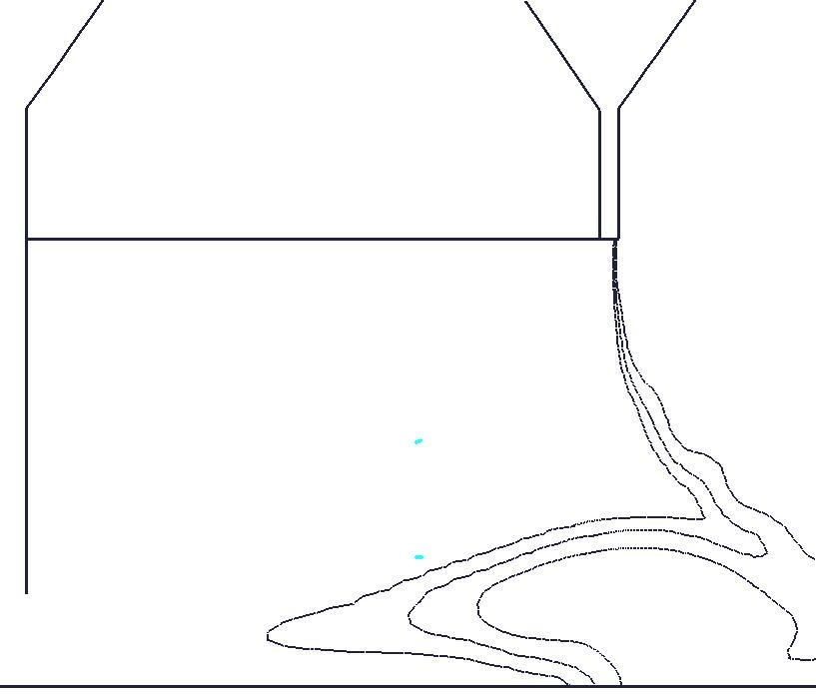
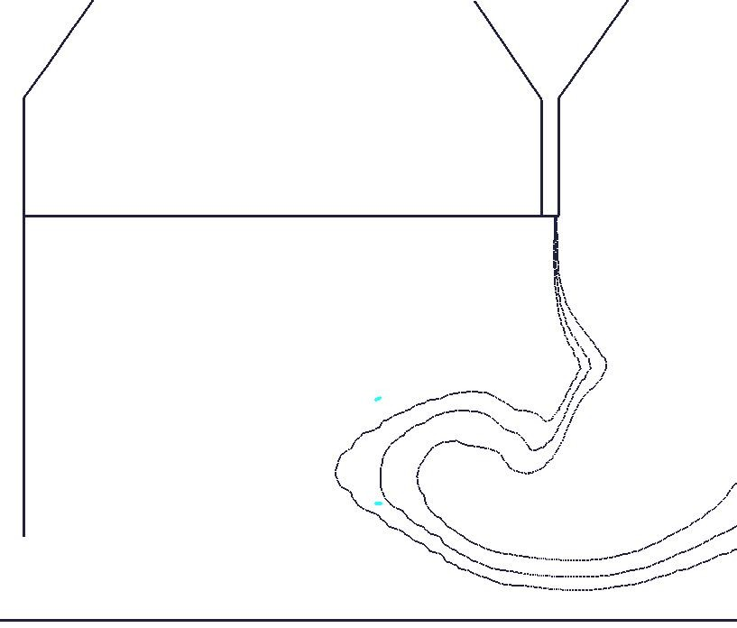
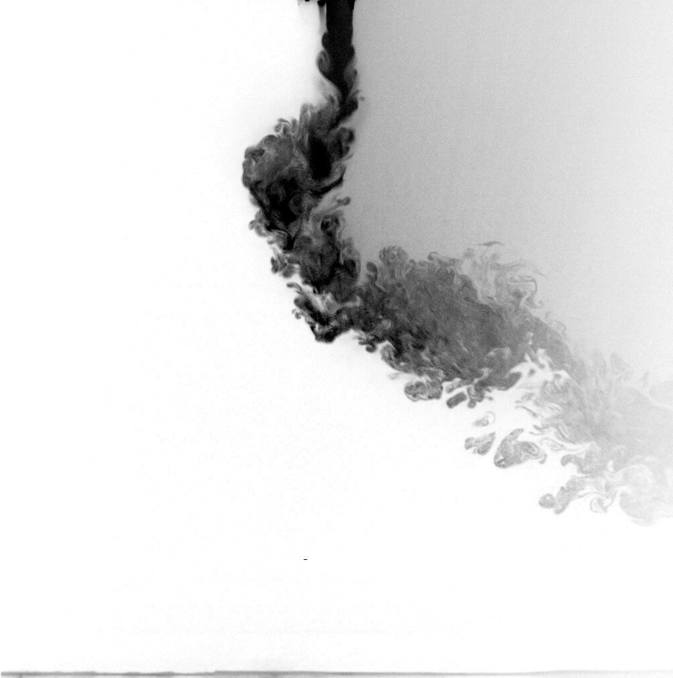
To evaluate the dynamic barrier efficiency, a pollution is generated with a constant rate outside the clean area. Two sampling points (up and down) exhibit the pollution concentration during the sharp change of pressure. In the framework of the airborne contaminations encountered in food industries, it is assumed that 99.9 % of the particles which must be eliminated have diameters less than 5 µm. In this particular case, the particles do not affect the flow. Thus, in the experiments a tracer gas (C₂H₆) is used as pollution and a flame ionisation detector (FID) is employed to measure the contamination of the protected area. For the numerical study, the pollution is assimilated to a passive scalar which perfectly follows the flow. The URANS equations which describe the motion of the turbulent airflow and the scalar dispersion are solved using the commercial CFD code ESTET with a standard k-ε model and a finite volume formulation.
Fig. 4 Prediction of the jet behaviour
for U₁ = 2.14 m/s
10⁻²
10⁻⁴
a)
t = 0.64 s
t = 0.64 s
t = 1.43 s
t = 1.43 s
t = 0.25 s
t = 0.25 s
b)
Experiments
Simulations

RESULTS

Behaviour of the jet

The efficiency of the device was evaluated according to several inlet jet velocities U₁ (0.98, 2.14 and 3 m/s). Previous experimental investigations had highlighted the complex behaviour of the air jet when it is subjected to external perturbations6. The jet, subjected to a rapid back and forth motion under the effect of the draughts, breaks and generates a vortex inside the protected area. For U₁ ≥ 2.14 m/s, this vortex hits the floor in the protected area whatever the value of the pressure drop ΔP_{max}. For U₁ = 0.98 m/s the vortex is pushed outside the protected zone for small ΔP_{max}. As seen in Fig. 4, the numerical results agree reasonably well with these experimental data and the behaviour of the jet is correctly simulated for each inlet velocity. Note that for readability, only 3 isolines of the normalised concentration are plotted to visualise the jet in the simulations although laser tomography visualisations are used in the experiments.

Efficiency of the protection device

Normalised concentrations recorded and simulated in the two sampling points are also compared. Air jets with inlet velocities greater than 2.14 m/s seem to minimise or prevent the passage of the pollution from the outside to the cleaned area. Indeed, it appears from numerical and experimental results that using a jet with U₁ = 2.14 m/s ensures a good protection of both sample points. The results also show that a jet with U₁ = 0.98 m/s is detrimental to the protection of the 'up' point. As concerns the 'down' point, while the maximum pollution is predicted with U₁ = 3 m/s (pollution due to the strong impact of the recirculation zone), the experimental data indicate again that the jet with U₁ = 0.98 m/s gives rise to the worst configuration in terms of protection against external contamination.

CONCLUSION

The response of a plane air jet to draughts was investigated. The use of different experimental tools associated to a numerical study gave us the understanding of the behaviour of the jet submitted to sudden perturbations according to its blowing velocity. Numerical results qualitatively agreed with experimental data and leaded to several conclusions. First, the open protection device is strongly influenced by external perturbations made up of sharp changes of pressure. Numerical simulations also suggest that the food processes are more protected for U₁ = 2.14 m/s, which is partially confirmed by experimental investigations. Finally, a classical k-ε turbulence model seems to be sufficient to qualitatively describe the jet behaviour and can be used to the initial design of such installations.

REFERENCES

1. Johnson, D. A., What are some benefits of an air curtain?, AMCA supplement to ASHRAE Journal, pp. 40-43, september 1998.
2. Rydock, J. P., Hestad, T., Haugen, H. and Skaret, J. E., An isothermal air curtain for isolation of smoking areas in restaurants, Proceedings of 7th International Conference on Air Distribution in Rooms - Roomvent, Reading, U.K., july 9-12, 2000.
3. Hu, S. C., Chuah, Y. K. and Yen, M. C., Design and evaluation of a minienvironment for semiconductor manufacture processes, Build. Environ., Vol. 37, pp. 201-208, 2002.
4. Navaz, H. K., Faramarzi, R., Gharib, M., Dabiri, D. and Modarress, D., The application of advanced methods in analyzing the performance of the air curtain in a refrigerated display case, J. Fluids Eng., Vol. 124, pp. 756-764, 2002.
5. Heitz, D., Etude expérimentale du sillage d'un barreau cylindrique se développant dans une couche de mélange plane turbulente, PhD Thesis, Université de Poitiers, Poitiers, 1999.
6. Rouaud, O., Etudes numériques et expérimentales de dispositifs de protection contre la contamination aéroportée dans les industries alimentaires, PhD Thesis, Université de Nantes, Nantes, 2002.

