ANALYSIS OF SYNTHETIC MICRO-JETS USING CBS FINITE ELEMENT METHOD ON MOVING DEFORMING GRIDS

Bayram Celik, Firat O. Edis , Aydin Misirlioglu
Faculty of Aeronautics & Astronautics
Istanbul Technical University
Maslak, 34626 Istanbul, Turkey

Introduction

Synthetic Micro-jets

During the past few years, the development in micromachining technology has increased the interest in microelectromechanical systems (MEMS). MEMS are small devices which have characteristic size range from submilimeter to submicrometer and may include sensors, actuators, motors, pumps, turbines, gears, ducts and valves. One of the MEMS technology products is synthetic jet and it is used for various applications including cooling of electronic packages, micro mixing and aerodynamic flow control. A synthetic jet is a zero net mass flow fluidic device and flow is generated at the orifice of a cavity by oscillating membrane opposite to the orifice as seen in Figure 1. Oscillatory motion of the membrane produces the fluctuating jet flow, it interacts with the main flow and transfers linear momentum to the main flow.
H
d
A
Cross flow
W
h
Oscilating Membrane
Free Stream
sdSStreamStream
Free Stream sdSStreamStream
Free Stream
sdSStreamStream
Figure 1.Synthetic jet Configuration

In Figure 1, a sample geometry and flow field is defined. In the figure, d and h are the slot width and height respectively. H and W are the cavity height and length respectively. Maximum oscillation amplitude of the membrane is denoted by A. A sample grid for the computations is shown in Figure 2.
The geometry and of the cavity and oscillation frequency of the membrane are important parameters in determining the efficiency of the jet producing desired flow deflections. The effect of these parameters are investigated in various numerical and experimental studies¹⁻⁴.

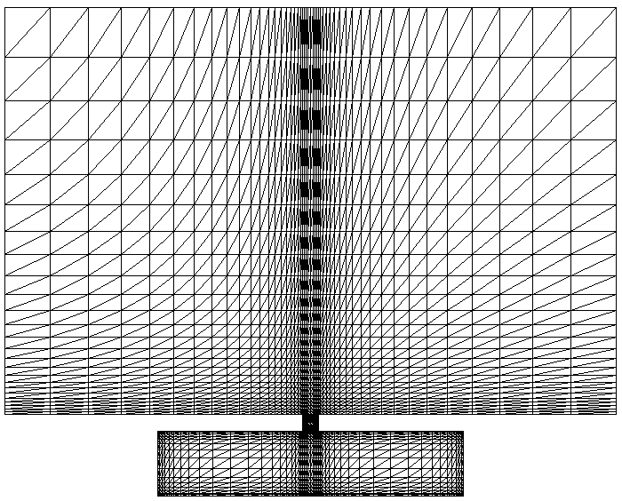
Figure 2.Numerical grid for the synthetic jet configuration

Slip regime

In micro devices, the flow regimes can be characterized by the Knudsen number (Kn, the ratio of gas mean free path λ to a characteristic microfluidic length L) ⁵. A full continuum or a full free-molecular analysis may be applicable depending on the Kn range. Typically, the continuum regime is in the range of Kn≤0.001. For the slip regime 0.001≤Kn≤0.1 and the Knudsen number of the transition regime is between 0.1 and 10². In the slip regime, the conventional Navier-Stokes solvers can be used for analysis if standard boundary conditions are modified.

Moving-deforming mesh

In the present study, flows in continuum regime are considered and they are modeled using Characteristic-Based-Split (CBS) algorithm as a Navier-Stokes solver⁶⁻⁸. To investigate numerically the diaphragm driven flow in and out of the synthetic jet cavity geometries, CBS algorithm can be coupled with space-time-finite element/moving-deforming-grid concept using ALE description⁹⁻¹⁰. It is required for modeling the movement of the piezoelectric-driven diaphragm of the cavity in realistic manner and computing the flow inside the jet cavity accurately¹. Coordinates of the nodes on the oscillating membrane are changed in time and known at every time step. But the coordinates of the nodes inside the cavity have to be determined by using nodes on the membrane and fixed nodes on the solid walls. It can be done by using a simple interpolation formula⁹⁻¹⁰.

Solver Implementation

Standard CBS algorithm, which can be applied to both compressible and incompressible flow problems, is used to analyze the micro synthetic jet by modifying the boundary conditions to account for the slip velocity and the temperature jump condition encountered in MEMS geometries for the Kn number up to 10⁻¹. Details of the Finite-Element formulation and the solution strategies of the CBS algorithm can be found in⁶⁻⁸. Pseudo-quadratic velocity/linear pressure elements (pP2P1) are employed in order to reduce the size of the implicit part of the CBS algorithm^{6, 11}. pP2P1 elements are constructed by dividing the pressure element, over which the pressure is interpolated linearly or bi-linearly, into sub-elements, over which the velocity also is interpolated linearly or bi-linearly. Combination of these first order velocity interpolations can be considered as pseudo second order velocity interpolation over the original pressure element. Overall, the solution can also be considered to be obtained on two different grids, one for the velocity solution and the other for the pressure solution. pP2P1 element is obtained by inserting mid nodes to the parent pressure element and interconnecting these to give 4 sub-elements over which the velocity is interpolated linearly¹¹.

Conclusion

Flow field generated by a synthetic micro-jet is analysed by implementing a CBS algorithm on a moving deforming grid with boundary conditions modified to accommodate for the slip and temperature jump observed in micro geometries. The results presented will include the flow field inside and outside of the cavity and effects of various parameters.

REFERENCES

- Aslan, R. A., Baysal, O., and Edis, F.O., Computing Micro Synthetic Jet in slip Regime with Moving Membrane, Proceedings of 2002 ASME International Mechanical Engineering Congress and Exposition, New Orleans, Louisiana November 17-22, 2002
- Smith. B.L. and Glezer, A., Vectoring and Small-Scale Motions effected in Free Shear Flows Using Synthetic Jet Actuators, AIAA 97-0213.
- Kiddy, J., Chen, P., Niemczuk, J., DeVoe, D. and Kiger, K., Active Flow Control using MEMS, Proceedings of AIAA SDM Conference, 2000.
- Kral, L.D., Donovan, J.F., Cain, A.B. and Cary, A.W., Numerical Simulation of Synthetic Jet Actuators, AIAA Paper 97-1824, 1997
- Gad-el-Hak, M. (Editor), MEMS Handbook, CRC Press, 2002, New York, NY.
- Edis, F. O., Aslan, R.A. and Celik B., Implementation of pseudo-second order velocity interpolation within the Characteristic-Based-Split Procedure European Congress on Computational Methods in Applied Sciences and Engineering ECCOMAS Computational Fluid Dynamics Conference 2001 Swansea, Wales, UK, 4-7 September 2001
- O.C. Zienkiewicz and R. Codina, A general algorithm for compressible and incompressible flows. Part I: The split, characteristic-based scheme, Int. J. Numer. Meth. Fluids, 20, 869-885 (1995).
- O. C. Zienkiewicz, P. Nithiarasu, R. Codina, M. Vazquez, and P.Ortiz, The characteristic- based-split procedure: an efficient algorithm for fluid problems, Int. J. Numer. Meth. Fluids, 31, 359-392 (1999).
- Gulcat, U., Misirlioglu, A. and Aslan, A. R., 3-D Navier-Stokes solutions with moving deforming finite elements, Communications in Numerical Methods in Engineering, Vol. 13, pp. 273-284, 1997
- Gulcat, U., Misirlioglu, A. and Aslan, A. R., 3-D viscous flow solution about the bodies in relative Motion, International journal of Computational Fluid Dynamics, Vol. 14, pp 1-19 2000
- Edis, F. O., Efficient finite element computation of incompressible viscous flows using pseudo-second-order velocity interpolation, Ph.D. Thesis, Istanbul Technical University, 1998

