ThermocapIllary Bubble MotIon WIth VarIable VIscosIty

S. Nas*, M. Muradoglu§ and M.O. Kaya*
*Department of Aeronautical and Astronautical Engineering,
Istanbul Technical University, Istanbul, Turkey
§Department of Mechanical Engineering,
Koc University, Sariyer, Istanbul, Turkey

Computations of thermocapillary motion of two dimensional bubbles in a non uniform temperature field are presented. One field formulation of Navier-Stokes equations coupled with energy conservation equation are solved by a Finite Difference/Front Tracking method[1]. In this method, the governing equations are written for whole computational domain and the different phases are treated as a single fluid with variable material properties. We assume temperature dependent surface tension and viscosity. The effect of variable viscosity due to temperature variation on the thermocapillary motion of the bubbles is studied and dependence of the motion on various governing non-dimensional parameters is examined. Numerical solutions for a non-deformable single isolated bubble are compared with the analytical solution in the limit of infinitely large Reynolds (Re) number. The interactions of two bubbles are also studied in various geometrical orientations and the method is applied to the thermocapillary motion of a bubble cloud. The results are compared with the temperature-independent viscosity cases.

Introduction
In the absence of gravity bubbles and drops in an ambient fluid will move in the direction of temperature gradient due to thermocapillary forces. Surface tension usually decreases with increasing temperature and these non uniform surface tension causes shear stresses on the bubble surface. These stresses are transmitted to the ambient fluid by viscous forces inducing a motion of the bubble in the direction of temperature gradient[2].

When the buoyancy forces are negligible, i.e., under microgravity conditions in the space, the thermocapillary forces can be dominant. For example, the thermocapillary migration can be used to remove gas bubbles in the melt before solidification in material processing under the microgravity conditions[3]. The thermocapillary motion can also be important in two-phase heat exchanger design since the bubbles migrate towards the hot surfaces and reduces heat transfer effeciency.

Thermocapillary motion of a single isolated bubble was first studied both experimentally and theoretically by Young et al.[4]. The thermocapillary motion of a single and many bubbles have then studied extensively by several authors including Balasubramainiam and Lavery[5], Szymczyk and Siekmann[8] and Haj-Hariri et al. [7].

Numerical simulations of thermocapillary migration of isolated single bubble as well as bubble clouds have been performed by Nas[9] and Nas and Tryggvason[10] using a Finite Difference/Front Tracking method for the case of temperature independent viscosity. In the present study, the Finite Difference/Front Tracking method is extended to account for the effects of the variations in viscosity due to non-uniform temperature field for the cases of single bubble, two-bubble interactions in different geometrical orientations and interactions of many bubbles in a bubble cloud. It is first assumed that only the ambient viscosity reduces linearly with the increasing temperature and the results for this case are compared with the analytical solution provided by Balasubramaniam[6]. To be consistent with the reality, an exponetial dependence of the viscosity on the absolute temperature is then assumed. Therefore the viscosities of both the ambient fluid and gas in the bubble are taken to be function of temperature. The results are compared with the temperature independent viscosity cases.

Preliminary computations of thermocapillary migration of a single bubble in a temperature independent and temperature-dependent viscosity cases are plotted in figure 1. The computational domain is taken as $8\text{ax}\text{32}a$ in horizontal and vertical directions, respectively, where $a$ is the initial bubble radius. The computational domain is resolved by $\text{128}x\text{512}$ uniform Cartesian grid. The top and bottom walls are taken as no-slip boundaries with constant temperature $T_{\text{hot}}$ and $T_{\text{cold}}$, and horizontal boundaries are periodic. The velocity vectors in the entire computational domain and near the bubble are shown in figures (a) and (b), recpectively for the case of linearly varying viscosity with temperature. The temperature and viscosity contours are plotted in figures (c) and (d) for the same case. Finaly, the terminal velocities for temperature-independent and temperature-dependent viscosity cases are shown in figures (e) and (f), respectively. It can be seen that the terminal velocity is reduced in variable viscosity case for about 10%.

References

- Unverdi, S. O. and Tryggvason, G. A front-tracking method for viscous, incompressible, multi-fluid flows. J. Comp. Phys, 100(1):25--37, 1988.
- Nas, S. and Tryggvason, G. Computational Investigation of the Thermal Migration of Bubbles and Drops. In AMD 174/FED 175 Fluid Mechanics Phenomena in Microgravity, Ed. Siginer, Thompson and Thefethen, ASME Winter Annual Meeting, 1993.
- Uhlmann, D.R. Glass Processing in a Microgravity Environment. Materials Processing in the Reduced Gravity Environment of Space, Edited by Rindone, G.E., Elsevier, NY, USA, pp.269—278, 1982.
- Young, N.O., Goldstein, J.S., Block, M.J. The Motion of Bubbles in a Vertical Temperature Gradient. J. Fluid Mech., 6:350—356, 1959.
- Balasubramaniam, R., Lavery, J.E. Numerical Simulation of Thermocapillary Bubble Migration Under Microgravity for Large Reynolds and Marangoni Numbers. Num. Heat Transfer A, 16:175--187, 1989.
- Balasubramaniam, R. Thermocapillary and Buoyant Bubble motion with variable viscosity. Int. J. Multiphase Flow, 24(4):679--683, 1998.
- Haj-Hariri, H., Shi, Q., Borhan, A. Thermocapillary Motion of Deformable Drops at Finite Reynolds and Marangoni Numbers. Phys. Fluids, 9(4):845--855, 1997.
- Szymczyk, J.A., Siekmann, J. Numerical Calculation of the Thermocapillary Motion of a Bubble Under Microgravity. Chem. Eng. Commun., 69:129--147, 1988.
- Nas, S. Computational Investigation of Thermocapillary Migration of Bubbles and Drops in Zero Gravity. Ph.D. Thesis, The University of Michigan, 1995.
- Nas, S. and Tryggvason, G. Thermocapillary Interaction of Two Bubbles or Drops. Int.J.MultiphaseFlow,(submitted),2002.
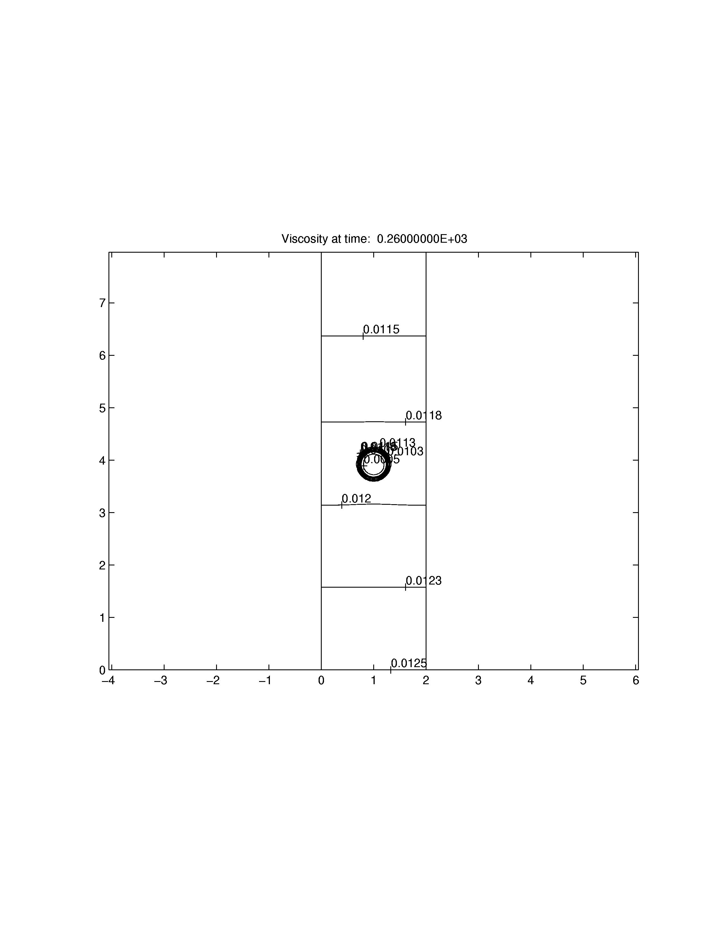
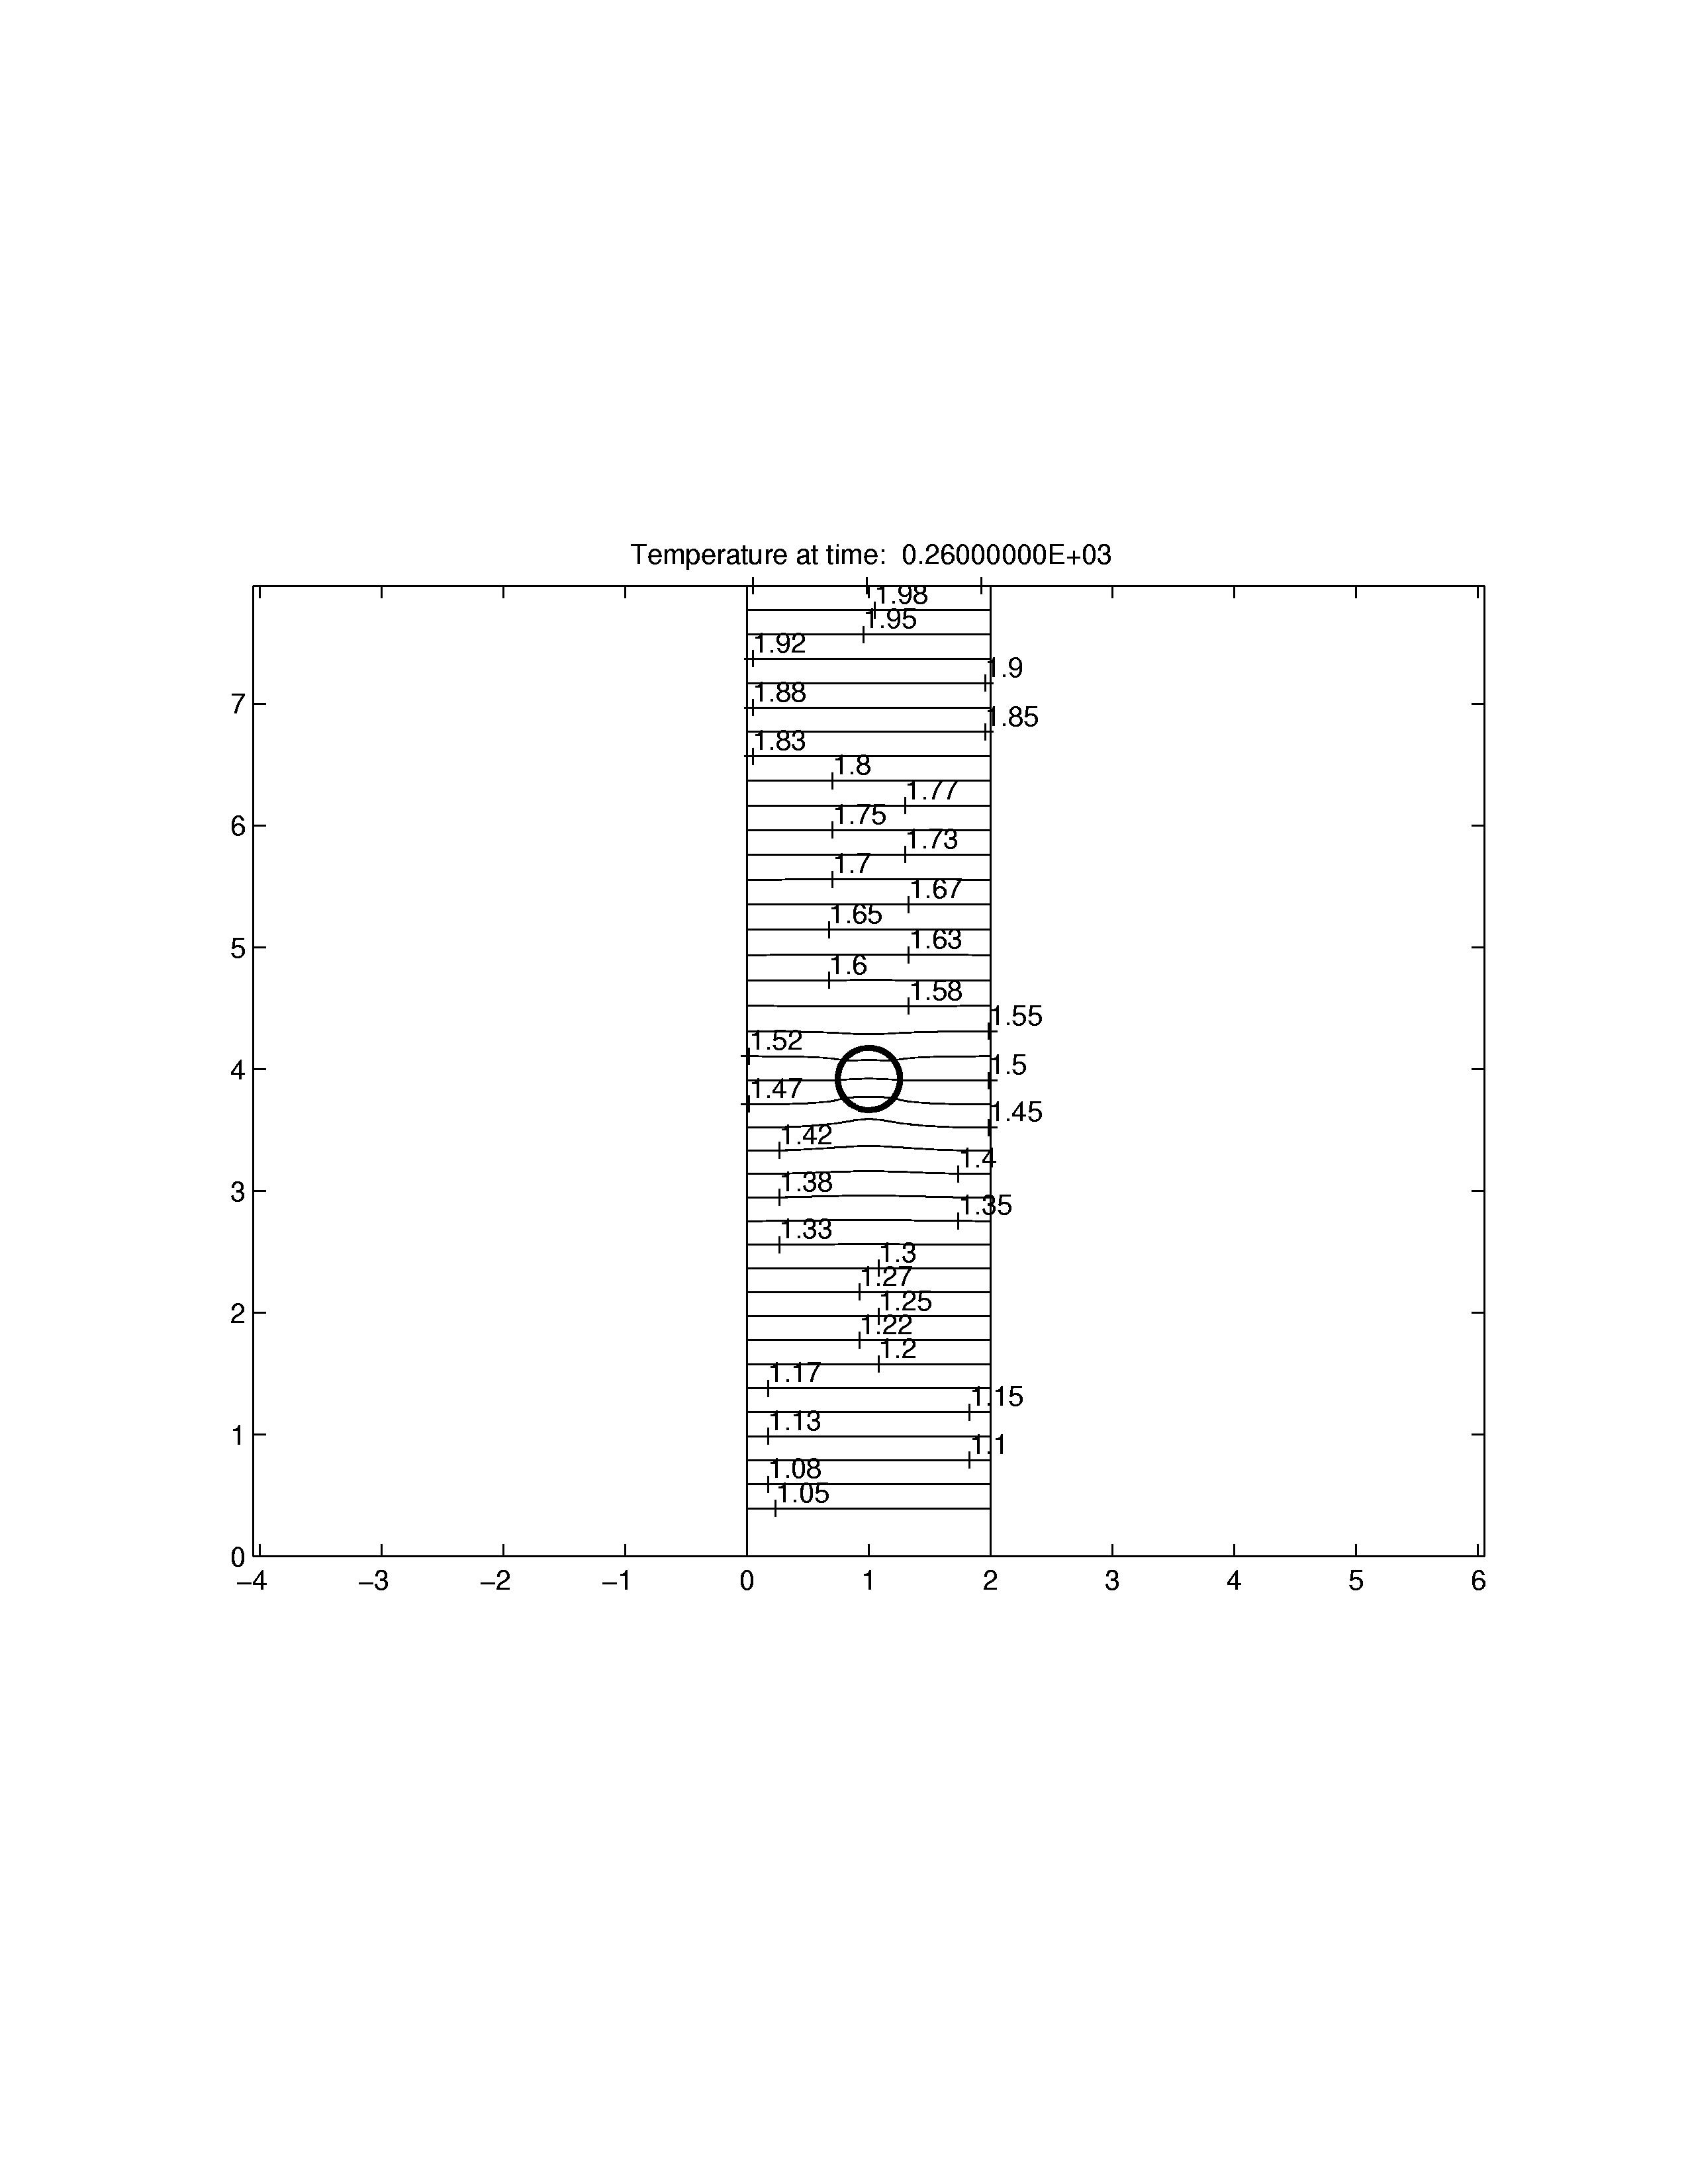
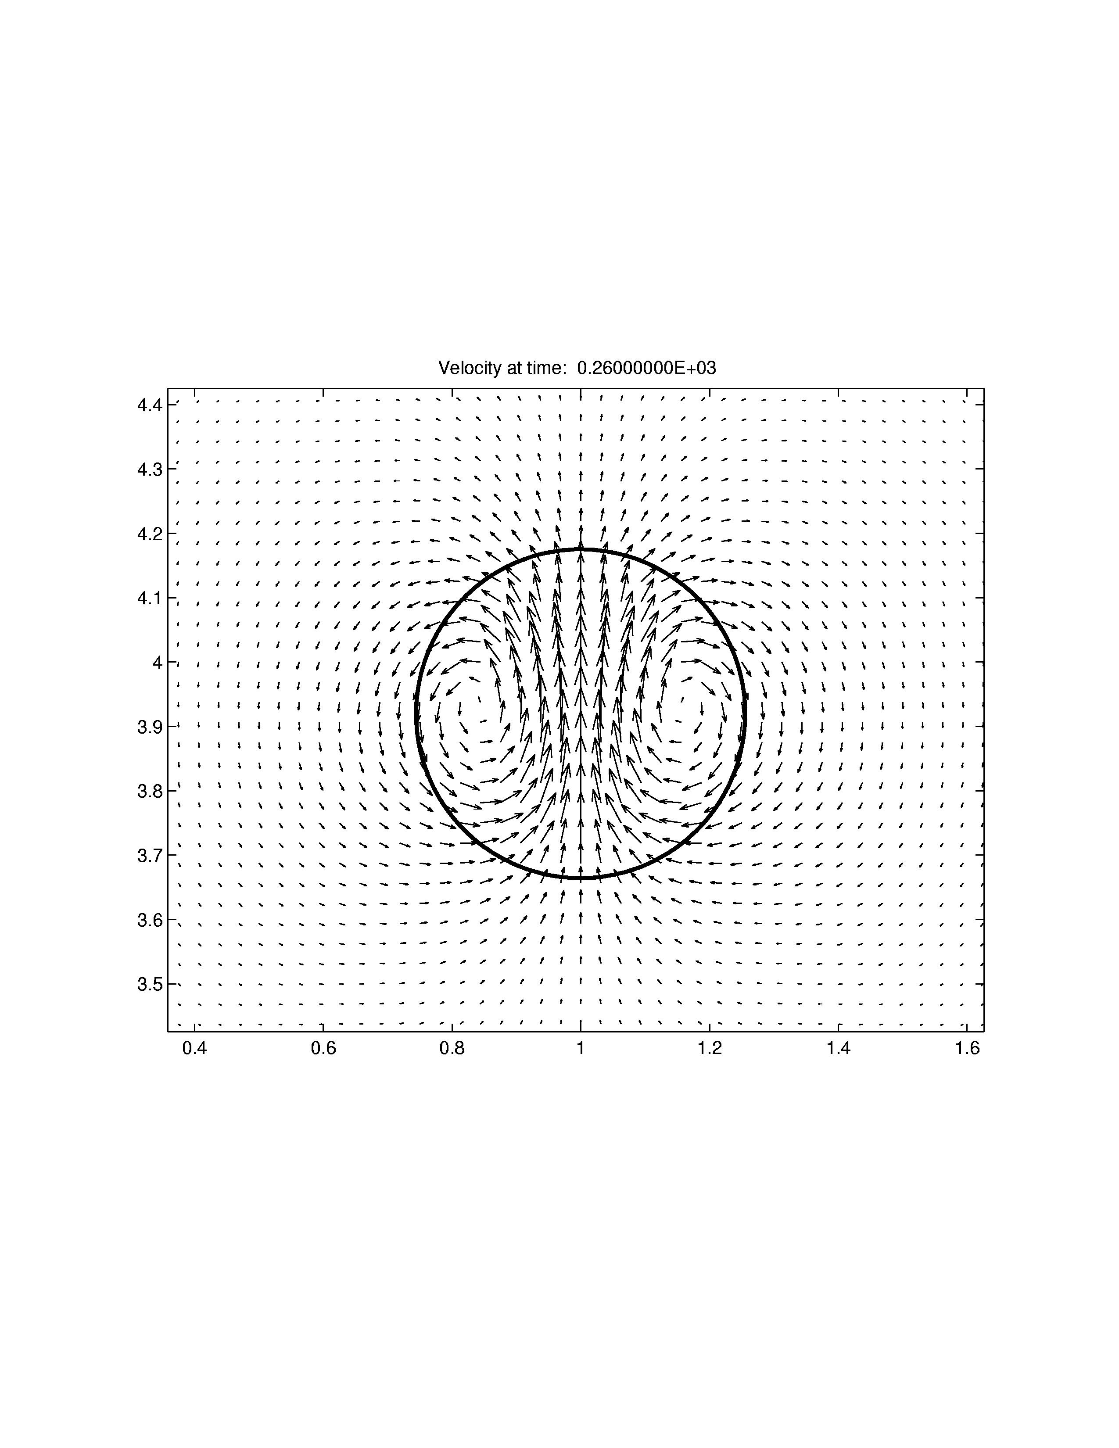
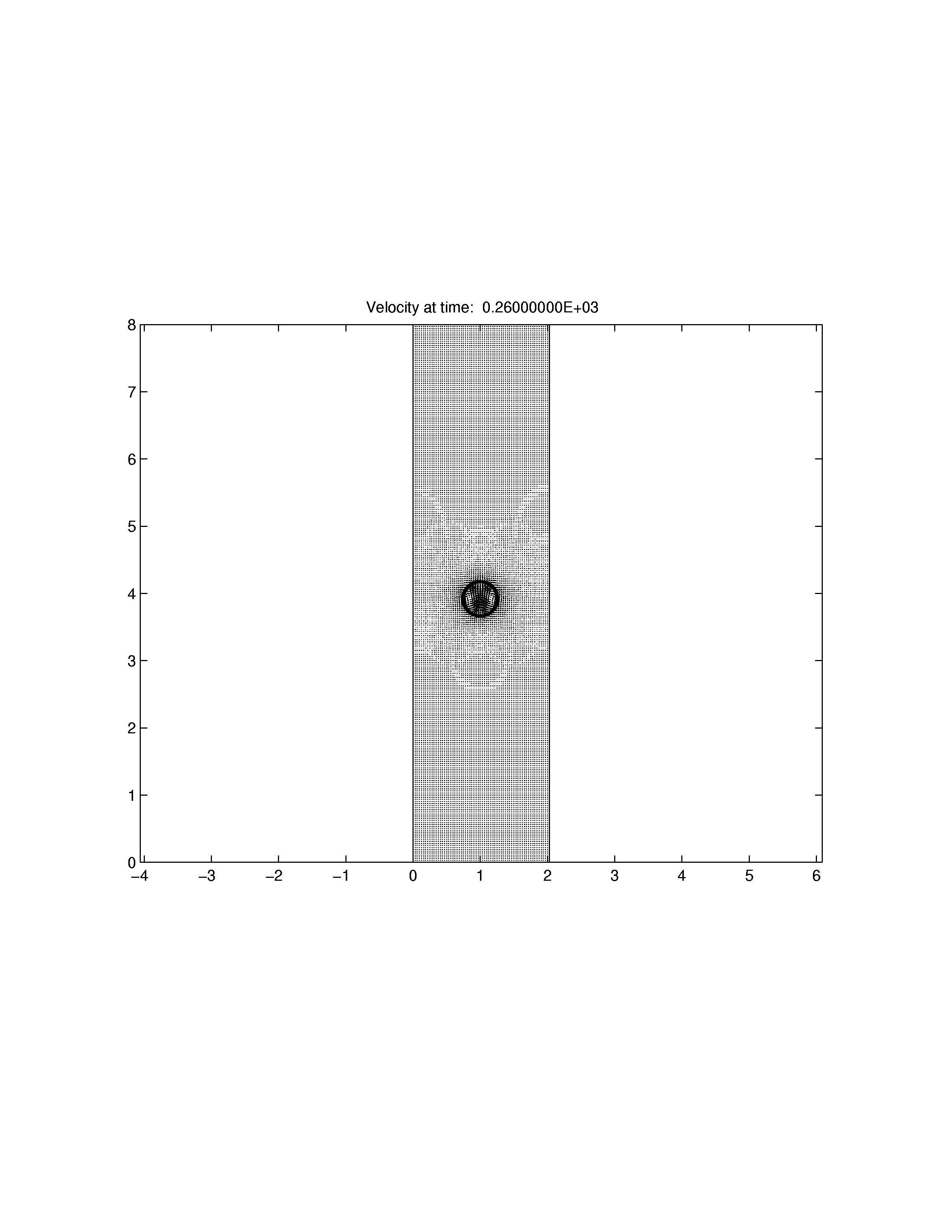
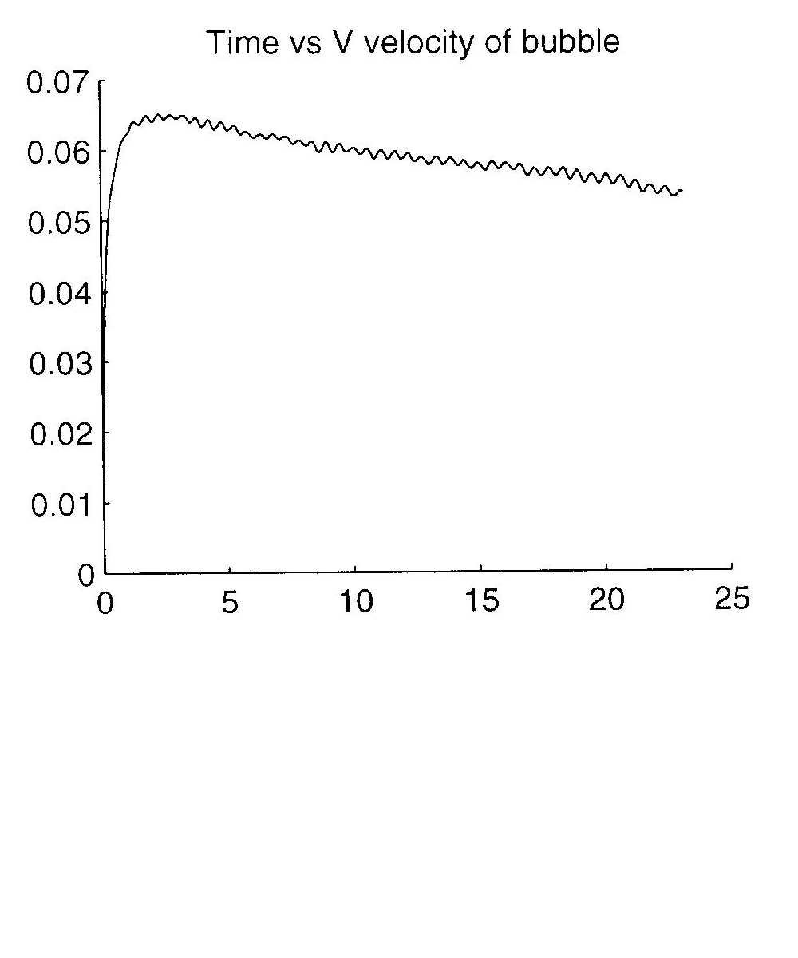
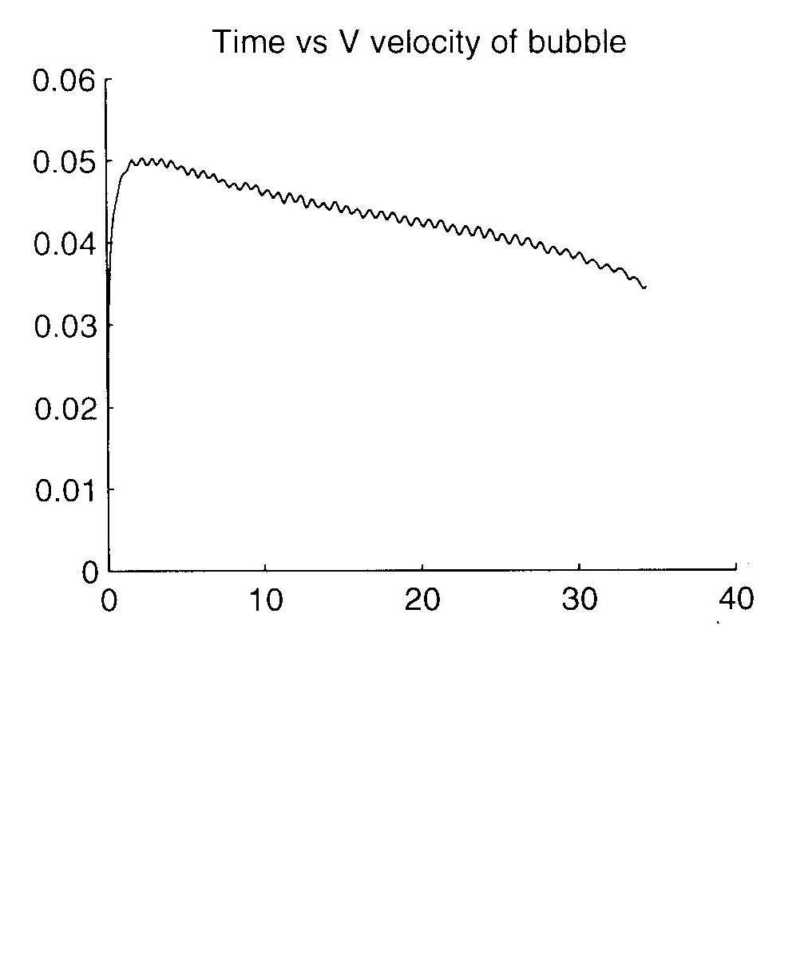
(c)
(d)
(e)
(f)
(a)
(b)
Figure 1

