HYDRODYNAMIC BEHAVIOR OF CONDENSATE OF CARBON DIOXIDE
IN THE SUBCRITICAL REGION

Isao Ishihara*, Hironori Mori**, Ryosuke Matsumoto*, Koichi Takemori*
* Department of Mechanical Engineering, Kansai University,
3-3-35 Yamate-cho, Suita, Osaka 564-8680 Japan
** Air-conditioning & Refrigeration System Hdqrs., Mitsubishi Heavy Industries, LDT.,
3-1 Asahi-machi, Nishibiwajima-cho, Nishikasugai-gun, Aichi-ken, 452-8561 Japan

EFFECTS OF PHYSICAL PROPERTY ON CONDENSATION

Condensation takes place in the cooling heat transfer process in power plants, chemical plants and other industrial plants. A great deal of papers have been reported the condensation heat transfer and condensate flow. As condensation heat transfer mainly depends on the thickness of condensate, it is very important to reveal the hydrodynamic behavior of condensate. In recent years, it is urged to take new measures against the global warming due to accumulation of the carbon dioxide gas –one of the greenhouse gases- in the atmosphere. The technology of ocean sequestration is considered as one of the effective measures, in which the liquefying process of the carbon dioxide gas under high pressure is comprised. This paper focuses on the condensate flow of carbon dioxide along the outer surface of a cooled vertical cylinder and the heat transfer under natural convection in the subcritical region, where some of the physical properties have a remarkable large dependence on both of the pressure and temperature. In such the condition, the density difference between the vapor and liquid decreases towards the critical point (Pc=7.383MPa, Tc=305.20K for carbon dioxide), and this small difference causes that the buoyancy becomes comparable to the gravity force, so that the flow velocity of condensate decreases. A small value of latent heat in the subcritical region makes the amount of condensate very large. This results in a thick layer of the condensate film. On the contrary, as the temperature approaches the critical temperature, the surface tension decreases sharply and approaches zero at the critical point. This very low value makes the condensate film breakable.

RESULTS AND DISCUSSION

Flow regime of condensate

As hydrodynamics of the condensate affects the condensation heat transfer, the state of the condensate flow was observed in detail. As a result, the flow of condensate film is classified into four regimes: smooth laminar flow, wavy flow, wavy flow with sharp crests and wavy flow with scattered droplets.
(1) Laminar flow (LF): The flow regime in which the wave does not exist in a liquid film surface.
(2) Wavy flow (WF): The flow regime in which the cyclic wave exists on the condensate film surface.
(3) Wavy flow with sharp crest (WF-C): The flow regime, in which the wave height is lower than the wavy flow and the crest of the wave is sharp.
(4) Wavy flow with scattered droplet (WF-D): The flow regime in which many droplets torn from top of the crest of the wave scatter into the ambient vapor and flow down along with the wavy film of the condensate. Figure 1 shows representative photographs of these classified flow regimes; the state of condensate on the full size of condensing surface (50mm height x 40mm diameter), enlarged photographs of the square area and illustrative sketches of the circular area. And figure 2 illustrates the flow pattern map obtained from observations in the present experiment. Laminar flow of the condensate film appears only at low vapor pressure Pv and very small temperature difference ΔΤ between the vapor and the condensing surface as shown in figure 1(1).
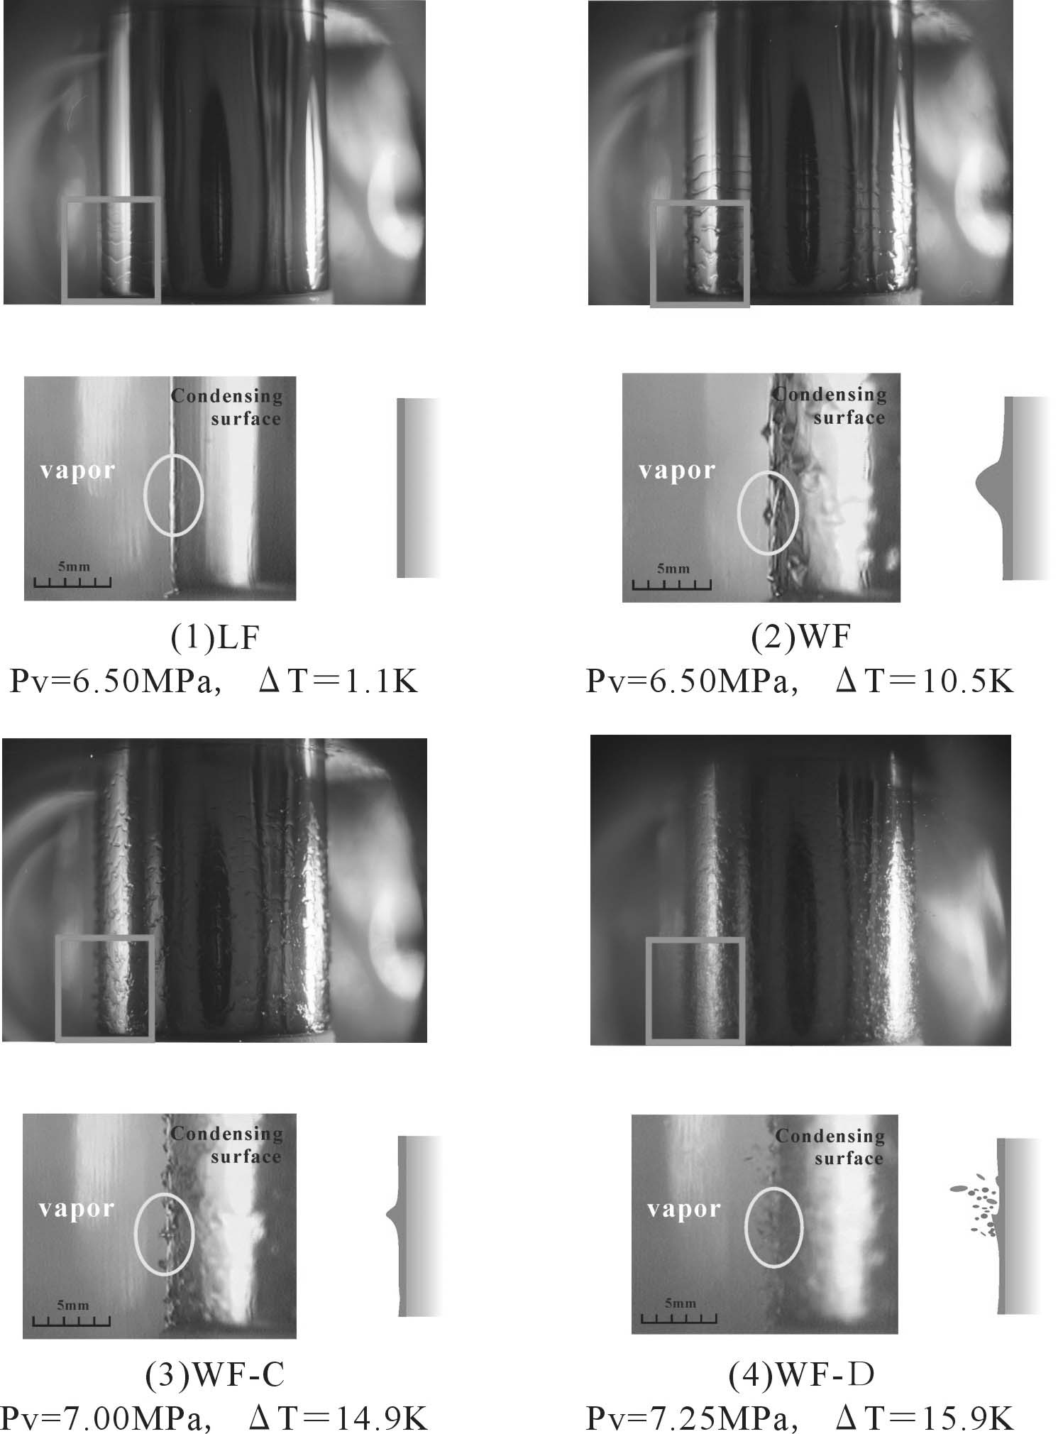
Figure 1 Photographs and sketches of the state of condensate

Figure 2 Flow pattern map
As ΔΤ increases, the flow changes into wavy flow (figure 1(2)) due to an increase of volume of the condensate. The wavy flow is also found in Pv=7.2MPa, but it is limited in case of very small ΔΤ as seen in figure 2. These two flow regimes are ordinarily observed in low-pressure experiments. As the pressure rises, corresponding saturation temperature increases too, and then the surface tension sharply decreases near the critical pressure. The crest of the wave, therefore, becomes sharp and the wave shape such as the sharp triangle is formed. This is named as the wavy flow with sharp crest, which is observed in the combined conditions of low pressure and large ΔΤ, or high pressure and small ΔΤ. Further increase of the pressure results in very low surface tension, and finally the crest of the wave is broken, many droplets generate and scatter into the ambient vapor. This flow regime is the wavy flow with scattered droplets, which appears only in the combined case of the high pressure near the critical point and large ΔΤ. This phenomenon may be caused by Kelvin-Helmhotz flow instability.

Figure 3 Thickness of condensate film Figure 4 Vertical velocity of wave

Thickness of condensate film

Figure 3 shows relationship between the maximum and minimum thickness of the condensate film, H_{p} and H_{b}, and the film Reynolds number Re* proportional to mass flow rate of the condensate. As H_{p} corresponds to the maximum height of wavy film, H_{p} increases with increasing Re* and moreover, shows larger values for the flow regimes of WF-C and WF-D. On the contrary, H_{b} is kept approximately a constant value regardless of Re* for Re*>200 because of the scattering of droplets. This predicts that the condensation heat transfer coefficient does not vary so much with the pressure change in the subcritical region.

Vertical velocity of wave

Figure 4 indicates the vertical velocity of the top of the wave, which increases with increasing Re*. Flow velocity for Pv=6.50MPa observing the flow regime WF shows higher values than that for the WF-C or WF-D in high pressure. As the driving force of the vertical velocity depends on difference between the gravity and buoyancy, and both two becomes comparable each other near the critical point, then the velocity decreases in high pressure. Since the scattering of droplets causes momentum loss of the condensate film contacting with the condensing surface, this also results in slow-down of the velocity.

CONCLUSION

(1) Flow of the condensate film is classified into four regimes: LF, WF, WF-C and WF-D.
(2) Value of the minimum film thickness H_{b} is kept approximately constant regardless of Re*.
(3) Vertical velocity of the wave for high pressure is lower than that for low pressure.

