LATTICE BOLTZMANN SIMULATION OF FLOWS IN A THREE DIMENSIONAL POROUS STRUCTURE

G. Bella, M. Bertolino, R. Rotondi
Università di Roma “Tor Vergata”
Dipartimento di Ingegneria Meccanica, Viale del Politecnico 00133 Roma Italy

Introduction

The problem of flows in porous media is very important in many engineering fields such as geophysics, soil mechanics, automotive industry, chemical engineering and so on. In these problems volume average approach is usually used to obtain macroscopic properties. For example, the Kozeny-Carman¹ equation is often used to estimate pressure drops in porous media for low Reynolds number, or the Ergun² equation is used for high Reynolds number. In general the flow analysis in porous media has not been performed from a microscopic point of view. In particular conditions, for example in the transient region from laminar to turbulent flow, the relation between the variation of pressure drops and the change of flow structure at the pore scale is not so clear. Thus it is necessary to solve the problem in the porous media from a microscopic point of view. In this area the integration of the Navier Stokes equations by means of conventional numerical methods encounters troubles with numerical instabilities. Therefore it is desirable to develop another computational method. In recent years the lattice Boltzmann method^{3,4} has developed into an alternative and promising numerical scheme for simulating fluid flow particularly for low Reynolds number and complex geometry. Starting from this characteristics in this paper the lattice Boltzmann method is applied to simulations of flows in a three dimensional porous structure. The 15-velocity model is used for calculations of isothermal flow. Boundary conditions for generic shape internal obstacles are explained in details. A numerical tool able to generate a numerical grid taking into account the real geometry of the porous media, has been developed. Flow field at a pore scale and pressure drops in the structure are obtained for various Reynolds numbers. Calculated pressure drops in the structure are compared with empirical equations based on experimental data.

Lattice Boltzmann Method

In the lattice Boltzmann method a modelled fluid composed of identical particle whose velocities are restricted to a finite set of vector C_{i} is considered and the evolution of particle population at each lattice side in physical space is computed. In the computation the physical space is divided into a lattice e.g., a cubic structured lattice for a 3D computational domain in which 15 particles population are moved according to the velocity shown in figure 1. The evolution of the distribution function $f_{i}\left(\bar{x},t\right)$ of the particle with velocity C_{i} at the point x and a time t is computed by the following equation:

$f_{i}\left(\bar{x}+C_{i}Δt,t+Δt\right)−f_{i}\left(\bar{x},t\right)=\frac{1}{τ}\left[f_{i}\left(\bar{x},t\right)−f^{{\text{eq}}_{i}}\left(\bar{x},t\right)\right]$ (1)
where $f_{i}^{\text{eq}}$is an equilibrium distribution, τ is a single relaxation time and Δt is the time step during which the particles travel a grid spacing. We use the BGK model for collision terms in equation (1). As in kinetic theory of gases we define density ρ, flow velocity u and internal energy e (constant in the present simulation in terms of the particle distribution function as:

$$ρ=\sum_{i}{f_{i}}$$
$\bar{u}=\frac{1}{ρ}\sum_{i}{f_{i}C_{i}}$ (2)
$$e=\frac{1}{2ρ}\sum_{i}{{f_{i}\left(C_{i}−\bar{u}\right)}^{2}}$$
and also we define pressure p in D-dimensional space by:

$p=\frac{2}{D}ρe$ (3)

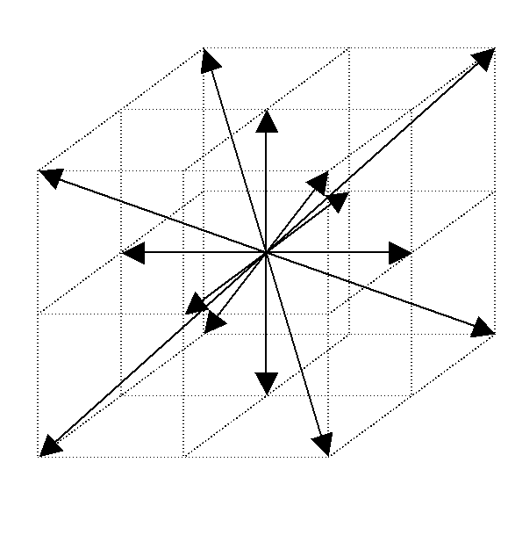
Figure 1 – lattice velocity

It is found that using equations 1÷3 we can obtain the macroscopic flow velocities and the pressure gradients for incompressible fluid with relative errors of $O\left(ε^{'2}\right)$ where $ε^{'}$is a modified Knundsen number, which is of the same order of lattice spacing and is related with the relaxation time.

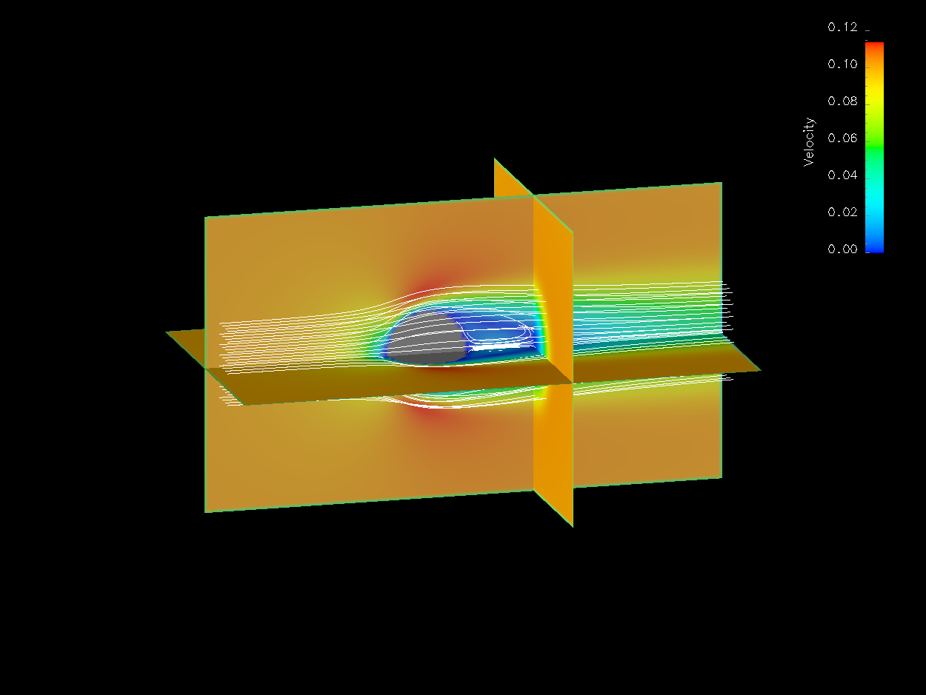

Figure 2 Flow field for Reynolds 100

Boundary conditions for the distribution function are needed in the computation. In the present computations the following boundary conditions have been developed:
- Inlet
- Outlet
- Surface of the generic obstacle

A computational example of a fluid around a sphere is reported in the figures 2 and 3 in which the flow field respectively at Reynolds number of 100 and 20 is reported. It is clear detectable, from the figure, that the vortex in the rear part of the sphere passing from Reynolds 100 (figure 2) to 20 (figure 3) decreases.

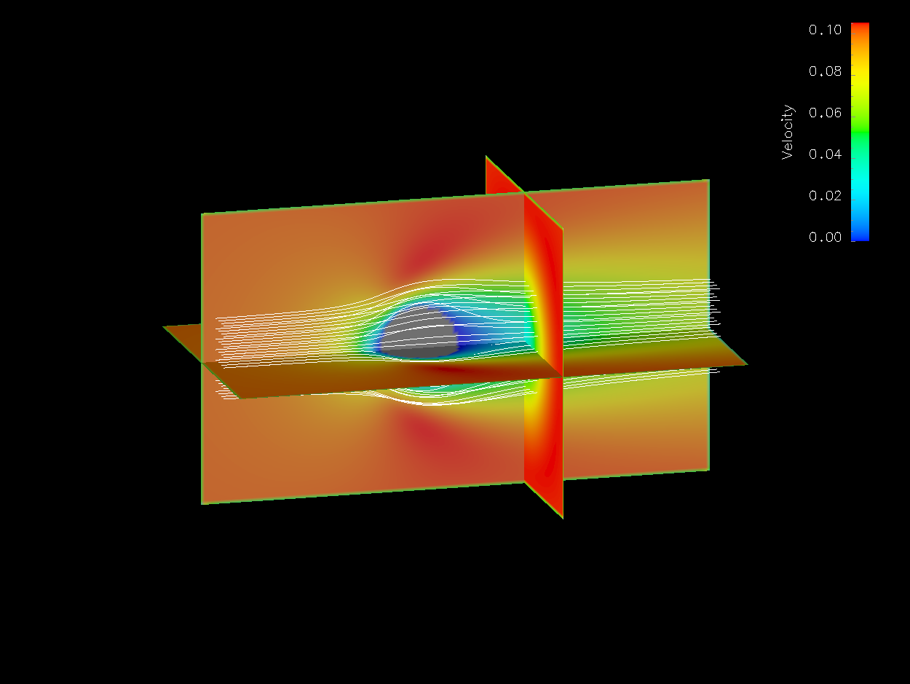

Figure 3 Flow field for Reynolds 20

References

- Bear J. “Dynamics of Fluid in Porous Media” Dover New York, 1972
- Bird R.B., Stewart W. E., Lightfoot E.N: “Transport Phenomena” John Wiley & Sons, 1960
- Succi S. “The Lattice Boltzmann Equations” Oxford Science Publications, 2001
- Chen S., Doolen G.D. “Lattice Boltzmann Method for Fluid Flow” Rev. Fluid Mech., 1998

