Convective heat transfer in valve-type pulsating-flow heat exchanger with a convectively permeable surface

Amil R. Aliev, Murad R. Aliev, Rizvan Z. Aliev

Dagestan Scientific Research Institute of Food Industry, ul. Irchi Kazaka, 12–95, Makhachkala, 367030, Russia, telephone/fax: 7 (8722) 621867, e-mail: dukra@datacom.ru

We propose methods for mass and heat transfer between flows of dispersed media through a convectively permeable surface separating them (which is permeable for fluid phases of flows)^{1,2}; they are an alternative to heat transfer processes in heterogeneous liquid- and gas-dispersion systems^{1,2}. These methods are conducted by initiating the repeated exchange of portions of fluid (liquid or gaseous) phases between the flows. Our paper is concerned with the case when the initiated heat exchange is created by alternating differences of the pressure between the flows.

The description of a valve-type pulsating-flow heat exchanger
Heat transfer between the flows of dispersed media is accomplished, for example, in the valve-type pulsating-flow heat exchanger shown in Fig. 1. The heat exchanger has two adjacent channels 1 and 2 separated by a partition 3 that is permeable for fluid phases of the flows^{1,2}. The operation of the heat exchanger is based on two time steps of duration t_{s} alternating successively in time, depending on the state of valves 4–7. During the first time step, 4 and 7 are open but 5 and 6 are closed. In this case, the first dispersed medium with an initial temperature of θ₁(0,t)=θ_{1in} is conveyed by means of pump 9 through 4 to 1 and is filtered through 3 creating a flow in 2, wherefrom it is discharged at a temperature θ₂(0,t)=θ_{2out} through open 7. During the second time step, 4 and 7 are closed but 5 and 6 are open. In this case, the second dispersed medium with an initial temperature of θ₂(L,t)=θ_{2in} is conveyed by means of pump 10 through 6 to 2 and filtered through 3 creating a flow in 1, wherefrom it is discharged at the outlet temperature θ₁(L,t)=θ_{1out} through open 5. Here, θ is the fluid-phase temperature, t is time, and L is the channel length. Thus, an alternating pressure difference is set up between the channels. With such a pulsating movement of the 1st and the 2nd dispersed media in the heat exchanger, portions of their fluid phases are exchanged many times without mixing up with their solid dispersed phases. In the process, countercurrent convective heat transfer takes place between the flows of the 1st and the 2nd media. The result is that the temperature of the medium θ_{2out} at the outlet from the channel 2 approaches the temperature θ_{1in} of the initial medium, and θ_{1out} of the 1st medium discharged from the channel 1 approaches the temperature θ_{2in} of the medium supplied to the inlet of the channel 2. The proposed heat transfer of the flows through a convectively permeable surface is much more intensive than through a nonpermeable wall.

The mathematical model
Equations for continuous incompressible physically heterogeneous Newton media are used to quantitatively describe the processes of heat transfer in dispersed flows. This description may be used for finely dispersed systems with a moderate volume fraction (up to 0.25) of the solid dispersed phase. The local velocities of the solid and the fluid phases may be assumed here to be roughly equal, especially when the solid and the fluid phases only slightly differ in their densities. We also believe that within the heat exchanger, the transfer of heat between the solid and the fluid phases, the molecular heat conductivity, and the radiant heat transfer are negligible compared with the convective heat transfer in the flows. This has been observed at Bi>>1 and Pe>>1. Accounting for the assumptions made, the set of equations of incompressibility, suspension flow, mass balance for the fluid phase and convective heat transfer in the fluid-phase flow can be written as follows:
$\oint{wdA}=0$, $\oint{ρ_{D}w(wdA)}+\oint{pdA}=\oint{σdA}$, $\int{\frac{∂ε}{∂t}dV}=−\oint{εwdA}$, $\int{\frac{∂\text{εθ}}{∂t}dV}=−\oint{\text{εθ}wdA}$, (1)
where w, ρ_{D}, and ε are the velocity, the density, and the porosity of the dispersed media, respectively; V and A are the arbitrary volume and the enclosed surface confining it, respectively; σ is the frictional stress tensor; p is the pressure. We assume that the fluid phase viscosity μ_{F}, the specific heat, and the density ρ_{F} do not depend on θ. In addition, the hydrodynamic relaxation time in going over from one time step to another is negligible compared with t_{s}.

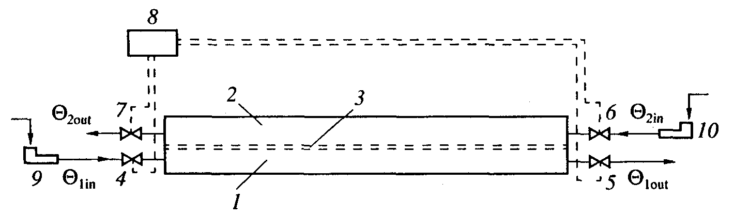 | Fig. 1. Schematic diagram of a valve-type pulsating-flow heat exchanger.
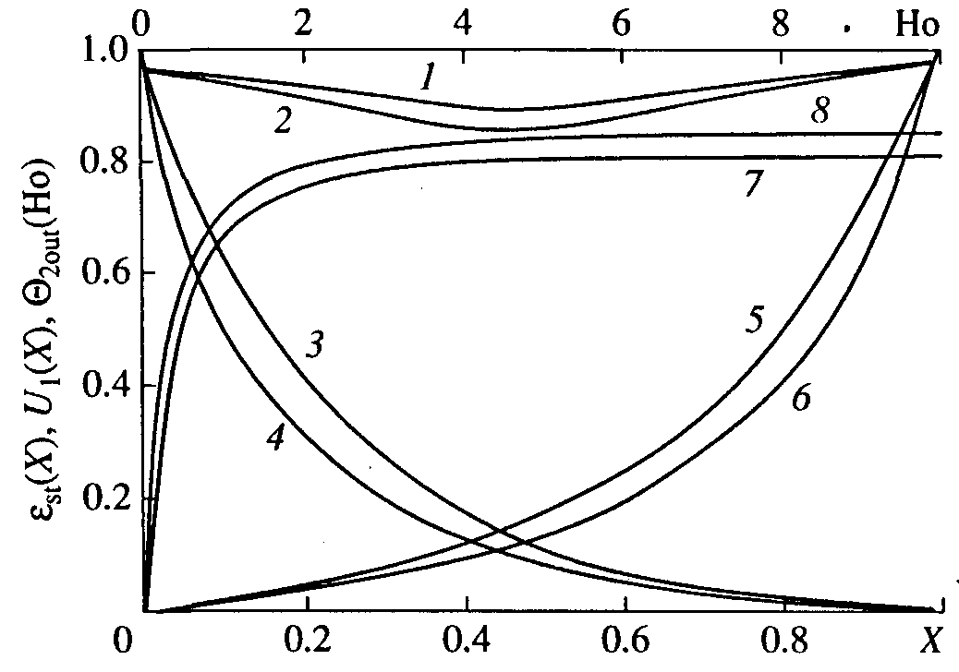 | 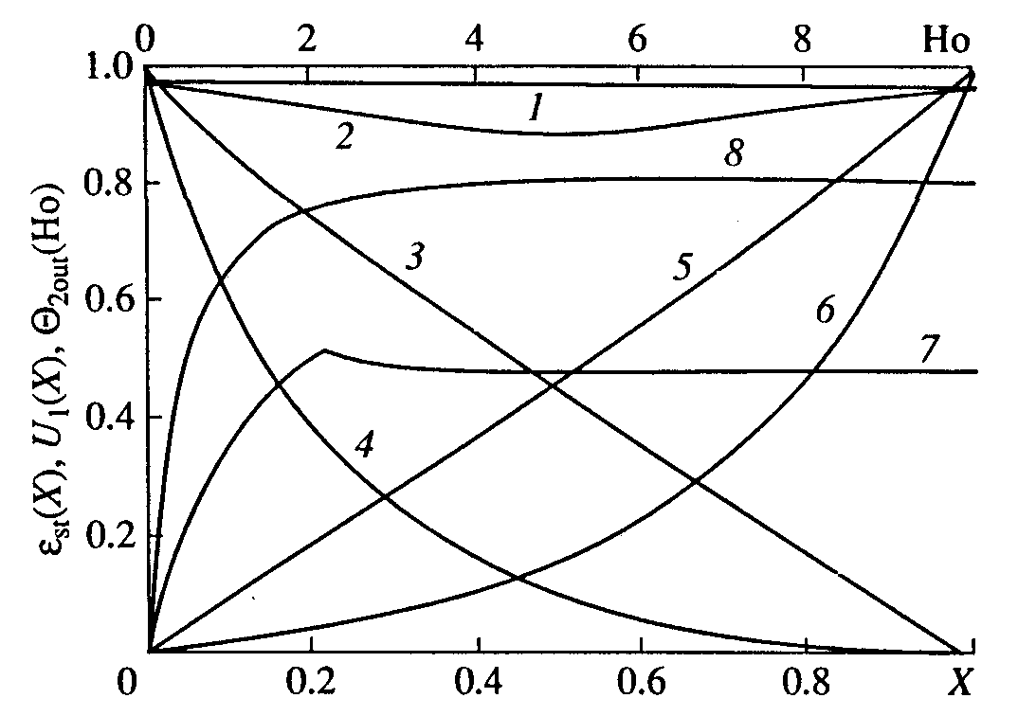
Fig. 2. Curves showing ε_{st}(X) (1,2), U₁(X) during the 1st and 2nd time steps (3,4 and 5,6, respectively), and Θ_{2out}(Ho) (7, 8) at different values of Re₀: 1,3,5,7 – 1000; 2,4,6,8 – 10000. | Fig. 3. Curves showing ε_{st}(X) (1,2), U₁(X) during the 1st and 2nd time steps (3,4 and 5,6, respectively), and Θ_{2out}(Ho) (7,8) at different values of L/d_{eq}: 1,3,5,7 – 100; 2,4,6,8 – 500.
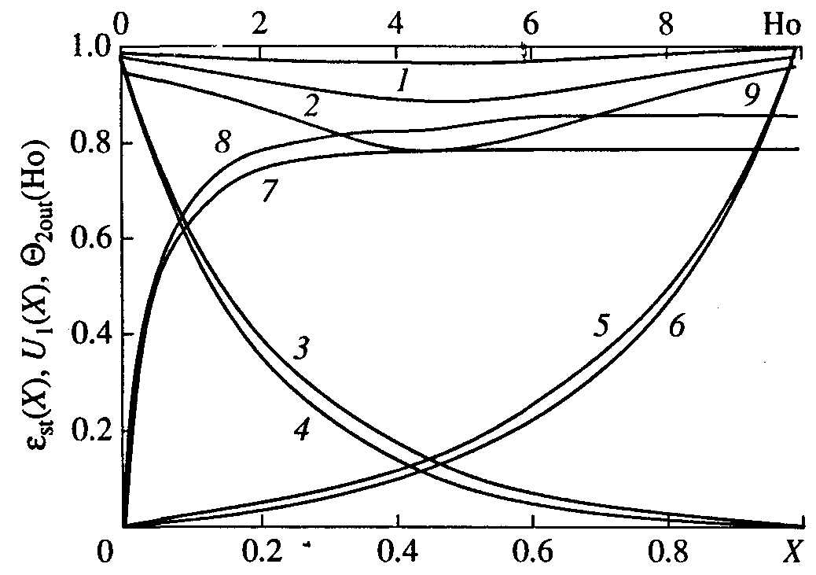 | 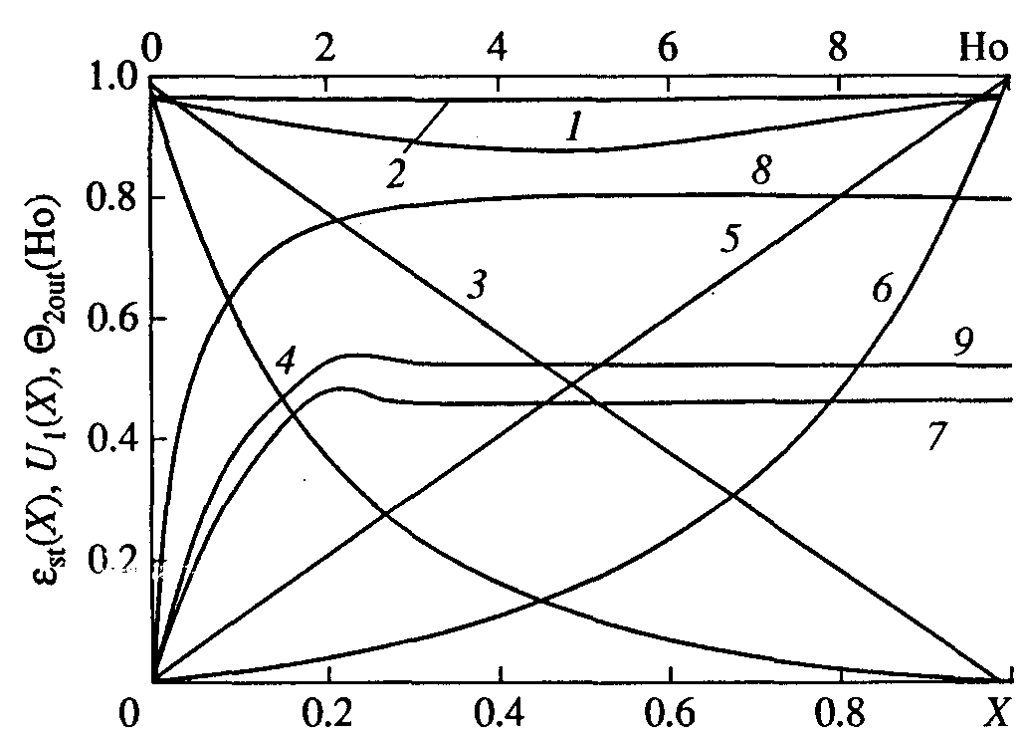
Fig. 4. Curves showing ε_{st}(X) (1,2,9), U₁(X) for the 1st and 2nd time steps (3,4 and 5,6, respectively), and Θ_{2out}(Ho) (7,8) at different values of ε_{in}: 1,3,5,7 – 0.99; 4,6,8,9 – 0.95; 2 – 0.97. | Fig. 5. Curves showing ε_{st}(X) (1,2), U₁(X) for the 1st and 2nd time steps (3,4 and 5,6, respectively), and Θ_{2out}(Ho) (7,8,9) at different values of R_{efl}: 2,3,5,7 – 10⁸; 1,4,6,8 – 10⁶; 9 – 10⁷.

The eqs (1) can be applied for the suspension flow in the channel³. Axis x is directed along the channel. Surface s formed by two sectional areas S of the channel and the side surface between them is selected. Integration is performed in (1) and projections on the x axis are taken. The equations are subdivided into distances dx between the sectional areas, and dx tends to zero. The layer of deposits on the wall is assumed to be thin compared with the equivalent diameter d_{eq} of the channel; therefore, S=const. This is true for suspensions having a low solid-phase content or for a short time step. We assume that w_{x}=0 on the channel walls; p, θ and ε are constant with respect to S. The latter assumption is partly justified by the fact that alternating cross flows are formed in the heat exchanger. We may consider two adjacent channels separated by a permeable wall^{4,5}. Equations (1) are written for each channel and we consider that the fluid transfer that takes place is the result of the pressure difference in the channels. When going over in (1) to dimensionless variables and using the coefficients of friction ξ and the flow of momentum β, we obtain^{3,4}
${dU}_{i}/dX=−L{\text{Re}}_{0i}{\text{Eu}}_{\text{ij}}{\left(d_{\text{eq}i}R_{\text{ef}i}\right)}^{−1}$, ${\text{dEu}}_{\text{ij}}/dX+d\left(ρ_{i}β_{i}U_{i}^{2}\right)/dX=−e_{\text{ui}}{Lρ}_{i}ξ_{i}U_{i}^{2}{\left(2d_{\text{eq}i}\right)}^{−1}$,
$∂ε_{i}/∂\text{Ho}+U_{i}\left(∂ε_{i}/∂X\right)=\left(ε_{i}−1\right){dU}_{i}/dX$, $∂Θ_{i}/∂\text{Ho}+U_{i}\left(∂Θ_{i}/∂X\right)=ε_{i}^{−1}\left(Θ_{i}−Θ_{\text{ij}}\right){dU}_{i}/dX$, (2)
where the subscripts i and j indicates the channel number, X=x/L, U=u/u₀, u is the mean of w_{x} with respect to S; u₀=u(0), e_{u}=u/|u|; Θ(X,Ho)=[θ(x,t)–θ_{2in}]/(θ_{1in}–θ_{2in}); Eu_{ij}(X)=[p_{i}(x)–p_{j}(x)]/(ρ_{F}u₀²); Ho=tu₀/L; ρ=ρ_{D}/ρ_{F}; R_{ef}=Sr₀δ_{w}/π_{v}, r₀ is the resistivity of the partition, δ_{w} is wall thickness, π_{v} is the permeable part of the perimeter of the channel section; Re₀=u₀d_{eq}ρ_{F}/μ_{F}. When Eu_{ij}>0, Θ_{ij}=Θ_{i}, and when Eu_{ij}<0, Θ_{ij}=Θ_{j}. The boundary-value problem for the heat transfer of flows is determined by setting the boundary conditions and the initial conditions.

Numerical solutions
Square-section adjacent channels having equal sectional areas were calculated. The wall separating the adjacent channels was permeable for the fluid phase and d_{eq1}=d_{eq2}, S₁=S₂. The rate of input of the flows to the first and second channels was the same: the characteristics of these flows are as follows: ρ_{F1}=ρ_{F2}, μ_{F1}=μ_{F2}, ε₁=1, ε₂=ε, ρ_{D2}=ερ_{F}+(1–ε)ρ_{S}, μ₂=0.59μ_{F}(ε–0.23)^{–2}, where ρ_{S} is the solid–phase density of the suspension. During the first time step, the effective dimensionless filtration resistance R_{ef1} is equal to the partition resistance. During the second time step, R_{ef2} is equal to the sum of the resistances of the partition and the deposit. The effective resistance of the deposit is assumed to be equal in the calculations with respect to X. Hence, we may take R_{ef2} to be independent of the coordinates. The following equations were used for the countercurrent pi-network: U₁(0)=–U₂(0)=1, U₁(1)=U₂(1)=0, Θ₁(0,Ho)=1 are the boundary conditions for the first time steps; U₁(0)=U₂(0)=0, U₁(1)=–U₂(1)=1, Θ₂(1,Ho)=0, ε(1,Ho)=ε_{in} are the boundary conditions for the the second time steps; Θ₁(X,0)=1, Θ₂(X,0)=0, ε(X,0)=ε_{in} are the initial conditions. In the calculations made using (2) for similar square-section channels with boundary conditions for any of the time steps we have U₁(X)=–U₂(X). In view of this, the hydrodynamic part of (2) was solved by an iterative method with respect to U_{i}, Eu_{ij}. The found functions U_{i}, Eu_{ij} were used in the temperature and porosity calculations from (2). Figs 2–5 show the functions ε_{st}(X), U₁(X) and Θ_{2out}(Ho) at Re₀=5000, L/d_{eq}=500, ε_{in}=0.97, Sr=t_{s}u₀/L=0.05, R_{efl}=10⁶, R_{ef2}/R_{efl}=1.5, Δ_{w}=δ_{w}/d_{eq}=0.01, ρ_{S}/ρ_{F}=1. Here, ε_{st} is the mean porosity during the first and the second time steps under steady-state operating conditions. The results obtained show that Θ_{2out}(Ho) grows with an increase in L/d_{eq}, Re₀, and Sr as well as with a decrease in ε_{in}, Δ_{w}, and R_{ef1}. The fact is that the greater the gradient ⏐dEu/dX⏐, the higher is the steady-state value Θ_{2out}(Ho). The data calculated on the model predict the highest values of ⏐dEu/dX⏐ for large numbers of Re₀, L/d_{eq} and small values of ε_{in} and R_{ef1}. A reduction in the porosity was noted in the middle part of the channel under all the considered operating conditions. In this case the degree of thickening of the suspension grows with ⏐dEu/dX⏐.

References
- Aliev, M. R., Aliev, R. Z., and Aliev, A. R., Sorption Dynamics in a Reactor – Mass Exchanger Unit, Theoretical Foundations of Chemical Engineering, Vol. 35, No. 3, pp. 272-280, 2001.
- Aliev, M. R., Aliev, R. Z., and Aliev, A. R., Continuous Selective Heat of Solid Phase in Dispersed Media, Theoretical Foundations of Chemical Engineering, Vol. 37, No. 1, pp. 1-7, 2003.
- Aliev M. R., Aliev R. Z., and Aliev A. R. Study of Turbulent Flow in a Long Permeable Channel, Chemical Engineering and Technology, Vol. 25, No. 7, pp. 735-737, 2002.
- Aliev, M. R., Aliev, R. Z., and Aliev, A. R., Liquid Flow in Long Adjacent Conduits Separated by a Permeable Membrane, Theoretical Foundations of Chemical Engineering, Vol. 33, No. 1, pp. 18-24, 1999.

