WAVELENGTH EFFECTS ON HEAT TRANSFER BY GÖRTLER INSTABILITY

L. Momayez, P. Dupont and H. Peerhossaini

Thermofluids and complex flows research group, Laboratoire de Thermocinétique - UMR-CNRS 6607, Ecole Polytechnique de l’Université de Nantes
Rue Christan Pauc BP 90604, F-44306 Nantes 3, France

Introduction

Boundary layers with curved streamlines are susceptible to an instability mechanism of centrifugal type often called the Görtler instability (Görtler 1940). The unstable regime consists of a laminar boundary layer over which an array of longitudinal vortices (Görtler vortices) is superposed. When they begin to appear, Görtler vortices are steady. However, when the control parameter, the Görtler number G_{θ} (G_{θ} = U_{n}θ/ν*(θ/R)^{1/2}, where U_{n} is the nominal velocity, θ the momentum thickness, ν the fluid viscosity and R the radius of curvature) is increased, they undergo a secondary instability and eventual breakdown into turbulence.
Görtler vortices embedded in the boundary layer affect heat, mass, and momentum transfer between the solid wall and the fluid (Peerhossaini 1997). Therefore, the different characteristic parameters of the Görtler vortices, such as wavelength, upstream perturbation strength, etc. affect the wall heat transfer.
In this paper we report on a heat transfer study of the Görtler vortices forced by an array of wires fixed upstream of a concave boundary layer. By changing the distance between the forcing wires we have controlled the wavelength of the Görtler vortices generated in the curved boundary layer under Görtler instability, and have investigated their effects on the wall heat transfer. The Stanton number was used to examine the relation between the vortex wavelength and wall heat transfer. We discuss this relation for different Görtler numbers.

Experimental apparatus

Experiments were carried out on the concave boundary layer of a concave-convex model mounted in a laminar open-loop wind tunnel. The nominal freestream velocity could vary between 1.5 and 10 m/s with a constant turbulence intensity of 0.7%.
The concave-convex model shown in figure 1 has four main parts:
- the leading edge in the shape of a thick laminar airfoil (NACA-0025)
- the concave part (radius of curvature 65 cm) in which the measurements have been carried out
- the convex part (radius of curvature 15 cm)
- the trailing edge, a flat plate that can rotate around the center of curvature of the convex section
The origin of the curvilinear axial coordinate x is fixed at the leading edge, and the concave wall starts at x = 9 cm. Görtler vortices are generated as the result of the amplification by the centrifugal instability of upstream perturbations entering the concave boundary layer. In this study the transverse position of the Görtler vortices was fixed by forcing predetermined wavelengths upstream of the leading edge. This was done by a perturbation grid made of 0.18-mm diameter wires with different wavelengths placed vertically 4 mm upstream of the leading edge.
The model surface was covered with a thin (130 µm) resistance film composed of a 70 µm constantan layer glued onto a 60 µm Kapton film and was heated by the Joule effect. 196 chromel-alumel thermocouples of 80 µm bead measured the temperature on the Kapton side of the heating film.
In order to reduce heat loss from the back side of the model wall, it was insulated with phenolic foam (λ = 0.002 W/mK) in which eight thermocouples were implanted. Measurement showed that heat losses by conduction from the back side of the model were 6 to 8 W/m², that is between 3 and 4% of the imposed flux.

Results and discussion

Stanton number variation with vortex wavelength
Experiments were run at nominal freestream velocities of U_{n} = 3 and 4.8 m/s and wall heat flux of ϕ_{p} = 200 W/m². The forced wavelength varied between 0.5 and 6 cm by increments of 1 cm. Fluid velocity and temperature were respectively measured by a Pitot tube and a Platinum probe, both in the freestream. Local wall temperature field was measured by the wall thermocouples and Stanton number was calculated from these data.
Figure 2 shows the evolution of Stanton number versus Görtler number for various spanwise forced wavelengths and freestream velocity of 4.8 m/s, where the correlations for laminar and turbulent boundary layer are also superposed. It can be observed that for Görtler numbers smaller than G_{θ} ≈ 3.8 experimental points follow closely the curve of flat boundary layer. However, beyond this value of the control parameter experimental results deviate from the theoretical flat plate revealing the effects of the Görtler vortices on the wall heat transfer. Of special interest is the effect of wavelength on the deviation point. It is observed that the smaller the wavelength the earlier the deviation from the flat plate boundary layer curve. For the wavelengths of 0.5 to 2 cm the plateau of constant Stanton number, normally observed (Toé et al 2002) for the Görtler vortices, is almost inexistent. These curves join the turbulent boundary layer curve at Görtler number G_{θ} ≈ 5.6 showing a rapid transition to turbulence. For other wavelengths (λ > 2 cm) the plateau is quite observable and transition to turbulence occurs at higher Görtler number of G_{θ} ≈ 7.5.
After transition, the turbulent Stanton number for λ < 2cm is fixed at 4.3x 10⁻³, while forλ > 2 cm it is only 3.6x10⁻³ meaning that the history of the vortex wavelength (which has caused the transition) affects the turbulent heat transfer properties of the boundary layer.
Question rises as to the effects of wavelength on heat transfer at a given Görtler number. Figure 3 shows the variation of Stanton number with λ for Görtler numbers ranging from 6 to 11 . It decreases monotonously with the increase of the wavelength. This behaviour can be explained by the heat exchanger type action of the Görtler vortices in the wall vicinity: the farther the vortices the smaller the heat transfer enhancement. It is interesting to recall that this range of Görtler number is the range where other investigators (Lee and Liu (1995), Crane and Sabzevary (1989), Mc Cormack (1970) and Lipmann (1945) – see Toé et al) have noticed a significant effect of Görtler vortices on the flow.

References

Görtler H. Über eine dreidimensionale instabilität laminarer grenzschichten an konkaven Wänden. Math. Phys. Klasse, 2: 1-16, 1940. Translated as Görtler H. On the three-dimensional instability of laminar boundary layers on concave walls. Technical report, NACA, 1954. TM-1375.
Liu J. T. C., Lee K. Heat transfer in a strongly nonlinear spatially developping longitudinal vorticity system. Phys. Fluids, 7(3) pp 559-599, 1995.
Peerhossaini, H., On the effects of streamwise vortices on wall heat transfer. In Compact heat exchangers for process industries, ed. R. Shah, Begell House Publishers, New York, pp 571-589, 1997
Toé R., Ajakh A. and Peerhossaini H. Heat transfer enhancement by Görtler vortices, Int. J Heat and Fluid Flow 23, pp 194-204, 2002

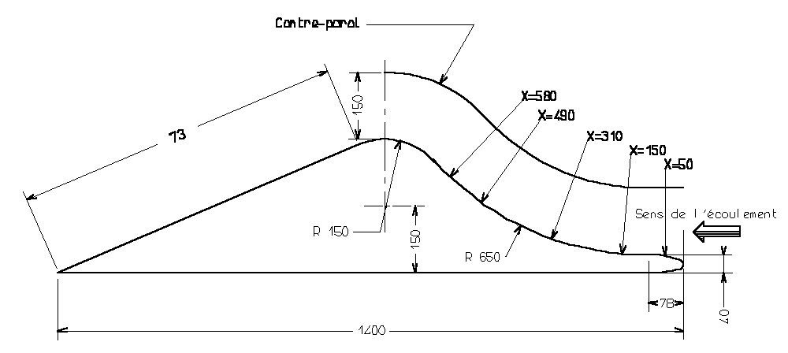
Figure 1:
Schematic view of the convex-concave model (scales in mm).

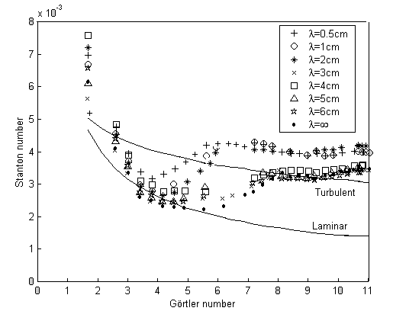  Figure.2  Evolution of the Stanton number with Görtler  number for various λ and U_{n} = 4.8 m/s, ϕ_{p} = 200 W/m². | Figure.3  Evolution of the Stanton number with spanwise wavelength ( λ ) for various Görtler numbers  (G_{θ} ≈ 6,7,8,9,10 and 11) and U_{n} = 4.8 m/s,  ϕ_{p} = 200 W/m²

