EFFECT OF BOUNDARY TEMPERATURE FLUCTUATIONS ON FLOW INSTABILITY
IN AN INVERTED VERTICAL BRIDGMAN APPARATUS

E. Semma*, M. El Ganaoui*, V. Timchenko** and E. Leonardi**
*SPCTS-UMR CNRS 6638, Université de Limoges/Faculté des Sciences, Limoges, France
**School of Mechanical and Manufacturing Engineering,
The University of New South Wales, Sydney, Australia 2052

Fluids heated from below exhibit very interesting non-linear behaviour applicable in many scientific fields. The classical Rayleigh-Bénard problem offers a first approach to understanding the complexity of flow development during the transition from conductive to convective regimes and its affect on the coupling with solid/liquid transition. Stable flows are of interest in practical applications because of their impact on the redistribution of species. For example, in the crystal growth for electronic applications, convection in the liquid phase strongly affects dopant segregation and influences the interface shape. To investigate this problem numerically two dimensional models have been used for investigation of directional solidification configurations based on thermal¹ or solutal control^{2,3}, under full or low gravity conditions.

Flow and thresholds of unsteadiness are further enhanced when thermal boundary conditions vary with time. Such situations are encountered for example in periodically energized electronic components, which induce unsteady heat generation.

In the present work the heat and momentum transfer is investigated based on the effect of the amplitude and the frequency of a given oscillation imposed on the hot wall [$T_{H}=1+ε\text{sin}(2π\text{ft})$]. The configuration shown in Figure 1 is considered and compared to available accurate results without temperature fluctuations. Firstly, the steady state regime is studied in terms of stream function variation and average Nusselt number. The study is then extended to investigate effect of the temperature fluctuations on the flow instability and transition thresholds.
Figure. 1 : Geometrical configuration

Numerical solutions were obtained using a primitive variables finite volume formulation. The convective terms are evaluated using the Quadratic Upwind Interpolation for Convective Kinematics scheme QUICK with ULTRA SHARP limiter to take into account high gradients in the solution. Diffusive terms are approximated using a second order central difference scheme⁴. Linear systems are solved with the classical Tridiagonal Matrix Algorithm (TDMA). The time discretization uses a second order Euler scheme. The pressure-velocity coupling is solved using the PISO algorithm.

In the paper the following definitions are used. The average value of stream function is defined as ; the difference between the average value of ψ for the frequency f and frequency 0 is defined as ; the amplitude of Nusselt number at the cold wall (interface) is defined as. The Nusselt and Rayleigh numbers are defined as $\text{Nu}=\int_{0}^{L}{\frac{\text{dT}}{\text{dy}}(x,L)\text{dx}}$ and .

Figure 2 shows variation of G(ψ) with frequency for two values of Ra numbers. It shows the existence of a frequency minimising the average value of ψ (G(ψ) reaches a maximal value). Figure 3 shows variation of G(ψ) with frequency for two values of amplitude for a Ra= 10000.

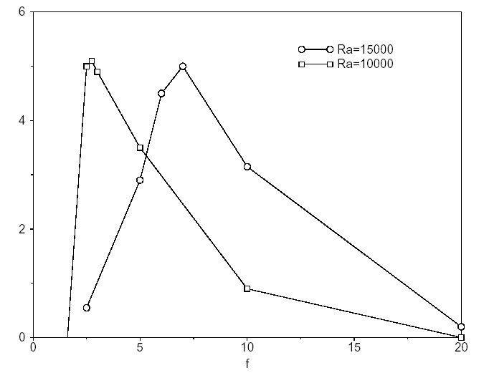
G(ψ)
Figure 2. Variation of G(ψ) versus frequency for Ra=15000 and Ra=10000

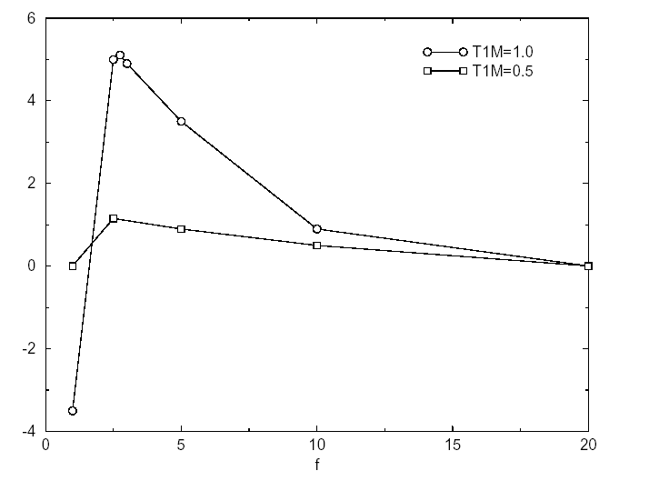
G(ψ)
Figure 3. Variation of G(ψ) versus frequency for ε=1.0 and ε=0.5, Ra=10000
The amplitude of the Nusselt number variation decreases with the frequency. This variation is practically independent on Ra number (Figure 4).

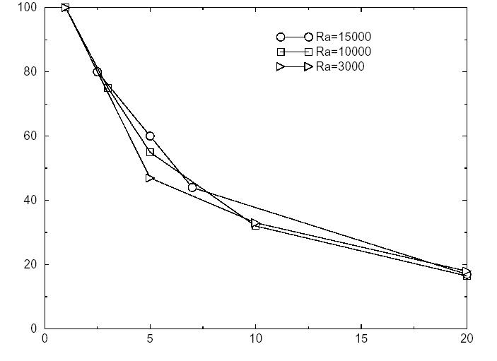
A(Nu)
f

Figure 4. Variation of the Nusselt number amplitude on the cold wall according to the frequency

REFERENCES

1. Larroudé, Ph., Ouazzani, J., Alexander J.I.D. and Bontoux, P., Symmetry breaking flow transitions and oscillatory flows in 2D directional solidification model, Eur. J. Mech. B/Fluids, Vol. 13, No. 3, pp 353-381, 1994.
2. El Ganaoui, M., Bontoux, P., Lamazouade, A., Leonardi, E. and de Vahl Davis, G., Computational model for solutal convection during directional solidification, Numerical Heat Transfer, Part B, Vol. 41, pp 325-338, 2002.
3. Phanikumar, M.S., Thermosolutal convection in a rectangular enclosure with strong side-walls and bottom heating, Int. J. Heat and Fluid Flow, Vol. 15, No. 4, pp 325-335, 1994.
4. Leonard, B.P. and Mokhtari, S., Beyond First Order Upwinding: the ULTRA-SHARP alternative for Non-oscillatory Steady-State Simulation of Convection, Int J. Numer. Methods Engineering, Vol. 30, pp 729-766, 1990.

