ON SOME LATENT HEAT EFFECTS ON UNSTEADY FLOW
CONTROLING CRYSTAL GROWTH

M. El Ganaoui¹, E. Semma¹, R. Bennacer², O. S. Mazhorova³

¹ SPCTS UMR 66 38, Universite de Limoges, 87000 Limoges, France.

² LEEVAM-LMSC, Université de Cergy Pontoise, 95031, France.
³ Keldysh Institute of Applied Mathematics RAS, Moscow, 125047 Russia.

Convection in the liquid domain under solidification/melting is an important control parameter in crystal growth. It was subjected to many numerical studies in order to understand and optimize experimental processes ^{1,2}.
In steady state case (system is stationary), the dynamic stability bifurcation diagram is not affected by the latent heat variation. Only the Fourier law assumes the coupling between the solid and the liquid domain throw the interface surface.
In the present work, two transient processes of crystal growth are considered: the Horizontal Bridgman configuration (HB) and the liquid bridge technique “floating zone configuration” (FZ). During the transition from state to other the latent heat (non zero Stefan number) affect and modifies the transition phenomena. We have complex competition time scales as: convective, solid diffusive, liquid diffusive and phase change time response characteristic. In concerned problem we have the strong 2-D effect not allowing standard assumption as scale analysis.

Horizontal Bridgman configuration
For the HB growth, a reference configuration is considered in a horizontal open domain [0,L]×[0,H] reduced by using the height H (fig. 1), A=L/H is the aspect ratio. Vertical walls are maintained at fixed temperatures (T(0, y)=T_{H}) and (T(L, y)=T_{C}<T_{H}). Solidification is considered for a pure material having a melting temperature T_{s} (T_{C} ≤ T_{s} < T_{H}). Surfaces corresponding to y=H and y=0 are submitted to a centered linear thermal gradient on a length L_{ΔT} = x_{c} – x_{f} between a hot point abscissa x_{c} and a cold point abscissa x_{f}. The horizontal (y=0) and vertical surfaces (x=0 and x=L) are supposed rigid (R). The top of the liquid domain (area corresponding to L_{ΔT} on) is able to be rigid (R) or free (F) (see figure 1). The melt is modeled as a Boussinesq fluid. The control parameter used for studying dynamic transitions is the classical Grashof number based on H and on A.(T_{H}-T_{s}).
We choose the conditions allowing an oscillatory solution and we analyse the Stefan number effect. It is observed that the flow is qualitatively independent on the latent heat according to the stream function evolutionΨ_{max}(t). The effect is more significant on the solid/liquid interface oscillation. The oscillatory amplitude is greatly reduced with increasing latent heat. The energy consumption during phase change (via the latent heat) acts as damping parameter. In fact for the rigid surface ($\text{Gr}=3\text{.}{\text{10}}^{4}$), the spatial average interface position versus time exhibits oscillation. The time evolution amplitude vary by three times between Ste⁻¹=0 and Ste⁻¹=10 (figure. 2).

Floating zone configuration
For the FZ configuration, a cylindrical ampoule with a radius R and a length L contains the melt sustained by the surface tension between the liquid and the rods maintained at the cold temperature T_{c}. The sketch of the generic configuration is illustrated in Figure 3. Free surface is considered planar and subject to slip dynamic boundary condition. One of the most important remark concerns the effect of Ste on the apparition and the time evolution of the melted phase (Figure. 4). We identify several different time scales characterising the different phenomena involved in such a coupled problem. The other interesting feature is the difference between the radial and the axial phase change separate evolution.

Numerical approach
The presented numerical solutions were obtained using a primitive variables finite volume formulation. The convective terms are evaluated using the Quadratic Upwind Interpolation for Convective Kinematics scheme QUICK with ULTRA SHARP limiter³ to take into account high gradients in the solution. Diffusive terms are approximated using a second order central difference scheme⁴. Linear systems are solved with the classical Tridiagonal Matrix Algorithm (TDMA). The time discretization uses a second order Euler scheme. The pressure-velocity coupling is solved using the PISO algorithm.

References
- El Ganaoui M., Bontoux P., Lamazouade A., Leonardi E. et de Vahl Davis G. Computational model for solutal convection during directional solidification. Numerical Heat Transfer, Part B, 41: 325-338, 2002.
- R. Bennacer, A.A. Mohamad, E. Leonardi, The effect of heat flux distribution on thermo-capillary convection in a side-heated liquid bridge, Numerical Heat Transfer, part a, 41, 657-671,2002.
- Leonard, B.P. and Mokhtari, S., Beyond first order upwinding: the ULTRA-SHARP alternative for on-oscillatory steady-state simulation of convection, Int J. Numer. Methods Engineering, Vol. 30, pp 729-766, 1990.

g
T_{H}
T_{C}
L_{ΔT}

H

Solid

Liquid

A.H
T_{C}

T_{H}

Figure 1: Horizontal Bridgman configuration (BH)

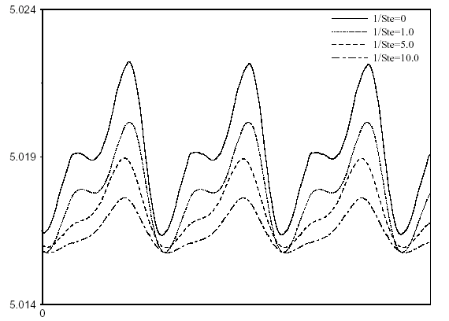

Figure 2: Effect of Stefan number on the time evolution of the total solid phase fraction (HB)

Figure 3: Floating Zone configuration (FZ)

Figure 4: Effect of Stefan number on the time evolution of solid phase fraction

