AN EXPERIMENTAL STUDY ON HEAT TRANSFER CHARACTERISTICS OF PLATE ABSORBER THROUGH FLOW RATE OF COOLING WATER

Ho-Saeng Lee, Ki-Suk Bang, Choon-Geun Moon, Kwang-Hwan Choi, Jung-In Yoon

Refrigeration and Air-Conditioning Dept., Graduate School, Pukyong National University
#100, Yongdangdong, Namgu, Busan 608-739, Korea

An experimental study of the absorption process of water vapor into a lithium bromide solution was performed. For the purpose of development of high performance absorption chiller/heater utilizing lithium bromide solution as working fluid, it is the most effective to improve the performance of absorber with the largest heat transfer area of the four heat exchangers. The experimental apparatus was composed of a plate type absorber which can increase the heat exchange area per unit volume to investigate more detail characteristics instead of the existing type, horizontal tube bundle type. The size of plate absorber was made for 0.4× 0.6 m2 and the design object of a refrigeration capacity was 1RT. The results were less than the design object values, that is, the refrigerating capacity was about 0.56RT and the overall heat transfer coefficient was 200 kcal/m2h℃ at the existing conditions.

EXPERIMENTAL APPARATUS AND METHOD

Experimental apparatus
Fig. 1 shows the schematic diagram of experimental apparatus used in this study, it's composed as absorber, evaporator, strong solution tank, generator, weak solution tank, refrigerant tank, heater and tubes etc. for connection of apparatus. And Fig. 2 shows the plate used to plate type heat exchanger. Table 1 shows the experimental conditions.

Experimental method
Experiment was progressed in batch type which can be divided into processes of establishment of experimental conditions, measurement of performance and generation of solution to perform the experiment in stable state.

Table 1 Experimental conditions
Pressure of Absorber P(kPa) |  | 1.0
LiBr Solution | Inlet Temperature Tsi (℃) | 47∼51
LiBr Solution | Inlet Concentration Csi (wt%) | 60∼62
LiBr Solution | Film Reynolds Number Ref | 5.03∼27.74
Cooling Water | Inlet Temperature Twi (℃) | 32
Cooling Water | Flow rate (ℓ/min) | 10∼18
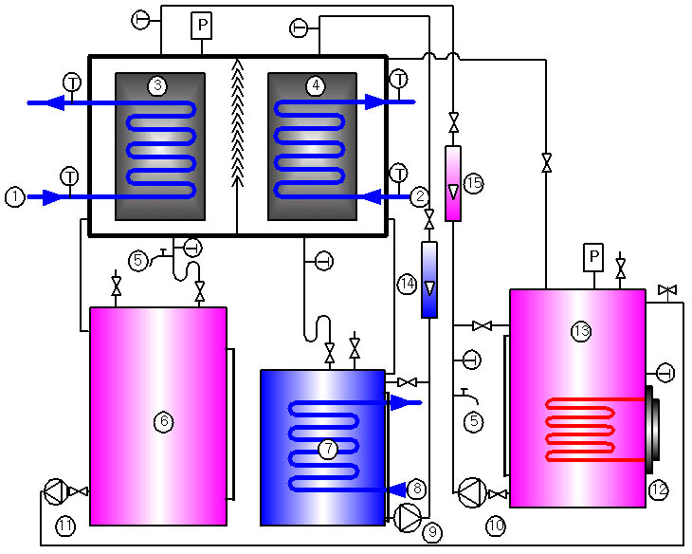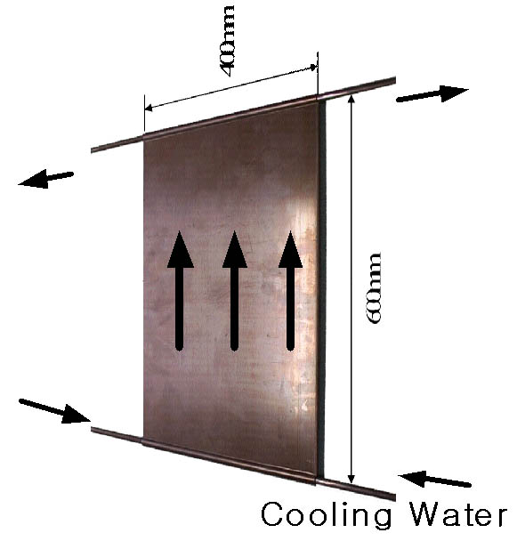

Fig. 1 Schematic diagram of experimental Apparatus Fig. 2 Plate type absorber

EXPERIMENTAL RESULTS AND DISCUSSION

The comparison by concentration
Here we are giving refrigeration capacity Qr and overall heat transfer coefficient K by changing solution flow rate about solution inlet concentration cs,i=60wt% and 62wt%. Through Fig. 3, we have found that refrigeration capacity Qr of cs,i=62wt% is higher than that of cs,i=60wt% with variable solution flow rate. From Fig. 4, We can say that overall heat transfer coefficient of cs,i=62wt% is better than that of cs,i=60wt% by increasing solution flow rate.
Fig. 3 Refrigeration capacity by concentration Fig. 4 Heat transfer coefficient by concentration

The comparison by cooling water flow rate
The comparison of refrigeration capacity Qr and overall heat transfer coefficient K with variable cooling water flow rate in experimental conditions are showed in Fig. 5 and Fig. 6. We say from Fig. 5 that as cooling water flow rate increases, refrigeration capacity is increased as well. But, we can also know through Fig. 6 that change of overall heat transfer coefficient by increasing cooling water flow rate is not remarkable. Overall heat transfer coefficient of about Ref=10 in Fig. 6 is smaller than that of solution with a small quantity, because plate is not fully wetted by small flow rate.

Fig. 5 Refrigerating capacity by flow rate Fig. 6 Overall heat transfer coefficient by flow rate
of cooling water of cooling water

CONCLUSION

Following conclusions can be reached based on the results of heat transfer characteristics from absorption experiment of plate absorber.
1. From the comparison by concentration, we can say that refrigeration capacity and overall heat transfer coefficient of the high concentration of solution is better than those of the low concentration
2. Through comparison by cooling water flow rate, it is evident that refrigeration capacity increase when cooling water flow rate is increased and the variation in the overall heat transfer coefficient is not remarkable.

REFRENCES
1. Naoyuki Inoue, "Practical Studies on Absorbers in Japan", Refrigeration Engineering Division EBARA Corporation, pp,1∼19, 1988.
2. J. I. Yoon and T. Kashiwagi, "Characteristics of heat and mass transfer for a falling film type absorber with insert spring tubes", Transaction of the KSME, Vol. 19, No .6, pp. 1501-1509, 1995.
3. I. Morioka and M. Kiyota, 3"Absorption of water vapor into a lithium bromide water solution film falling along a vertical plate"3, Transaction of the Japan Society of Mechanical Engineering, Vol.53, No. 485, pp. 236-240, 1987.
4. T. Kashiwagi, Y. Kurosaki and I. Nikai, "Heat and mass diffusions in the absorption of water vapor by aqueous solution lithium bromide", Transaction of the JAR, Vol. 1, No.1, pp.89-98, 1984.
5. J. I. Yoon and T. Kashiwagi, "Characteristic simulation of the waste-heat utilization absorption cycles", Trans. of the JAR, Vol. 12, No. 1, pp. 43-52, 1995

