APPLICATION OF ARTIFICIAL NEURAL NETWORKS IN ANALYSIS OF CHF EXPERIMENTAL DATA IN ROUND TUBE

Yanping HUANG ^{1,2} Jianqiang SHAN ² Bingde CHEN²
Xuemei LANG² Dounan JIA ¹ Xiaojun WANG²

(1 Xi’an Jiaotong University ,Xi’an, P.R.China , 710049)
(2 Nuclear Power Institute of China, Chengdu, P.R.China, 610041)
Address: P.O.BOX 622-205, Chengdu Sichuan P.R.China, 610041
Tel: 86-28-85908156
Fax: 86-28-85186492
E-mail: adslbpnc@mail.sc.cninfo.net

Artificial neural networks (ANNs) is applied successfully to analyze the critical heat flux experimental data from some round tubes in this paper. A set of software adopting artificial neural network method for predicting CHF in round tube and a set of CHF database are gotten. Comparing with common CHF correlations and CHF look-up table, ANN method has an stronger ability of allow-wrong and an nice robustness, the CHF-ANN prediction software can improve the prediction accuracy in a wider parameter range.

Introduction
The critical heat flux (CHF) is one of the main factors, which limit the heat transfer capability of the boiling heat transfer facilities such as reactor and boiler. A large amount of experimental researches for CHF have been performed, with the experimental data obtained by the different lab. increasing, if the analysis method has a stronger ability of allow-wrong and a nice robustness when a large amount of experimental data was produced, the precision of the prediction system would be improved rationally. This paper aims at developing a theoretical approach by means of artificial neural networks theory and based on the enough CHF experimental data.

Model of artificial neural networks
A BP network of ANN model and the error back transmitting arithmetic and simulated annealing algorithm are employed in this research. A modified output neuron function is represented and the relative error is adopted as the objective function, the method in which the random weighting value of the input layer is divided by the maximum input is adopted, the network structure in this paper adopted is depicted in Figure 1. Where the number of the input layer neuron is 5; the numbers of the two hidden layer neurons are 30 and 40, respectively; the number of the output layer neuron is 1, namely CHF value.

CHF database
The totally 6942 CHF experimental data were employed in this paper, the parameter range is as follows: the system pressure is from 0.10 to 20MPa, the tube diameter is from 0.01 to 0.0375m, the heated length is from 0.0254 to 4.966m, the mass flux is from 13 to 18580kg/m².s, the inlet subcooling is from 0 to 1667kJ/kg, the local quality is from –0.85 to 1.0 and the CHF value is from 9 to 2152W/cm². Due to the need of different researching aims, the following two CHF sub-databases are derived:CHF sub-database based on inlet condition and CHF sub-database based on local condition.

CHF-ANN prediction system and evaluation

CHF-ANN prediction system
Two sets of CHF-ANN prediction system, CHF-ANN prediction system based on inlet conditions in round tube and CHF-ANN prediction system based on local conditions in round tube are obtained.
Assessment of prediction results
The four methods are employed to assess the predicting result of CHF-ANN method, they are Biasi correlation, Bowring correlation, Katto correlation and AECL Look-up table.
The comparison results show that the method brought forward in this study has the widest effective range and the highest prediction precision among Bowring, Katto and Biasi CHF prediction correlation, CHF look-up table of AECL and CHF-ANN method developed in this study under the full-parameter range. Because predicting range goes beyond using range of four kinds of general methods, their prediction precisions have some influence distinctly.
Test using the experimental data out of database
To examine the comprehensive characteristic of CHF-ANN, two groups of experimental data , totally 283 experimental data points, obtained in 1998 in National key laboratory of Bubble physics and natural circulation are employed to test the predicting characteristic of CHF-ANN method.
24 points data in all, the parameter range is as follows: the pressure is from 13.4 to 14.8 MPa, the tube diameter is 0.08 m, the heated length is 1.0 m, the mass flux is from 572 to 4143 kg/m².s, the inlet subcooling is from 97.2 to 692 kJ/kg and the CHF experimental value is from 111. to 811. W/cm². The comparison between experiment results and prediction shows in Fig. 2.
259 points data in all, the parameter range I as follows: the pressure is from 4.2 to 11. MPa, the tube diameter is from 0.006 to 0.012 m, the heated length is from 0.2195 to 2.007m, the mass flux is from 679. to 4426. kg/m².s, the local quality is from 0 to 0.91 and the CHF experimental value is from 111. to 811. W/cm². The comparison between experiment results and prediction shows in Fig.3.

Conclusions
The researching results show that ANN method is better than general methods in dealing with the dispersed experimental data and is specially suitable for analyzing and reducing of experimental data with large amount data, wide parameter range and complicated data distribution. the predicting precision and effective prediction range of CHF-ANN are improved very distinctly than four kinds of general methods.

References
[1] Moon S.K., Baek W.P., Chang S.H., Parametric trends analysis of critical heat flux in tubes, Nuclear Engineering and Design, 163(1996) 29-49.
[2] Shan J.Q., Huang Y.P., Chen B.D., Application of artificial neural networks in CHF predication and parametric trends analysis, in: Harold B. Ray, Kunio Hamada, Bertrand Barre (eds.), 6th international conference on nuclear engineering ICONE-6, SAN DIEGO, CALIFORNIA, USA, May 10-14, 1998.
[3] Groeneveld D.C., Leung L.K.H., Kirillov P.L., Bobkov V.P., Smogalev I.P., Vinogradov V.N., Huang X.C., Royer E., The 1995 look-up table for critical heat flux in tubes, Nuclear Engineering and Design, 163 (1996) 1-23.
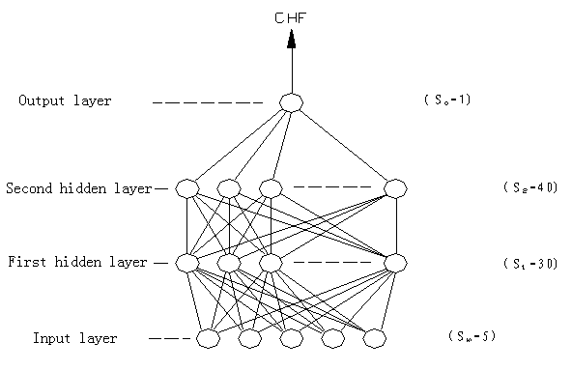
Fig. 1 Schematics of CHF-ANN networks structure

CHF predicting value [W/cm²]
CHF Experimental Value [W/cm²]

Fig.2 Test results of CHF-ANN based inlet condition

CHF predicting value [W/cm²]
CHF Experimental Value [W/cm²]

Fig.3 Test results of CHF-ANN based local condition

