Analysis of Particle Laden Flow and Heat Transfer

in Turbine Cascade and Rocket Nozzle

H. H. Cho*, W. S. Kim*, M. S. Yu* and J. C. Bae**
*Department of Mechanical Engineering

Yonsei University, Seoul 120-749, KOREA
**Agency for Defense Development

Yusung, Taejon 305-600, KOREA

ABSTRACT
Many components of gas turbines and rocket engines suffer severe damage by various particles, such as dust, sand, pulverized coal, and aluminum oxides ¹⁻³. The damage modes are mechanical erosion of blade walls, partial or total blockage of cooling hole passages, and engine control system degradation³⁻⁴. Initial damages by the particles cannot be serious, but the safety of engine control can be compromised. For an example, jet vanes installed in rocket nozzles can be ablated severely by high temperature aluminum oxide droplets³. Therefore, it is necessary to predict depositing regions and damaged degrees on the vanes, blades and nozzles for the safe and effective operation of engines when the particles flow into the components. The present study was conducted by using numerical analysis of the two-phase flows over the blades and nozzles based on a Lagrangian particle-tracking method.

Figures 1(a) and (b) illustrate particle trajectories around the turbine blades for the cases of particle’s diameters 20 μm and 50 μm, respectively. Most of the particles collide with the pressure side surface of the blade. The bigger the particle sizes are, the larger the number of particles that collide on the pressure side surface. The particle impact angle on the surface is increased gradually along the surface from the leading edge to the trailing edge. The reason is that the flow curvature along the blade changes rapidly from the leading edge to the trailing edge. The damage of the blade by the particle-laden flow is more severe on the leading edge region than on any other region of the blade due to larger momentum changes.
(a) d_{P} = 20μm (b) d_{P} = 50μm

Fig. 1 Particle trajectories in the turbine cascade for the particle’s angle of attack, 40°

Figure 2 presents the predicted erosion rates on the pressure side surface for two different materials, such as ceramic and soft metal. At the leading edge position, x≅0.075, the mechanical erosion rate has the maximum value due to the normal impact angle. The minimum erosion rate exists just after the leading edge region because the particle’s impact angle is nearly equal to the blade’s design angle. Particles may slip on the surface in this region. The erosion rate increases gradually on the pressure side surface due to the increase in the impact angle. The aspects of erosion rates are different for the two materials. The ceramic shows severe mechanical erosion at the large impact angle because ceramic is one of the most brittle materials when exposed to impact.

Figures 3(a) and (b) show Al₂O₃ particle trajectories of the two-phase flow in the rocket nozzle for the cases of particle sizes 1 and 5 μm, respectively. For the particle size of d_{P}=1 μm, Al₂O₃ particles follow the streamlines closely. However, as the particle size increases, particles are separated from the streamline because the bigger particles have relatively larger inertia force. The particles start to collide with the contraction part of the nozzle wall for d_{P}=5 μm. Figure 3 shows that the size of particle free zone, in which particles do not exist ideally, grows gradually in the diverged part of the nozzle with increasing particle diameter.
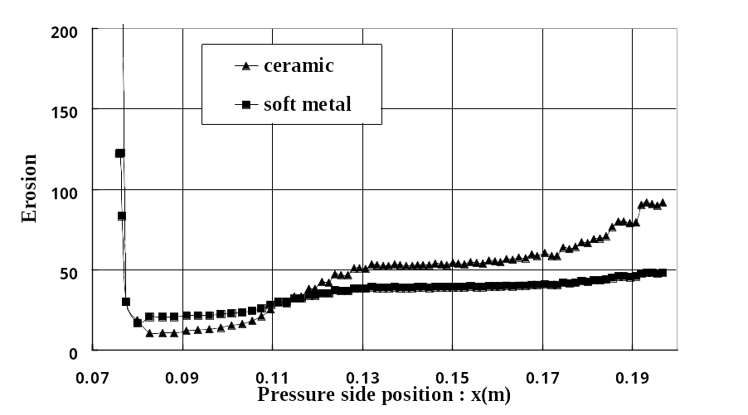
Fig. 2 Erosion rates on the blade surface for two materials by d_{P} = 50μm

(a) d_{P} = 1μm (b) d_{P} = 5μm

Fig. 3 Al₂O₃ particle trajectories in rocket nozzle
The predictions of mechanical and thermal energy transfer by particles are illustrated in Fig. 4 on the converged nozzle surface. Thermal energy transfer to the nozzle wall by the particles is 10² order larger than the mechanical kinetic energy⁶. This means that thermal energy influence on the nozzle surface is more dominant than the mechanical impact. Therefore, heat transfer on the nozzle surface including ablation by Al₂O₃ particles should be predicted precisely in designing this type of engine system.

REFERENCES

- Hamed, A., Effect of Particle Characteristic on Trajectories and Blade Impact Patterns, J. of Fluid Engineering, Vol. 110, pp. 33-36, 1988.
- Dunn, M. G., Baran, A. J. and Miatech, J., Operation of Gas Turbine Engines in Volcanic Ash Clouds, Trans. ASME, J. of Engineering for Gas Turbines and Power, Vol. 118, pp. 724-731, 1996.
- Mironov, V., Jet Vane Thrust Vector Control System, Seminar Material, KAIST, Daeduk, Korea, 1998.
- Metwally, M., Tabakoff, W. and Hamed, A., Blade Erosion in Automotive Gas Turbine Engine, Trans. ASME, J. of Engineering for Gas Turbines and Power, Vol. 117, pp. 213-219, 1995.
- Hwang, C. J., Numerical Study of Gas-Particle Flow in a Solid Rocket Nozzle, AIAA Journal, Vol. 26, No. 6, pp. 682-689, 1988.
- Debendra K Das, Moore, G. R. and Boyer, C. T., A Numerical Study of Two-Phase Flow and Heat Transfer in a Nozzle, AIChE Symposium Series, Heat Transfer, Vol. 83, No. 257, pp. 243-248, 1987.

(a) Kinetic energy transfer by particles (b) Heat energy transfer by particles

Fig. 4 Energy transfer to the converged nozzle wall by particles

