CONVECTIVE HEAT TRANSFER ON AN INLET GUIDE VANE

Marie-Louise Holmer¹, Lars-Erik Eriksson² and Bengt Sunden³
¹Thermo and Fluid Dynamics, Chalmers University of Technology, 41296 Göteborg, Sweden, email: louise@tfd.chalmers.se

²Volvo Aero Corporation, 46181 Trollhättan, Sweden, email: vac.lars@memo.volvo.se
³Division of Heat Transfer, Lund Institute of Technology, Box 118, 22100 Lund, Sweden, email: bengt.sunden@vok.lth.se

Abstract
The flow and temperature fields around an inlet guide vane are determined numerically by a CFD method. In particular the outer surface temperatures and heat transfer coefficient distributions are calculated. Static pressure distributions are also presented. Three different thermal boundary conditions on the vane blade are analysed. The computed results are compared with experimental data from tests in a hot cascade rig at ABB Alstom Power AB in Sweden. Later also the film cooled case will be investigated. The importance of the thermal boundary condition is to be revealed.

The governing equations are solved by a 3D finite-volume Navier-Stokes solver developed at Volvo Aero Corporation. The standard k-$ω$ turbulence model by Wilcox is implemented to enable calculations of turbulent flow cases. The flow field is resolved even close to the wall boundaries but a realizability constraint is applied to reduce the generation of unphysical turbulent kinetic energy, particularly close to the leading edge.

The grid used in the calculations is block-structured, and the total number of grid points is around 250 000. The influence on the results of variation of the grid structure close to the blade surface has been studied.

Commonly calculations of heat transfer for guide vanes and turbine blades are carried out for either a uniform wall heat flux or a uniform wall temperature boundary condition. In the present work, pure convective heat transfer to the vane is considered but the importance of the wall thermal boundary condition is investigated by applying three different boundary conditions, namely: a) uniform wall temperature on the outer vane surface, b) non-uniform wall temperature distribution on the outer vane surface based on experiments, and c) conjugate heat transfer wall condition. The conjugate heat transfer condition means that the heat transfer coefficient and bulk temperature distributions are prescribed on the inner surface of the vane and also that the wall thickness and thermal conductivity of the vane material are prescribed. The vane outer surface temperature is then found as part of the numerical solution. Furthermore results from 2D calculations, carried out at AAP using the commercial code TEXSTAN and with a prescribed outer surface temperature distribution, are used for comparison and validation.

It is shown that the calculated results agree best with measurements if the conjugate heat transfer approach is applied and thus this wall condition is recommended for related future investigations of film cooling of guide vanes and turbine blades.

The results presented in Fig.1 show that the calculated pressure distribution along the inlet guide vane surface, at a section cut at 25 per cent of the distance from hub to shroud, agrees very well with the experimental results. On the pressure side, calculation and measurement results agree extremely well all the way from the leading to the trailing edge. For the main part on the pressure side the variation in pressure is relatively smooth.

Applying a non-uniform wall temperature distribution, based on measurements, for the vane gives very good results for the pressure side, see Figure 2. For the suction side the trends from measurements are better captured than with a uniform wall temperature. First some kind of reverse transition or relaminarization occurs followed by a transition back to turbulence. The transition back to turbulence is not exactly positioned.

The TEXSTAN calculations presented are run with non-uniform wall temperatures. Compared to TEXSTAN 2D calculations, the present calculated results are much closer to the measurements on the pressure side. An exception is the location of the point of transition. In TEXSTAN this has to be specified.

From Figure 3 it is obvious that applying a varying heat transfer coefficient distribution for the inside of the vane gives much better results compared to measurements than applying a uniform distribution.

Applying a varying wall thickness distribution in the calculations has no significant influence on the results except in the areas close to the stiffeners (inside the vane).

On the suction side the stiffener has some influence on the results almost all the way to the trailing edge, until the calculation results show a transition back to a fully turbulent state. The same trends of relaminarization as in Figure 2 for the suction side can be found in all the calculated results when a varying heat transfer coefficient distribution is applied.

Figures showing the flow field through the vane passage, distributions of the Mach number and static pressure are provided in the full paper.

Fig. 1: Calculated pressure distribution compared to measurements.

Fig. 2: Calculated heat transfer coefficients with varying wall temperature in comparison with constant wall temperature, measurements and 2D calculations with TEXSTAN.
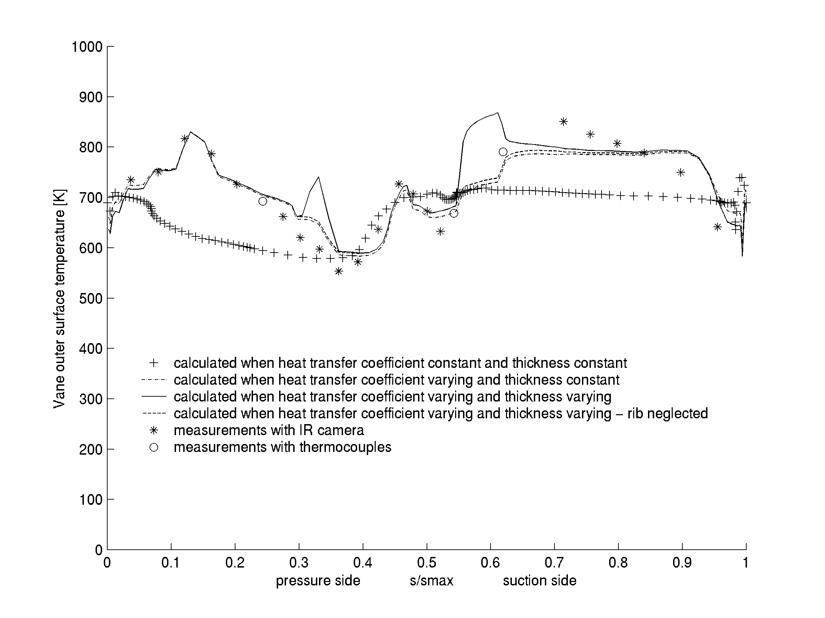

Fig. 3: Calculated vane outer surface temperature with conjugate heat transfer boundary condition.

