CONTRIBUTION OF HEAT TRANSFER TO TURBINE BLADES AND VANES FOR HIGH TEMPERATURE INDUSTRIAL GAS TURBINES

Ken ichiro Takeishi and Sunao Aoki
Takasago Research and Development Center,

Mitsubishi Heavy Industries Ltd., Takasago 676-8686, Japan

ABSTRACT
There is a strong demand for efficient electric power generation to meet environmental regulations and energy saving requirements. Large LNG (Liquid Natural Gas) burning gas-steam combined cycle power plants fulfill these requirements. One of the most powerful means of achieving higher efficiency in industrial gas turbine engines is to raise the turbine inlet temperature (TIT). For this reason, high-temperature industrial gas turbines have been actively developed as Figure 1¹indicates. The thermal efficiency of a combined cycle power plant with a 1300° class gas turbine is about 54% (LHV (Low Heat Value) level), but for a 1500° class gas turbine it exceeds 58%.
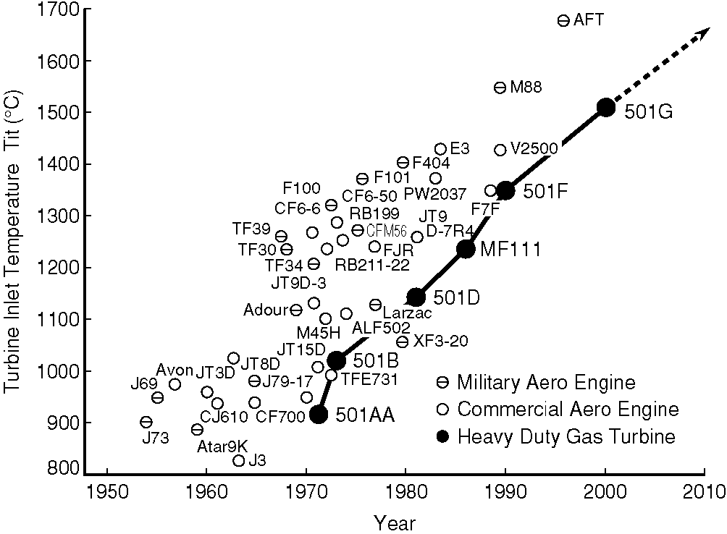
Figure 1 Evolutions of turbine inlet temperature of heavy-duty gas turbines
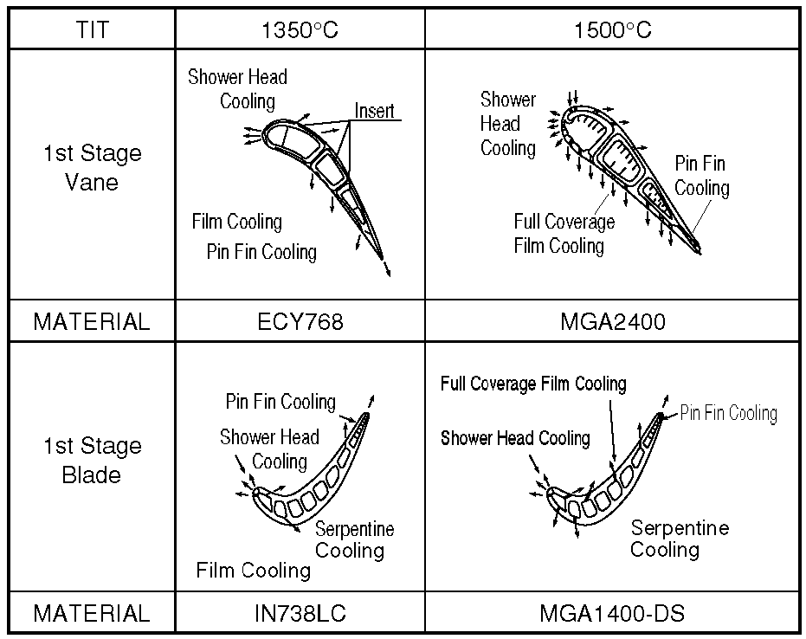
Figure 2 Cooling Structure and Material for the First stage Vane and Blade
The key improvements for turbine blades and vanes for high-temperature industrial gas turbines are made in the areas of advanced cooling technology, the development and use of advanced thermal resistant material and the application of anti–oxidation/thermal barrier coatings. However, the effect of enhanced heat transfer to raise the TIT is the most significant factor. Figure 2 shows the improvement of cooling technologies applied to the first blades and vanes for Mitsubishi’s 1350° class F-type and 1500° class G-type gas turbine. In the development of the turbine blades and vanes of the G-type gas turbine, advanced cooling technologies such as full coverage film-cooling, shaped film-cooling, and angled turbulence promoter for serpentine flow passages etc. have been adopted, while the base concept of the F-type gas turbine was kept. Shaped film-cooling in particular played an important role in improving film-cooling effectiveness, which results in enhancing the thermal efficiency by reducing the coolant flow rate.
Many experimental and numerical studies have been conducted to attain higher film-cooling effectiveness. Goldstein², Goldstein et al.³, Makki et al.⁴ , Watanabe et al.⁵ and Gritsch et al.⁶ investigated the so-called fan diffused film-cooling geometry, and Papple et al.⁷ studied the film- cooling improvement by using curved film-cooling holes. In recent years, numerical works to solve the complicated flow phenomena associated with the cooling jet in diffused holes were published by Kohli⁸. However, there are still only few data available to optimize the film-cooling geometry of diffused holes on turbine airfoils.
This paper presents the results of a parameter study, in which the film-cooling geometry on turbine blades and vanes was varied between shaped film-cooling holes, full coverage film-cooling and presents heat transfer coefficients of rotating serpentine flow passage with /without angled turbulence promoter.

Low speed cascade test
An experimental investigation has been conducted in a low-speed wind tunnel cascade to determine the film-cooling effectiveness of the film-cooling hole geometry on turbine airfoils. The profile of the model vane, the location of film-cooling holes, and film-cooling hole geometries are given in Fig. 3 and Table 1. The typical 1st row vane of modern industrial gas turbines, made of low thermal conductivity material (Bakelite), was chosen for the profile of the model vane. The film-cooling effectiveness was obtained by measuring the adiabatic wall temperature using thermocouples embedded in the wall downstream of the film- cooling holes.
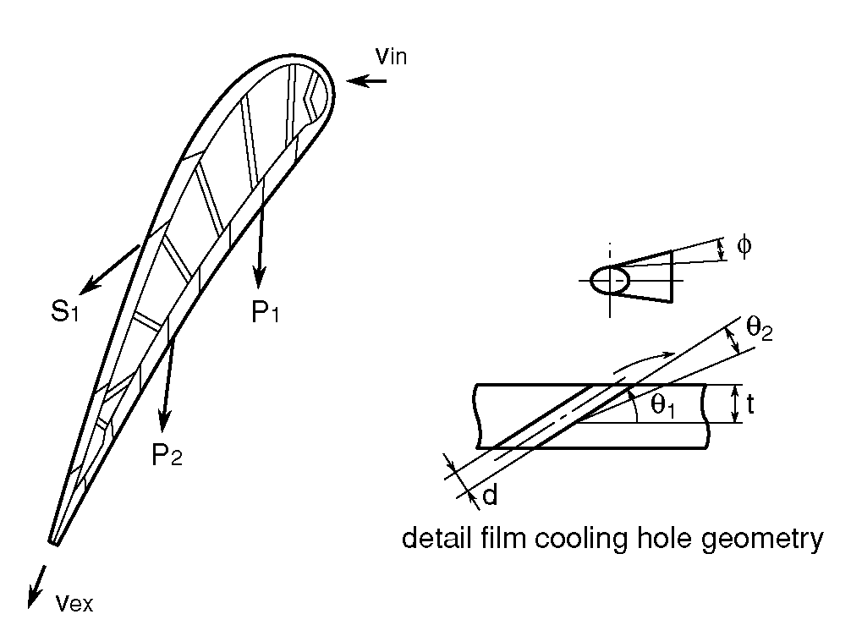
Figure 3 Location of film cooling holes on vane surface
The film-cooling effectiveness measured on the suction surface around the row of film-cooling holes S1 is shown in Fig. 4. It becomes apparent from the results that the film-cooling effectiveness of shaped film-cooling holes is about 50-70% higher than that of conventional cylindrical cooling holes. Figure 4 also indicates that there is little mixing between the main stream and the film-cooling jet because there is a notable difference in film-cooling effectiveness for locations downstream of the cooling hole and in between the cooling holes.
Table 1 Film cooling hole geometry
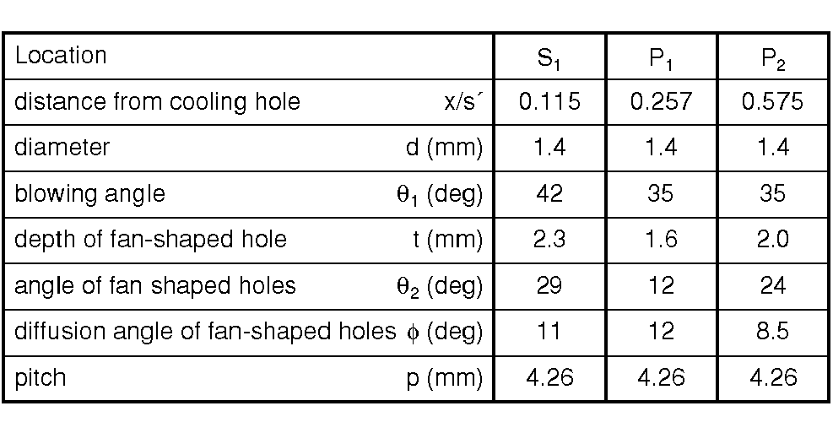
The adiabatic wall temperature distribution for measurement locations below film-cooling hole row S1 was also measured using infrared imaging. Typical measurement results are shown in Fig. 5. It is obvious that fan-shaped film-cooling persists much longer than the conventional circular film-cooling. It is also noted that fan-shaped holes tend to cover larger areas in the span-wise direction.
Similarly, the film-cooling effectiveness measured on the pressure surface (coolant flow blowing through one row of film-cooling holes P1) is shown in Fig. 6. Here, the film-cooling effectiveness decreases more rapidly with increasing distance than on the suction surface. Another characteristic is that the difference in film-cooling effectiveness between locations downstream of the film-cooling hole and in between the holes, which was noted for the suction surface, does not exist on the pressure surface. This is assumed to be the result of a strong mixing of the coolant and the mainstream on the pressure surface, while the mixing rate is lower at the suction surface.

SUMMARY
Turbine cooling technologies contribute to raising the turbine inlet temperature of industrial gas turbines. Among them, shaped film-cooling and full coverage film-cooling are the most useful cooling schemes for reducing the amount of cooling air and decreasing thermal stress. Few data are available on the characteristics of shaped and full coverage film- cooling on turbine blades and vanes.
Low speed cascade tests have been conducted by using heat transfer models in order to determine some of these characteristics. The results indicate that shaped film- cooling is one of the most effective cooling methods if it is adopted in the region where the mixing between the main stream and the film-cooling jet is suppressed. The film-cooling characteristics of shaped film-cooling holes on turbine airfoils have been pointed out.
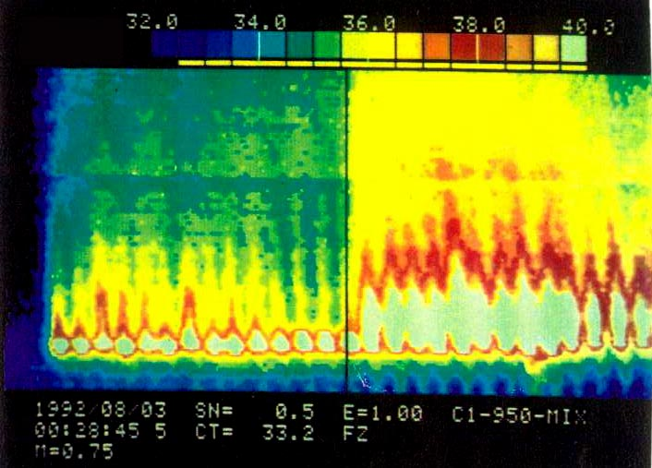
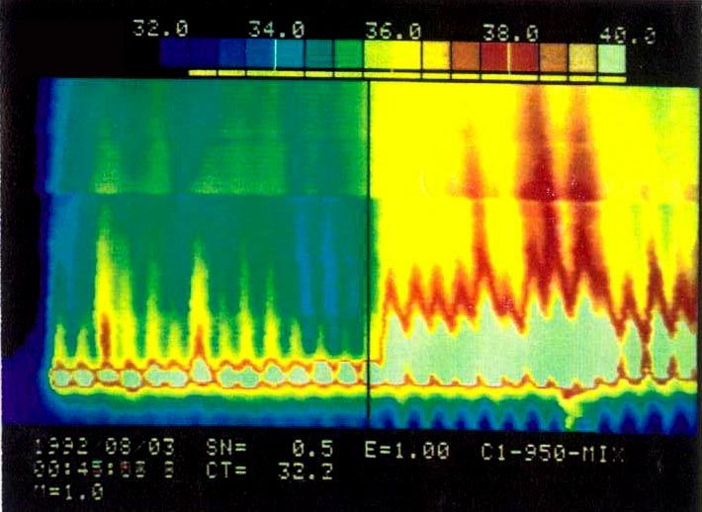
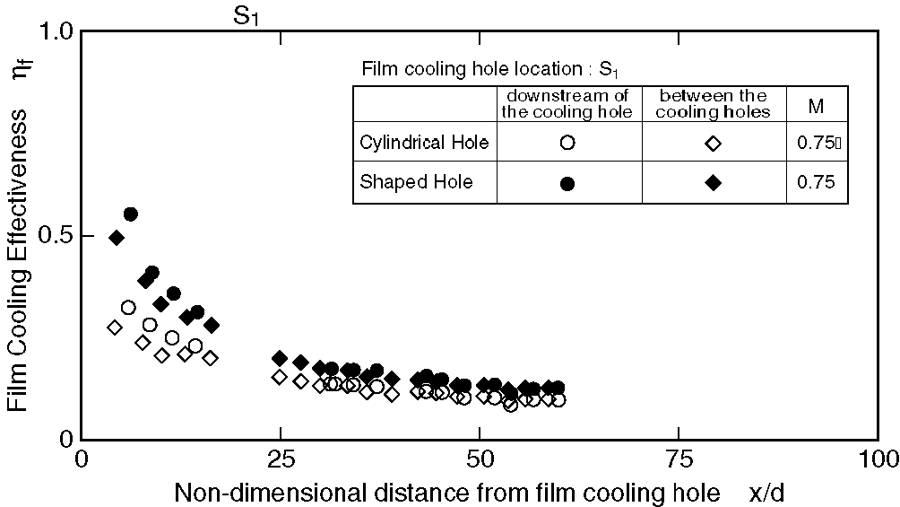
Figure 4 Film cooling effectiveness on suction surface of 1st model vane (blowing through S₁ film cooing hole)
M=0.75
Tg=32.9℃
Tfo=60.3℃
Figure 5 Distribution of the adiabatic wall temperature measured by the infrared camera

M=1.00
Tg=32.9℃
Tfo=60.6℃
Circular holes
Fan-shaped hole
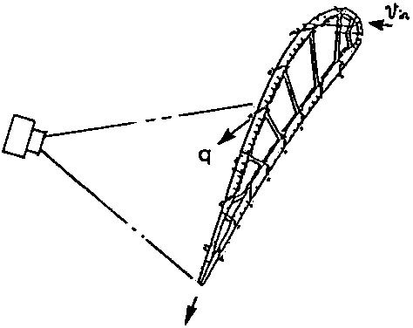
The results of full coverage film-cooling and heat transfer characteristics of rotating serpentine flow passage with/without angled turbulence promoter will be presented in the full paper.
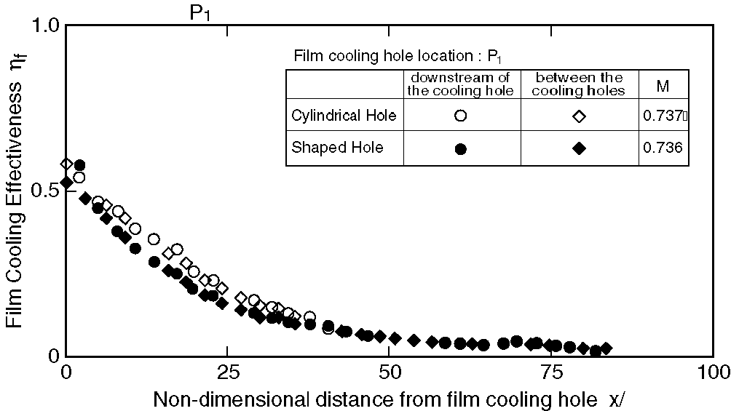
Figure 6 Film cooling effectiveness on pressure surface of 1st model vane (blowing through P₁ film cooling hole)
REFERENCES
1. Amagasa, S. et. al., Study on the Turbine Vane and Blade for a 1,500°C class Industrial Gas Turbine, Trans. ASME, Journal of Turbo-machinery, Vol.116, pp 597-604. 1994.
2. Goldstein, R. J., Film Cooling Advances in Heat Transfer, Vol.7 Academic press, New York, pp 321-371. 1971.
3. Goldstein, R. J., and Eckert, E. R. G., Effect of Hole Geometry and Density on Three-Dimensional Film Cooling, Int. J. Heat Transfer, Vol.17, pp 595-607. 1974.
4. Makki, Y. H., and Jakubowski, G. S., An Experimental Study of Film Cooling from Diffused Trapezoidal Shaped Holes, AIAA Paper, AIAA-86-1326. 1986.
5. Watanabe, K. et. al., An Experimental Study on the Film Cooling Effectiveness with Expanded Hole Geometry” IGTC ‘99 Kobe TS-48. 1999.
6. Gritsch, M., Schulz, A. and Witling, S., Heat Transfer coefficient Measurements of Film cooling holes with Expanded Exits, ASME Paper, 98-GT-28. 1998.
7. Pappell, S. S., Wang, C. R. and Graham, R. W., Film-Cooling Effectiveness Developing Coolant Flow through Straight and Curved Turbulator Passages, NASA TP-206. 1982.
8. Kohli, A., and Thole, K. A., A CFD investigation on the effects of entrance cross flow Directions to Film-Cooling Holes, HTD-Vol.350, National Heat Transfer Conference, 12, pp.223-232. 1997.

