Some current research in rotating-disc systems

J Michael Owen and Michael Wilson
Department of Mechanical Engineering
University of Bath BA2 7AY, UK

Rotating-disc systems provide simplified experimental or computational models of the complex internal cooling-air systems of gas-turbine engines. Interest in this subject has increased considerably over the past ten years, and major gas-turbine manufacturers in Europe, USA and Japan are currently funding a large number of research projects. This paper provides an overview of the rotating-disc systems that have received the most attention, including rotor-stator systems, rotating cavities, and contra-rotating discs. These are illustrated in Fig. 1, where the parameter Γ is the ratio of the angular speeds of the two discs.

For the rotor-stator system (Fig. 1b), areas of current research interest include transition and instability, pre-swirl cooling systems and hot gas ingress from an external mainstream. The increasing use of direct numerical simulation (DNS) has given insight into the transitional processes by which steady, axisymmetric flow can become unsteady and three-dimensional. In pre-swirl systems, the cooling air is swirled, in stationary nozzles, so as to reduce its temperature relative to the rotating disc (and, consequently, relative to the turbine blades which are cooled by this air in an actual engine). Recent research has shown that there is a critical pre-swirl ratio, β_{p,crit} (where β_{p} is the ratio of the tangential velocity of the cooling air at inlet to the system to the rotational speed of the disc); when β_{p} = β_{p,crit}, the frictional moment on the rotating disc is reduced to zero. There is also an optimal pre-swirl ratio, β_{p,opt}, at which the heat transfer from the disc to the cooling air is a minimum.

For rotating cavities with a superposed radial inflow or outflow of cooling air (Figs. 1c,d) the fluid dynamics is well understood, and agreement between computation and measurement of velocity and heat transfer is mainly good. For the rotating cavity with a stationary outer casing, and with peripheral inflow and outflow (Fig. 1e), the flow is unstable: even with axisymmetric boundary conditions, the flow can be unsteady and three-dimensional. In particular, the Rankine vortex (or combined free and forced vortex) flows that have been observed experimentally are difficult to compute. The flow and heat transfer in rotating cavities with stepped and angled stationary casings is also discussed.

Contra-rotating discs (Fig. 1g) are considered for –1 ≤ Γ ≤ 0. At Γ = 0 (the rotor-stator case), Batchelor-type flow occurs: there is radial outflow and inflow respectively in the boundary layers on the rotor and stator, and the interior core between the boundary layers rotates at an intermediate speed. At Γ = –1, Stewartson-type flow occurs: there is radial outflow in the boundary layers on both discs, but there is virtually no rotation in the interior core. For –1 < Γ < 0, there is transition between Batchelor-type and Stewartson-type flow. For turbulent flow, the agreement between the computed and measured velocities and heat transfer is mainly good.

Buoyancy-induced flow in a rotating cavity with an axial throughflow of cooling air (Fig. 1f) is the "Everest of the rotating-disc problems". The flow is unsteady and three-dimensional, and it is unclear when (or even if) transition from laminar to turbulent flow occurs. For the case of a sealed cavity (or annulus), with no throughflow and with a hot outer cylindrical surface and a cold inner surface, cells with cyclonic and anti-cyclonic circulation are formed. These circulations are related to those that occur in the Earth's atmosphere, and such flows have chaotic tendencies. Computations reveal the existence of discrete pairs of vortices, the number of which depend strongly on the radius-ratio of the cylindrical annulus: transition between metastable states can cause the number of cells, and the associated heat transfer, to change with time. Computations show qualitative agreement with observed flow structures, but the quantitative agreement between computed and measured Nusselt numbers is not good. It is a challenging problem for computationalists to develop and validate codes that can produce accurate solutions.

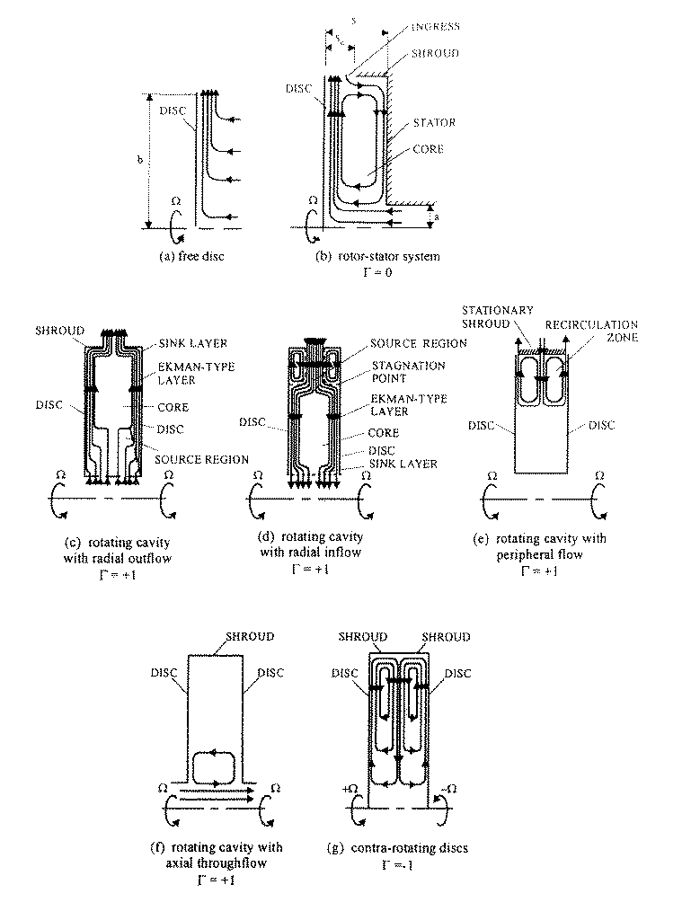

Fig. 1 Schematic diagram of rotating-disc systems

