Unsteady Flow Modelling in Turbine Stage
Prof. Francesco Martelli ,
Energetics Department, University of Florence Italy

The flow in the stage of any kind of turbomachinery is strongly unsteady for several reasons; the first and more relevant phenomena is related, of course, to the relative motion of rotor and stator, but other unsteady phenomena occur which can have significant effect especially on the stage behaviour in off—design conditions , i.e. the vortex shedding at trailing edge, the tip leakage vortex which can be unstable interacting with other unsteady and unstable situation in the flow passages. The effect of unsteadiness have significant effect on the performance of the stage, and actually it is demonstrated that the behaviour of a single row differs from its when located in a multiple row environments. In the turbine blades of the firsts stages of Gas Turbine , where metal temperature are very important, the effect in not only on performance but on the blade heat transfer as well and therefore on the possible life of the bucket itself. Further the unsteady forces can interact with blade elasticity producing flow induced vibration (flutter) with strong effect on structural survival of the rows.

For long time the stage have been computed, analysed and designed with steady assumption , mainly due to the complexity of unsteady flow, and unsteady viscous effect modelling; more recently the improvements in computing capacity and the need to increase the efficiency in the last few percentage points, the maximum operating temperature and life of turbine stage has stressed this kind of modelling.

The research activity has been focused on three different approach according to the target of the study ( unsteady aerodynamics, flutter, unsteady losses et.):
- Fully unsteady calculation with different features of the numerical solver (Rai, Giles, Martelli,…);
- Steady models based on the Adamczyk averaging procedure ( (determinist stress);
- Quasi unsteady methods where the unsteadyness is computed in hybrid way ranging from linear decomposition forms to other numerical approaches based only on the unsteady Boundary Conditions.

At present time we are more interested in the study of turbine stage aerodynamics and heat transfer; these items require a fully unsteady simulation in order to catch crucial points of the heat transfer phenomena and dissipation mechanism in the unsteady boundary layer and the losses related to the vortex shedding as well.

In order to match properly this kind of simulation two focal arguments exist, one is related to the physical modelling of turbulence and transition, (the last especially relevant in the heat transfer evaluation), and tough work is underway is this direction; the other is related to the numerical improvement in terms of both accuracy and storage & cpu time reduction, as the 3D unsteady calculations could require several millions of mesh points and several thousands physical time steps to get reasonable periodic configurations. In order to achieve these targets the solvers have to use special treatment of boundary condition and to move towards massive parallel computing architecture.

The paper will present the most up-to day results in thes arear coming from the open literature and from the author research group as well. Heron some example of preliminary two –dimensional calculations , performed on a experimented turbine stage is reported and the discrepancy between steady solution solving the averaged equations and the mean solution averaging the unsteady solution from unsteady equations. In the next fig.1 typical mesh arrangement is reported.

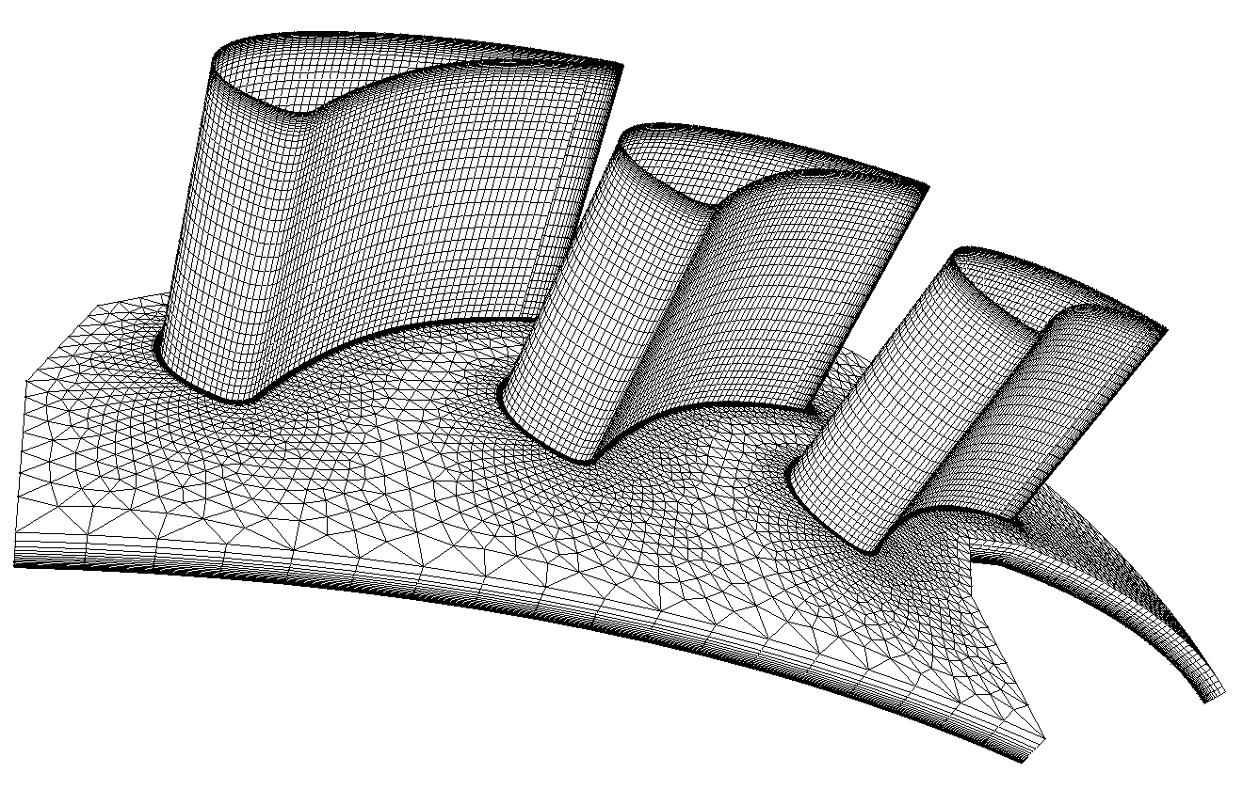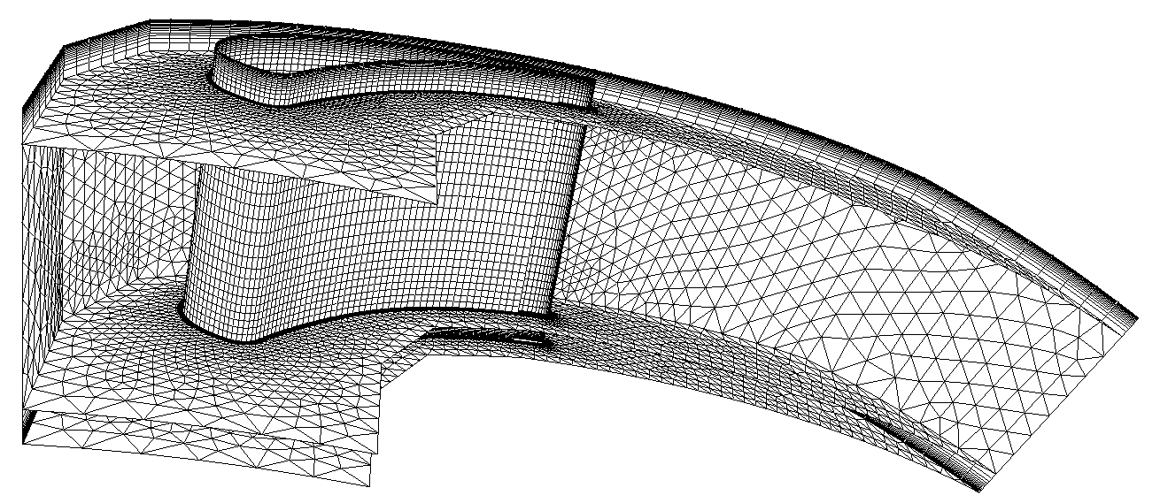

Fig. 1
The effect of steady/unsteady calculation is reported in Fig.2

STEADY SOLUTION UNSTEADY SOLUTION

Fig. 2
The strong different behaviour of the two solutions can be realised looking at the fig.3 where steady flow picture is reported against three configurations for different time steps.
Steady Solution Unsteady solution time 1
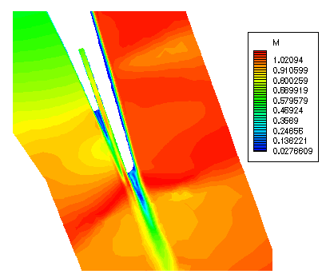
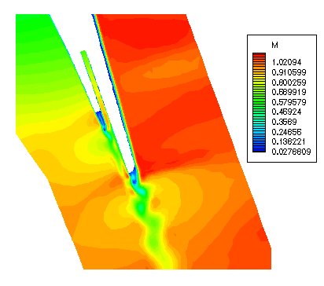
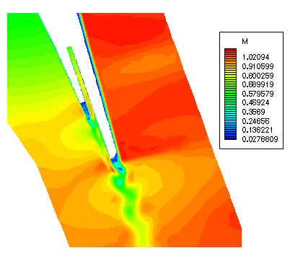
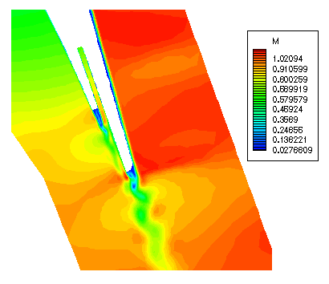

Unsteady Solution time 2 Unsteady Solution time 3

Fig. 3

Comments on the different numerical approaches, different physical models and sample of the flow phenomena comprehension are widely addressed in the paper as well as the discussion of the future improvements under way in the research community and in the author research group.

