Film cooling:
Case of double rows of stagGered jets

P. Noirault^{(*)}, E. Foucault^{(*)}, J.L. Bousgarbiès^{(*)}, E. Dorignac⁽⁺⁾ & J.J. Vullierme⁽⁺⁾

^{(*)}Laboratoire d’Etudes Aérodynamiques (UMR 6609)
Teleport 2, BP 179, 86961 FUTUROSCOPE Cedex. FRANCE.
⁽⁺⁾Laboratoire d’Etudes Thermiques (UMR 6608)
ENSMA, Teleport 2, BP 40109, 86961 FUTUROSCOPE Chasseneuil Cedex. FRANCE.

Introduction

This work concerns the experimental study of thermal fields close to a heated plane wall which limits a flow at room temperature, and an inclined staggered jets double row passes through this wall. Mean temperature and fluctuation rate profiles have been measured using the cold wire technique for two different values of injection ratio couple. The results are compared with those obtained from the examination of the wall temperature map using an infrared camera. The latter technique is then used to extend the study to a larger range of parameters.

Description of experiments

The experiments were carried out in an opened circuit wind tunnel with ambient air flow. The flow configuration consists of the interaction of 11 air injections through the tunnel floor with subsonic turbulent boundary layer (boundary layer thickness δ = 15 mm at x = 0). Figure 1 : (x, z) coordinate system and hole pattern The hole configuration considered is two rows of circular staggered holes. The holes have a diametre D equal to 5 mm, they are laterally spaced by 3D on the row and they are angled at 45 degree to the mainstream. The two rows are spaced by 3D (figure 1).During the test, the plate is maintained at a uniform heat flux density. To obtain this condition, we used the technique of printed circuit to have a surface comparable to a fluxmetre. We imposed an electric dissipated power about 2500 to 3000 W/m² which gives a mean surface temperature of approximately 55°C for a main flow velocity equal to 32 m/s and a range of injection rates (R_{ja} = V_{ja}/ U_{e}, R_{jb} = V_{jb}/U_{e}) between 0.16 to 1.56. At thermal balance, the electric power is dissipated by convection in the fluid, and by conduction in the plate. The plate is isolated on the back face; we have checked experimentally that the losses by the back were weak (less than 100 W/m²). The wall surface temperature map is established using an infrared camera. This technique supposes a precise calibration that requires correct evaluation of the wall emissivity (0.94 here). Concerning the main flow, the velocity and the temperature are uniform and nominally maintained at 32 m/s and between 14 and 19 °C, respectively.

Results

The thermal field detailed study has been realised for two different values of couple of injection ratio (R_{ja} = R_{jb}) respectively equal to 0.63 and 1.56. Variation profiles of the mean temperature and its fluctuation rate have been carried out along the normal at the wall (Figure 3). Their analysis allows us to reveal the leading part of each row. The examination of the different profiles close to the wall shows that from the two considered test conditions, it is the flow generated with the couple R_{ja} = R_{jb} = 0.63 which ensures the best overlap of the plane wall. Indeed, for this couple of values, the temperature close to the wall is almost always greater than that registered in the case where R_{ja} = R_{jb} = 1.56. The wall temperature maps (Figure 2) obtained with the infrared camera confirm this result.This latter technique was then used to register the wall temperature. The injection velocity of one of the rows was kept constant while the injection velocity of the second row was varied in the range of 5 m/s to 50 m/s. The analysis of the obtained temperature maps allows us to determine the injection conditions ensuring more efficiently the plane surface overlap. The comparison of all of the results reveals that when the injection velocity V_{ja} and V_{jb} are equal, there is protection along the whole length of the plate whatever the value of V_{ja} and V_{jb} since it is greater than 0.5. If these two velocities are not equal, it is then better to have V_{ja} < V_{jb} to ensure the protection of the plate.

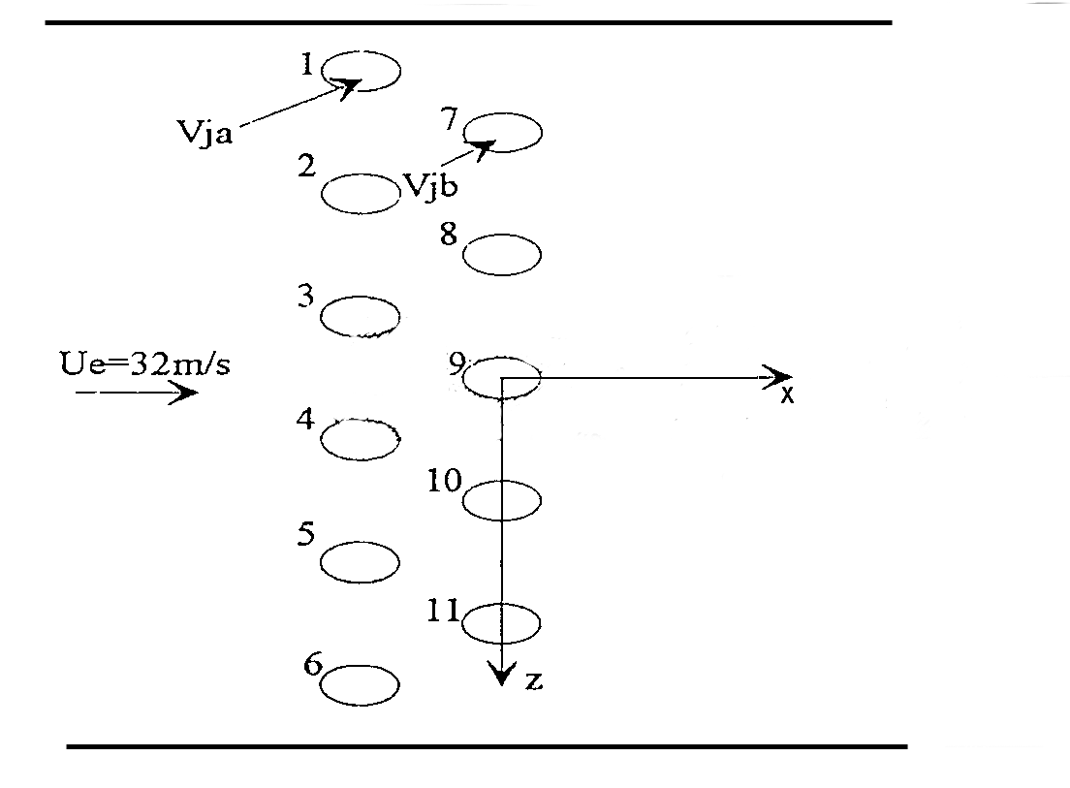
Figure 1 : (x, z) coordinate system and hole pattern

D = 5 mm Px = 3D, Pz = 3D T_{e} = 17,4°C T_{j} = 64°C P = 1983 W/m²
Figure 2 : Wall temperature field by Infrared thermography

Z/d= Z/d=
1.5 1.2
1 0.8
0.6 0.4
0.2 0.1
0
Figure 3 : Dimensionless mean value □ and fluctuation rate ■ temperature profiles in several locations (z/d) in the x/d=1 plane.
Injection rates : Rja=Rjb=0.63
D=5mm; Px=3d; Pz=3d
Te=17.4°C ; Tj=64°C ; P=1983 W/m²

REFERENCES
JABBARI, M.Y.-GOLDSTEIN, R.J. : Adiabatic wall temperature and heat transfer downstream of injection through two rows of holes, J. of Engineering for Power, Vol. 100, pp. 303-307, (1978).
NOIRAULT P. : Interaction entre une couche limite plane et une double rangée de jets en quinconce : application au refroidissement de parois. Thèse de l'Université de Poitiers 1999.
Figure 3 Dimensionless Mean Value and fluctuation rate temperature profiles in several locations (z/d) in the x/d=1 plane. Injection rates : R_{ja}= R_{ja}=0.63
D=5mm, Px=Pz=3d
Te=17.4°C, Tj=64°C, P=1983W/m²

