COOLING SYSTEMS FOR ULTRA-HIGH TEMPERATURE TURBINES

Toyoaki Yoshida
Aircraft Propulsion Research Center, National Aerospace Laboratory
7-44-1 Jindaiji-higashi, Chofu, Tokyo 182-8522, Japan

INTRODUCTION

In the middle of the nineties, turbine inlet temperature reached 1500 degC level in some advanced practical turbine engines not only of aircraft propulsions but also of big-scale industrial gas turbines. Recently, the Japanese research turbo-fan engine for a hypersonic transport propulsion, HYPR verified its availability under the 1700degC level gas temperature condition by the demonstrator engine tests. This hot topic is to be presented in this symposium by one of the members engaged in the development ¹. High-temperature turbines in all of these are air-cooled.

A recent notable trend of cooling technology is to employ foreign gas other than air as coolant for hot parts. Various research and development projects on this technology have been conducted. It is well known that steam cooled combustor and turbine sections are put into practical use in some representative big-scale industrial gas turbines. This kind of activities is mainly aimed for the considerable increase in total thermal efficiency of the engine system. Further elevating turbine inlet temperature is not essential subject and thus it remains at around 1500degC level.

The author's group has been conducting extensive studies on a future cooling system for ultra-high temperature turbines. The system utilizes heat pipes for turbine vane cooling in its ultimate case together with a heat exchanger as a heat-releasing device. The basic concept of the system was once introduced by the author ².

This paper describes features of coolant species on heat transfer characteristics at first, and then some representative work on steam cooled turbine vanes and blades. As the main part of the contents, a series of the work on the said cooling system are summarized. Those include formation of the system, analytical and experimental studies of the individual component of the system, and total engine performance evaluation by numerical simulation for a target engine applying the present system.

COOLING SYSTEM
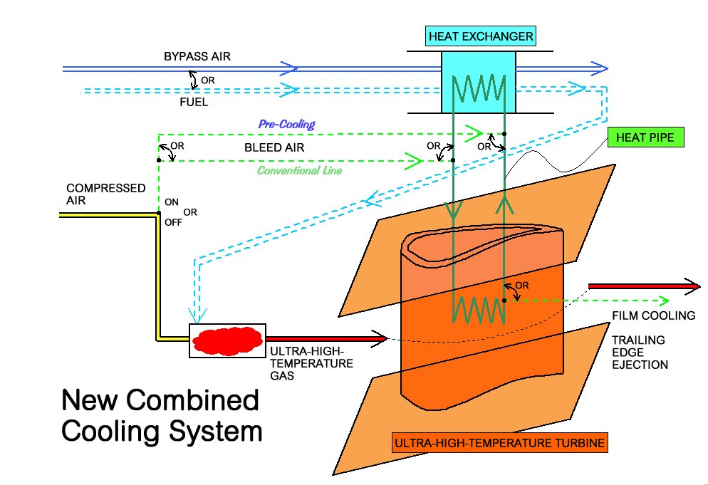
Fig.1 Concept of
cooling system
The concept of the system is shown schematically in Fig.1. It consists of a heat exchanger, coolant transportation lines and ultra-high temperature turbine vanes. Cooling air is pre-cooled and/or heat pipes are introduced to the lines, in either case, the heat exchanger is used as a heat-releasing device. This application will enable turbine vanes to endure gas flow temperature of 1700 degC level or higher and thus it will contribute drastic improvement in specific output power and thermal efficiency of gas turbine engines.
In order to verify advantages of the above concept, following researches were done; a total system performance simulation of the HYPR target engine for the case with the present cooling system, and fundamental works on manufacturing techniques, mechanical strength evaluations and heat transfer characteristic tests of the system components.

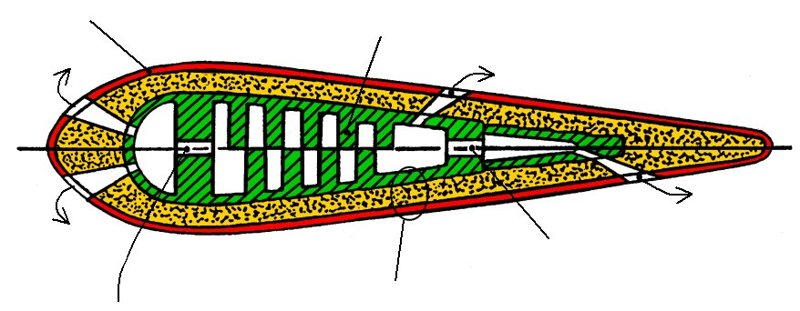
Ultra-high temperature vane
A: Thermal Barrier
Coating
B: Substrate
C: Staggered Array Fins
Three Layer Construction
Impingement Holes
Film Cooling Holes
Impingement Holes
Fig.2 Schematic construction of ultra-high
temperature turbine vane

A new fundamental construction was devised. Its schematic drawing is given in Fig.2. It consists of three layers, a thermal barrier coating (outer surface), substrate (advanced superalloy) and high-heat conductive material (inner liner). Two types of practical high-temperature test models without film cooling holes were successfully manufactured (basic circular models and quasi vane models like Fig.2).

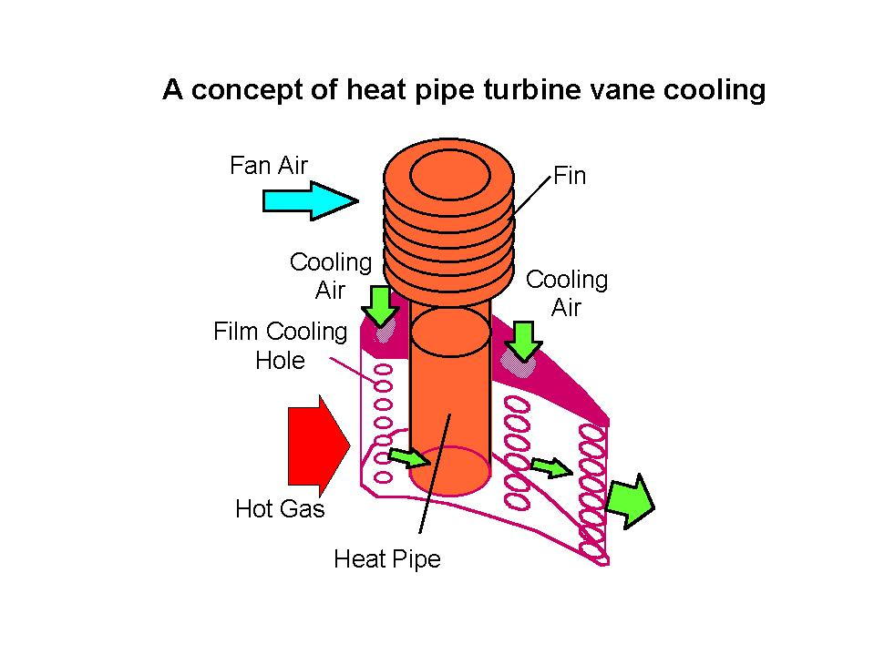
Based on heat conduction analysis of the circular models and those high-temperature wind tunnel tests, heat transfer characteristics of the individual three layers and pre-cooling condition of cooling air were quantitatively disclosed ³. From high-temperature wind tunnel tests of the quasi vane models, the average cooling effectiveness reached an order of 0.67 with the design air flow ratio of 7.5% without film cooling. Its deviation remained less than 0.1 in the chordwise direction ⁴. Hence this type of vanes are considered applicable to ultra-high temperature turbines if cooling air is moderately pre-cooled.
Fig.3 Concept of turbine vane
cooling by heat pipe

High-temperature heat pipe

Introducing a high-temperature heat pipe for turbine cooling is very challenging. In order to realize its practical application to aero-engines, there are some barriers that should be overcome, such as sensitivity to gravitational force, temperature response time until high-temperature working condition and safety against water. There have been some leading studies on the heat pipe applications to aero-engines ^{5, 6}. A concept of the present work is schematically shown in Fig.3. In parallel with the heat pipe cooling, conventional air cooling may also be applied as shown in the figure.

A series of high-temperature heat pipes were prepared that would match the HYPR target engine temperature condition ⁷. These utilize sodium or eutectic NaK as coolant. Wick construction is made of nickel sintered powder metal. At the bottom of the heat pipe shell, an artery is placed for the promotion of return flow of liquid phase coolant. Non-condensable gas is sealed to shorten start-up time. These were manufactured by Thermacore. Heat transfer experiments were conducted in the high-temperature wind tunnel at NAL. Start-up time and heat flux indicated relatively weak dependence on a heat pipe set angle, namely the effect of gravitational force. This can be considered as a good feature for the practical application. In a representative heat pipe test model, the start-up time was an order of 8 minutes and the highest heat flux could transport heat by about 40 W/cm² under the present test maximum heat load condition. According to the discussion on the limits of test facility heat load and heat pipe's various proper characteristics such as wick limit, sonic limit, entrainment limit and boiling limit, the maximum heat transport was predicted at about 3kW. Its applicability to the practical use was evaluated by the following engine performance simulation.

Engine performance simulation

Numerical simulation was conducted on a turbo-fan engine total performance for the case with the present cooling system. The effect of heat pipe application to turbine cooling system on engine fuel consumption and specific output were mainly discussed.

The advantage of heat pipe application is becoming superior to an existing system when cooling air flow rate can be saved by 20%. With the heat pipe developed in the present study, it is predicted that the cooling air can be saved by half of the designed value in the HYPR target engine ⁷.

Fig.4 shows a representative performance map of the HYPR target engine at Mach 3.0 cruise condition ⁸. In the figure, lower net map stands for the case with the present cooling system, where heat pipe system and pre-cooling of air are assumed, while upper one is for the case with advanced air-cooled turbines. A drastic increase in specific thrust, say 20% and an improvement of SFC by about 2% can be achieved by the present system at Mach 3.0 cruise condition. In all the flight conditions, a considerable increase in specific thrust is obtained, while SFC depends on the conditions. These remarks are made under the designated TIT and thrust conditions of the HYPR engine.
Fig.4 Turbo-fan engine performance with
and without heat pipe cooling system
Once we have freedom for the design of a turbo-fan engine, optimization of performance improvement can further be made.

CONCLUSION

Pre-cooling of cooling air is very effective for the improvement in gas turbine performance. Also, introducing steam or foreign gas other than air is very promising. Heat pipe application may be realized in future gas turbines. Although these applications need additional component such as a heat exchanger, it is very worth while to consider these cooling technology.

REFERENCES

1. Yamawaki, S., ICHMT Turbine 2000, Cesme, Turkey, August 14-18, 2000.
2. Yoshida, T., Proc.of ICHMT Heat Transfer in Turbomachinery, Greece, 1992, pp 19-30.
3. Yoshida, T. and others, Proc.of the 3rd Int'l Sympo. on Japan's National Project for a HYPR
system, Tokyo, Japan, May 1999, pp 125-130.
4. Yoshida, T. and others, Proc.of the 12th ISABE, Melbourne, Australia, Sept. 1995, pp 1113-1120.
5. Anderson, W.G., Hoff, S. and Winstanley, D., ASME Paper 93-GT-220.
6. Silverstein, C.C., Gottschlich, M.J. and Meininger, M., ASME Paper 94-GT-306.
7. Yamawaki, S. and others, ASME J.of Eng. for Gas Turbine and Power, V120, 1998, pp 580-587.
8. Tagashira, T. and Yoshida, T., Proc.of the 14th ISABE, 99-7198, Florence, Italy, Sept. 1999.

