STUDY OF GEOMETRIC EFFECT ON MULTIHOLE COOLING PLATES USED FOR COMBUSTION CHAMBER WALLS

B. LEGER**, J. M. EMIDIO*, F. PARDO*
* Turbomeca, Sce aérothermodynamique
** Laboratoire Aquitain de Recherche en Aérothermique (Pau University)
C/O Turbomeca
64511 Bordes cedex (France)
Email: bruno.leger@univ-pau.fr

introduction

The cooling of a combustion chamber in a turbomachine is becoming more and more important for manufacturers. Multihole cooling has been used and studied for a long time¹⁻²⁻³ but the efficiency of this process can be improved by controlling the wall temperature with the bare essential cold airflow.
A special test bench (fig. 1) has been made to simulate on a multiholed plate, the flows and thermals conditions found in a combustion chamber. The values of flow rates, temperature and pressure can be controlled in a range around realistic conditions.
Figure1: Test Bench Figure 2 : Plate geometry

The measurement of the temperature is obtained by mean of IR thermography ⁴⁻⁵. So we can calculate the true temperature of the plate with a self-developed code⁶.

Geometric effect on cooling

The tested plates are defined by several geometric parameters (fig. 2) such as α (angle of the hole), D (Diameter of the holes), L (longitudinal pitch), P (transversal pitch). These parameters had been separately studied under all dynamical and thermal conditions. So it is possible to discuss the influence of each geometrical parameter on the cooling effect.

Results:

The figure 3 shows the result obtained on the temperature measurement along a multiholed plate by the augmentation of the hole diameter D, from 0.3 mm to 0.5 mm when the hot stream temperature is 860°C. We can immediately see that the cooling effect is more important when the hole diameter is increasing but also the temperature gradient increase. The same type of conclusions can be made with the others geometric parameters which are angle hole and longitudinal and transversal pitch.
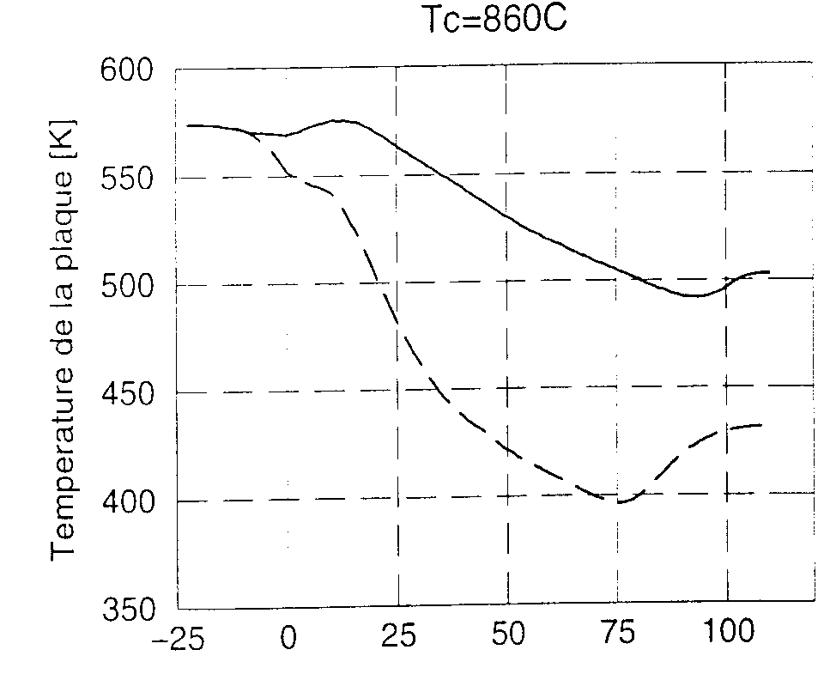
mm

Figure 3: hole diameter effect

Conclusions
The numerous tests done, lead us to advice different cooling geometries, depending on the local dynamic and thermal conditions the combustion wall meet. Each geometry parameter has been separatively investigated, and it allows us to introduce correlations in a specific code. This code help the designer to make choice for the geometric distribution of the multihole cooling device, depending on temperature level wanted, with an acceptable temperature gradient.

Bibliography

- G. E. Andrews, M. L. Gupta et M. C. Mkpadi. Full coverage discrete hole wall cooling : Cooling effectiveness. ASME n° 84, GT 212, 1984.
- J. L. Champion, E. Dorignac et B. Deshaies. Etude expérimentale du processus de refroidissement d’une plaque multiperforée. Congrès sur la thermique de l’homme et de son proche environnement, Société Française des Thermiciens, pages 254 à 259, Mai 1995.
- R. E. Mayle et F. J. Camarata. Multihole cooling film effectiveness and heat transfer. Journal of Heat Transfer, pages 534 à 538, Novembre 1975.

- D. Balageas, D. Boscher, A. Déom, J. Fournier et R. Henry. La thermographie infrarouge : un outil quantitatif à la disposition du thermicien. Revue Générale de Thermique, 27 (322) pages 501 à 510, Octobre 1988.
- G. GAUSSORGUES (1989) La themographie Infrarouge, Principes, Technologies, Applications, troisième édition, Lavoisier
- J.M. Emidio, B. Leger, P. Andre, G. Grienche, G. Schott (1997) Application of infrared thermography modeling local heat transfer coefficient adiabatic effectiveness on multihole cooling in real cases. 4th world conference on experimental heat transfer,fluid mechanics and themodynamics, EXHFT4, Brussels, June 2-6,pp 141-152,Edizioni ETS.A.

