A NOVEL Digital Image Processing System
for the Transient Liquid Crystal Technique
applied for Heat Transfer and Film Cooling Measurements

G.Vogel, A. Bölcs
Laboratoire de Thermique Appliquée et de Turbomachines (LTT)
Swiss Federal Institute of Technology
1015 Lausanne, Switzerland

This paper is dedicated to the transient liquid crystal technique measurements for multiple view access by using a novel digital recording and image processing system. The transient liquid crystal technique is widely used for heat transfer works in turbomachinery and is applied in our laboratory in several test facilities such as a linear cascade for external film cooling measurements on airfoils or on a ribbed squared duct for internal cooling measurements.
The transient technique consists in measuring the surface temperature evolution in time triggered by a heat pulse. This heat pulse can be generated by electric heater foils on surfaces or with heater grids in the flow, or by rapidly exposing a preconditioned model to a different temperature level. Transient experiments have the advantage of avoiding conduction problems and to be usually of short duration, hence allowing to perform more measurements in a limited amount of time compared to steady state techniques.
The transient surface temperature can be measured by thermocouples or thin film gauges on discrete positions but with a known drawback of a poor spatial resolution. In order to obtain a higher spatial resolution, field methods need to be employed such as the thermo-chromic liquid crystal technique which consist of monitoring the surface temperature evolution by acquiring the color signal of a liquid crystal coating. The signal acquisition is performed by a CCD camera and it needs a certain illumination quality as well as a good optical access.
Depending on the size and shape of the test section and on the optical access, the color play of the liquid crystals on the surface during the transient temperature evolution can either be recorded by one or by multiple cameras. Typically multiple cameras are used allowing to capture complex shaped geometry surfaces such as blades. By using various focal lengths of the camera lenses, different zones can be captured at low or very high spatial resolutions.
However, multiple camera use can become problematic as the amount of data collected during the measurements increases rapidly. In the past, specific very expensive devices where used and the liquid crystal signal had to be filtered in real time during the experiment as the computers were limited by the amount of data to be treated. In some cases, images were even lost due to non-sufficient computer capacity and if the signal was of too poor quality or the filtering parameters not well adjusted, the experiment had to be re-performed. Because of all these problems the real time signal processing has been avoided and replaced to a new method where the different camera signals are independently recorded on multiple digital supports for each camera view during the transient experiment.
New digital recording devices have the advantage of ensuring a precise signal acquisition which can easily be restituted to a computer with a high speed data bus transfer. After the measurements, digital video sequences of each camera used are then transferred one after the other to a computer where the image processing and the data reduction are performed.
In the past, data reduction had to be executed by powerful workstations. But thanks to the recent evolution of computer performances, liquid crystal signal data reduction is now performed on a personal computer with in-house programs written in the commercial LabView® language and using the IMAQTM image processing functions. Powerful coordinate transformations and image filtering functions are programmed and can be applied on the digital video sequences for a good elimination of noise signals, undesired zones or light in-homogeneities. A hue, saturation and intensity filtering of the calibrated liquid crystal signal gives very precise temperature levels of the recorded surface. The heat transfer coefficient in the different regions of the measured surface is determined by focusing on a specific temperature value and by measuring the time it takes to reach this level along the transient experiment. For film cooling measurements, by using a multi-regression process, this transient liquid crystal technique, based on a digital image processing system, also gives the film cooling effectiveness.
The figures below show typical results of heat transfer coefficient and film cooling effectiveness behind a shaped hole row located on the suction side of a nozzle guide vane. The hole diameter is 0,5 mm giving a spatial resolution for this measurement of 10 points (pixels) /mm.
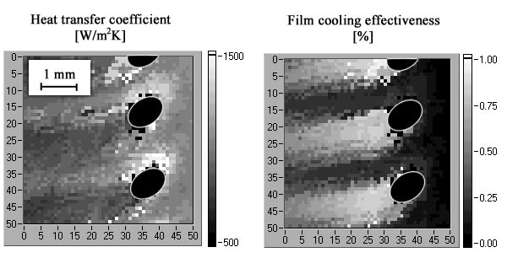
Advantages and weak points of this novel acquisition system of digital recording and software-based image filtering are described in this paper. It has already been employed in two different test facilities on flat plates and airfoils models with very good data results and it will be adapted in the future for transient liquid crystal technique on heater foils with step heating methods which will be suitable for film-cooled end-wall or platform investigations.

