HEAT TRANSFER TECHNOLOGY FOR INTERNAL PASSAGES OF AIR-COOLED BLADES FOR HEAVY-DUTY GAS TURBINES

Bernhard Weigand*, Klaus Semmler, Jens von Wolfersdorf**
*Institute for Aerospace Thermodynamics,
University of Stuttgart, 70569 Stuttgart, Germany
** Heat Transfer Group,
ABB ALSTOM POWER, 5401 Baden, Switzerland

The need for cooling gas turbines has steadily increased over the last thirty years because of the increasing differences between turbine inlet temperature and allowable material temperature. The aim of the here presented work is to review the current status of the heat transfer technology for internal passages of turbine blades. Special focus will be given to the heavy-duty gas turbines. Compared to the heat transfer requirements for an aero - engine, the cooling of blades for industrial gas turbines differs in some aspects. Maybe the most important differences are firstly that blades for heavy-duty gas turbines, because of there much bigger dimensions, are subjected to much higher Reynolds numbers in the internal cooling passages. Secondly, the larger size of the blade and also the internal cooling passages gives much more freedom for designing the shape of cooling features inside the blade which have to be casted in. On the other hand the durability of the heavy-duty gas turbine and the guaranteed long live of the blades of about 50000 operating hours require a very safe design of the cooled blades.
In order to review the heat transfer technology for internal passages of blades for heavy-duty gas turbines it is important to first look on the actual design of such blades. Fig. 1 shows typical examples for a vane and a rotating blade. For vanes, impingement cooling is used very often
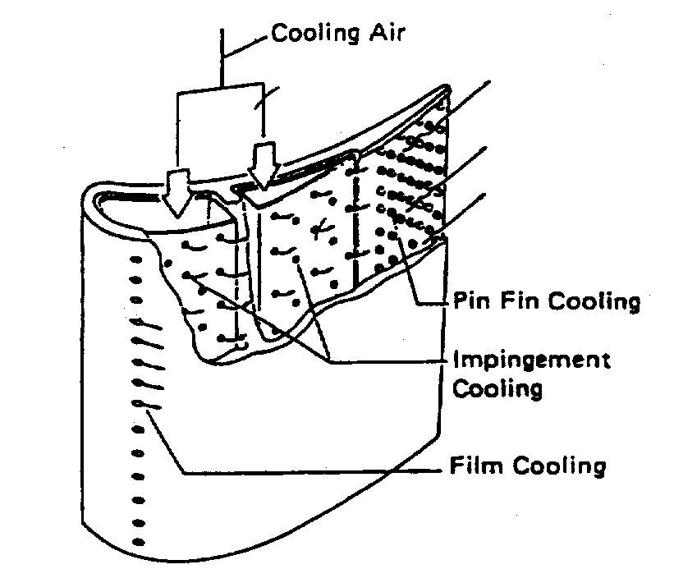
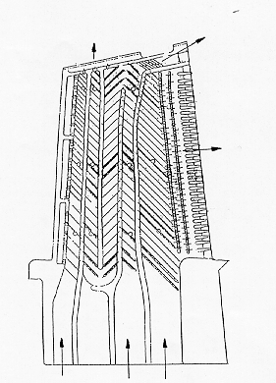
Feeding
Pins
Impingementt
Film cooling
Turbulators
Bends

Vane Rotating blade

Fig. 1: Typical cooling features for stationary and rotating blades.

together with pins and turbulators. For rotating blades mostly turbulators are prefered together with pins in order to efficiently cool the blade. Both cooling schemes can use additionally film cooling if the external hot gas temperature is too high for cooling the blade only by internal convection. The external heat transfer of the blade provides the boundary conditions for the internal cooling problem. Therefore, the present review paper will also focus briefly on the prediction methods for the external heat transfer with and without film cooling. Additionally it is important to discuss here the areas of the blade, where highly three-dimensional external boundary conditions are present. These areas are the endwall and the blade tip.
After the external boundary conditions are known, the internal heat transfer can be discussed. For the internal heat transfer it is important to understand the methods for enhancing the internal heat transfer coefficients first. As already mentioned above the common methods for doing this are: turbulators (ribs), impingement, pins and combinations thereof. As it can be seen from Fig. 1 above, the radially aligned coolant channels are connected by 180° turns. Current trends are towards increasing number of channels, so that the flow and heat transfer characteristics around bends and turns is of high interest. Fig. 2 shows a flow visualization for a 180° bend. It can be seen that the flow characteristics in the
1 Regions of low velocity
2 Flow direction
3 Area of flow separation
4 Separation line
5 Flow attachment point
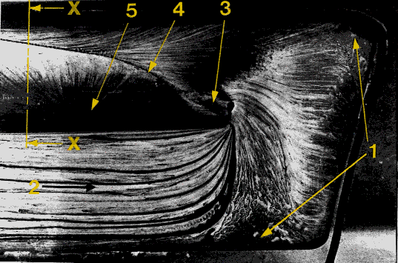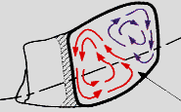
X-X:
Fig. 2: Flow visualization (oil painting) for the flow in a bend.

bend region are quite complex. Secondary flow features and separation zones lead to complex three-dimensional flow features. Rotation can significantly influence heat transfer in the serpentine passages, especially in the bend area. In literature there are many experimental and numerical studies known which deal with heat transfer enhancement in channels and the flow structure in bends¹⁻³. Mostly these studies are done for idealized geometries. This means that rectangular channels are normally used for these type of experiments. Correlations for predicting the pressure drop and the heat transfer for these type of channels can be found in literature. Additionally several numerical investigations have been done, which show in general that the pressure drop of such channels can be predicted precisely, whereas heat transfer can only predicted qualitatively in most cases. However, in blades of a real gas turbine complex geometries have to be used for the cross section of coolant passages because of constraints given by stress analysis, aerodynamics and manufacturing. This requires some sort of component tests for the heat transfer of the designed blade at the end. Such tests can be done for heavy-duty gas turbines by using large scale models, as the one shown in Fig. 3, where the transient liquid crystal method has been used for measuring the heat transfer inside the blade. The use of test engines is also common for testing the capability of the designed blade, but the number of tests in such test engines is normally much less than the one for aero-engines because of the enormous costs involved for heavy-duty gas turbines. The large scale tests mentioned above are further be used for evaluating and improving CFD tools. Nowadays, these 3D tools are used more and more in the design process.

Because of the larger dimensions of heavy – duty gas turbines the internal heat transfer of the blades face also other special problems. One of these special problems are creep elongation of larger blades because of the large number of operation hours the blade has safely to operate. Another common problem is allocated to the various types of different fuel heavy-duty gas turbines have to deal with. Here the usage of crude oil for example restricts very much the features which can be used for the cooling design (for example film cooling will not be possible). Also the internal cooling design of the blades for industrial gas turbines has to deal dirt inside the secondary air system. Therefore, measures have to be taken in order to guarantee a safe design also in such aggressive environments.

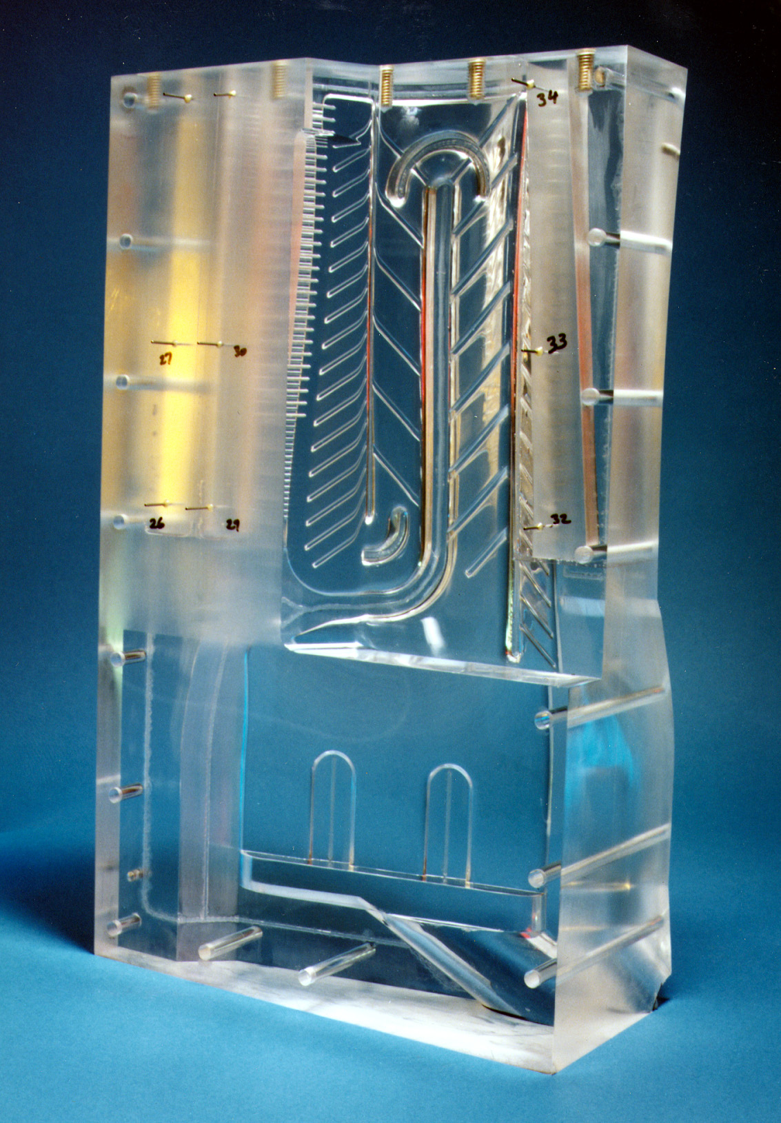
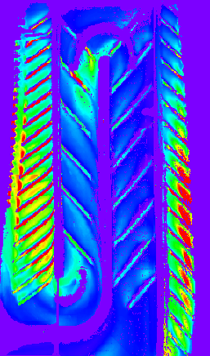

Large Scale Model Heat Transfer Results (red = high)

Fig. 3: Large scale model and test results for the heat transfer inside a modern gas turbine blade.

Several innovative developments for the internal cooling design of industrial gas turbines have been thought of in the newer past. One is the use of steam as the working fluid for the internal cooling loop. By using steam, the internal heat transfer capability can be increased dramatically, but on the other hand several problems have to be dealt with like start and shut down of the engine, corrosion, sealing and so on. Another innovative development of the last years is to use 3D shaped turbulators to locally influence heat transfer in the internal channels of industrial gas turbines.

CONCLUSION
The here presented review paper, also far from been complete, aims to give an overview about the present state of the art in the field of internal cooling of gas turbine blades. The special focus has been put on the cooling of blades for heavy-duty gas turbines, which show several differences compared to blades for aero-engines.

REFERENCES
- Metzger, D.E., Cooling Techniques for Gas Turbine Airfoils – A Survey, Proceedings of
AGARD Conference, Bergen, Norway, 1984, pp. 1 – 13.
- Kawaike, K., Anzai, S. Takehara, I., Sasada, T. and Matsuzaki, H., Advanced Cooling Design
of Turbine Blades with Serpentine Cooling Passages, CIMAC, London, England, 1993, G12, pp.1-16.
- Lakshminarayana, B., Fluid Dynamics and Heat Transfer of Turbomachinery, John Wiley & Sons, Inc., New York, 1996.

